Template Social Media Posts (to copy and paste)
Facebook Post
The SEND Local Offer is the place to find info and services for children and young people with special educational needs and / or disabilities (SEND).
- Are you worried that your child may have SEND and don't know where to start?
- Has your child got a SEND diagnosis and want to know what support is available?
- Are you wondering what help is out there if your family's needs change, or as your child grows older?
Visit https://next.shropshire.gov.uk/the-send-local-offer/ and follow them on Facebook

Instagram Post
The SEND Local Offer is the place to find info and services for children and young people with special educational needs and / or disabilities (SEND).
- Are you worried that your child may have SEND and don't know where to start?
- Has your child got a SEND diagnosis and want to know what support is available?
- Are you wondering what help is out there if your family's needs change, or as your child grows older?
Visit https://next.shropshire.gov.uk/the-send-local-offer/ and follow them on Instagram
#Shropshire #SEND #LocalOffer

Example images to use on social media

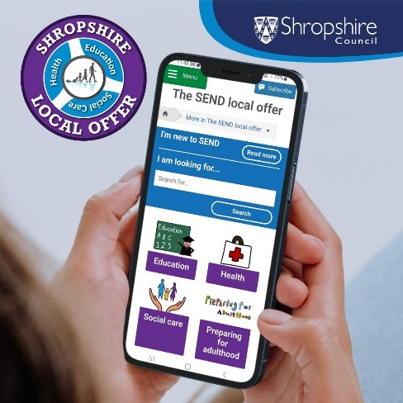
AltText: A photograph of a woman’s hands holding a mobile phone. The Shropshire SEND Local Offer website is displayed on the screen.

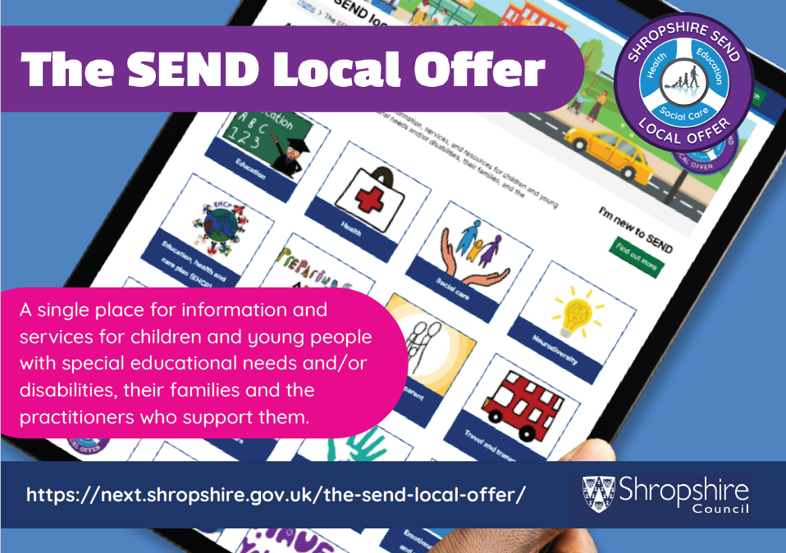
AltText:A photograph of a tablet displaying the SEND Local Offer website. The text reads: The SEND Local Offer. A single place for information and services for children and young people with special education needs and/or disabilities, their families and the practitioners who support them. www.shropshire.gov.uk/localoffer

