ANNUAL REVIEW REPORT
of an Education, Health and Care Plan (EHCP) 0 - 25
Type of Annual Review | Choose an item.
Date of Review
Date of last Review

For Phase Transfer Reviews or where there is a request for a change of setting, please provide the young person’s/parent/carer(s) 3 preferences
1
2
3

If there is a phase transfer coming up i.e. transition to another education setting, please describe options discussed
This will support the Annual Review Process to be able ensure YP’s plans can show how they are being supported for the upcoming transition. I.e. In the year 9 annual review, has the family and YP thought about post-16 options and what the setting can do to support the transition and ensure it can be successful.

Child/Young Person’s Details
Name
DOB |  | NCY
Current setting
YP Home address
Young Person’s Contact Details
These must be provided where appropriate, for young people who are over 16 we will direct future correspondence to them and not parents/carers
Email |  |  | Phone Number
CLA Status and Contact Details
Is the YP CLA | Choose an item. | If yes, which Local Authority is the YP in care to?
Name of Social Worker and Team | Please also include here if the young person is open to the disability team
Workplace address
Phone number
Email address

Young Person Consent

Is the young person over 16 and do they consent to their parent/carer(s) making contributions to the Annual Review process?
Choose an item.

Parent or Carer Details
Parent/carer name |  | Parent/carer name
Address (if different from above) |  | Address (if different from above)
Telephone number |  | Telephone number
Email address |  | Email address
Parental Responsibility: Choose an item. |  | Parental Responsibility:Choose an item.

Primary area of need
Choose an item.

Attendance
% of Attendance:
All part time timetables must be agreed via panel at the local authority before being implemented
https://www.shropshirelg.net/eas/attendance/reduced-timetables/

Please describe current attendance (i.e., days per week, timetable, accessing AP etc.):
Are there barriers to accessing learning?
Please also include details of dual placements and how many days are being accessed at AP etc.

 | Name (including title/role) | Contact details (i.e., email) | Invited (Y/N) | Attended/report provided (Y/N)
Chair
Parent/carer
Parent/carer
Young Person
Advocate/Family Representative
SENDCO/School Representative
Local Authority Representative
Social Care
Health

Section A: Child/Young Person/Parent’s Views/Aspirations
The young person should be invited to attend part (or all) of their annual review, if they are not able to attend their views should be gathered prior to the meeting taking place.
How were the young person’s views gathered? (i.e., through observation, through play, from conversations over a period of time, through informal discussions)
Name of the person(s) who helped gather the young person’s views?
Name and relationship to young person: | Date:

Child/Young Person’s Views & Aspirations for Adulthood: To be completed prior to the meeting wherever possible, however, can be amended at the meeting if views have changed.
What is important to me/what I want to achieve in life
Think about what you want your life to be like when you’re older.

Think about where you might want to live or what job you’d like.

Think about what makes you feel happy, safe, and confident.
These are the people (including family members or professionals) that are important to me

Think about the people you trust and feel comfortable with.

Think about family members, friends, or adults in school who help you.

Think about anyone you would want to stay involved in your life.
My interests and what I like to do

Think about the activities, hobbies, or subjects you enjoy.

Think about what you like doing at home, at school, or in your free time.

Think about what makes you excited or proud.
My strengths and what I am good at

Think about things you do well or feel confident about.

Think about skills you have, in school, with friends, or at home.

Think about what other people say you’re good at.
What I find difficult

Think about things that feel hard or stressful for you.

Think about times of day, lessons, or situations that are challenging.

Think about anything that makes you worried, tired, or upset.
How others can help and support me

Think about what adults can do to make things easier for you.

Think about what helps you at school, with friends, or when you go out.

Think about what support you need to feel calm, safe, and successful.
How I would like to be included in making decisions
This is relevant for young people 16 and over.
Any other comments – this could include anything that you would like to be different
Parent/Carer Views and Aspirations for Adulthood: To be completed prior to the meeting wherever possible. It can be amended at the meeting if views have changed
(only to be completed if consent has been given)
Our aspirations for the future

What is important to us?
Think about what helps your child feel happy, safe, and understood.

Think about what matters most to your family in school life.

Think about the values, routines, or relationships that support your child.
How to support us

Think about what school can do to make things easier for you at home.

Think about the type of communication or updates that help you most.

Think about what support you need to feel included in decisions.

Things that are working well for us

Think about what is going well at home or school right now.

Think about routines, strategies, or people that help your child succeed.

Think about times of day or activities that feel positive.
Things that are not working well for us

Think about what feels difficult or stressful for your child or family.

Think about any routines, environments, or situations that cause challenges.

Think about what you would like to see change or improve.
Any other comments – this could include anything that you would like to be different

Overview of Personal/Education Attainment and Achievement over last 12 months and looking forward to the next academic year

Qualification (i.e., Subject, GCSE, Functional Skills, Vocational Subject) | Attainment/level currently working at (i.e., reading spelling age) | Date due to be completed

Additional Data i.e. CAT4 or other screeners/any other information such as reading comprehension

Looking Forward to the Next Academic Year
Please focus on Preparation for Adulthood and transitions to future settings (Further Education and Employment, Independent Living, Community Participation, Good Health and Wellbeing).
Preparing for adulthood | Shropshire Council
Please specify here what the young person will be doing/aspires to be doing in the next academic year.
YP views

Parent/carer views

Setting views

Are there any short-, medium- and long-term focuses:

Section B, E and F
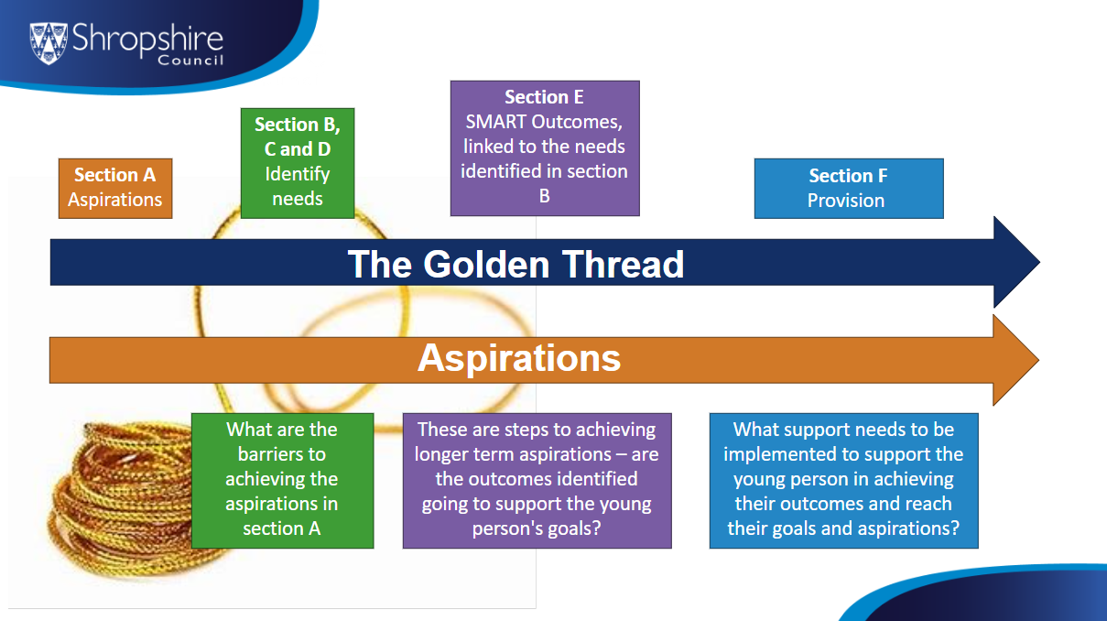

Section B  Special Educational Needs: Is Section B of the EHC plan still an accurate description of the child/young person’s special educational needs?  (Without the supporting professional advice, the team will not be able to make the necessary changes).  When reviewing the EHCP please review both strengths and difficulties, ensuring neither area are blank.  If difficulties are removed and not replaced with new information under each existing heading, this may result in this being removed as an area of need.  School advice should detail who the statement has come from i.e. the class teacher reports that. | Yes ☐​ No ​☐​
Updates to Section B that the setting wishes to be known:
Use this space to make updates to section B.
Communication & Interaction (to include Community Participation, Friendships and relationships)
Strengths

Difficulties

Cognition & Learning (to include Employment Related Skills)
Strengths

Difficulties

Social Emotional & Mental Health (SEMH) (to include Wellbeing)
Strengths

Difficulties

Physical & Sensory (to include Good Health)
Strengths

Difficulties

** This can be in collaboration at the Annual Review, and the Case Officer will review as part of the process**
Section E
Outcome 1: Choose an item. | By when (end of Key Stage)
Has this Outcome been met? | Yes ​☐​ No ​☐ Partially ​☐​
Comment on progress towards meeting this Outcome | Young person views:
Comment on progress towards meeting this Outcome | Parent/carer views:
Comment on progress towards meeting this Outcome | Setting views:
Is this Outcome still relevant and appropriate? | Yes ​☐​ No ​☐
New proposed SMART Outcome
(there MUST also be identified Provision in section F to support this proposed Outcome)
New proposed steps
Section F
Is the Provision in Section F still relevant? | Yes ​☐​ No ​☐​
Suggested amendments | SENDCo Reflection  If the provision has been left unchanged, please indicate why:  ☐ The provision is appropriate and continues to meet need  ☐ I am unsure what alternative provision may be appropriate  ☐ I need further guidance, training, or support to adjust provision  ☐ Other (please specify): ___________________________

Section E
Outcome 2: Choose an item. | By when (end of Key Stage)
Has this Outcome been met? | Yes ​☐​ No ​☐ Partially ​☐​
Comment on progress towards meeting this Outcome | Young person views:
Comment on progress towards meeting this Outcome | Parent/carer views:
Comment on progress towards meeting this Outcome | Setting views:
Is this Outcome still relevant and appropriate? | Yes ​☐​ No ​☐
New proposed SMART Outcome
(there MUST also be identified Provision in Section F to support this Outcome)
New proposed steps
Section F
Is the provision in Section F still relevant? | Yes ​☐​ No ​☐​
Suggested amendments | SENDCo Reflection  If the provision has been left unchanged, please indicate why:  ☐ The provision is appropriate and continues to meet need  ☐ I am unsure what alternative provision may be appropriate  ☐ I need further guidance, training, or support to adjust provision  ☐ Other (please specify): ___________________________

Section E
Outcome 3: Choose an item. | By when (end of Key Stage)
Has this Outcome been met? | Yes ​☐​ No ​☐ Partially ​☐​
Comment on progress towards meeting this Outcome | Young person views:
Comment on progress towards meeting this Outcome | Parent/carer views:
Comment on progress towards meeting this Outcome | School views:
Is this Outcome still relevant and appropriate? | Yes ​☐​ No ​☐
New proposed SMART Outcome
(there MUST also be identified Provision in Section F to support this outcome)
New proposed steps
Section F
Is the Provision in Section F still relevant? | Yes ​☐​ No ​☐​
Suggested amendments | SENDCo Reflection  If the provision has been left unchanged, please indicate why:  ☐ The provision is appropriate and continues to meet need  ☐ I am unsure what alternative provision may be appropriate  ☐ I need further guidance, training, or support to adjust provision  ☐ Other (please specify): ___________________________

Section E
Outcome 4: Choose an item. | By when (end of Key Stage)
Has this Outcome been met? | Yes ​☐​ No ​☐ Partially ​☐​
Comment on progress towards meeting this Outcome | Young person views:
Comment on progress towards meeting this Outcome | Parent/carer views:
Comment on progress towards meeting this Outcome | School views:
Is this Outcome still relevant and appropriate? | Yes ​☐​ No ​☐
New proposed SMART Outcome
(there MUST also be identified Provision in Section F to support this outcome)
New proposed steps
Section F
Is the Provision in Section F still relevant? | Yes ​☐​ No ​☐​
Suggested amendments | SENDCo Reflection  If the provision has been left unchanged, please indicate why:  ☐ The provision is appropriate and continues to meet need  ☐ I am unsure what alternative provision may be appropriate  ☐ I need further guidance, training, or support to adjust provision  ☐ Other (please specify): ___________________________

Review of Health and Social Care
(Section C and D of the EHCP)
Changes to Section C, D, G, H1 and H2 MUST be evidenced by professional advice and reports. Any new health reports must be attached to the Annual Review report.
Please also capture where the young person has recently had a referral, is on a waiting list or is waiting to transition between services, i.e., children to adult services.
Health Needs (C)
Have the health needs changed since the last EHCP was issued?
Yes ☐ No ☐
Any updates you have received (appointment letters/new diagnosis/up to date professional reports and then upload to portal as part of the AR paperwork)

Health Provision (G)
Is there any new health provision since the last EHCP was issued? If yes, please list the provision below.
Yes ☐ No ☐
Does the child/young person’s health have an Individual Healthcare Plan?
Yes ☐ No ☐
If yes, has a copy been provided in the appendices?
Choose an item.

Social Care Needs (D)
Have the social care needs changed since the last EHCP was issued?

If social care is recorded in the previous EHCP, have you sent the request for information to Social Care?

Yes ☐ No ☐
Social Care Provision (H1)
Is there any new health provision since the last EHCP was issued? If yes, please list the provision below.
Yes ☐ No ☐
Social Care Provision (H2)
Have the social care needs changed since the last EHCP was issued?
Yes ☐ No ☐
Was this review completed alongside the PEP? (CLA)
Yes ☐ No ☐
If yes, has a copy been provided in the appendices?
Choose an item.

Annual Review Recommendation

(must be completed)

In-line with the young person’s progress, please make a recommendation to the Local Authority
(only one)

Can the setting continue to meet need?
Yes ☐ No ☐
Have you included a costed provision map as part of the review?
Requests are taken to panel, and the local authority requires this information for discussion
Yes ☐ No ☐ Not applicable ​☐​

Maintain – no amendments  EHCP is still required and the placement, provision and outcomes remain appropriate. | EHCP remains appropriate ☐
Amend  EHCP is still required although amendments are needed. (Annotated EHCP must be attached as well as any supporting professional advice).  If parent/Carer/Young Person are requesting a re-assessment, please record here. | EHCP requires significant changes which cannot wait until the end of the current Key Stage ☐  Parent/Carer/Young Person are requesting a re-assessment of needs ☐
Cease  Transfer to SEN Support or FE high needs  If you have selected cease, what is the reason:  - EHCP is no longer required. The child/young person still requires a level of educational support which can be met through a Graduated Support Plan (GSP) or FE high needs funding.  - The child/young person no longer requires special educational provision to be made through an EHCP and has met or will meet their outcomes by the end of the current academic year.  - The young person/parent/carer have requested for the plan to be ceased.  - The young person is leaving/has left education, e.g., going to university or paid employment.  Has a referral to the relevant support services been made, i.e., adult social care or Enable? | Recommendation to cease to maintain the EHCP ☐
 | Please use this space to capture any additional comments around this decision, e.g., going to university.
 | Cease Reason
1 ☐

2 ☐

3 ☐

4 ☐

Declaration

Chair of the annual review meeting (mandatory – must be signed)
I confirm that the information provided in this paperwork is correct and that all the necessary documents identified above will be submitted with this annual review report.
Name
Role
Signature
Date

Parent/carer
I confirm that the information provided in this paperwork is correct and gives an accurate summary of the annual review meeting.
Name
Role
Signature
Date

Young Person
I confirm that the information provided in this paperwork is correct and gives an accurate summary of the annual review meeting.
Name
Role
Signature
Date

FOR REQUESTS FOR RE-ASSESSMENT ONLY
Please refer to Section 9.191 and 9.192 for further guidance.
SEND_Code_of_Practice_January_2015.pdf
I consent for Shropshire Council undertaking a statutory re-assessment of special educational needs, which may result in an amended Education, Health and Care Plan (EHCP) for the young person named above.
I consent for Shropshire Council to request, obtain and share information with relevant agencies when carrying out their functions regarding: assessment, planning and commissioning as part of the Children’s and Families Act 2014 for the child named above.
Parent/Carer/Young Person’s name | Signature | Date

Where do you need to send the paperwork?
Please send this annual review report and any additional documents to the EHCP Team via the Shropshire SEND Portal. Please click on the ‘Annual Reviews’ folder, add a new folder and name it using the following naming convention ‘Name, Date of Birth, Year group, Date AR took place’ and then upload your documents. You do not need to email us as well as we are automatically notified of any folders added to the annual reviews folder.
If you are a nursery or out of county school that is not yet signed up to the portal, please still continue to send via encrypted email to senannualreviews@shropshire.gov.uk
The SEND Code of Practice states that the completed annual review report and any additional documents must be sent to the EHCP Team within two weeks of the meeting date, this must not be exceeded. This ensures that statutory deadlines can be met.
If you need any help with this, please email EHCPTeam@shropshire.gov.uk

