**Internal (ABBOTT) and External Quality Controls EQAS**

**Crib Sheet for the Afinion AS** **and**

**ABBOTT AF2 Shropshire NHS Health Check Devices**

**Please note – Both devices use the same quality control procedures.**

**Table of Contents**

1. Quality Control Schedule, Machine Preparation and Cassette Panel use.

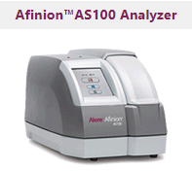

**Afinion 2**

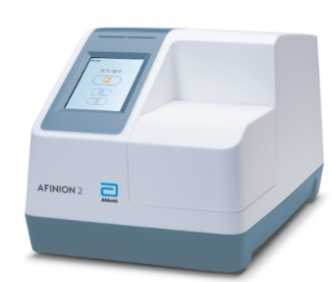

1. Receiving, storing and use of the Quailty Controls

1. Undertaking and recording Internal ABBOTT HbA1c and Lipid Quality Control.

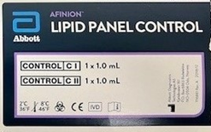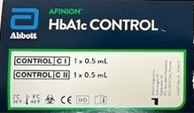

1. 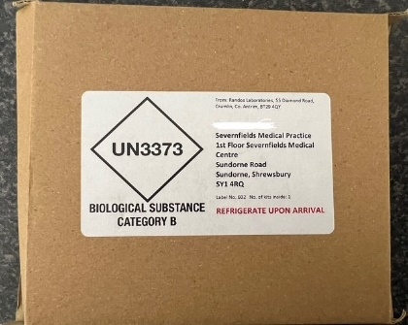Undertaking and recording External RIQAS Lipid and HBA1C Single Sample Control.

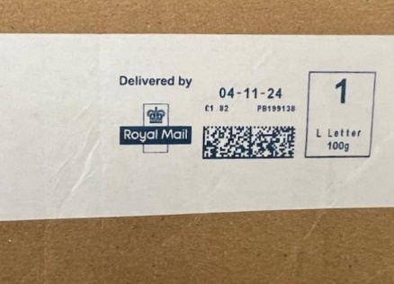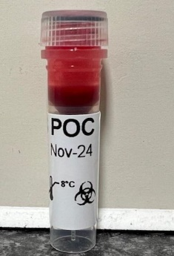

Back - With Delivery Date

Front

1. Trouble shooting / Error Codes / Quick Reference Guides and Device Manuals
2. **Quality Control Schedule / Machine Preparation / Cassette Panel use**

* If you are the nominated person trained by Abbotts Alere to Undertake Quality Controls on the Afinion devices used either for NHS Health Checks or SMI Health Checks – you will be undertaking the following control schedule.
* Internal Abbot Controls are completed Monthly.
* External RIQAS controls are completed monthly.

**Device and QC Preparation**

**To ensure accurate QC results and prevent error codes.**

**We recommend.**

If running controls from a cold device start – please start up the device and leave on for 1 hour prior to undertaking the control.

If the device has been undertaking human sampling prior to QC – please restart the device prior to undertaking the control.

Ensure the device machines software is up to date. **AS100 7.05** – **AF2 21.14** – If software is not up to date please contact [mike.parry@shropshire.gov.uk](mailto:mike.parry@shropshire.gov.uk) or [nathan.thomas@shropshire.gov.uk](mailto:nathan.thomas@shropshire.gov.uk)

**Cassette Panels**

**Testing Cassettes -** All testing cassettes that are ordered should be placed immediately in a fridge upon arrival.

**LIPID**

* Must be out of the fridge for at least 15 minutes to warm up before they can be used.
* Must be used within 10 minutes of opening the package and must be put into the device **within 1 minute** of taking a sample.
* The cassettes must be left out of the fridge once removed and be used with **14 days** (please mark this date on the box or individual cassette packaging)

**HBA1C**

* Cassettes should be out of the fridge for at least 15 minutes to warm up before they can be used.
* Use within 10 minutes of opening the package and be put into the device **within 2-3 minutes** of taking a sample.
* Cassettes must be left out of the fridge, and be used within **90 days** (please mark this date on the box or individual cassette packaging)

1. **Receiving, Storing and Use of the Quality Controls**

Quality Control samples are delivered on a monthly and bimonthly basis for both Internal (ABBOTT) Controls and RIQAS External single sample control.

Please store all QC samples in a fridge immediately upon arrival until ready to use.

Samples may need to be brought to room temperature before use – please refer to the internal supplied instructions with each sample type.

To reduce the risk of errors, undertake the controls within the specified retention period and recommendation for each sample type.

**Typically**

**Internal ABBOTT controls will be delivered bimonthly by the end of the first full week of the month.**

Internal ABBOTT **HBA1C** Controls should be brought to room temperature for 45 minutes and used within the hour.

Internal ABBOTT **LIPID** Controls can be used directly from the Fridge.

**And**

**External RIQAS Single Blood Sample control will be delivered in the first full week of each month.**

You should receive an email from Randox letting you know the sample is on the way and the submission deadline date. The single sample is used for both the HBA1C and Cholesterol control test.

The External RIQAS Single Blood samplecan be used after 45 minutes of coming up to room temperature

**Storage and Retention**

Internal ABBOT controls can be kept in the fridge and used within the expiry date util opened.

External RIQAS Controls **MUST** be stored immediately in a fridge. Only be retained for single use and disposed of immediately after use*.*

**Use**

Internal ABBOT controls (HBA1C and LIPID) can be used monthly and returned to the fridge for 60 days once opened - please mark day of first use and expected 60-day expiry date on the box.

External RIQAS Blood sample control **MUST** be used and reported to the online platform within 9 days of receipt.

**IMPORTANT** –

**Handle all samples as you would Patient sampling.**

**Internal ABBOT controls can be returned to the fridge for later use.**

**Once you have run the monthly external RIQAS control – please dispose of immediately and DO NOT return to the fridge.**

1. **Undertaking and recording Internal HBA1C and LIPID control**

**Please Note – Undertake Internal Controls using BLUE C Control Icon**

Abbott controls are delivered Bimonthly in one box with two small boxes inside.

****Internal HBA1C**

* Inside the box, there are two small bottles marked C1 and C2

*

* Please follow the instructions which come with the controls on storage and mixing prior to running a test.
* Undertake Control using two HBA1C cassettes with the same LOT number.
* Ensure that the test results are within the expected range indicated on the QC package insert.
* Record result in the logbook.
* For practices with more than one device, there is enough QC sample for all devices during the QC period.

**Internal LIPID**

* Two small bottles with labels

  Description automatically generated Inside the box, there are two small bottles marked C1 and C2

* Please follow the instructions which come with the controls on storage and mixing prior to running a test.
* Undertake Control using two LIPID cassettes with the same LOT number.
* Ensure the test is within the expected QC range indicated on the QC package insert.
* Record result in the Logbook
* 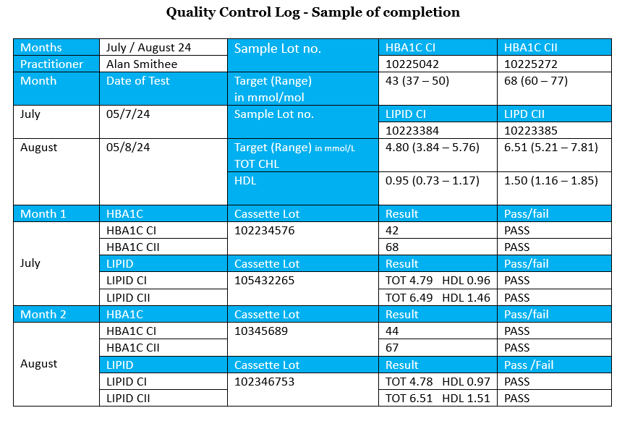for practices with more than one device, there is enough QC sample to for all devices during the QC period.

**Logbook Recording examples.**

Internal ABBOTT Controls

Download from [here](https://www.shropshire.gov.uk/public-health/healthy-shropshire/nhs-health-check/professional-resources/)

1. **Undertaking and Recording External RIQAS control**

**Please Note – Undertake External Controls using Patient RED ICON**

**Single Blood Sample for HBA1C And LIPID Control (RIQAS)**

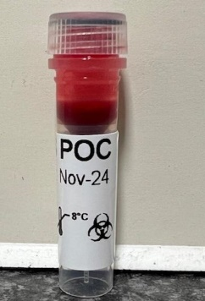

**IMPORTANT – Please use the SINGLE SAMPLE delivered to complete 1 test each of HBA1C and Cholesterol**

* Undertake 1 sample of **LIPID** and note Total Cholesterol and HDL in mmol/L
* Undertake 1 sample of **HBA1C** and note result in mmol/mol
* For practices with more than one device, you will receive enough sample to process all devices.
* You will receive an email each month that the window for sample submission is open
* You will have **9 days** from receipt of the EMAIL to Submit the result.
* The sample is only viable to test in the **9-day window**
* Please record the results in the online platform. (Use Google Chrome for the online platform)

**Please note – Results Cannot be Submitted Outside of the Quality Control Entry Window**

External Randox Quality Control 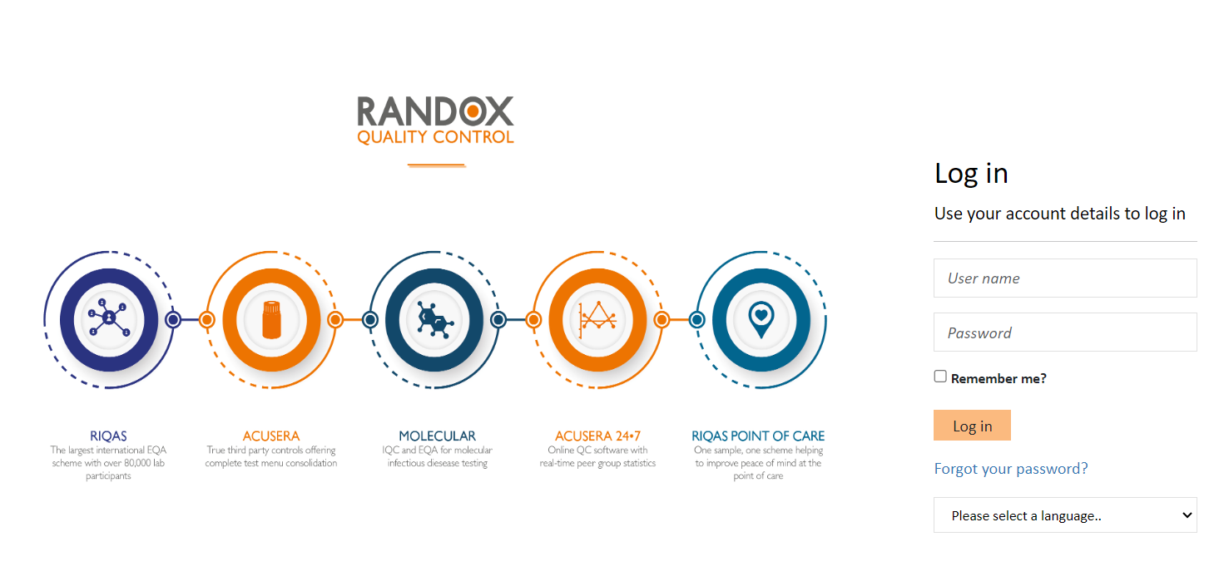Sign in page

External Randox Quality Control Result Entry – Click on Result Entry.

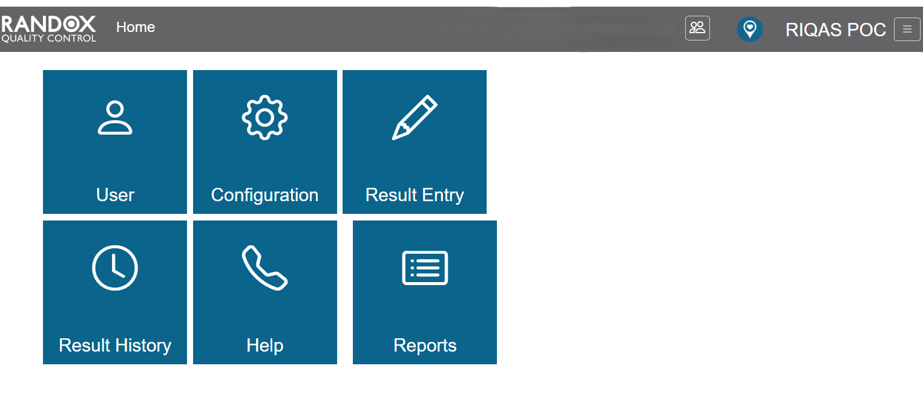

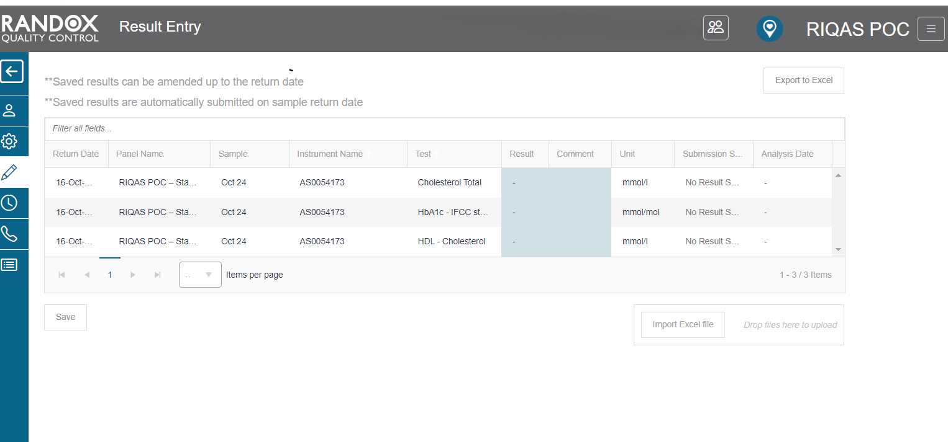External Randox Quality Control Result Entry – Type in result for each sample and save

Please note – during the window you can

* Edit the result if inputted incorrectly
* Add a comment if there is an error.

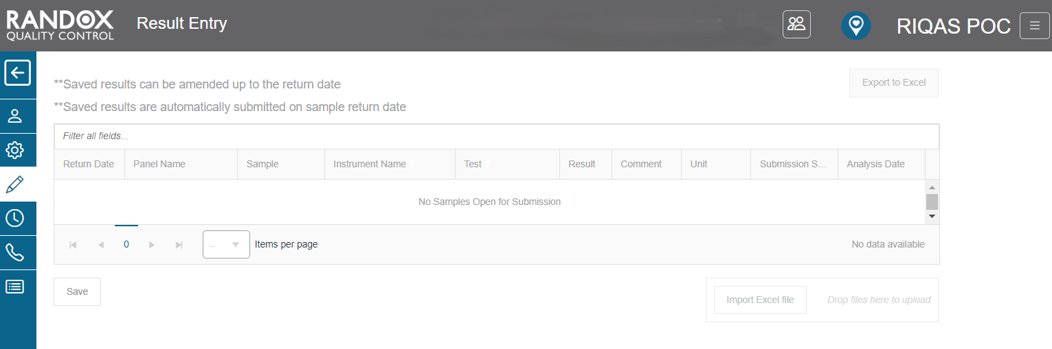logging in to submit outside of the window will show a ‘no samples open for submission’ message

1. **Trouble shooting / Error codes / Quick Reference Guides and Online Manuals**

**If you experience any issues with results or error codes, please write down all the information below,**

* Machine Software Version
* Cartridge Type
* Cartridge Lot number (Outer lot = Kit lot no. and/or Inner lot = Cartridge lot no.)
* Cartridge storage
* Any shipping concern noted for the cartridges and/or controls?
* Environment/ Facility condition /Temperature/ Humidity?
* Any noted deviation when received by the customer or any deviation in the customer’s facility?
* Sample type
* What was the appearance?
* Frequency of failed assays
* Control outer and inner Lot, if applicable
* What is the frequency of occurrence/number of assays failed?
* Was the test repeated? What was the outcome?
* Are the codes appearing across different tests/different lots?
* Do you have additional instruments with the same issue?

**Please email to** [**EME.TechSupport@abbott.com**](mailto:EME.TechSupport@abbott.com) **and contact** [**mike.parry@shropshire.gov.uk**](mailto:mike.parry@shropshire.gov.uk) **and** [**nathan.thomas@shropshire.gov.uk**](mailto:nathan.thomas@shropshire.gov.uk)

**For external quality controls**

Contact Details for any errors, questions or queries with External control.

RIQAS POC team via:

• email on riqas_poc@randox.com

• telephone on 028 944 54399 between the hours of 0840 – 1720 GMT.

**Quick reference guides and POCT device manuals**.

Quick Reference Guides for Randox Point of Care external Quality Controls and Afinion POCT device manuals can be found at the Shropshire Council NHS Health Check Professional Resources Page

[**Shropshire Council NHS Health Check Professional Resources**](https://next.shropshire.gov.uk/public-health/healthy-shropshire/nhs-health-check/professional-resources/)