**Circle of Support – Assessment Tool**

4 Questions:

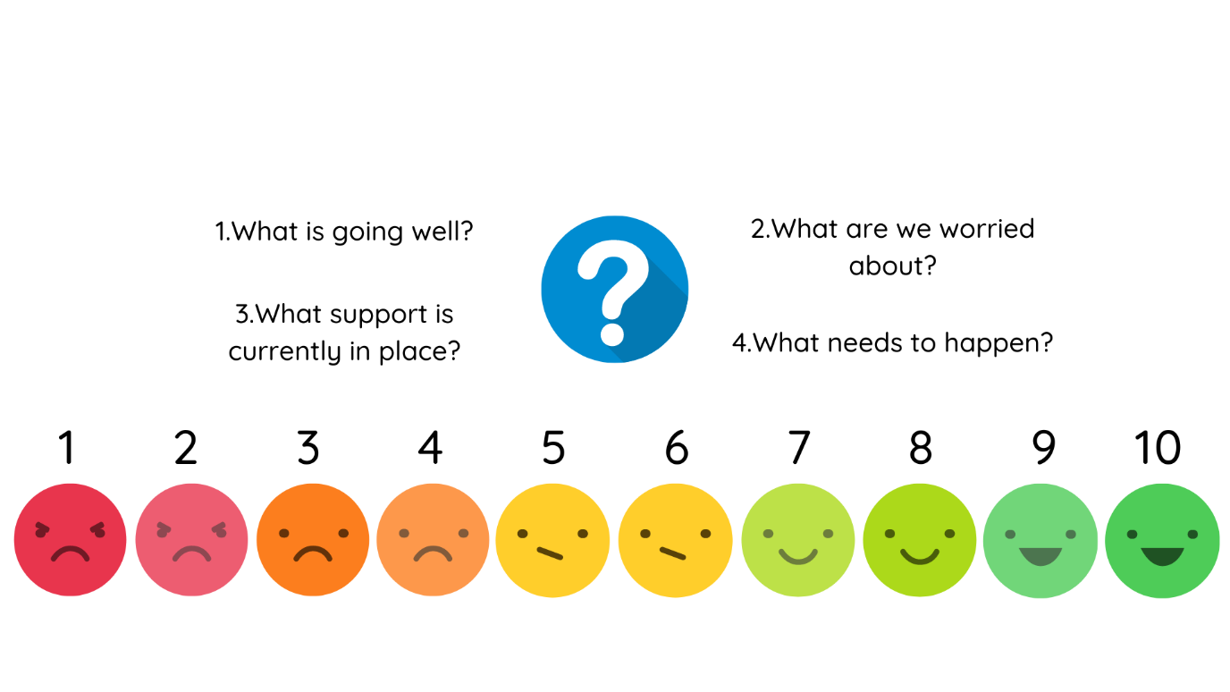



**Good Education**

1. What is going well?
2. What are we worried about?
3. What support is currently in place?
4. What needs to happen?



**Early Years Development**

1. What is going well?
2. What are we worried about?
3. What support is currently in place?
4. What needs to happen?



**Mental/Physical Health**

1. What is going well?
2. What are we worried about?
3. What support is currently in place?
4. What needs to happen?



**Substance Use**

1. What is going well?
2. What are we worried about?
3. What support is currently in place?
4. What needs to happen?



**Family Relationships**

1. What is going well?
2. What are we worried about?
3. What support is currently in place?
4. What needs to happen?



**Keeping Children Safe**

1. What is going well?
2. What are we worried about?
3. What support is currently in place?
4. What needs to happen?



**Crime Prevention**

1. What is going well?
2. What are we worried about?
3. What support is currently in place?
4. What needs to happen?



**Domestic Abuse**

1. What is going well?
2. What are we worried about?
3. What support is currently in place?
4. What needs to happen?



**Housing**

1. What is going well?
2. What are we worried about?
3. What support is currently in place?
4. What needs to happen?



**Finances**

1. What is going well?
2. What are we worried about?
3. What support is currently in place?
4. What needs to happen?