

GUIDANCE FOR MANAGING CHOKING – version 5 – 2026.
For Adults with Support Needs in Shropshire

Daniel Powner
Service Manager, Community Partnerships & Day Opportunities Adult Social Care Management

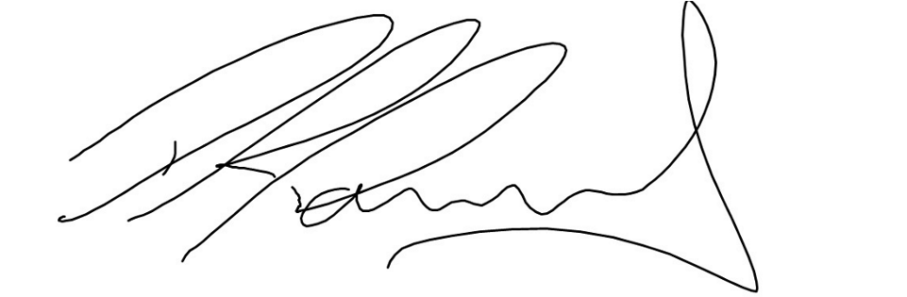

CONTENTS
Acknowledgements, Definition 3
Introduction 4-5
Purpose of the Guidance, Scope, Hazards 5
Emergencies 6
Observation and Reporting of Risk Factors 7
Initial Risk Assessment, Documentation, Monitoring, Follow up, Reassessment
and review 8-9
Training, Additional Advice or Intervention, Ensuring Implementation of Recommendation from Professional Team 10-11
Dysphagia (swallowing difficulty) 12
References 13
Appendices:
Appendix 1 Observation sheet template 14
Appendix 2 Common Choking Hazards 15-16
Appendix 3 Choking Risk Assessment for Adults with Support Needs 17-20
Appendix 4 Management/care Plan for those who are at Risk from Choking 21-23
Appendix 5 Summary of who to refer on to 24-25
Appendix 6 Emergency procedure 26
Appendix 7 Check list to be completed following an Emergency Incident 27
Appendix 8 Cover sheet 28
Appendix 9 Accessible Information on Eating Safely 29-40
Appendix 9a One Page Profile for eating, drinking and swallowing.
– guidance and image of template with link to downloadable
Version 42-43
Appendix 10 Flowchart of choking guidance process and documentation 44
Appendix 11 List of changes from 2023 guidance 44
ACKNOWLEDGEMENTS
Shropshire Council would like to thank the Speech & Language Therapy Team at Midlands Partnership NHS Foundation Trust for their support in producing this guidance. In particular, Gerry Coulson, Lead Speech & Language Therapist for the significant work devoted to creating this document, alongside representatives from Shropshire Council’s Day Services and H&S Team..

DEFINITION
Choking is the introduction of a foreign object (edible or non-edible) into a person’s airway which becomes lodged and reduces or completely obstructs the air flow to the lungs. Choking is a natural occurrence in human beings due to the closeness of the structures in the throat through which we both eat and breathe and the close coordination of both of these functions. Most obstructions are cleared by the person coughing but in some cases airflow is completely blocked, there may be no sounds to alert others and a person can die within minutes.

INTRODUCTION
In 2021 in the general population of England and Wales there were 276 deaths attributed to choking as cause of death. This may hide the true figure as some death certificates state general conditions like Dementia or even Learning Disability as cause of death rather than the specific cause. 181 of these were in people over the age of 65. 10 were under the age of 19.

In 2019, there were also 276 deaths but in 2018 there were 398, so the figure may have reduced and stabilized but in 2011 there were only 180 so it may also be variable or reporting may have changed. Since 2015, the number of elderly people dying from choking has risen by 20% with most occurring within hospitals or care homes. (Office for National Statistics, 2018). Choking is due to several factors; including eating ‘or being fed, too fast; trying to swallow too large portions of food; by having less saliva due to ageing; from certain medications for conditions like stroke or Parkinson’s disease which makes swallowing foods more difficult. Having fewer teeth or ill-fitting dentures can also make chewing hard, resulting in people trying to swallow foods which are not soft enough or are too large. Many people with swallowing difficulties are not supervised sufficiently when eating and drinking.

It is not clear how many of the total number of deaths were adults with a learning disability. National figures for adults with learning disability in England have been estimated at 905,000 (Emerson and Hatton, 2011) and one document from Public Health England on dysphagia in Learning Disability (2020) suggests that 15% of adults with learning disabilities require support with eating and drinking. People who have a learning disability are known to be at a higher risk of choking than the general population (Thacker, 2008 and Samuels and Chadwick, 2006). This may be due to reduced capacity in the individual to understand and manage risks like choking. It is also likely to be due to other factors which often co-occur with a learning disability including physical problems which can affect chewing, controlling food in the mouth and swallowing (dysphagia). There may also be behaviours such as bolting food or pica (eating inappropriate and non-food items). People with learning disability are also living longer, like the rest of the population and are therefore more likely to experience complex difficulties associated with older age e.g. dementia; an additional risk factor for choking. Many people with a learning disability have other health problems like epilepsy and mental health difficulties and these, as well as the effects of medication, can impair a person’s ability to manage food safely.
In 2007 The National Patient Safety Agency found 605 reports of choking-related incidents in England and Wales involving adults with learning disabilities between 30 April 2004 and 30 April 2007. Serious case reviews have found failings in the identification and management of this risk especially around speed of response and monitoring, as well as about judgemental attitudes to those who cram foods, care plans not being followed, people being exposed to foods or items when they are known to have difficulties, lack of carer supervision, people being bored or hungry so they are more likely to take food and poor First Aid responses (Hampshire Safeguarding Board, 2012, LeDeR Review, 2019).
PURPOSE OF THE GUIDANCE
This guidance contains a risk assessment and management plan which is aimed at doing as much as possible to minimise the risk of choking and prevent injury, illness and death in those whose vulnerability to this risk is increased. It is for use with any adult with support needs who may be at increased risk of choking. It will assist staff to identify hazards and risks associated with choking and offer guidance in what to do about managing these and should be completed when there are any concerns about a person’s potential to choke.

This is version 5 of this guidance which was first launched in 2013 and reviewed in 2016,2021, 2023 and 2026. Updates have been made to reflect current evidence and practice and to include all adults who may be at an increased risk of choking; not just those with a Learning Disability and to try to improve ease of use for those completing the documents from feedback received from service managers and staff using it. See Appendix 11 for a list of the main changes to the 2023 guidance.

SCOPE
Shropshire Council will adopt this guidance as a policy and it will be made available to partners as best practice guidance and advise that they follow it as a minimum standard.

This guidance applies to all Shropshire Council staff supporting an adult with learning disability and other support needs and the best practice described in the document is relevant to any person supporting an adult with support needs in Shropshire. It is specifically designed for use with adults with reduced cognitive and or physical or mental ability.

Individual risk factors and the action to be taken may vary dependent on a person’s needs or medical condition and on the local service available to meet that need or condition. In addition, local SLT services may offer their own relevant guidance. Where such guidance differs significantly from this document advice from a suitably qualified and competent professional at the local service should be obtained,

This guidance should only be adapted by or in consultation with a suitably qualified and competent professional.

HAZARDS
There are many hazards around us which may cause choking if put into the mouth (see Appendix 2).

Knowledge of these hazards and preventative measures related to managing risk factors should result in fewer emergency situations involving choking.

EMERGENCIES

Emergency procedures are taught in mandatory training on basic life support. Further individualised risk assessment and plans will need to be put in place for people who use wheelchairs, are obese or have a body shape which would potentially make abdominal thrusts or back blows ineffective. Advice should be sought for this from the training providers, and it is recommended that if the person has severe & multiple Learning Disabilities, the Team looking after that person will need to contact their medical physician for advice. Each individual case will have different needs i.e. displacement of heart/lungs, ribs, no sternum which only their doctor may be aware of.
The Resuscitation Council (UK) does not comment on the care of specific individuals and final decisions regarding which treatments are appropriate rest with the multidisciplinary team responsible for care.

If you are unable to safely deliver back blows or abdominal thrusts with an individual in a wheelchair, they must be safely moved to the floor - this can be done quickly, safely and easily without a hoist - please see our Moving and handling guide for reference. https://www.resus.org.uk/library/publications/publication-guidance-safer-handling
Once on the floor, if they can be managed in a seating position, then back blows and abdominal thrusts may be delivered. If not, they lay the person down and perform chest thrusts from the front (the same as a chest compression).

A summary of the updated emergency procedure for choking is included in Appendix 6.

Where it has not been possible to prevent someone from choking and they experience an emergency incident, first aid procedures must take place and an accident/incident form must also be completed. In addition, Appendix 7 contains an updated checklist documenting areas for consideration after a choking incident has occurred. This should be completed and attached to the accident/incident form.

OBSERVATION AND REPORTING OF RISK FACTORS
When a person is new to a service, information should be gathered about any previous choking or swallowing assessments and recommendations. The individual should be observed for any signs of choking or swallowing difficulty or risk factors. (See Observation sheet template Appendix 1). The person completing the observation should be competent in watching a person eat, drink or take medication and writing the observations down by describing the behavior exactly e.g. writing that ‘the person coughed after the third spoonful of food was placed in the mouth’ rather than making judgements like ‘the person seemed to be having swallowing difficulties’. The person making the observations is required to have basic dysphagia awareness training. They should usually be able to complete observations competently and with confidence after that and a period of 6-12 months of working with adults with additional support needs. Competencies should be monitored by locality leads and senior staff.
For any individual, known to a service or not, if any of the risk factors on the risk assessment (Appendix 3) are observed in an individual or an individual has a choking episode, the person making the observation should document this in the daily contact sheets after ensuring that the individual is safe and not at imminent risk of harm from choking. They should then complete the risk assessment and/or notify the manager or whoever is responsible for completing the risk assessment and follow the recommended action on the risk assessment. Ideally a person who knows the individual well should be involved in completing the risk assessment.
A risk management/care plan (see Appendix 4) should then be completed and documented in the person’s records and disseminated to all those involved in supporting the individual and put into place immediately. An example of this is where the plan suggests an increased level of supervision is needed before and during meals to observe or give verbal prompts, to cut up food, to keep food or other high risk items out of reach and to ensure that visitors do not expose the individual to high risk items.

If any risk factors are present which either cannot be managed immediately or suggest the involvement of a professional assessment the plan should be completed anyway as an interim and the individual should be referred to the appropriate person as indicated on the risk assessment and summarised in Appendix 5. Completion of the observation usually takes about half an hour. The risk assessment, management/care plan and action following this for onward referrals can take on average between 1 and 2 hours dependant on what action is needed and what other information gathering is necessary to complete the risk assessment.

There may still be emergency incidents despite completion of a risk assessment and management/care plan documentation. This documentation is also aimed at helping to provide good evidence that preventative procedures have been identified and put in place should an incident occur.
There will be a number of individuals who have capacity to understand the information and the implications of continuing to eat and drink and/or take medication in a way which increases the risk of harm to them. Where this is the case there must be documented evidence that the information regarding the potential or actual risk has been given to them in a way that they understand and can communicate about, in line with the Mental Capacity Act, 2005. For those who cannot consent due to reduced capacity, this must also be assessed and recorded and a best interest decision made and recorded in line with the act.

INITIAL RISK ASSESSMENT, DOCUMENTATION, MONITORING, FOLLOW UP and REVIEW:
Individuals who are new to a service or have never had a choking risk assessment must have a choking risk assessment completed prior to or immediately on starting with a service.
In addition to this:
A. A regular choking risk assessment should be carried out by the service provider. All assessments and reviews are recorded on the cover sheet (See Appendix 8). The risk assessment is usually reviewed every 3 months for adults with support needs who have been assessed as high risk. It may be reviewed more regularly e.g., monthly, weekly, or even daily for those whose physical or mental health is deteriorating quickly, those with uncontrolled epilepsy, those with progressive or unstable conditions or those recovering from more debilitating physical symptoms. Those who have been assessed as having either no or low risk can be reviewed annually. Those with medium risk where needs have been identified and recommendations are in place and where needs are assessed as stable can also be reviewed annually. (This can be shared with an individual and their GP as part of an annual health check recommended for adults with learning disability.)
B. Documentation of mealtime observations and recommendations by service providers and professionals should be included in the provider’s management or care plan. (See Appendix 1 for observation sheet) Observations should be documented for initial risk assessment or when reviewing an individual – see below.
C. Choking episodes should be documented as incidents as well as in the service user’s file and reported as per policy.

ENSURING IMPLEMENTATION OF RECOMMENDATION FROM PROFESSIONAL TEAM
A. Service providers must review the choking risk assessment as advised and any additional professional recommendations to ensure these are part of the individual’s personalised management/care plan.
B. The service provider will ensure the plans are implemented and carried out by the assigned staff. A one-page profile for eating, drinking and swallowing will be completed with information given or copied verbatim from dysphagia report recommendations. It must be kept with the individual needing support to eat and drink and take medication at all times. This is so that vital information on how to support an individual to reduce risks of aspiration and/or choking is accessible to staff at all times when the person is eating, drinking, and taking medication. This information must be treated with the same strict confidentiality as any medical or personal information. An individual may choose to have the information visible, but this must be protected from the view of others.
C. The relevant professional providing updated recommendations should ensure that the updates are comprehensive; highlighting new recommendations and requesting removal of out-of-date recommendations and advising on how often the risk assessment should be reviewed. One-page profiles must reflect the latest recommendations with the date and version number recorded on them.

Where an individual’s needs have not changed and are being managed in line with recommendations from a previous management plan and written professional guidance this can be recorded and dated on the observation, plan and cover sheets as a review.

TRAINING
- All services should have documented a suitable and sufficient first aid risk assessment that identifies a minimum level of trained first aid cover at all times based on the needs of the individual circumstance. The training is to be updated every 3 years.

- Staff should be aware of the need to report incidents, near misses and accidents and trained in the reporting process. Staff require training in Safeguarding.

- All appropriate staff should receive training in dysphagia awareness. This training is to be repeated every 3 years.

- Service users should be provided with appropriate information relating to choking – see Appendix 9 for an example.

Shropshire Council Staff, specific guidance:

- Online Dysphagia Awareness training – all Shropshire Council START Support Workers are to complete this as part of their induction.
- Dysphagia Awareness delivered by a qualified Speech and Language Therapist through Joint Training – all START Senior Support staff, START Shift Leaders, all grade of Day Services Support Staff and all Four Rivers care and nursing staff are to complete this as part of their induction.

Shropshire Council - Accident and near miss reporting procedure

- Signpost staff to additional e-learning, recommended by SALT team:
https://www.nutricia.co.uk/hcp/services/nutricia-elearning.html
https://iddsi.org/Resources/Videos/Implementation
NHS Heath Education England e-learning for health dysphagia guide
http://portal.e-lfh.org.uk/Component/Details/651364
Help stop choking (Belfast resource)
https://belfasttrust.hscni.net/service/speech-and-language-therapy/help-stop-choking/

ADDITIONAL ADVICE OR INTERVENTION
If a provider is in any doubt as to whether to refer for professional assessment or how to manage a risk factor, they should contact a professional for advice. Based on the needs of the individual and the impact of the current management/care plan the following may also be recommended and would need to be added to the management/care plan: -
A. Speech and Language Therapy (SLT) will assess and advise on appropriate changes in food texture, amount, taste, pacing etc.
B. Occupational Therapy and Physiotherapy will evaluate for adaptive feeding equipment, sensory integration and positioning during mealtimes.
C. Modified Barium Swallow Assessment also known as a Videoflouroscopy study (VFS): This is likely if aspiration or difficulty in swallowing is suspected but not clear from observational assessment alone and where further clarification needs to be sought to ascertain the extent of this and the impact of any recommendations. This type of assessment takes place at a hospital and the GP, Consultant or SLT can refer. For some individuals a FEES assessment may be appropriate. This is a Fibre Optic Examination of Swallowing
This is not an exhaustive list of professionals – see Appendix 5

Dysphagia
Choking can sometimes be caused by a physical swallowing difficulty (dysphagia). If this is suspected please check the Signs to Look Out for list below and if there are significant signs present refer for a Speech and Language Therapy assessment of the swallow and add this to the choking risk assessment and management/care plan information.
- Coughing while swallowing, or on different textures e.g. biscuits, cereal, liquids
- Slow, effortful or absent swallow
- A rattling/gurgly voice after swallowing
- Bringing food or liquid back up after swallowing.
- Food or liquid coming down nose
- Taking longer to eat a meal
- Taking longer to chew (if applicable)
- Having to take smaller sips of fluid
- Breathing patterns change during meal
- Eyes watering during meal
- Colour changes during meal
- Urinary Tract Infections (can be linked to dehydration).
- Recurrent chest infections
- Problems with pressure sores, changes in condition of skin or hair
- Loss of appetite due to effort involved in eating (avoidance)
- Difficulty eating/drinking enough to stay healthy.
- Weight loss
- Dehydration (adapted from Krawczyk,2005)

References
Emerson, E. & Hatton, C (2011) People with learning disabilities in England – Services and Structure. Lancaster: Centre for Disability Research
Krawczyk, K. (2005). Dysphagia: Combining conflicting models? In C. Anderson & A. Van Der Gaag (Eds.), Speech and language therapy: Issues in professional practice (pp.131–152). London: Whurr
Learning disability Mortality Review (LeDeR) sourced online 14.01.2020 http://www.bristol.ac.uk/media-library/sites/sps/leder/2093_DysphagiaAspirationPneumonia_PDF.pdf
Mental Capacity Act 2005
Public Health England information sourced online 14.01.2020 https://www.gov.uk/government/publications/dysphagia-and-people-with-learning-disabilities/dysphagia-in-people-with-learning-difficulties-reasonable-adjustments-guidance
Samuels,R. & Chadwick, D.D. (2006) Predictors of asphyxiation risk in adults with intellectual disabilities and dysphagia. Journal of Intellectual Disability Research 50(5):362-370
Rotherham Doncaster and South Humber Mental Health NHS Foundation Trust - Policy for the management of dysphagia and/or the risk of choking 2011
Reducing the risk of choking for people with a learning disability – A multi-agency review in Hampshire – Hampshire safeguarding adults board - Multi-agency partnership 2012
Thacker, A., Abdelnoor, A., Anderson, C., White, S. & Hollins, S. (2008) Indicators of choking risk in adults with learning disabilities. Disability rehabilitation 30(15):1131-8
The Office for National Statistics (2018) accessed on line ons.gov.uk 5.11.2019
The Office for National Statistics (2021) accessed on line ons.gov.uk 14.02.2023
UK resuscitation council (2023) advice sought individually by Gerry Coulson
www.nrls.npsa.nhs.uk/resources

Appendix 1 Observation Sheet Template – Choking guidance
To be completed by competent staff (see page 7 of main guidance) during observations of eating, drinking and taking medication for initial risk assessment or when reviewing an individual
Name of individual being observed (permission sought)____________________
Initial/review
If this is a review observation was the choking risk management/care plan followed? Yes/No
Date | Describe the individual’s eating, drinking and swallowing and how the person was supported e.g., positioning and stability of position, texture of food and how it was prepared, type of food and drink, temperature of food and drink, amount for each mouthful, pace of eating and drinking, what help did the person need and any signs of swallowing difficulty | Action taken | Name of member of staff

Appendix 2 Common Choking Hazards
Food is the most common cause of choking
Foods

- Toast, crackers, or rice cakes
- Bread crusts
- White bread (when mixed with saliva can form a glue-like ball)
- Raw vegetables
- Pieces of meat especially chicken with bone, gristle, rind or cooked fat eg bacon rind
- Nuts, whole grains and seeds
- Grapes and other small round food especially with skins or husks like peas and beans
- Sweets including hard boiled, marshmallows and chewing gum or bubble gum
- Raisins and sultanas
- Oranges and satsumas, especially whole segments with pith
- Crisps and popcorn
- Biscuits
- Very thick sticky spreads
- Chunks of hard cheese or chocolate
- Pizza
- Salad items e.g., lettuce (flat large pieces), celery, tomatoes, cucumber and any items with stringy or fibrous parts and the skins and seeds
- Other hard fruits e.g., apples
- Mixed texture foods where the liquid is runny and separates out from hard food e.g. some breakfast cereals and milk

Household items

- Coins
- Pen and bottle tops and lids
- Marbles or small balls
- Jewellery
- Arts and craft materials especially crayons, rubbers, pen tops,
- Material
- Padding
- Balloons
- Buttons and button type batteries
- Toys with small parts
- Medicine syringes
- Safety pins
- Stones
- Screws
- Beanbag stuffing material
- Rings and other small jewellery items
- Tiny figures and decorations

Tablets and capsule medication
Advice must be sought from a doctor or pharmacist and recorded when considering altering the form of medication

NB Anything that can get lodged in the mouth or throat and block the airway is a potential hazard and access to choking hazards needs to be strictly managed for those at risk

Appendix 3 CHOKING RISK ASSESSMENT FOR ADULTS WITH SUPPORT NEEDS
Date of assessment……………………………………..
Name of individual being assessed…………………………………
Name and signature of person completing risk assessment …..……………..
……………………………………………………………………………………………..
Name and signature of manager of person completing risk assessment if different from person above
……………………………………………………………………………………………...

Consent for assessment must be sought prior to completing this. Where the individual lacks capacity to make this decision a best interest decision must be taken in line with the Mental Capacity Act (MCA( 2005)

Has accessible information been used to assist with decision making for the individual? Yes/No
If no please state why………………………………………………………………

If you indicate YES to any of the risk factors below the individual is at an increased risk of choking and the recommended action shown in the right-hand column should be taken  Where additional local Speech and Language Therapy guidance is available, this should be used to determine the appropriate action to manage the identified risk factor.  In all cases where there are any new risk factors present the management/care plan (see Appendix 4) must be put into place immediately  Factors in bold print are the most common causes of choking in adults with learning disability |  | Consent must be sought from the individual for any action taken. If the individual lacks capacity to make this decision a best interest decision must be made (MCA) and recorded
Risk Factors | Yes/No | Action
Person expressing (either verbally or non-verbally) that they are distressed or in pain during meals or when taking tablets |  | Observe and enquire for possible sources of pain. Seek medical advice
Uncontrolled seizure activity when eating |  | Seek medical advice
Physical disability, injury or damage, especially cerebral palsy, tardive dyskinesia and other problems affecting muscle tone where the person is not able to be supported to maintain an upright and stable posture with controlled movement and sensation during meals |  | Refer to Physiotherapy
History of choking not previously assessed by Speech and Language Therapist |  | Refer to Speech and Language Therapy
History of swallowing problems not previously assessed by Speech and Language Therapist |  | Refer to Speech and Language Therapy
Eating very fast (a meal in less than 15 minutes) |  | Ensure level of supervision to prompt the individual to slow down. If this does not improve the situation refer to Speech and Language Therapy
Cramming food in mouth |  | Ensure level of supervision is appropriate to prompt the individual to put a manageable amount of food into their mouth. If this does not improve the situation refer to Speech and Language Therapy who will also consider referral to Occupational Therapy for Sensory assessment
Deliberate attempts to block their airway |  | Refer to Psychology
Excessive coughing or wheezing when eating |  | Refer to Speech and Language Therapy. If the cough or wheezing is after eating seek medical advice
Weak cough or complete lack of a cough resulting in inability to clear the throat of food residue |  | Refer to Speech and Language Therapy and Physiotherapy
Difficulty with chewing or unable to chew |  | Check individual’s mouth and teeth.  Reduce texture of food to puree if completely unable to chew, finely chop and moisten food if having difficulty and avoid all high-risk foods and refer to Speech and Language Therapist and dentist if problem with teeth suspected
Untreated acid reflux or heartburn |  | Seek medical advice
Missing teeth, ill-fitting dentures, dental carries or poor oral health or hygiene which are new, have increased or where there is no previous advice |  | Seek dental advice
Swallowing problems (dysphagia) e.g. poor tongue movements, uncontrolled loss of food from the back of the mouth into the throat which are new, have increased or where there is no previous advice |  | Refer to Speech and Language Therapy
Alcohol or drug abuse |  | Seek medical advice
Gagging or vomiting on foods or liquids or complete lack of gag reflex |  | Seek medical advice
Eating despite having poor or variable levels of alertness or getting very tired when eating |  | Ensure level of supervision during meals to support the person to pause when they are not alert enough. Smaller more frequent meals
Distracted during mealtime and keeps eating |  | Ensure level of supervision and organization of room or seating to reduce distractions in the environment
Improper positioning or moving around when eating |  | Ensure level of supervision to support the individual to sit in a stable upright position where possible.
Storing food in the mouth or food left in mouth or cheeks after swallowing |  | Ensure level of supervision to prompt to clear mouth and if not successful refer to Speech and Language Therapy
Taking food |  | Ensure level of support or supervision appropriate to remove need or ability to take food. If not successful refer to the Community Learning Disability Team for behavioural advice
History of PICA (eating non-food items) |  | Ensure environment is free from choking hazards. Seek medical advice and make referral to Occupational Therapy for Sensory assessment
Foods inadequately prepared to reduce risk e.g. putting too much into mouth, not cutting food up enough |  | Ensure level of supervision is appropriate and support individual to prepare food appropriately
Inadequate staffing or support levels |  | Increase staffing levels. If not possible inform manager and if appropriate apply for increase in staffing. If this is not possible refer to Safeguarding
Eating foods or non-food items which are high risk e.g. boiled sweets, toast etc. when previously advised not to |  | Support the individual to prepare these in a way which reduces risk eg crushing sweets or suggest alternatives. Assess capacity and document this. If the person lacks capacity to decide to eat these items against advice there needs to be a best interest decision about restricting access to these items. A Deprivation of Liberty Safeguard/Liberty Protection Safeguard may be needed.
Demonstrating symptoms related to e.g. dry mouth, sedation or extra pyramidal symptoms (tremor or loss of physical control) which seem to be affecting the person’s ability to control food, drink or medication when swallowing |  | Seek medical advice to ensure risk from side effects is minimized.
Regurgitation of food |  | Seek medical advice. If there is no medical cause identified make a referral to Speech and Language Therapy who will also consider referral to Occupational Therapy for sensory assessment
Pushing fingers, food, or utensils forcefully to the back of the mouth |  | Support the individual to prevent this e.g. distraction techniques and to remove harmful utensils. Seek medical advice and make a referral to Occupational Therapy for a sensory assessment. If it is only food that is pushed to the back of the mouth prepare it so it is unlikely to get stuck and refer to Speech and Language Therapy.
Secretive bingeing |  | Ensure level of supervision appropriate to remove need to binge. If the bingeing does not stop make a referral to Psychology
Down Syndrome, Stroke, Dementia, Head injury, Head and neck cancer, head and neck surgery, Progressive neurological conditions such as Parkinson’s disease |  | Look out for signs of deterioration in ability to prepare food appropriately or to manage it when eating. Support with verbal and/or physical prompts and if there are signs of dysphagia present refer to Speech and Language Therapy
Has had food textures changed to be softer due to swallowing problems or previous choking incidents |  | Ensure recommendations are being followed. Refer to Speech and Language Therapy if there is further deterioration
Takes sudden intakes of breath or talks or laughs when eating |  | If this causes coughing or gagging refer to Speech and Language Therapy
Food or liquids coming out of nose or mouth |  | Seek medical advice and make referral to Speech and Language Therapy
Excessive rocking during or just after meals |  | Seek medical advice in relation to possibility of reflux or other gastric disturbance if not medical cause is identified make a referral to Occupational Therapy
Difficulty swallowing tablets |  | Seek medical advice and make a referral to Speech and Language Therapist if advice from pharmacists suggests that format of medication cannot change or improve the situation. Do not use a syringe unless trained.
Unable to understand the risks related to swallowing safely and how to protect themselves from this |  | Ensure the individual has had accessible information at an appropriate level and format on this issue. See example in appendix 9.

Once the risk assessment above has been completed, a risk management/care plan (Appendix 4) must be completed.
Appendix 4 – Management/Care Plan for those who are at risk from choking
Name of individual …………………………………  Name and signature of person completing plan ……………………………..  ………………………………………………………………………………………….  Name and signature of manager of person completing plan if different from person above  ………………………………………………………………………………………….. | Date of plan  ………………………..  Date to be reviewed  ……………………….

The main goal is to ensure the environment is managed so individuals are not exposed to choking hazards
Summary of choking risk factors present:

Level of risk identified (tick/highlight):
Low (review 12 months)
Medium (review 12 months, or as advised if professional involved, once management plan in place)
High (review formally every 3 months and complete informal observations whenever the person is supported)
Management plan (or care plan):
This should be based on the recommended action shown in the right-hand column of the risk assessment (Appendix 3) and is based on managing the environment to reduce access to potential hazards, or the affect of risk factors and on supporting the individual to manage their food safely. This might mean support to control their movements or ensure that their posture is stable and upright whilst eating and drinking. It may also involve using techniques such as pacing, with physical and verbal prompting and positive communication. Where necessary modifying textures and sizes of food types so that a person can manage foods safely may also be indicated. It may also involve managing sensory needs that have a negative impact on the ability to acquire safe nutrition.

If further assessment by a professional is needed state this on the plan. If assessment has already been done by professionals the recommendations should be included in the plan. Where appropriate, to increase accessibility of recommendations made by Speech and Language Therapy, a One Page Profile of eating, drinking, and swallowing will be produced showing the recommendations verbatim. This needs to be easily accessible so support staff can check recommendations easily whilst also ensuring that it is kept with the individual wherever they eat and drink, in a secure place to ensure privacy of information.
Level and type of supervision and support e.g. a member of staff nearby in the room, and/or verbal prompting, or one to one close supervision during meal etc.
Changes to the environment e.g. screens to reduce distraction, supporting the individual to sit where they can see what is happening more easily, putting high risk items away securely etc.
Preparation of food
e.g. cutting food up into pieces smaller than a fingertip, adding sauces to soften food, having a drink available during a meal or snack etc.
Other preventative intervention to reduce immediate risk e.g. accessible information on eating safely shared with individual (see Appendix 9)
Additional referrals for medical and/or dental advice and/or professionals

Training needed | Identify who needs further training, what the training should be (e.g. basic life support, dysphagia awareness) and what action has been taken to pursue this
I have explained the above to the individual and key support staff and will ensure all staff follow
its recommendations and any additional recommendations from doctors, dentists or other professionals. The information on the individual’s choking risk and management/care plan has been added to their hospital passport/grab sheet.
Signed:………………………………Manager/key worker……………………………… Date:………………
I have read and understand this choking risk management plan
Signed(staff):…………………………………………….. Date:………………………..
(Continue on separate sheet if necessary)

Appendix 5 Summary of who to refer on to:-
GP or consultant if one of the following factors is present: -
- Deterioration of health suspected in relation to one of the choking risk factors e.g. ageing, dementia or other health condition, seizure activity, gagging or vomiting, psychotropic or multiple medication, level of alertness or fatigue, excessive rocking during or after meals (may indicate reflux), reflux, regurgitating food, drug and alcohol abuse, allergies, expressing distress, pain or discomfort when eating or taking tablets

Dentist if one of the following is present: -
- Ill-fitting dentures, dental carries, or poor oral hygiene

Physiotherapist if one of the following is present: -
- Deterioration or change in positioning at mealtimes, physical ability, muscle tone, movement, control and coordination or sensation

Occupational therapist if one of the following is present: -
- Foods inadequately prepared by the individual
- PICA
- Cramming food or storing food in the mouth
- Inappropriate food choices for level of ability
- Pushing fingers, food items or utensils to the back of the mouth
- Change in physical level of sensation

Psychologist if one of the following is present: -
- Deliberate attempts to block airway
- PICA
- Taking food from others
- Secretive binging on food (BED – Binge Eating Disorder)

Speech and Language Therapist (SLT) if one of the following is: -
- Deterioration or change in physical ability, eating very fast or slowly, cramming food, excessive coughing or complete lack of a cough, difficulty or absence of chewing, food stored in the mouth, food textures have had to be changed due to inability to manage hard, dry, chewy foods etc.
- Also, if swallowing problems have not previously been assessed, the individual takes sudden intakes of breath, talks or laughs when eating, eats despite having poor levels of alertness or being distracted or continuing to eat high risk foods despite being advised not to, where food is found in mouth or cheeks after swallowing, food or liquids come out of the nose or mouth, history of choking
- Where additional guidance is available from the local SLT service, please follow that advice regarding referral.

Safeguarding if one of the following is present: -
- Inadequate staffing or support levels, risk management plan not being adhered to, professional recommendations received but not included in risk management plan or not being adhered to, history of choking not risk assessed or managed
- Visitors or families not complying with risk management plan
- SUI (Severe untoward incident)

For referrals for community health services for older adults contact Shropshire Community Health NHS Trust or Shrewsbury and Telford Hospital NHS Trust via their websites.
The Specialist Community Team for Adults with a Learning Disability on 01952 457417 or 01743 211210 for Consultant Psychiatry, Psychology, Speech and Language Therapy, Occupational Therapy, Physiotherapy, Community Nursing, Acute Liaison, Intensive Support Team (Behaviour), Intensive Health Outreach Team.
For Dementia services this may also be accessible for the community via a Community Mental Health Team covering the appropriate area for the person.
Appendix 6 Emergency procedure

NB: This will have to be risk assessed and amended for an individual for whom back blows and/or abdominal thrusts are not suitable e.g. wheelchair user and an individually tailored procedure will need to be designed. If you are unable to encircle the victim's abdomen, the BLS/AED Subcommittee of the Resuscitation Council (UK) recommends that you stand behind the victim, as for abdominal thrusts, but position your hands somewhat higher, over the lower end of the sternum (breastbone). Pull hard into the chest with quick thrusts. If you are unable to safely deliver back blows or abdominal thrusts with an individual in a wheelchair, they must be safely moved to the floor - this can be done quickly, safely, and easily without a hoist - please see our moving and handling guide for reference. Guidance for safer handling during cardiopulmonary resuscitation in healthcaresettings,
Once on the floor, if they can be managed in a seating position, then back blows and abdominal thrusts may be delivered. If not, they lay the person down and perform chest thrusts from the front (the same as a chest compression).
1. Person choking -> assess severity. They may be able to cough and expel the item themselves.
2. Person choking and unable to expel item -> Call for help. Support the person and remain calm but act quickly. You need to drive energy into the casualty’s chest cavity and towards the mouth in order to clear the obstruction. “Support the chest with one hand and lean the victim well forwards so that when the obstructing object is dislodged it comes out of the mouth rather than goes further down the airway. Give five sharp blows between the shoulder blades with the heel of your other hand”. RC UK
3. Person still choking and unable to expel item -> Support the person and remain calm and from behind hold your hands together to do up to 5 abdominal thrusts;
- Stand behind the victim and put both arms round the upper part of the abdomen
- Lean the victim forwards
- Clench your fist and place it between the navel and the ribcage
- Grasp this hand with your other hand and pull sharply inwards and upwards
- Repeat up to five times
4. If not working get someone to call for an ambulance and continue the cycle of 5 back blows and 5 abdominal thrusts until help arrives.
5. If the person becomes unconscious begin Cardiopulmonary resuscitation (CPR) and continue until medical help arrives.
NB: If a person has recovered but has had to have abdominal thrust, they must have a medical review as soon as possible. It is advisable to call 999 following abdominal thrusts for anyone who has a serious or complex physical and/or medical condition. (UK resuscitation Council, 2023). It is also unlikely that oral suctioning can be used in an emergency of this nature unless to remove excessive oral secretions following a choking incident and should only be carried out by competently trained individuals following a set protocol

Appendix 7
Checklist to be completed following an emergency incident
Name of individual…………………………………………………………………..

Name of person completing checklist…………………………………………..

Date of completion of checklist…………………………………………………..
Emergency procedures followed including medical review if abdominal thrusts have been necessary | Yes/No | Comments…
Accident/incident form completed | Yes/No | Comments…
Safeguarding process started | yes/no | Comments…
Swallowing risk assessment & management/care plan completed or reviewed | yes/no | Comments…
Appropriate professional(s) e.g. Speech and Language Therapist contacted/referral made | yes/no | Comments…
Management/Care Plan and Risk Assessment updated, and changes communicated to all necessary staff | yes/no | Comments….
Additional measures put in place, observed and recorded | yes/no | Comments….
Carer and /or any appropriate third parties informed of the incident. This can be evidenced. | yes/no | Comments

Appendix 8 Cover Sheet
To be completed whenever the risk assessment is done; both initially and at every review (at least annually)
Name of individual being assessed……………………………………………………..
Date | Initial assessment completed or review undertaken  I/R | Name of person completing the risk assessment or review | Signature of person completing the risk assessment or review | Further action required | Date of next review

Appendix 9 Example of accessible information on eating safely
Information on choking and what to remember when eating and drinking see booklet over next few pages. This may need to be amended for a person depending on recommendations for them regarding the safest texture for food and drinks.
Photographic images taken specifically for this document or from Clipart, NHS Photolibrary or © Photosymbols3
Also check International Dysphagia Diet Standardisation Initiative (IDDSI) website iddsi.org.uk for information on food texture modification descriptors and food examples. Always ensure meals and snacks match the texture recommended for an individual with dysphagia or who is at risk of choking

Eating Safely to Lower the Risk of Choking

Choking is when something gets stuck in the
throat and stops us breathing
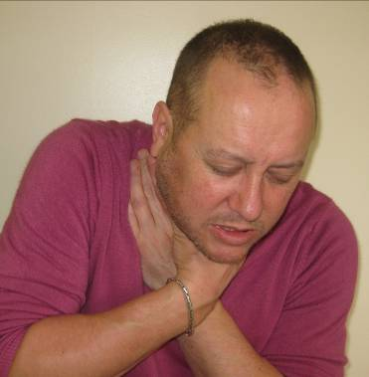

Choking is very dangerous and can cause death

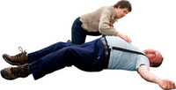

Some foods are very difficult to chew and swallow
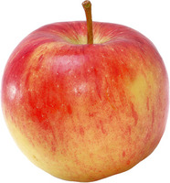

Take Care When Eating


STRINGY, FIBROUS TEXTURES
like pineapple, runner beans, celery, lettuce
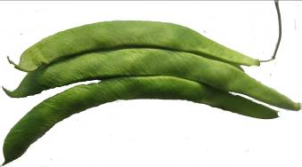
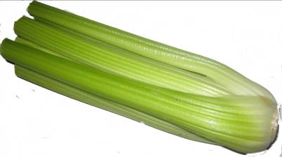
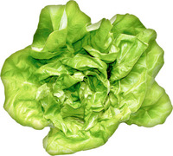

MEAT, VEGETABLE AND FRUIT SKINS
like on sausages, grapes, peas
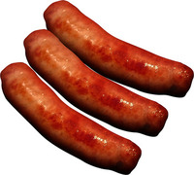

MIXED TEXTURE FOODS
Like stew with thin gravy or like cereals which
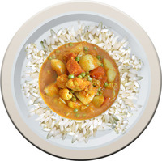
stay hard when mixed with milk
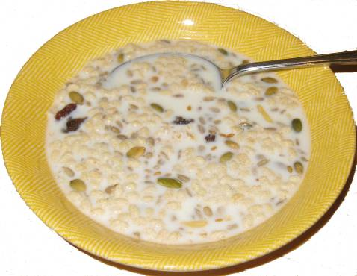

CRUNCHY FOODS
like toast or crisps
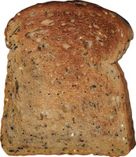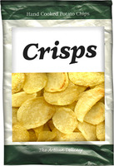

CRUMBLY ITEMS
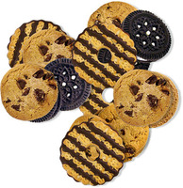
like dry biscuits

HARD FOODS
like boiled sweets or nuts and seeds
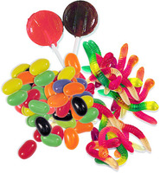

CHEWY FOODS
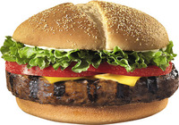
like pieces of chewy meat

HUSKS

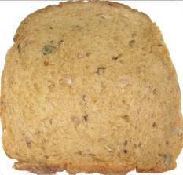
like sweetcorn and granary bread

VERY STICKY FOODS
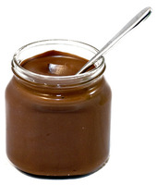
like peanut butter, chocolate spread


Remember

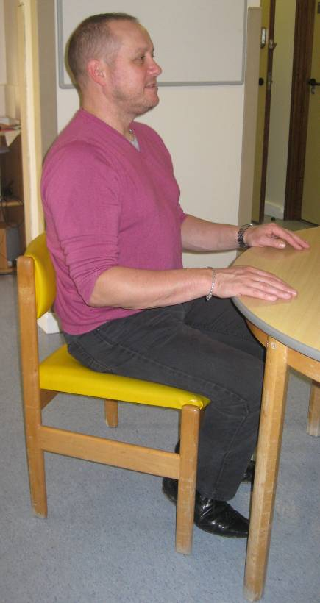
Sit up in a chair

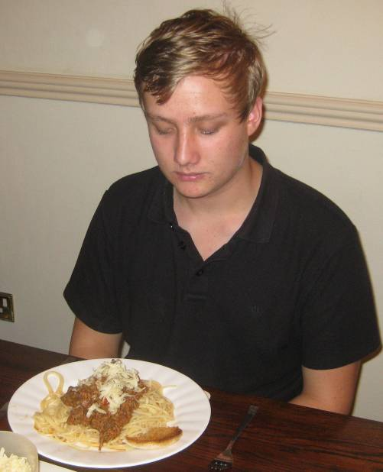
Eat and drink in a calm quiet place


Think about what you are doing

Cut up food into small pieces
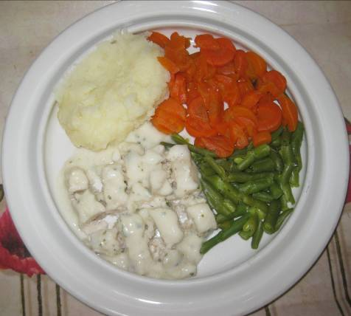

Chew well

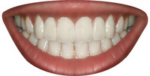

Stop talking
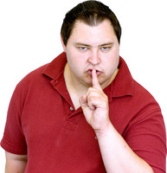

Eat small amounts at a time
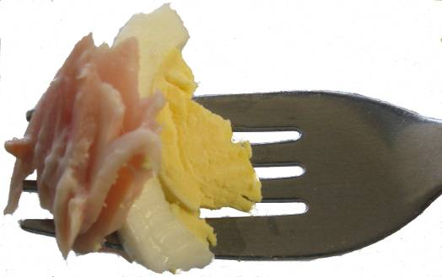

Eat and drink slowly

Eat and drink slowly
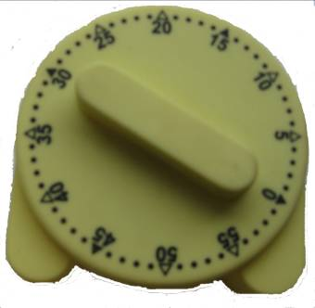

Eat soft moist foods

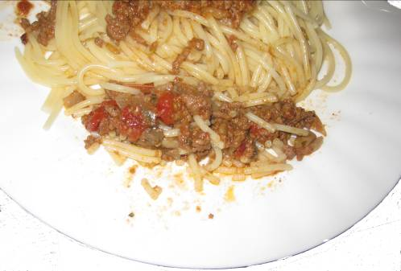


Get someone to help you when you need to
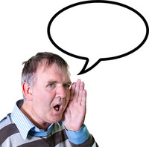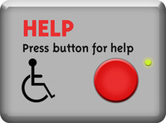

Appendix 9a – One Page Profiles on eating, drinking and swallowing – guidance and template
Guidance on One Page Profiles containing Speech and Language Therapy (SLT) recommendations for eating, drinking and swallowing -
• One Page Profiles for Eating, Drinking and Swallowing are intended to be used to increase accessibility of information on dysphagia recommendations from SLT reports to make them easier to understand and be available
• The information must match the recommendations from the SLT reports verbatim
• SLT reports should contain recommendations falling under the same categories as the boxes on the One Page Profile for Eating, Drinking and Swallowing for ease of transfer of information
• If the wording is changed to match the level needed for a person with learning disability to use themselves this should be stated on the profile with reference to the main SLT report and there may need to be a separate one for support staff/families
• Each profile has a space for the name of the SLT who has written the recommendations and their contact details. There is also space for the date and version number of the profile to allow for updated recommendations provided by an SLT
• They are designed to be used mostly by family and staff supporting the individual to eat, drink and take medication
• The profile must not be archived unless replaced by an update
• For the person’s safety, the profile should be available at all times for meals, snacks, drinks, medication doses and when the person is out and about but it must be kept securely to protect personal information
• Some people like to have them in front of them on the table at mealtimes, others prefer that they are kept in a file in the dining area or inside a kitchen cupboard for guidance during food and drink preparation. Copies can be made so they are available in a number of locations where appropriate, but they must be kept securely
• The profile should be printed in colour and can be laminated to protect it and allow for cleaning

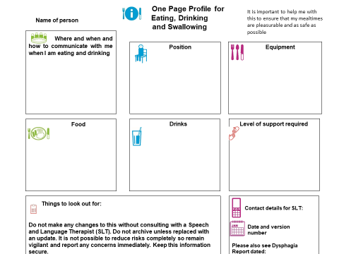
Link to downloadable, editable version available via Joint Training section of Shropshire Council’s website below.
Joint training | Shropshire Council then navigate to Policies and Guidance tab.

Appendix 10 – Flowchart of choking guidance process and documentation

Appendix 11
List of main changes to Choking Guidance from 2023 version.
- Signatory changed to reflect updated structure in Adult Services, Shropshire Council
- Purpose of the Guidance – Version number and dates of review changed.
- Scope – The following sentence added to largely acknowledge differences in referral process for SLT services. “In addition, local SLT services may offer their own relevant guidance. Where such guidance differs significantly from this document advice from a suitably qualified and competent professional at the local service should be obtained.”
- Appendix 3 – Risk Assessment Template – Added in reference to other SLT relevant guidance.
- Appendix 5 – Summary of who to refer on to. Added in “Where additional guidance is available from the local SLT service, please follow that advice regarding referral.”
- Acknowledgement edited to reflect that the guidance has been produced with support from MPFT.

