Cole Mere Ramsar / SSSI
Recreation Mitigation and Monitoring Strategy

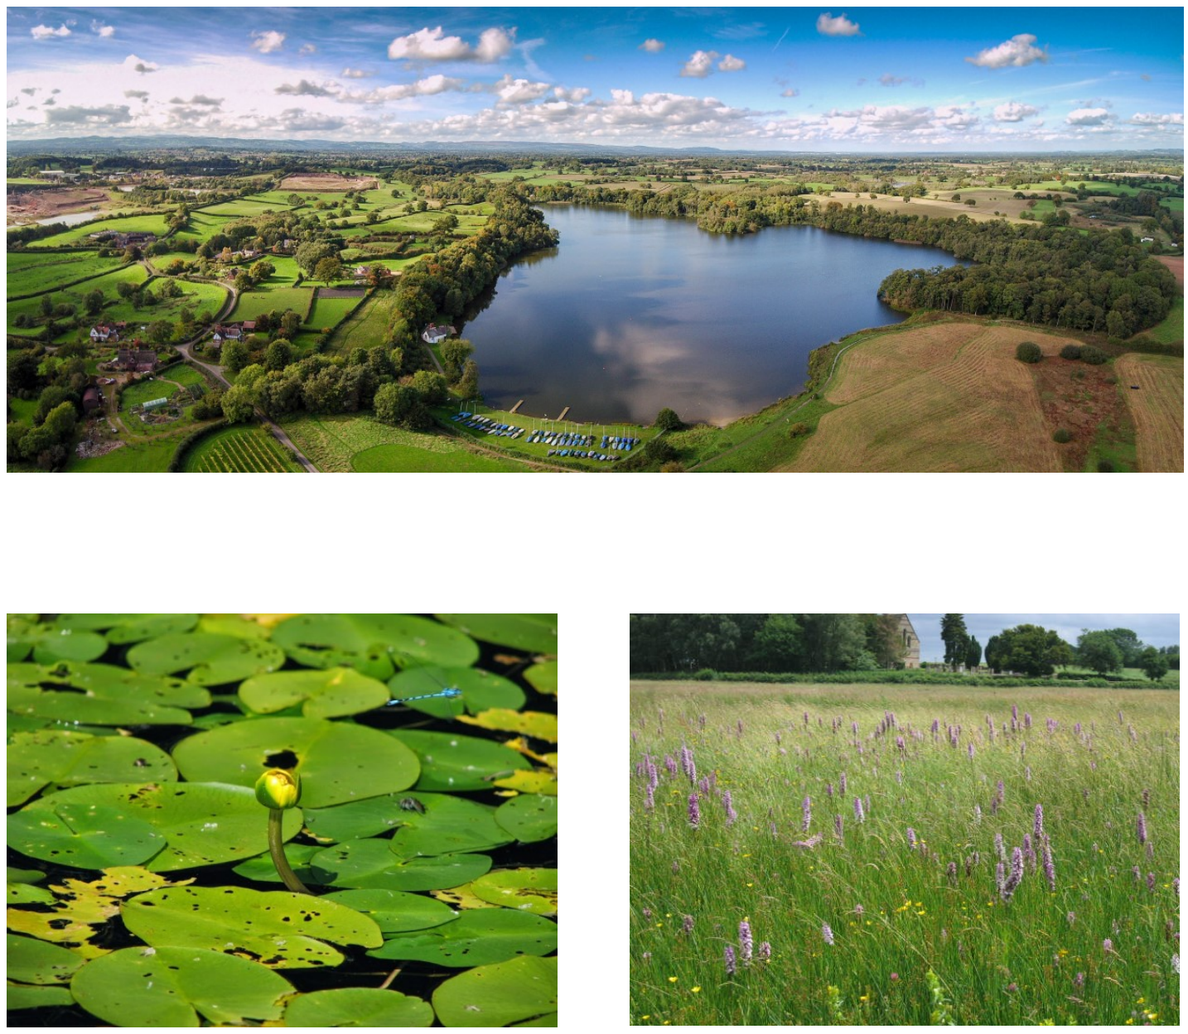

Cole Mere Ramsar / SSSI
Recreation Mitigation and Monitoring Strategy

Compiled by: Suzanne Wykes (Specialist Practitioner of Ecology) &
Shaun Burkey (Country Parks & Heritage Sites Officer)
Date: Jan 2023
Version: 02
Status: Draft for comment
CONTENTS
EXECUTIVE SUMMARY …………………………………………………………………………………………………4
- BACKGROUND
  - Overview of Cole Mere
  - Visitor Surveys
  - Recreation Impacts
  - Habitats Regulations Assessment
  - Local Planning Policy
- The Cole Mere Ramsar Recreation Mitigation and Monitoring Strategy
  - Introduction
  - Mitigation for Planned Growth
  - Access Management and Infrastructure
  - Communication
  - Monitoring
  - Delivery
- COLE MERE COUNTRYSIDE HERITAGE MANAGEMENT PLAN 2019-2025
- CONCLUSION
- REFERENCES

APPENDICES
APPENDIX 1: Ramsar and SSSI citations
APPENDIX 2: 11.7 km 75th percentile visitor buffer (Zone of Influence
APPENDIX 3: Breakdown of planned growth in Shropshire 2023-2038 within the 11.7km ZoI of Cole Mere
APPENDIX 4: Summary of mitigation and monitoring elements of the strategy

EXECUTIVE SUMMARY
This report provides a strategy to mitigate for the potential in-combination impacts of new housing development on Cole Mere Ramsar / Site of Special Scientific Interest (SSSI) in Shropshire, for the period 2023 – 2038. This timeframe corresponds largely with the period of the new Local Plan for Shropshire (2016 to 2038) which was submitted for examination in September 2021.
The strategy focusses on in-combination effects to the nature conservation interest of Cole Mere as a result of recreation arising from new residential development.
It is projected that from 2023 to 3028, approximately 1157 new dwellings are likely to come forward within the 11.7 km zone of influence, an increase of 10% from the 2018 baseline.
A suite of mitigation measures that would be necessary to be confident of no adverse effect on the integrity of the Cole Mere are presented, rationalised and costed within the strategy. Proposed delivery, monitoring and funding for the measures is also proposed.
It is concluded that with the implementation of this strategy, the planned housing growth between 2023-2038, within the 11.7km zone of influence of Cole Mere in Shropshire will not have an adverse effect on the integrity of Cole Mere, which is a component part of the West Midland Meres and Mosses Phase 2 Ramsar and a SSSI.

- BACKGROUND
  - Overview of Cole Mere
Cole Mere Countryside Heritage Site is owned by Shropshire Council and managed by The Outdoor Recreation Team of Shropshire Council. It is situated approximately 4km south-east of Ellesmere, 1km east of the A528 and 1km south of the A495 and covers an area of 47 ha (117 acres) in total.
Cole Mere is both nationally and internationally designated for its nature conservation importance. It is a Ramsar site, a Site of Special Scientific Interest (SSSI) and a Local Nature Reserve.
Cole Mere is one of the largest of the Shropshire meres, with an almost complete fringe of woodland. There is a comparatively rich flora of aquatic macrophytes, including small pondweed Potamogeton berchtoldii, fan-leaved water crowfoot Ranunculus circinatus and autumnal water-starwort Callitriche hermaphroditica. Least water-lily Nuphar pumila occurs here at what is probably its only English locality – the main centre of distribution of this species is the Scottish Highlands. Most of the surrounding woodland is of artificial origin but is of value as a habitat for birds and adds to the diversity of the site. However, near the eastern end there is an area of semi-natural alder carr in which greater spearwort Ranunculus lingua and the rare elongated sedge Carex elongata occur. At the south-eastern end of the site there is an area of damp, rush-dominated pasture, with characteristic species such as lesser spearwort Ranunculus flammula and carnation sedge Carex panicea. The aquatic invertebrate fauna of Cole Mere is particularly diverse.
See Appendix 1 for the reasons for the site’s designation as a Ramsar and the SSSI citation.
  - Visitor surveys
In August and September 2017, Ecological Planning and Research (EPR) were commissioned by Shropshire Council to undertake face to face visitor questionnaire surveys using a standard methodology at Cole Mere. The results suggest that baseline recreational pressure is at around 8.5 people per hour (averaged over the year) and 37,000 people per year.
The majority of visitors completed the 2.5km circular walk around the lake. Dog walking was the most commonly cited reason for visiting (47.1%), although walking and exercise were also popular. The majority of dog walkers said their dog(s) were let off the lead (86.2%) and almost half of dog owners said their dogs went into the water. The study proposed an indicative catchment area of 11.7km (75% of visits) from Cole Mere, within which developments involving a net increase in housing may contribute to an increase in recreation pressure at the site. See Appendix 2 for a map illustrating the 11.7km zone of influence (ZoI).
The report concluded that in light of the high baseline visitation levels at Cole Mere, any increase in recreational pressure arising from new housing within the 11.7km ZoI is likely to give rise to significant adverse effects upon the structure, function and integrity of the site, acting in combination with other factors.
Since the 2017 surveys, an automated counter on the gate between the car park and Yell Field has been collecting data. As the counter counts both people entering and exiting the site, the number of counts recorded can be divided by 2 to get an idea of the number of people visiting the site and to see the trends in the data. There is no counter installed by the other access into the site from Little Mill Field and also no counter from people accessing the site from footpaths off the canal and to the east of the site, so counts are likely to be an underestimate of total visitor numbers. The 2017 visitor survey recorded half as many people entering the access off Little Mill Field than at the main access by Yell Field.
Table 1: Visitor Survey Trends – automated counter data
 | 2018 | 2019 | 2020 | 2021 | 2022
Jan-Mar | 18009 | No data | No data | No data | 18321
Apr-Jun | 22761 | 21032 | 26085 | 29930 | 33227
Jul-Sep | 22841 | No data | 38106 | No data | 31254
Oct-Dec | 20081 | No data | 27439 | No data | 19283

Fig.1. Automated counter data trends
As can be seen from the data collected, there has been an upward trajectory in visitor numbers counted by the automated counters since 2018, particularly visits in the spring and summer. 2020 was the year that COVID struck with many more people than usual accessing the outdoors. This is reflected in the automated counter data at Cole Mere.
  - Recreation Impacts
Evidence from the 2017 visitor surveys, together with information provided by the managers of the site, the current management plan and other sources of relevant information enabled the identification of potential impacts from recreation that could lead to significant adverse effects on the designated features.
Trampling and Erosion
Habitats which are located off designated paths include dry woodland, wet grassland and wet woodland, which are sensitive to trampling and erosion. Access into areas off designated paths both disturbs faunal species and also influences vegetation communities, with species sensitive to trampling replaced by those with more tolerance.
Disturbance of Aquatic Vegetation & Sediments
Surveys in 2017 identified that the majority of visitors had dogs with them (56.9%) and 48.3% of visitors said their dogs entered the water. Access into the mere churns up sediments, increases turbidity and releases nutrients, which affects aquatic vegetation. Where swimming occurs along the shoreline where the least water-lily is located, direct damage to plants can occur.
Dog Fouling
Eutrophication through dog fouling of habitats dependent upon low nutrients can alter the composition of vegetation, with more common vigorous plant species replacing rarer and notable species which are indicative of a particular habitat type. This is an issue on Yell Field, which comprises of species-rich grassland.
Interference with Habitat Management
Higher numbers of visitors to Cole Mere could lead to an increase in opposition to habitat management such as tree and scrub clearance, which is necessary to maintain suitable habitat conditions for least water-lily.
Additional visitors would also be accompanied by more dogs leading to increased risk to grazing livestock and opposition to their presence, which is required to maintain the areas of species-rich grassland. During visitor surveys in 2017, slightly more groups said they didn’t like the cattle than did.
  - Habitats Regulations Assessment
Shropshire Council has a duty as a Competent Authority under the Conservation of Habitats and Species Regulations 2017 (as amended) (‘the Habitat Regulations’) to ensure that planning application decisions comply with the Habitats Regulations.
The Council must ensure that decisions made on planning applications, and policies in the Local Plan, will avoid and mitigate impacts on Cole Mere Ramsar SAC. If there are any likely significant effects, the Council is either unable to grant planning permission due to the restrictions of the Habitat Regulations., or it must ensure there are appropriate mitigation measures in place.
  - Local Planning Policy
Adopted Local Plan
The adopted Local Plan for Shropshire comprises the Core Strategy (2011) and the Site Allocations and Management of Development Plan (SAMDev) (2015). The adopted plan covers the period 2006-2026. Habitats Regulations Assessments undertaken as part of the local plan adoption process identified that Cole Mere Ramsar was at risk of being adversely affected by increased recreational pressure as a result of new housing proposals in its vicinity, and therefore, policies CS8, CS9, CS17, MD12 and MD2 were included in the plans to detail the method of avoiding adverse effects on Cole Mere. This included compilation of individual Appropriate Assessments and infrastructure considerations, including contributions as required to mitigate any adverse effects on site integrity.
Draft Local Plan
The Draft Shropshire Local Plan covers the period 2016-2038 and was submitted to the Planning Inspectorate in September 2021. The HRA accompanying the submission version identified that Cole Mere was at risk of adverse effects as a result of increased recreational pressure from housing within 11.7 km of the site, and policies DP13, DP15 and DP 16 in the draft local plan contain wording to detail how development within the 11.7km zone can mitigate for recreational impacts. This includes the requirement for an Appropriate Assessment of projects and consideration of both on and off-site mitigation measures, including over provision of open space on development sites and/or on-site mechanisms to mitigate for recreational impacts, through developer contributions.
Planned Growth
The number of proposed dwellings including those saved from SamDev and new allocations and windfall in the draft Local Plan as at 31 March 2022 is 1157 within the 11.7km ZoI, as detailed below in Table 2. A full breakdown by area and settlement is provided in Appendix 3.
Table 2: Planned growth in Shropshire 2023-2038 within the 11.7km ZoI of Cole Mere
Planned Growth in Shropshire County 2022-2038
Total Allocations (2023 – 2038) | 673
Windfall (2023-2038) | 456
Saved SamDev Allocations remaining (2023-2038) | 28
Total remaining Housing Growth 2023-2038 | 1157

  - Strategic approach to European site mitigation schemes
In areas where there is significant development which is likely to have a significant effect on a European site (either alone or in combination with other plans or projects), in accordance with the Habitats Regulations, Appropriate Assessments for each planning application covering the same issues are usually undertaken.
An alternative approach is a strategic approach which enables an agreed and consistent method to be applied to each project; in this case, planning applications for housing.
For some impacts, a package of mitigation measures can be formulated that are agreed to collectively remove or adequately reduce potential impacts related to a specific impact pathway (in this case, recreation) to levels where they are not likely to have a significant effect on a European site. These can be considered and agreed in advance of the potentially impacting projects coming forward for approval.
When and if each individual project ‘signs up’ to funding the agreed package of mitigation measures, then effectively, the need for each planning application to have an individual ‘project’ level HRA is removed as mitigation will already have been agreed and in place to remove, or adequately reduce, the identified significant effects on European sites arising for the planning application.
This approach is also relevant for SSSIs.

- The Cole Mere Ramsar/SSSI Recreation Mitigation and Monitoring Strategy
  - Introduction
Given the evidence that one or more net dwellings would have an adverse effect on the site’s integrity, a fully costed on site mitigation strategy has been produced in consultation with officers from Outdoor Partnerships at Shropshire Council who manage Cole Mere, and Natural England.
The strategy seeks to mitigate adverse effects of increased visitor numbers on Cole Mere resulting from the cumulative effect of all residential development within the ZoI planned for between 2023 to 2038 through the implementation of on-site mitigation measures, and complimentary monitoring for the lifetime of the developments (taken to be 100 years).
The costed mitigation measures and monitoring elements of the strategy are detailed in Appendix 4 and also described in sections 3.2 – 3.4, below.
For details on the location and extent of these features/habitats, please refer to ‘Colemere Countryside Heritage Site Management Plan 2020 – 2025’, dated Dec 2019.
  - Mitigation for Growth
The 2018 visitor survey report identified that there were 14,732 existing dwellings within the 11.7 km catchment for Cole Mere. Projected housing growth between 2023-2038 is at least 1157 dwellings, an increase of nearly 8% from the baseline.
It should be noted that the mitigation measures detailed in Appendix 4 are considered to mitigate for the scale of development that is planned to come forward between 2023 and 2038 in Shropshire, however, some of the measures are already in place or occurring as part of the current management of the site.
With the planned growth increasing the number of households in the ZoI by 8 % between 2023-2038, many existing mitigation measures will need to be undertaken more frequently, and therefore, where this is the case, costs for which developer contributions will be sought have been fairly attributed to reflect only those required to mitigate the effects of planned growth.
Should additional development come forward either as part of the examination of the new Local Plan or any subsequent plans or projects, mitigation measures as set out in this strategy will need to be reviewed to ensure that they remain fit for purpose. Consideration will also be given to the requirement for on-site development led mitigation as appropriate on a case-by-case basis.
In addition, should monitoring identify the requirement for additional mitigation measures, not already identified in the plan, this would be costed and agreed and the contributions amended to deliver this additional evidenced mitigation.
  - Access Management and Infrastructure
Paths
The surfacing, design and maintenance of paths can affect how people use them and as a result reduce the impacts from recreation, without any change in visitor numbers. Path design can be used to help focus visitor flows and influence how people move within a site. It is a relatively ‘soft’ approach in that it is possible to influence people’s behaviour without people feeling their access is being restricted.
Well maintained paths will encourage use of less sensitive areas and mitigate against trampling that would result in soil erosion and compaction of sensitive habitats located off paths including species-rich grassland (Yell Field) and wet woodland supporting rare flora surrounding the mere.
An annual assessment of path condition, including the boardwalk through Yell Field, is proposed together with an annual programme of repair to maintain paths in a good condition.
Screening
Dogs currently swim in the water around the majority of the margin of Cole Mere. It is acknowledged that this is a legitimate activity that is valued by visitors, and so rather than attempting to prevent it altogether access is proposed to be prevented along the northern shore through the use of dead hedging composed of brash to protect the key locations of least water-lily.
Brash arisings would be generated on-site by felling of trees along the mere edge where they are causing shading of waterside flora.
This would be an ongoing activity to ensure access was prevented in the most sensitive locations for least water-lily.
Car Parking
The car park at Cole Mere is well used and surrounded by wooden kick rail to prevent unauthorised parking outside of the limits of the designated parking area. It is important that the car park is well maintained to ensure that visitors do not attempt to park on areas outside of the designated car park. Previously, in busy periods, damaged kick rail has allowed cars to park in undesignated areas, damaging vegetation.
An annual assessment of car park condition is proposed together with a five yearly resurfacing programme to maintain the surface of the car park in a good condition.
Fencing
Fencing is used around the site to funnel visitors along paths and to fence off vulnerable areas of habitat from public access. The car park is delineated by kick-rail fencing to constrain car parking to only the designated car park and to avoid damage to adjacent vegetation.
An annual assessment of fencing is proposed together with an annual programme of repair to maintain fences in a good condition.
Other visitor infrastructure
Gates and bridges are additional elements of visitor infrastructure which, in conjunction with paths and fencing, act to manage visitor access and behaviour. An annual assessment of gates and bridges is proposed together with an annual programme of repair to maintain gates and bridges in a good condition.
  - Communication
Signage
Signage at Cole Mere currently comprises of x interpretative panels located at . These are outdated and do not clearly identify the importance of the site, or inform people of ways in which they can contribute to the care of the site, through sensitive visitor behaviour.
In addition, there is no specific interpretation about the least water lily, its importance and why measures such as tree felling and screening are being implemented to help protect and enhance the population.
Four new interpretative panels will be designed and installed at strategic locations around the site to provide information on Yell Field, the population of least water lily, the wet woodland and the site as a whole. The panels will include a section detailing positive ways in which people can contribute to the site’s conservation.
Dog fouling
Dog fouling is an issue on many semi-natural sites that are popular with visitors, and at Cole Mere, Yell Field is thought to be particularly affected due both to the fact that it is very close to the main entrance, so receives the majority of dog faeces, and that it is composed of vegetation that can be negatively affected by nutrient enrichment.
Previous strategies for engaging with dog walkers on this issue have been met with mixed results, and at worse, by aggression, however, as it has the potential to impact upon the site it is proposed to be monitored. If it is identified as a problem during the course of monitoring, additional interventions will be investigated and if necessary implemented, with a commensurate increase in contributions to fund this.
Interventions may include a dog strategy, and, if required, fencing alongside the boardwalk, whilst maintaining access to Yell Field through a gate.
  - Monitoring
The monitoring measures proposed are primarily concerned with monitoring visitor numbers, visitor origins and behaviours, dog fouling and any changes in vegetation, to identify any emerging effects related to planned development. Other potential mitigation measures will be introduced as and when a need is identified through the monitoring programme.
An annual audit of infrastructure condition will be undertaken, at the same time of year.
- Visitor monitoring will be undertaken, via electronic counters at access points and every ten years through a visitor survey.
- A log-book will be kept of any incidents relating to the cattle which graze Yell Field in the autumn.
- Vegetation monitoring will be undertaken as well as counts of dog faeces in Yell Field at the busiest time of the year.
In addition to the introduction of the above detailed monitoring elements, existing commitments to monitoring will continue to be undertaken and are therefore not an additional cost detailed in this plan. Periodic condition assessment monitoring undertaken by Natural England, to report on SSSI condition will continue for instance.
  - Delivery
Delivery of the mitigation and monitoring strategy will be through contributions secured from qualifying development within the ZoI. Mitigation will be funded through CIL or Section 106 to provide the mitigation and monitoring required to satisfy the Habitats Regulations (as amended), as well as national and local policy regarding the protection of environmental assets.
Contributions will be required from every development producing one or more net dwellings within the ZoI unless the developer can demonstrate to the satisfaction of the local planning authority and Natural England that the developer can provide alternative measures which will fully mitigate or avoid significant impacts of the development (either alone or in combination) upon Cole Mere.
The cost per net dwelling is £316.05 based upon the cost of the projects over the lifetime of the developments shared amongst the total amount of planned development in Shropshire within the ZoI over the period 2022 to 2038, the breakdown of which is detailed below, in Table 3.
Table 3: Cost per dwelling
Total cost of mitigation and monitoring strategy implementation (a) | £430,678.00
Planned growth in Shropshire within Cole Mere ZoI 2023-2038 (no. of dwellings) (b) | 1,157
Total cost per dwelling (a/b) | £372.24

- COLE MERE COUNTRYSIDE HERITAGE MANAGEMENT PLAN 2019-2025
The management of Cole Mere is undertaken by officers of Shropshire Council, who work in Outdoor Partnerships.
The current management plan for Cole Mere runs from 2020 to 2025 and includes detailed background information on the history, environmental conditions, habitats, species and usage of the site together with aims and objectives of management and prescriptions of actions to be undertaken for each habitat compartment, to seek to bring each compartment, and hence the site into a favourable condition.
The Recreation Mitigation and Monitoring Strategy has been written in the light of the current management plan and will complement and support its aims and objectives to improve the condition, and hence the resilience of habitats to the effects of increasing visitor pressure.

- CONCLUSION
With the implementation of the mitigation and monitoring measures as set out in this report, and summarised in Appendix 4, it is considered that the planned housing growth between 2023-2038, within the 11.7km ZoI of Cole Mere in Shropshire will not have an adverse effect on the integrity of Cole Mere, which is a component part of the West Midland Meres and Mosses Phase 2 Ramsar and a SSSI.

- REFERENCES
Ecological Planning and Research. ‘Cole Mere Countryside Heritage Site- Shropshire Visitor Survey Report’ (May 2018) EPR
Joint Nature Conservation Committee. ‘Information Sheet: UK11080 - Midland Meres and Mosses Phase 2, Version 3.0’ (13.06.2008) JNCC
Natural England, ‘Cole Mere SSSI citation’ (1963) NE
Shropshire Council. ‘Colemere Countryside Heritage Site Management Plan 2020 – 2025’ (Dec 2019) Shropshire Council
Shropshire Council. ‘Draft Shropshire Local Plan 2016-2038’ (September 2021) Shropshire Council
Shropshire Council. ‘Five Year Housing Land Supply Statement’ (February 2022) Shropshire Council
Shropshire Council. ‘Habitats Regulations Assessment of the Regulation 19 pre-submission version of the Draft Shropshire Local Plan 2016-2038’ (September 2021) Shropshire Council

APPENDIX 1: Cole Mere Ramsar criteria for designation and SSSI citation
Ramsar criterion 1: The site comprises a diverse range of habitats from open water to raised bog. Ramsar criterion 2 Supports a number of rare species of plants associated with wetlands, including the nationally scarce cowbane Cicuta virosa and, elongated sedge Carex elongata. Also present are the nationally scarce bryophytes Dicranum affine and Sphagnum pulchrum. Also supports an assemblage of invertebrates including several rare species. There are 16 species of British Red Data Book insect listed for this site including the following endangered species: the moth Glyphipteryx lathamella, the caddisfly Hagenella clathrata and the sawfly Trichiosoma vitellinae.
Reasons for Notification (as a SSSI):
The Meres & Mosses of the north west Midlands form a nationally important series of open water and peatland sites. These have developed in natural depressions in the glacial drift left by the ice sheets which covered the Cheshire-Shropshire plain some 15,000 years ago. The majority lie in Cheshire and north Shropshire, with a small number of outlying sites in adjacent parts of Staffordshire and Clwyd.
The origin of most of the hollows can be accounted for by glaciation but a small number have been formed at least in part by more recent subsidence resulting from the removal in solution of underlying salt deposits.
There are more than 60 open water bodies known as ‘meres’ or ‘pools’ and a smaller number of peatland sites or mires known as ‘mosses’. They range in depth from about one metre to 27 metres and have areas varying between less than a hectare to 70 hectares.
Although the majority of the meres are nutrient rich (eutrophic) the water chemistry is very variable reflecting the heterogeneous nature of the surrounding drift deposits. Associated fringing habitats such as reedswamp, fen, carr and damp pasture add to the value of the meres. The development of these habitats is associated with peat accumulation which in some cases has led to the complete infilling of the basin. During this process the nutrient status of the peat surface changes and typically becomes nutrient poor (oligotrophic) and acidic thus allowing species such as the bog mosses Sphagnum spp. to colonise it. The resulting peat bogs are the 'mosses'. In a few cases colonisation of the water surface by floating vegetation has resulted in the formation of a quaking bog known as a 'schwingmoor’
Cole Mere is one of the largest of the Shropshire meres, with an almost complete fringe of woodland. There is a comparatively rich flora of aquatic macrophytes, including small pondweed Potamogeton berchtoldii, fan-leaved water crowfoot Ranunculus circinatus and autumnal water-starwort Callitriche hermaphroditica. Lesser yellow water-lily Nuphar pumila occurs here at what is probably its only English locality – the main centre of distribution of this species is the Scottish Highlands.
Most of the surrounding woodland is of artificial origin but is included in the site since it is of value as a habitat for birds and adds to the diversity of the site. However, near the eastern end there is an area of semi-natural alder carr in which greater spearwort Ranunculus lingua and the rare elongated sedge Carex elongata occur.
At the south-eastern end of the site there is an area of damp, rush-dominated pasture, with characteristic species such as lesser spearwort Ranunculus flammula and carnation sedge Carex panicea.
The aquatic invertebrate fauna of Cole Mere is particularly diverse.

APPENDIX 2: 11.7 km 75th percentile visitor buffer (Zone of Influence) where new residential development proposals would have an adverse effect on Cole Mere Ramsar through increased recreation, in combination with other plans and projects.

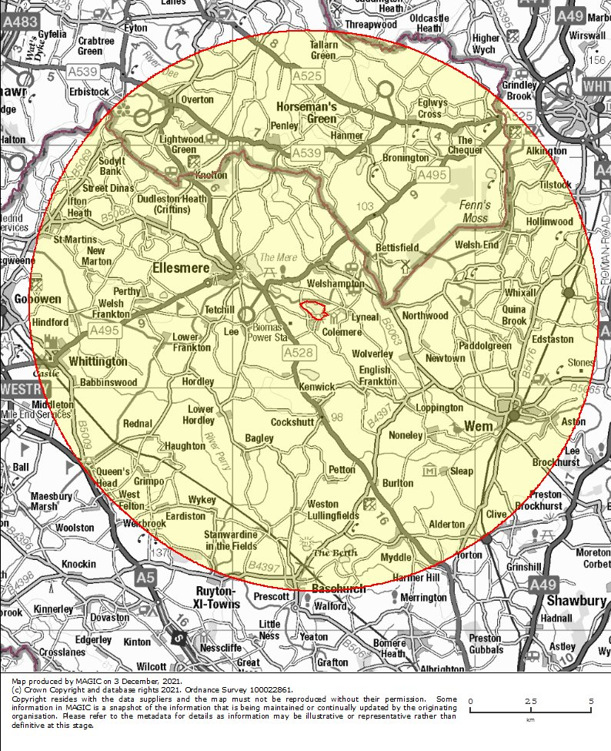

APPENDIX 3: Breakdown of planned housing growth in Shropshire 2023-2039 within the 11.7km ZoI of Cole Mere
Area | Settlement | Saved Samdev without planning permission | New Local Plan allocation without planning permission | Windfall | To be delivered 2023-2038
Shrewsbury | Baschurch |  | 55 | 40 | 95
Wem | Clive |  | 20 | 18 | 38
Ellesmere | Cockshutt | 6 |  |  | 6
Ellesmere | Dudlestone Heath |  |  | 19 | 19
Ellesmere | Ellesmere |  | 63 | 170 | 233
Whitchurch | Prees | 22 | 35 | 29 | 86
Oswestry | Ruyton XI Towns |  | 65 | 34 | 99
Oswestry | St Martins |  | 95 | 36 | 131
Wem | Wem |  | 210 | 89 | 299
Oswestry | West Felton |  | 60 | 6 | 66
Oswestry | Whittington |  | 70 | 15 | 124
 |  | 28 | 673 | 456 | 1157

APPENDIX 4: Summary of mitigation and monitoring elements
Mitigation Category | Mitigation Measure | Cost attributed to new dwellings delivered over plan period in perpetuity (100 years) | Rationale
Access Management and Infrastructure | Dead hedging around lake to prevent people and dogs entering water to protect least water lily | £182,400 | 1,200m of shoreline to be cleared of overhanging trees to provide materials for dead hedging at cost of £38.00/metre. Ongoing cycle - every 25 years
Access Management and Infrastructure | Car park re-surfacing and fencing | £4,244.00 | £2,000/5 years currently. Projected increase in population in catchment will increase maintenance requirements (by 10%)
Access Management and Infrastructure | Path maintenance | £10,560 | £1200/annum currently. Projected increase in population in catchment will increase maintenance requirements (by 10%).
Access Management and Infrastructure | Boardwalk maintenance and replacement | £18,000 | £50,000 to replace whole boardwalk-assumed replaced every 25 years. Projected increase in population in catchment will increase frequency of replacement required.
Access Management and Infrastructure | Bridges. kissing gates etc maintenance | £4,444 | £500/annum currently. Projected increase in population in catchment will increase maintenance requirements (by 10%).
Communication | Interpretive signage explaining site's particular interests and sensitivities in order to reduce damaging visitor behaviour. | £48,000 | Four interpretive signs £1,200/each, replaced every 10 years.
Monitoring | Least water lily, yell fields and wet woodland species condition assessment survey and extent mapping. | £100,000 | Estimated cost of £5,000/visit & report for monitoring by external consultant/specialist groups every five years.
Monitoring | Visitor counts, visitor interviews/behaviours | £50,000 | Estimated cost of £5,000/visit & report for monitoring by external consultants every ten years.
Monitoring | Visitor counters at two site entrances | £23,000 | Two counters at £1,150 each, replaced every 10 years.
 |  | £440,628 | TOTAL
 |  | £9.500 | Contributions already received
 |  | £430,678 | TOTAL CONTRIBUTIONS SOUGHT
 |  | 1,157 | No. of new dwellings
 |  | £372.24 | Contribution per new dwelling

Cole Mere SSSI condition assessment undertaken by Natural England, 27/03/2014, M Cousins

