

**S.C.R.A.P Briefing Note**

Fly tipping is the unauthorised dumping of solid or liquid waste on land or water. It can be anything from a single bag of waste to lorry loads of building waste. Fly tipping is a crime that carries serious penalties – the maximum being a five-year prison sentence and an unlimited fine.

If your waste is fly tipped, even by someone else on your behalf, you could still be issued with a fixed penalty notice.

Shropshire Council are working in close partnership with West Mercia Police, Defra, Environment Agency, and other Local Authorities to tackle the issue of fly tipping across our county. We need everyone to play their part and we are asking for everyone to be vigilant.

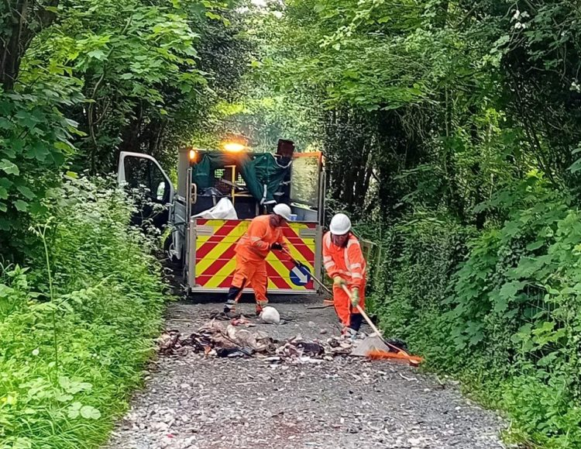 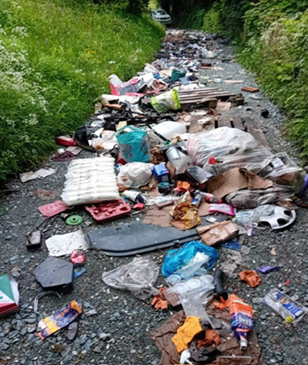

Follow the S.C.R.A.P Code to ensure your waste is correctly disposed of:

* **S**uspect all waste carriers; do not let them take your waste unless they can prove that they are legitimate. A legitimate waste carrier should be happy to answer reasonable questions.
* **C**heck their waste carrier’s registration details. These can be verified by checking the Environment Agency website or by calling 03708 506 506. Make a note of the registration details of the vehicle used to remove your waste.
* **R**efuse unexpected offers to have any rubbish taken away. If you suspect that someone you have spoken to is disposing of waste illegally, report their name and vehicle registration to the Environment Agency.
* **A**sk what will happen to your rubbish and seek evidence that it will be disposed of appropriately.
* **P**aperwork should be obtained. Make sure you get a full receipt and waste transfer note for your waste removal. This should give a description of the waste and provide the waste carrier’s licence number and contact details.

By following the SCRAP code, we can all help contribute to the protection of our environment, improving local areas and communities. Taking a united stance against individuals who believe they can unlawfully dump waste. The money spent by Shropshire Council removing fly tipping is money that could be used to support other services.

* If you would like to report an incident of fly-tipping, you can do so via FixMyStreet mobile App: [FixMyStreet (shropshire.gov.uk)](https://improvingyourroads.shropshire.gov.uk/)

This will ensure that each enquiry is logged, acknowledged, and issued with a reference number. The enquiry will be allocated to the appropriate service area who will investigate the matter and action as required.

We are actively looking to improve customer engagement and this process of recording Street Scene enquiries is vital to the development of the service and will assist with identifying and prioritising service improvement.