

**Shropshire**

**Manual** for

**Adoptable**

**Roads** and

**Transport**

**SMART 2021**

A Highway Design Guide and   
Specification for all New Development within Shropshire

Table of Contents

Introduction 3

Structure of the document 5

Part A Design Principles 7

A.1. Design Considerations 7

A.2. Highway Design 8

A.3. Design Concepts 9

A.4. CORE POLICIES & STRATEGY 10

A.5. Principles of Estate Road Design 11

A.6. Road Hierarchy 12

A.7. Sustainable Travel, Access and Movement 15

A.8. Surface Water 15

A.9. Highway Drainage 16

A.10. Design of Construction Thickness 17

A.11. Adoptable Construction Standard 17

A.12. Financial consideration 18

A.13. Structures 19

A.14. Security and Crime 19

A.15. Management and Maintenance 21

A.16. Carriageway and Footway Materials 21

A.17. Soft Landscaping 22

A.18. Road Safety 23

A.19. Speed Restraint 23

A.20. Access to Bus Services 24

A.21. Footways and Cycleways 25

A.22. Facilities for the Disabled 26

A.23. Car Parking and Servicing 26

A.24. Refuse & Recycling Collection 27

A.25. Safety Audits 27

A.26. Transport Statements & Travel Plans 28

A.27. Planning Obligations 28

A.28. Community Infrastructure Levy 28

Introduction

1. Shropshire is a beautiful county with a rich heritage and history which provides a rich mix of attractive landscapes and streetscapes. It is the quality of both the natural and historic built environments which helps support Shropshire’s vibrant visitor-focused economy, whilst at the same time providing a cherished environment to work and live.
2. We have a responsibility therefore, to ensure that all new development, whilst supporting future economic growth, must be attractive, appropriate and sustainable and respectful of the past. The aim of ‘The Shropshire Manual for Adoptable Roads and Transport’ (SMART) is therefore to establish well designed residential streets and neighbourhoods where buildings, streets and spaces combine to provide local places which improve the life of Shropshire residents whilst making it an attractive place to visit and invest in in the same way this has been achieved in the past.
3. SMART covers many elements of site development and aims to help achieve cohesive design layout and construction so that any new development is integrated, sustainable, and of the highest quality.
4. SMART will assist developers, designers, house builders and other professionals in preparing the right infrastructure to achieve street layouts which meet the needs of all users and do not allow vehicles to dominate. The objective is to create an environment that is safe and pleasant for everyone to use and enjoy, where people have the freedom to walk, cycle, and drive, and feel safe doing so.
5. The new structured approach to design as set out in this document is intended to assist the design process and facilitate negotiations between developers and the Highway Authority. It aims to simplify and explain the highway planning and approval processes, to avoid the submission of abortive work and ultimately lead to the creation of more pleasant and safer residential environments.
6. SMART reflects the approach to design as set out in Department for Transport’s ‘Manual for Streets 1 & 2’ which emphasise the overall importance given to place making and encourages the design of streets based on their function, rather than purely level of traffic carried. It also replaces two previous Shropshire County   
   Council publications:

* ‘Residential Developments in Shropshire – A Design Guide’ (1996) and
* ‘Specification for Residential/Industrial Estate Roads’ (2000).

1. With further development and economic growth comes an ever-increasing maintenance liability on the Local Highway Authority, for the new streets and spaces which are created, and adopted. Therefore, consideration and advice is provided for adopting and managing roads and spaces, including the appropriate use of materials, emphasising quality, longevity and the use of local resources. Where special features are required to ensure a ‘sense of place’, SMART includes such considerations and mitigations, including commuted sum payments.
2. SMART also highlights design considerations for different road   
   users and situations, encouraging multi-use spaces and innovative   
   measures for speed control, such as visual perception traffic calming, where appropriate.
3. SMART should be used for any residential street typically serving   
   multiple dwellings, for mixed use developments and for industrial/ commercial schemes.

Structure of the document

SMART is made up of several documents, colour coded as shown below, concentrating on specific topics and themes, making it easier for the reader to find the relevant information.

|  |  |
| --- | --- |
|  | 1. **DESIGN PRINCIPLES** (this document)   This is the primary policy to which all other related documents are focused. It sets out the general parameters and criteria appropriate for developers to consider and design new streets and future adoptable highway assets. |
|  | 1. **SPECIFICATION** (for highway adoptable assets)   This outlines the general highway construction specifications and guidance for undertaking adoptable works with the necessary emphasis on health and safety. |
|  | 1. **LEGISLATION**   This sets out the general overarching highway legislation and any  other appropriate legal requirements for all new developments in Shropshire, or where a new or altered access to the existing public highway is necessary. |
|  | 1. **PROCEDURES**   This specifically sets out the required procedures and documentation all developers should follow and use, in respect to all adoptable highway related matters. |
|  | 1. **TECHNICAL NOTES**   These documents provide a wide range of associated information, technical resources, guidance and specifications, to assist the developer in successfully developing new or modifying existing highway infrastructure in Shropshire. |

**List of Documents in Part E:**

1. How to Secure a Section 38 Agreement
2. How to Secure a Section 184 Agreement
3. How to Secure a Section 278 Agreement
4. Bonds, Fees & Commuted Sums
5. Flood & Water Management + SuDS Guidance*
6. Structures
7. Street Lighting*
8. Traffic Signals*
9. Car Parking Guide
10. Standard Detail Drawings
11. Refuse and Recycling Guidance*
12. Local Transport Plan (Core Document) *
13. Shropshire Bus Strategy*
14. Cycling Guide*
15. Travel Plan Guidance*
16. Mobility Guidance*
17. Private Street Works Code
18. Highway Advice on Minor Planning Applications
19. Glossary of Terms & Abbreviations

*(Note:* ***\**** *indicates previously published Shropshire Council documents)*

**SMART should also be read in conjunction with all other appropriate   
and current national and local planning, design, specifications, best practice, policies and guidance.**

The links provided are for ease of reference and the designer should   
ensure that all relevant guidance and legislation has been appropriately considered.

Part A

# DESIGN PRINCIPLES

A.1. Design Considerations

1. The following national and local design guidance, best practice and relevant legislation should also be considered in conjunction with this document.
2. It should be noted that the following list is not exhaustive, and the Developer is responsible for applying all appropriate best practice guidance to ensure the proposed scheme meets Shropshire Council’s requirements.

* Manual for Streets 1 & 2 (MfS),   
  <https://www.gov.uk/government/publications/manual-for-streets>
* Design Manual for Roads & Bridges (DMRB)  
  <https://www.standardsforhighways.co.uk/dmrb>
* Volume 1 - Manual of Contract Documents for Highway Works <http://www.standardsforhighways.co.uk/ha/standards/mchw/index.htm>
* Shropshire Council Flood & Water Management - SuDS Manual <https://www.shropshire.gov.uk/media/12304/surface-water-management-interim-guidance-for-developers.pdf>  
  <https://shropshire.gov.uk/drainage-and-flooding/development-responsibility-and-maintenance/new-development-and-watercourse-consenting/suds-requirements-for-new-developments/>
* Shropshire Core Strategy, SAMDev & Supplementary Planning Guidance   
  <https://shropshire.gov.uk/planning-policy/local-planning/local-plan-partial-review-2016-2036/>  
  <https://www.shropshire.gov.uk/planning-policy/local-planning/>  
  <https://www.shropshire.gov.uk/search/?start=0&s=Samdev>  
  <https://www.shropshire.gov.uk/public-transport/local-transport-plan/>
  + Inclusive Mobility, DfT (Dec 2021)  
    [Inclusive Mobility. A Guide to Best Practice on Access to Pedestrian and Transport Infrastructure](https://assets.publishing.service.gov.uk/media/61d32bb7d3bf7f1f72b5ffd2/inclusive-mobility-a-guide-to-best-practice-on-access-to-pedestrian-and-transport-infrastructure.pdf)
* Handbook for cycle-friendly design, Sustrans (2014)  
  <https://www.sustrans.org.uk/for-professionals/walking-and-cycling-infrastructure-design-guidance/>
* Building Health Places   
  [Building healthy places - GOV.UK](https://www.gov.uk/government/collections/building-healthy-places)
* Construction (Design and Management) Regulations 2015   
  <http://www.legislation.gov.uk/uksi/2015/51/contents/made>
* Highways Act 1980 (HA 1980)   
  <http://www.legislation.gov.uk/ukpga/1980/66/contents>
* The Health and Safety at Work Act 1974 <http://www.legislation.gov.uk/ukpga/1974/37/contents>
* New Roads & Street Works Act 1991 (NRSWA)  
  <http://www.legislation.gov.uk/ukpga/1991/22/contents>
* Traffic Signs Regulations & General Directions 2016 <http://www.legislation.gov.uk/uksi/2016/362/contents/made>

A.2. Highway Design

1. The following provides information and advice to assist everyone involved in the design of new adoptable highways. This will help to create environments in Shropshire that are:

* visually attractive,
* safe,
* sustainable,
* fit for purpose,
* secure,
* cost effective (construction & maintenance)

1. The most lasting impression of any development is created by the spaces between the buildings, rather than the buildings themselves. The roads and footways affect the arrangement, spacing and appearance of the buildings and spaces they serve. This subsequently influences the size and shape of gardens, the choice of planting, and the location of open areas and play spaces, as well as the routes for public utility service providers.
2. The layout of the street scene (highway) is therefore an integral part of the design process of any new development and should not be regarded as a separate technical task once planning approval has been granted.
3. SMART is intended to create opportunities for designers to achieve a better balance between spatial elements by balancing the physical and visual dominance of the highway to make it easier to create attractive spaces.
4. The concept of shared vehicle and pedestrian streets where safe and appropriate is now generally accepted. This increases the opportunities to develop new residential areas with innovative designs that respond to the individual characteristics of each site. However, the overall design should be fully ‘inclusive’ and consider the needs of all potential users of the street.
5. This is appropriate, as the nature of development sites for house building is also changing, with an increasing emphasis being placed on the re-use of previously developed land and on the development of the more challenging sites within built up areas. Development at higher densities is also being considered, to reduce the amount of ‘greenfield’ land needed for new housing.
6. The design of the built environment should be treated holistically, as advocated in the Manual for Streets (MfS). This draws from the historic context to inform the character of future developments and identifies the need to create a sense of place and community as a key design objective. Therefore, a closer working relationship between highway engineers, architects, urban designers, planners and landscape architects should be encouraged to recapture this sense of   
   overall vision.
7. Shropshire Council recommends that the design of schemes should follow the   
   user hierarchy below.
8. This hierarchy is not meant to be rigidly applied and does not necessarily mean that it is always more important to provide for pedestrians and cyclists than it is for the other modes. However, their needs should at least be considered first, followed by consideration for the others in the order given. This helps ensure that the street will serve all users in a balanced way.
9. It should be remembered that all parts and appendices of the Shropshire Manual for Adoptable Roads and Transport (SMART) must be considered in conjunction with all other relevant national legislation, best practice, planning policy statements (PPS) and guidance (PPG). The Local Development Framework Core Strategy, supplementary planning guidance and other related Development Management Policies must also be considered.
10. Within the whole of this document, appropriate links and references to appropriate related documents have been provided. However, these links and references are not exhaustive, and it is the developers’ responsibility to consider and identify any reference material appropriate for the development being submitted.

A.3. Design Concepts

1. SMART is specific to Shropshire but draws heavily on existing legislation and best practice. It aims to set out a design philosophy for all new streets within the County to deliver a better, more sustainable highway environment for the future.
2. Shropshire Council encourages innovation in design. As sites become more challenging, then the design solutions will become less standardised. Therefore, any examples of road form and layout illustrated in SMART are neither definitive nor exhaustive. This is because standards tend to become rigid and limit creativity. The important consideration is the spirit and not the letter of the law.
3. This guide should be regarded as a flexible and creative tool, which explains a philosophy and sets out principles and design objectives, while imposing the least constraint on designers.
4. To achieve the aims of SMART it is essential to recognise the opportunities and constraints of individual sites. An analysis of the site must be the starting point in the design process with the creation of a ‘masterplan’ and developers shall consider seeking appropriate pre-application advice from Shropshire Council. Too often in the past, designers, developers, and planners have attempted to fit all design considerations to a pre-determined road layout with disappointing results.
5. Road layouts should be designed to contribute to a distinctive spatial identity for each scheme, giving access in ways that respect the characteristics of the site whilst meeting the performance requirements of SMART.
6. The identification of the design parameters of each site can only be decided through a systematic study of the context of each site, identifying the character of its surroundings and the important features of the site. In some settlements, Village Design Statements may be a helpful way of identifying important local design characteristics.
7. The design of residential areas can also play a part in reducing the risk of crime, vandalism and opportunities for anti-social behaviour. SMART intends to aid the creation of more secure environments, where there is less actual crime and less fear of crime. To achieve this objective, road and footpath systems, landscaping and the position of buildings, should be considered in relation to their contribution to crime reduction and personal security.
8. Nearly all new development in Shropshire will be within or on the edge of existing settlements. The fundamental principle of any new built environment is to ensure its functional integration both internally and with the wider environment, in order that all movement and activities are accommodated in logical and convenient ways, both within and beyond the site itself.
9. Pedestrian and cycle routes must provide reasonably direct and safe connections to popular destinations such as schools, play areas, shops and bus stops, particularly, in mixed use projects and on re-development sites. It should also be recognised that new facilities, within such developments, provide a wider local role by attracting movement from surrounding areas. Therefore, it may be appropriate to demonstrate how these amenities on and off the site relate to the proposed road, footpath and public transport infrastructure.
10. Mixed use developments, which provide a range of employment, shopping, social and recreational facilities alongside, or as part of the residential development will help to reduce overall distances travelled to facilities and promote cycling and walking by providing amenities locally.
11. The design of any scheme has an important role as we move towards more sustainable forms of development and patterns of movement. Considerations, ranging from the location and types of facilities being provided, to designs for individual buildings which can conserve energy and reduce water use, could all contribute to a more sustainable environment.
12. It will also be important to ensure that the materials and construction techniques are appropriate for the location and will remain in a safe, durable and visually presentable condition, without the need for frequent maintenance or premature replacement.

A.4. CORE POLICIES & STRATEGY

1. The Council has set out its core policies and objectives for all new development, through the Shropshire Core Strategy, SAMDev & Supplementary Planning Guidance. This is a collection of various planning policy and planning guidance documents which play a crucial role in prioritising and shaping development in Shropshire up until 2026. <http://shropshire.gov.uk/planning-policy/local-plan/>
2. Shropshire also produces a Local Transport Plan (LTP) 2011- 2026, which sits alongside the Shropshire Core Strategy, to ensure that the highway network is accessible to all, is well maintained and is kept in a safe state. It also aims to minimise and control the impact on the environment and rationalise the strategic development of the highway network.  
    <https://www.shropshire.gov.uk/public-transport/local-transport-plan/>
3. The LTP is regularly reviewed and updated, to maintain its relevance and flexibility with every changing demand and challenge. Currently, LTP4 is in the process of being adopted.
4. It is considered that these LTP documents play an important role in how individual planning applications and proposals for new development will be assessed. Therefore, this Design Guide has incorporated the appropriate flexibility to encompass the main direction of the Core Planning Policies and Guidance, as well as the Local Transport Plans.
5. The overall aim is to achieve better development, better transport, sustainable movement and in so doing improve the environment as well as the places where we live, work and spend our leisure time.

A.5. Principles of Estate Road Design

1. This section of the guide provides advice on the principles of residential estate road design and encourages improved layouts that are designed to reflect the local context. The advice is intended to be sufficiently flexible to allow the design of road layouts that are both imaginative and suitable for adoption.
2. The primary function of the residential road is to create a safe, convenient, and attractive environment around residents’ properties. It is therefore important that the highway standards and advice contained in this guide are used as part of an integrated approach to the design of residential areas and that full use is made of the range of road types and configurations included in this guide.
3. A journey has three components - leaving, travelling, and arriving. It is only during the travelling stage that vehicular movement is the major consideration. In the residential context, therefore, travelling roads would be the distributor and collector roads where drivers should have a greater sense of dominance. Previously these roads were referred to as Higher Order Roads, being primarily to facilitate movement. The Manual for Streets recommends that these be referred to as **‘Roads’**.
4. All other roads are places where people live, i.e. where journeys start and finish, and the human environment takes priority over the needs of the vehicle. On these roads the ‘Place’ function takes priority and primary considerations are environmental quality and safety for pedestrians and cyclists. Previously, these roads were referred to as Lower Order Roads, but in accordance with the Manual for Streets, these will be referred to as **‘Streets’**.
5. The principal design objectives for the highway network are:

* To achieve high environmental quality in new residential developments.
* To ensure that the groupings of buildings, the layouts of roads, footways and spaces, combine to achieve a distinctive identity and environment for each housing development within its context.
* To secure layouts which provide for the needs of pedestrians, cyclists, public transport, and appropriate vehicle speeds.
* To restrict traffic within the housing area to that generated by those who live there and to those who need to be there, such as visitors, tradesmen, public utilities and refuse collection, and thus limit traffic flows near homes.
* To provide a safe and convenient environment for all residents of new development.
* To provide adequate access for service vehicles, including emergency service and refuse collection vehicles.
* To ensure that the needs of the disabled are catered for. Unacceptable gradients and steps without alternative ramps should be avoided. Also, consideration should be given to the position of lamp columns, signposts   
  and the design of gratings etc.
* To ensure an acceptable quality and standard of construction for adoptable areas which can be satisfactorily maintained at reasonable cost
* To allow for the efficient provision of public utilities and other services.

1. Good highway design depends on the establishment of an appropriate Design Speed Value. The Design Speed Value of a highway is the maximum speed, which is considered appropriate. There are three controlling factors:

* Traffic volume; the number of motorists trying to use a road at a specific time affects driver tolerance towards a low design speed and hence the effectiveness of that Design Speed Value.
* Physical discomfort for the driver; this is induced by vehicle behaviour when travelling more quickly than the design speed and is directly related to the geometric characteristics of the road.
* Psychological unease; this arises from driving quickly through an environment which is quite obviously associated with the home and where there is a high level of visual event, pedestrian movement and children at play; this is affected by the visual perception of the layout and disposition of buildings, walls and landscaping features.

1. All three controls are important to the achievement of appropriate speeds, but   
   the most direct and effective control of speed is by careful consideration of the geometric characteristics of the road and the way it relates to its surroundings   
   so that it is both difficult and undesirable to exceed the established Design   
   Speed Value

A.6. Road Hierarchy

1. A tree-like configuration of cul-de-sacs has become commonplace, especially in large developments. Street systems based on extensive systems of unconnected cul-de-sacs served from a local distributor road or collector road can give priority for access by car over the requirements of the pedestrian and make pedestrian routes longer and less direct. Although they have much to commend them, other types of layout may provide better facilities for pedestrian and cycle movement and promote better social integration.
2. For example, a well-designed interconnected layout can discourage non-access traffic and ensure adequate speed restraint while providing better opportunities for bus, foot and cycle journeys. More connectivity in the street network results in shorter journey distances, greater permeability, clearer and more direct pedestrian routes and a more even spread of traffic volumes across the   
   street system.
3. A combination of both types could therefore form the basis for a very   
   effective design.
4. An effective hierarchy, which will signal the appropriate vehicle speed and the relative priority for vehicles and pedestrians, is mainly achieved by:

* A clear indication of priorities between roads/streets which can be readily understood by motorists and other road users especially pedestrians and cyclists by distinctive junction design.
* Clear changes in speed values between road/street types.
* The distinctive appearance of differing types of road/street by the imaginative use of surfacing, junction design, edge detail, landscaping and the changing relationships between the road/street and development fronting onto it

**ROADS – *Defined as that part of the highway network used for the ‘journey’ between start/finish points***

1. **Local Distributor Road** - a road distributing traffic between residential and/or industrial estates and identified communities (i.e. within a large town or between smaller settlements)
2. **Collector Road** - a residential spine road which collectstraffic within a residential estate. Typically, a formal highway serving up to 500dwellings by means of a loop road orinter-connected street pattern servedby at least two points of access to thedistributor road network. This may beincreased by 250 dwellings with eachadditional access point. It providesaccess to Lower Order Roads, whichincludes a Major Access Road. The lattercan form part of the same ResidentialSpine Road.
3. **Major Residential Access Road (or Residential Spine Road)** –this is a loop road or connected streetthat serves up to 300 dwellings. This street can form part of the sameResidential Spine Road serving beyond300 dwellings although to emphasise thetransition a well-defined entrancefeature will be required where it meetsthe Collector Road.

**STREETS** **– *Defined as that part of the highway network where the journey starts and/or finishes***

1. **Access Road** – a loop road or connecting street serving up to 200 dwellings, or cul-de-sac serving up to 100 dwellings which gains access directly to either a Major Residential Access Road or a **Road** (Higher Order Road).
2. **Minor Access Ways** - streets serving up to 25 dwellings in the form of a cul-de-sac or up to 50 dwellings as a connecting street providing that at no point on the street there is traffic generated from more than about 25 dwellings (i.e. subject to equal traffic distribution). This can be achieved either by creating a link (two accesses onto higher category roads/streets) or by creating a loop configuration, beginning and terminating at the same junction with a higher category road/street.
3. **Mews Court** - serving no more than 25 dwellings as a loop or link subject to equal traffic distribution, or 12 as a cul-de-sac.
4. **Housing Square** - a joint use pedestrian/vehicle cul-de-sac serving up to   
   10 dwellings.

**PRIVATE streets – (*not part of the highway network where journeys start/ finish)***

1. Any proposed street serving 5 dwellings, or thereabouts, will not be adopted by the Council, as these are not considered to be of sufficient utility to the public.
2. Cul-de-sacs proposed to serve significantly more than five dwellings, may also be considered to become Private Streets (i.e. not adopted), and become the responsibility of the subsequent occupiers.
3. It is incumbent on the developer to undertake the appropriate measures to ensure that the future maintenance and management of the private street is established and continued in perpetuity. For example: through the establishment of a Maintenance or Management Company, whose terms of reference are secured by means of a Section 106 Agreement of the Town & Country Planning Act, as well as the developer seeking exemption under Section 219 of The Highways Act 1980
4. Providing careful thought is given to the design of the layout, SMART should   
   enable all forms of housing development to be adequately served by an adopted street. Nevertheless, where private drives are used, it is recommended that   
   they be constructed to a similar standard to that of an adoptable road to avoid future problems.

A.7. Sustainable Travel, Access   
and Movement

1. Layout designs should ensure that the convenience of access for pedestrians, cyclists and public transport operators is given priority over the need to accommodate motorised traffic. Local facilities such as shops, schools, clinics, leisure and recreation facilities should be grouped along main footpath and cycleway routes. Main footpaths and cycle routes should be built in the early phases of development.
2. Bus routes should focus on local facilities offering opportunities for interchange, and bus services should be provided at the early phases of development to establish patterns of movement. To reduce the use of private cars for local trips houses should be within 400 metres of a regular bus stop wherever possible. Ideally all houses should be less than 600 metres from a primary school or 1500 metres from a secondary school, and layouts should seek to achieve this where new schools are included in development proposals.
3. Cycling and pedestrian networks should be accessible, direct and visible. This encourages community interaction and aids natural surveillance, which discourages criminal and anti-social behaviour.
4. Further information is respect to the policies and principles of access, transport and movement are available in the following documents

* Technical Note 12 – Shropshire Local Transport Plan (Core Document)
* LTP4 document (<https://www.shropshire.gov.uk/public-transport/local-transport-plan/>).
* Technical Note 13 Shropshire Bus Strategy

A.8. Surface Water

1. The first consideration when ‘master planning’ a prospective new development site must be “how will the surface water be managed and/or controlled?”
2. All surface water systems **must** comply with the Shropshire Council Flood & Water Management SuDS Manual (Technical Note 5) and the SMART Part B - Specification for Highway Adoptable Assets.
3. All surface water systems should be designed to capture as much surface water as possible. The objective being to control its discharge to local streams, ponds, or to recharge aquifers through maximum use of absorbent rather than hard surfaces. Swales, filter strips and storm water balancing basins/ponds could also be provided in areas of open space to channel water over absorbent ground. Depending on ground conditions, roofs and hard surfaced areas within house plots can be drained by soakaways, where appropriate, sited a minimum of 5 metres clear of the highway boundary
4. The suitability of these features will depend upon site characteristics, together with any maintenance and/or safety aspects should be carefully considered and discussed with the land drainage authority (Shropshire Council).
5. Further information in respect to the policy and principles of surface water management is available in Technical Note 5 - Flood & Water Management &   
   SuDS Manual

A.9. Highway Drainage

1. **SUSTAINABLE FORMS OF WATER MANAGEMENT (SuDS) MUST BE CONSIDERED IN THE FIRST INSTANCE FOR ALL SITES. PLEASE REFER TO SMART PART E, TECHNICAL NOTE 5**
2. Details of the proposed highway surface water drainage systems **must** be provided for all development sites.
3. If and only when the use of more sustainable forms of drainage have been eliminated and demonstrated as unsuitable, can more traditional forms of highway drainage be considered.

**Design parameters**

1. **(In all cases)** Calculations for traditional highway drainage system designs (i.e. gullies & pipes) will be based on a DMRB HA102 (equivalent to 5-year 15-minute storm) with flow widths of:

* 0.5m on all carriageways with footways (or other kerbed channel), or;
* 0.75m on all carriageways adjacent to a flush soft verge, or;
* 1.0m on carriageways which have a hard-shoulder.
* Gully spacing shall be no less than 20m. (If the spacings are shown to be closer than this then either the vertical profile should be amended or alternatively the use of kerb drains can be considered)

**EXCEEDANCE flows**

1. In addition, Shropshire Council’s “Flood and Water Management & SuDS Manual” (Technical Note 5) requires that exceedance flows up to the 1 in 100 years plus climate change level should not result in the surface water flooding of more vulnerable areas within the site, or contribute to surface water flooding of any area outside of the development site.
2. The proposed management of exceedance flows generated by this return period **must,** therefore, also be considered and catered for. This will be demonstrated by the provision of a contoured plan of the finished road levels showing the proposed management of any exceedance flow. (The discharge of any such flows across the adjacent land would not be permitted)

**Vulnerable areas of the development**

1. Where there are any areas of the development where exceedance is likely to result in the flooding of property, or contribute to flooding outside of the development site, highway gully spacing **should be doubled** **over the entire length of highway contributing to the vulnerable area** to ensure a 1 in 100-year 15-minute storm is managed or attenuated on site. Where this might lead to an impractical level of gully provision (i.e. less than 20m spacing) then kerb drainage or the re-profiling of the carriageways should be considered.
2. By calculating highway gully spacings in this way it will ensure a highway surface water drainage system for a site which is fully compliant with regulations and is of a sufficiently robust design.

A.10. Design of Construction Thickness

1. The developer is required to undertake, prior to undertaking initial design, appropriate ground investigations, including: core samples, trial pits, ground penetration radar, etc., of all and any land on which a road is to be constructed, and/or where such a road is tying into an existing carriageway. This is required to establish the local ground and existing pavement conditions present, to facilitate and inform an acceptable pavement design.
2. Material taken for testing is to be sourced from trial pits, boreholes and/or cores taken through the centre line of the proposed highway at intervals of no more than 30m. However, this frequency may be amended dependent on the prevailing site conditions.
3. Where the development is to be undertaken in areas that exhibit soft ground, buried structures, landfill sites etc. special design measures may need to be considered by the Developer. The detailed design so produced to cater for these eventualities must be approved by the Council prior to any construction works taking place.
4. Sampling and testing shall be undertaken in accordance with the relevant current British Standards. All laboratory analyses are to be reported on UKAS certificates. It is possible that other reporting formats may be utilised, however, they must be approved by the Council prior to use.

A.11. Adoptable Construction Standard

1. The Council requires that all new streets are constructed to adoptable standards. In exceptional circumstances this requirement may be waived, for privately maintainable roads, subject to approval of the Council. Thereafter these private streets will remain unadopted and shall be privately maintained in perpetuity.
2. Inspections of the construction of all new streets and the payment of the Council's reasonable fees for inspection, will be required as a condition of approving plans.

**Adoption of New Streets**

1. The Council will agree to adopt all new streets where it is considered appropriate. The exception will be when a street is not considered to be of sufficient utility to the public to justify it being maintained at the public expense.
2. New streets will generally not be of sufficient utility to the public and therefore will not be adopted where: -

* The Council is satisfied that the street is not and is not likely within a reasonable time to become joined to a Highway maintainable at the public expense.
* No more than 5 properties are served off a private drive on a new housing estate or are served on a street with direct access to an existing adopted road.
* No more than 7 properties in a barn conversion complex are served on a street with direct access to an existing adopted road.
* 75% of the frontages on both sides are likely to consist of industrial premises.
* In all cases where the Council adjudges the street to be of insufficient utility to the public.

**Visibility Splays and Sightlines**

1. The Council requires all visibility splays and sightlines to be within the   
   adopted highway.

**Service Strips**

1. All service strips on new developments shall have the highway boundary delineated by means of either:

* a pre-cast concrete continuous edging kerb laid flush with the surrounding surfaces, or:
* an approved pavior block, or granite sett, fixed in concrete and laid flush with the surrounding surfaces.

1. The planting and maintaining of service strips in all new developments shall be controlled by means of a licence, under S142 (HA1980)
2. The costs incurred granting the licence and an annual charge of a reasonable amount for administering the licence shall be recovered from the occupier or owner of the premises adjoining the part of the highway in question. It should also be noted that the owner/occupier will also require appropriate public liability insurance. Further information can be found in SMART: Part C – Legislation (s.142 Highways Act 1980 – Planting of trees & shrubs in the highway)

A.12. Financial consideration

(SMART: Part E - Technical Note 5 – Bonds, Fees & Commuted Sums)

**Charging Mechanism**

1. A charging mechanism is in place to recover the Council's costs in administering all adoptable highway infrastructure and assets.

**Infrastructure Costs**

1. The Council will seek to ensure that where improvements to the infrastructure (including highway capacity and drainage) are required to enable a new street to be developed, these costs will be borne by the Developer.

**Commuted Sums**

1. The Council will make use of commuted sums in any highway agreement where there is a dedication of asset or transfer of liability by the developer to Shropshire Council. This will be used to cover all additional maintenance costs likely to be incurred by the Council, within the future public realm (i.e. where non-standard materials and/or where high maintenance items are used).

**Private Street Works - Apportionment**

1. In settling the apportionment of costs, consideration will be given to the degree of benefit derived by any premises from the street works, and the amount and value of any work already done by the owners or occupiers of any premises.
2. Any premises which do not front the street, but have access to it through a court, passage or otherwise as a primary means of access and which shall gain benefit from the works shall be included in the apportionment. The apportionment shall be fixed by reference to the degree of benefit to be derived by those premises.

A.13. Structures

1. No works shall be carried out adjacent to or at the approaches to, below, or through, on, or over any existing highway structure without the written permission the Council. Such permission will be withheld where the Council considers the works, or the way the works are to be carried out, may endanger the structural condition, stability or safety of the structure. Also refer to Technical Note 6 – Structures
2. Structures supporting, carrying, spanning or adjacent to the adopted highway require technical approval in accordance with Section 167 - Highways Act 1980. All submissions will be based on the premise of DMRB - BD 2, Technical Approval of Highway Structures, published by Highways England via their website.
3. All designs are to be in accordance with Eurocodes and “Well-managed highway infrastructure” – A Code of Practice – Oct 2016, as detailed in SMART Part E -Technical Note 6 – Structures

A.14. Security and Crime

**CRIME DEPENDS ON CONCEALMENT AND**

**ANONYMITY PROVIDES OPPORTUNITY FOR CRIME**

1. Well, used and overlooked streets significantly deter criminals. Therefore, the design of housing layouts can make a major contribution to the prevention of crime and anti-social behaviour, as well as alleviating the fear of crime.
2. There should be a clear definition of ownership and responsibility for all parts of a development, and defensible space around buildings. Routes through a development for all forms of movement should be as clear and direct as possible.
3. Crime reduction measures must be considered as an integral part of the overall design and moderated by the design concept for the whole residential environment. Normally this will lead designers to rely on natural surveillance and overlooking to act as a deterrent. This will also impose fewest restrictions on the permeability of the development especially for pedestrians and cyclists, whilst improving the public realm quality and opportunities for community development and interaction.
4. Security and crime deterrence will always be assisted if the following basic principles are adhered to in designing housing development:

* Front gardens, the approach to front doors and car parking areas should be visible from neighbouring houses.
* Long segregated footpaths should be avoided, where possible footpaths should follow the line of roads and be visible to road users.
* Any segregated footpaths should be well lit with visibility from end to end with no places where criminals can hide from view.
* Shared car parking areas or garage courts should be no larger than 15-20 parking spaces and visible from windows in the houses they serve.
* All open spaces should be overlooked from the front of some houses and play areas for small children should also be within earshot of nearby houses.
* Open spaces or segregated footpaths adjoining the rear gardens of houses should be avoided wherever possible.

**DEFENSIBLE SPACE**

1. Designs should clearly establish the hierarchy of spaces from public to private. The spaces related to residential streets should be designed as semi-public spaces where only residents or visitors to individual houses or groups of houses are expected. These should be directly supervised from surrounding houses.
2. Front boundaries of private gardens should be clearly defined, although the boundary treatments and structural planting should be part of the overall   
   spatial concept.
3. Private spaces in rear gardens should not be overlooked except by immediate neighbours and should not abut public or semi-public spaces without secure boundary treatment such as walls or high fences.
4. Segregated footpaths linking cul-de-sacs can provide alternative escape routes for criminals to avoid pursuit and should be used sensibly, and be overlooked by adjacent properties. Footpaths should be part of the overall movement strategy and linked to facilitate easy and direct routes for pedestrians. In high crime areas this ease of movement may need to be tempered by concerns for safety.
5. Entrances into semi-public areas should always be visible from adjoining buildings to oversee the entrance, providing natural surveillance over comings and goings.

**PROMOTION OF NEIGHBOURLINESS**

1. The design objectives for roads and footpaths that are set out in this guide will also assist the development of community spirit. Places which achieve these objectives will make residents feel more secure and deter crime. The key   
   elements are:

* Safe and attractive public spaces where traffic moves slowly.
* Direct, short connections for pedestrians and cyclists to local facilities.
* Overlooked and supervised public spaces where residents can meet each other, children can play in safety, neighbours can support each other, and strangers can be identified.
* All development must take account of elderly and disabled people. Care and attention need to be given to parking (and servicing) arrangements for sheltered housing and retirement homes; this includes development that, whilst not dedicated to such uses, is attractive to the elderly or infirm.

A.15. Management and Maintenance

1. The issue of maintainability is an important consideration in the design of any development. All schemes must therefore be designed to minimise future maintenance requirements or mitigate any on-going financial burden to   
   the Council.
2. At an early stage, the responsibility for the future maintenance of roads, cycleways, footways/footpaths, verges and open spaces must be identified. Developers will be required to submit maintenance proposals with their planning applications indicating the intended responsible maintenance organisation for all areas of land that are not intended to be conveyed to the owners of dwellings.
3. SMART Part B Specification for Adoptable Assets & the associated Appendices, provides detailed advice on the permissible specification for the various elements of new street works, where no ‘commuted sum’ maintenance payment will be required. The use of alternatives should only be used where justified by the design objectives and when considerations of durability and maintainability are satisfied.
4. To ensure that new street infrastructure is retained in a safe and durable condition, developers may be required to provide a commuted maintenance payment, via a legal agreement, to offset any abnormal future maintenance costs likely to be associated with the use of some materials
5. It will be necessary to ensure that the materials used within the limits of the public highway, as well as the form and function of amenity landscaping, are acceptable to the responsible directorates within Shropshire Council. (SMART Part B - Specification for Adoptable Assets)

A.16. Carriageway and Footway Materials

1. The following broad principles should be followed when choosing the most appropriate materials:

* In most developments the permissible range of materials attracting the least maintenance liability shall be used.
* Modular block paving is to be avoided in adoptable areas, which are subject to traffic use, as it can fade, absorb oil, become loose/unstable and rapidly become unsightly. Where its limited use is accepted, it will be subject to a commuted maintenance payment;
* Coloured or natural finished aggregate surface dressings can be used for small developments not exceeding 50 dwellings. They should generally be restricted to locations where such materials will provide a recognisable continuation of existing surface treatments and for the construction of some speed restraints. Their use is likely to give rise to a requirement for a commuted maintenance payment due to their limited durability.
* In situations where the road construction is subjected to higher traffic stresses and volumes, such as at junctions, roundabouts, signalised pedestrian crossings, humps, plateaus, or other speed restraints. In these situations specialist materials will be considered to reduce the likelihood of highway construction failure and subsequent increased maintenance.
* All footways/footpaths that accommodate utility equipment shall have a conventional surface specification to avoid attracting a maintenance payment. The construction thicknesses will also be increased in front of properties to reduce early failures and damage to services, due to vehicular overrun.
* Similarly, all ironwork and chamber covers within the proposed adopted highway, including footways, will be to D400 specification.
* The use of recycled or secondary aggregates should also be considered, wherever possible.

1. Further information in respect to the policy and principles of managing surface water is available in SMART: Technical Note 5 - Shropshire Council Flood & Water Management & SuDS Manual.

A.17. Soft Landscaping

1. Where landscaping is proposed within the limits of the new street intended for adoption as a publicly maintainable highway, the following broad principles should be observed:

* Tree, shrub and hedge planting should be sited well clear of utility providers. This is in order that the root systems (at maturity) will not damage underground apparatus and that the planting will not be damaged by excavations to maintain the services.
* In visibility splays, caution is necessary in the treatment of areas critical to visibility, for highway safety reasons. This is also true in respect to street lighting and care should be taken to ensure effective illumination of the street, junctions and footways in the interests of safety and security.
* Where areas of soft landscaping are proposed in new street areas, intended for adoption as publicly maintainable highways, it is important to ensure that a satisfactory maintenance arrangement is established and agreed with the Highway Authority so that they may be considered for adoption as a publicly maintainable highway.

A.18. Road Safety

1. Safety in housing areas must be a priority for designers and local authorities.
2. Highway safety studies indicate that the number of personal injury accidents is very much reduced where:

* traffic is moving slowly,
* through traffic is eliminated,
* On-street parking is minimised.

1. Potential risks must be minimised even though the level of vehicular traffic movement will be low within new housing areas. Shropshire Council will demand the desirable design speed values be achieved and a level of off-street parking provision appropriate to the location of the site and the size and type of house being provided.
2. SMART aims to achieve safe speeds by advocating a three-dimensional approach to layout design and by encouraging alternative highway layout arrangements. Vertical speed restraints such as humps and speed tables may be used as a last resort, but only as an integral element of a coherent design strategy - not as an afterthought.
3. Clear differentiation between road types is a key requirement in improving safety, influencing the way in which drivers behave and the speeds at which they travel. This can be achieved by providing distinct physical characteristics for each type of road and at the junctions between them, both in the details of the road and in the spatial environment around the highway. Shared surfaces must be clearly distinguishable from segregated highways.

A.19. Speed Restraint

1. All new residential developments containing a road system must be designed to ensure that the average speed of traffic is maintained at no greater than the “design speed” of 20 mph (30 kph). Unless otherwise directed by the highway authority.
2. The aim should always be to achieve the desirable design speed values set out in this guide by layout design. In the great majority of developments this should be using junction design and changes in horizontal alignment. This approach should be complemented with the careful arrangement of buildings and landscaping so that forward visibility and sight lines at junctions reflect the design speed.
3. It is also recognised that occasionally additional speed restraint measures may be required or may even be considered necessary to aid the overall design.
4. There are many different speed controlling devices that achieve the necessary levels of physical discomfort and psychological unease to achieve the design speed value. If necessary, these should be supplemented by changes in vertical alignment.
5. Physical restraint measures should be distinguished by use of different surface materials from the rest of the carriageway and should be well lit.

A.20. Access to Bus Services

(SMART: Part E - Technical Notes 13 – Shropshire Bus Strategy)

1. Large developments are likely to lead to the introduction of specific new bus services. Operators will wish to consider adapting existing services for all but the smallest housing schemes.
2. The aim is to have at least one bus stop within 400 metres walking distance of every dwelling. This should be reduced to 200 metres on hilly sites. The type of bus to be used by operators when development is complete and the roads most likely to be used by buses should be identified at the **Design Concept** Stage.
3. Ideally the Local Distributor Road layout should permit circular routes but, in some cases, turning areas for buses may be necessary. **Roads** (Higher Order Roads) and, where appropriate, **Streets** (Lower Order Roads), should therefore, be designed to accommodate bus provision. Local bus operators should be consulted and the Council’s Passenger Transport Team can also provide advice.
4. The construction phasing of large-scale developments should consider allowing bus service access to conveniently serve the development from the earliest possible time, even if this means making temporary arrangements for stops, shelters etc.
5. The Council’s Passenger Transport Team can provide guidance on the need for bus stops and shelters. Where these are required they should generally be located at intervals of about 300-500 metres to satisfy local demand. Bus stops on opposite sides of a road should be staggered in order that buses stop ‘tail to tail’ and move away from each other. The staggered stops should be approximately 45 metres apart. Care should be taken to attempt to locate bus stops where they will not cause a nuisance or loss of privacy to residents.
6. Pedestrian routes should link to all bus stops. At bus stops, it may be appropriate, in addition to bus passenger shelters, to also locate post boxes and information boards. Where this is carried out the footway must be well lit and be widened, usually to a minimum of 3 metres.
7. Attention will be necessary to ensure that safe set-down and pick-up arrangements are made at schools for timetabled services and for special school buses that bring pupils in from other neighbourhoods. Ideally these facilities should be off-street but where this is impractical then lay-bys may be necessary and these can be extensive at larger schools.
8. Further information in respect to the policy and principles of access, transport and movement is available in TN12, 13, 14 and 15 of Part E within SMART.

A.21. Footways and Cycleways

1. The provision of footways, footpaths and cycleways should be considered at the masterplanstage to ensure safe and convenient access between dwellings and to local facilities such as schools, shops and employment areas. It is essential that footpaths and cycle-routes within the site and which are to connect to external routes are established at the earliest possible time before car dependent travel habits become established.
2. The Council may require walking and cycle audits to be undertaken to ensure that schemes provide improvements to, or, at least, have no negative impact on routes used by pedestrians and cyclists.
3. Depending on the size and location of the development, the provision for cyclists may include cycleways (separate or in combination with roads or footways), and cycle by-passes may be used at traffic calming measures. Cycle stands outside shops and community facilities will also be required.
4. In developments of up to 200 houses, pedestrians and cyclists can usually be accommodated safely within the adoptable highway (i.e. carriageway and footway). For larger schemes or where small schemes combine with existing housing it may be necessary to consider the specific provision of appropriate facilities to connect to key walking and cycling routes.
5. These could take the form of cycle lanes within the road, or where this is not possible, segregated cycleways next to footpaths or footways. The need for segregated cycle routes must be considered at the masterplanning stage.
6. Cycle networks are being provided and planned jointly by the Highway Authority and Planning Authority through the Council’s Cycling Strategy, along with external organisations (i.e. Sustrans) and Developers should check the latest position.
7. Roundabouts are recognised as being particularly difficult for pedestrians and cyclists. Therefore, consideration for these movements must be applied to ensure the continuity and safety of these non-motorised routes through roundabouts.
8. Footways and footpaths should be located to maximise their use by pedestrians. Routes should be as direct as possible from point to point, especially between dwellings and local shops and employment, schools, play areas and all community buildings. They should not generally be segregated from passing traffic and dwellings.
9. Pedestrian crossings such as Zebra, Puffin and Toucan crossings should be included to serve schools or shopping areas to aid pedestrian movement and safety and avoid severance between residential areas and associated amenities.
10. The provision and location of adequate places for pedestrians to cross roads is a key safety consideration and needs to be considered at the masterplanning stage. This will enable consideration to be given to combining crossing points with speed restraint measures where these are required. It will also ensure that crossings are not only convenient and safe points to cross but also on ‘desire’ lines. Appropriate dropped crossings and tactile paving will be required.
11. Further information in respect to the policy and principles of access, transport and movement is available in the following documents:

* Inclusive Mobility, DfT (2005)
* <https://www.gov.uk/government/publications/inclusive-mobility>
* <https://www.sustrans.org.uk/our-blog/opinion/2018/february/space-for-cycling-in-new-developments/>
* Handbook for cycle-friendly design, Sustrans (2014)
* <https://www.sustrans.org.uk/for-professionals/walking-and-cycling-infrastructure-design-guidance/>
* Building Health Places   
  [Building healthy places - GOV.UK](https://www.gov.uk/government/collections/building-healthy-places)
* Shropshire Council Cycling Guide – TN14 within PartE of SMART.

A.22. Facilities for the Disabled

1. Public access to any development should be equally available to all sections of the community and therefore the housing layout should consider the special needs of the disabled and elderly. Attention needs to be paid to the latest Department for Transport guidance on pedestrian crossing points and use of tactile paving surfaces.
2. Dropped kerb crossings with tactile paving on adjacent footways will be required at any obvious crossing point or junction radius area of priority junctions on Local Distributor Roads, Residential Spine Roads and Minor Access Roads.
3. The design for the construction of new footways/footpaths should aim for a general maximum gradient of 5% (1in 20) or an absolute maximum gradient of 8% (1in 12). In these circumstances special provisions might be required dependent on the circumstances e.g. handrails, landing areas, anti-slip surfacing etc.
4. Further information is respect to the policy and principles of access, transport and movement is available in Technical Note 10 - Shropshire Local Transport Plan (Core Document) and Technical Note 14 - Mobility Guidance

A.23. Car Parking and Servicing

1. The standards for off-street car parking provision should be consistent with   
   the local area strategy in the Local Transport Plan (LTP) and/or the appropriate Local Plan.
2. All dwellings should have safe, secure and convenient parking arrangements to minimise the dangers that can be caused by on-street parking and ensure easy access for the emergency services.
3. Car parking must be considered in relation to the surrounding area to ensure existing on-street parking conditions are not compromised or exacerbated.
4. Care and attention needs to be given to parking (and servicing) arrangements for site locations which are highly accessible by walking, cycling and public transport. This also applies to instances where dwellings are provided to meet special needs where the demand for car parking is likely to be less.
5. Further information and examples of car parking and servicing arrangements can be found in Technical Note 9 of Part E – Car Parking Guide

A.24. Refuse & Recycling Collection

1. An area which is often overlooked during the design phase is the storage and collection of household refuse and recycling. Shropshire Council uses a system of 2 wheelie bins and several coloured boxes and bags appropriate to the type of material being recycled.
2. Not only do these bins and boxes need suitable storage within the property curtilage, but also on collection days. As these items need to be both accessible from the highway, yet not be stored in a manner which can obstruct the highway.
3. In addition, the refuse collection vehicles currently in use by Shropshire Council are generally larger than those previously used to assess estate road design and turning head geometry. Therefore, it is important that such vehicles are considered in the design and demonstrated to be able to move through the proposed development without undue hindrance.
4. Details of the vehicles specification and the Shropshire Council policies planning guidance can be found in SMART Part E, Technical Note 11.

A.25. Safety Audits

1. Safety Audits will be required to be undertaken, in accordance with national guidance (link to website) and undertaken by an independent assessor (who is not part of the design team), for all proposed works which will affect the existing public highway.
2. Safety Audits for internal streets/junctions within a new development will not normally be required, unless the proposed new street/junction is to become a public thoroughfare or an innovative design layout is being proposed.
3. Footway and verge crossings supporting minor development will generally be exempt from Safety Audit, unless requested by the Highway Authority. Therefore, early discussion with Shropshire Council, in respect to possible Safety Audit requirements, is encouraged.

* A Stage 1 Safety Audit for any new or modified junction on to the public highway must be undertaken and submitted to support the development proposals sought through the planning process.
* A Stage 2 Safety Audit must be submitted to support the detailed design for any proposed Section 278 Agreement.
* A Stage 3 Safety Audit will be required following completion of any Section 278 Agreement works and any approved amendments will be implemented, at the developer’s expense, prior to subsequent adoption of the S278 works.
* A Stage 4 Safety Audit may also be required, at the Council’s discretion, on all major highway improvement or enhancement schemes, delivered as part of any new development under Section 278 Agreement. Any approved amendments identified by the Audit will be implemented, at the developer’s expense, within a time scale to be agreed with the Council.

A.26. Transport Statements & Travel Plans

1. Supporting documentation which may be requested to accompany planning proposals by Shropshire Council include a Transport Assessment or Statement (for smaller developments and generating less traffic) and a Travel Plan.
2. Travel Plans, Transport Assessments and Statements are all ways of assessing and mitigating the negative transport impacts of development to promote sustainable development and make the site accessible and attractive for walking and cycling. <https://www.gov.uk/guidance/travel-plans-transport-assessments-and-statements>
3. They are generally required for developments which generate significant amounts of movements. Travel Plans are generally required to accompany Transport Assessments but can also be developed on a voluntary basis.
4. Travel Plans are typically a package of practical measures to encourage employees and users to choose alternatives to single occupancy car use and even reduce the need to travel for work at all. Travel Plans should be site specific and should offer a range of measures that will make a positive impact at that site.
5. Typical examples of measures include: car sharing schemes, flexible working schemes, offering good walking and cycle facilities, negotiating for improved public transport facilities with providers, restricting or charging for car parking, and setting up video conferencing to reduce business travel.
6. Developers are advised to check at an early stage with Shropshire Council to establish what type of document and level of information is required or desirable.

A.27. Planning Obligations

1. New developments have a direct and indirect impact on the transport system in the County. Therefore, as a general principle, development should contribute towards the cost of any additional highway and transport infrastructure provision that would not have been necessary, but for their development.
2. Where a development has a specific and direct impact on the local highway and/or transport system, and where the appropriate planning tests can be applied (i.e. Necessary, Related, Fair, Relevant & in all other respects Reasonable) then a Planning Obligation, under Section 106 Town & Country Planning Act, will be sought by Shropshire Council. This is usually (but not limited to) a financial contribution, to cover the expenses incurred by the local authority in the making of legal orders, such as Traffic Regulation Orders (i.e. speed limits, waiting restrictions, etc.)

A.28. Community Infrastructure Levy

1. CIL was introduced within the National CIL Regulations, and Shropshire Council was one of the first Authorities to introduce a CIL Charging Schedule. The Schedule came into effect on the 1 January 2012 and applies to all eligible development approved after this date. <https://www.shropshire.gov.uk/planning-policy/community-infrastructure-levy-cil/>

SMART

Part B SPECIFICATION

(FOR ADOPTABLE ASSETS)

**This document is part of the “Shropshire Manual   
for Adoptable Roads & Transport” (SMART) and  
 should be read in conjunction with all   
other appropriate documents.**

Table of Contents

B1 Scope Design Principles 32

B.1. Design Considerations 32

B.2. SERIES 100 33

B.2.1. Risk Assessment 33

B.2.2. Commencing Works 34

B.2.3. Precautions against Dust, Mud, Dirt and Debris 35

B.2.4. Control of Noise and Vibration – (S278) 36

B.2.5. Weather Conditions 37

B.2.6. Hazardous materials 38

B.2.7. Accessing the Works 38

B.2.8. Making Good Damage to the Highway 38

B.2.9. Signing, Guarding and Lighting the works 39

B.2.10. Safe systems of work and method statements 39

B.2.11. Emergency Telephone Numbers 40

B.2.12. Traffic Safety and Management 41

B.2.13. Temporary Traffic Signal and Road Closure Applications 41

B.2.14. Information Boards 43

B.2.15. Utilities 44

B.3. SERIES 200 45

B.3.1. General Site Clearance & Retention of material arising 45

B.4. SERIES 500 46

B.4.1. Highway Drainage 46

B.4.2. Flow widths 48

B.4.3. Combined drainage and kerb systems (Kerb Drainage) 48

B.4.4. Highway ironwork 49

B.4.5. Gully Pots 52

B.4.6. Headwalls 53

B.4.7. Attenuation & surface water storage 53

B.4.8. Flow Control Chambers 53

B.4.9. Land Drains, Watercourses and Sewers 54

B.5. SERIES 600 55

B.5.1. Excavation and Filling 55

B.5.2. Drainage of Sub Grade 56

B.6. SERIES 700 57

B.6.1. Breaking up or perforation of existing pavement 57

B.6.2. Cold Milling of Bituminous Bound Flexible Pavement 57

B.6.3. Carriageway Foundation 58

B.6.4. Carriageway Layers 59

B.6.5. BOND COATS, TACK COATS AND OTHER BITUMINOUS SPRAYS 59

B.6.6. ‘Standard’ Bituminous Carriageway Construction 59

B.6.7. Bituminous ‘Shared Surface’ Carriageway (light) Construction 61

B.6.8. Grouted Bituminous Carriageway (heavy) Construction 61

B.6.9. Block Paved Carriageway Construction 62

B.6.10. ‘Permeable’ Carriageway Construction 62

B.6.11. Surface Regularity and Tolerances 63

B.7. SERIES 1100 64

B.7.1. Footways/Cycleways 64

B.7.2. Kerbs and Edgings 65

B.7.3. Vehicular, Pedestrian and Cycle Crossings 66

B.7.4. Standalone Footway/Verge Crossing 67

B.8. SERIES 1200 67

B.8.1. Traffic signs 67

B.8.2. Traffic Bollards 68

B.8.3. Road Markings 68

B.8.4. Street Nameplates 69

B.9. SERIES 1300 70

B.9.1. Street Lighting and Traffic Signals 70

B.10. SERIES 1700 71

B.10.1. Concrete and Grout 71

B.11. SERIES 3000 72

B.11.1. Destruction of Weeds Injurious to Agriculture 72

B.11.2. Verges and Visibility Splays 72

B.12 TESTING REQUIREMENTS FOR ADOPTABLE ASSETS 75

B1 Scope

# DESIGN PRINCIPLES

B.1. Design Considerations

1. The design and construction of all potential public highways by (or on behalf of) a private developer, where it is intended that Shropshire Council, as local Highway Authority, will undertake to adopt the agreed highway infrastructure and assets, as “maintainable at public expense”, after the satisfactory and authorised completion of the works.
2. It is expected that this will be undertaken through the successful application of a **Section 38 and/or Section 278 Agreement** under the **Highways Act 1980,** together with any other relevant processes. These agreements and processes are considered in the following documents:

* SMART - Part C – Legal Agreements
* SMART - Part D - Procedures
* SMART – Part E - Technical Note 1: How to make a S38 Agreement
* SMART – Part E - Technical Note 3: How to make a S278 Agreement

1. The specifications are presented in a similar numbering series and sequence as used by the Design Manual for Roads & Bridges, and New Engineering Contract (NEC 3 & NEC4) for ease of reference.
2. All the specifications presented in this document are considered applicable to all highway agreements. Where an item is specific to either S38 or S278 this will be indicated in the sub-section title.
3. It should be noted that the specification of items and materials used in this document have been developed to ensure appropriate longevity and provide economic maintenance of the asset.
4. **All new adoptable assets are expected to have a** **minimum design life of 60 years.** Where this cannot be provided anappropriate commuted sum will be applied, which will be based on achieving this design life, in accordance with the relevant ADEPT Guidance.
5. Not every item or asset likely to be present within the adoptable highway is covered in this specific document, therefore the developer will need to provide an appropriate design and specification for consideration by Shropshire Council.

B.2. SERIES 100

B.2.1. Risk Assessment

1. The contractor shall, before commencement of any work within the public highway, ensure that all such works are assessed for their risks in accordance with the general requirements of the MANAGEMENT OF HEALTH AND SAFETY AT WORK REGULATIONS 1999.
2. It should be noted that within any existing road pavements there may be ‘tar’ present and the developer’s contractor must be familiar with the required actions and precautions, in the event of encountering tar. Copies of Hazardous Waste Consignment Notes for the disposal of road-tar contaminated arisings are to be provided to Shropshire Council.
3. Furthermore, the contractor shall also ensure the safety of his employees and others who may be affected by his work activity by conducting risk assessments, as required by the following Health and Safety Regulations: -
4. The Control of Substances Hazardous to Health Regulations.
5. Manual Handling Operations Regulations.
6. Health and Safety (Display Screen Equipment) Regulations.
7. The Provision and Use of Work Equipment Regulations.
8. Personal Protective Equipment at Work Regulations.
9. The Noise at Work Regulations.
10. The contractor shall, before the commencement of any works associated with the public highway, provide to Shropshire Council, copies of all risk assessments prepared in accordance with the requirements of the preceding paragraph of this clause, if requested to do so.
11. Where throughout the duration of the contract, any of the risk assessments prepared in accordance with the requirements of this clause, are in any way modified or amended, the contractor shall provide a copy of any such amendment or modification to the project manager.
12. The contractor shall ensure that, prior to the commencement of any work on the part of any sub-contractor in relation to the contract, the sub-contractor carries out risk assessments in accordance with requirements of the previous paragraph and submits the risk assessment to the contractor.
13. The contractor shall ensure that any risk assessment submitted by a sub-contractor is sufficient to meet the requirements of the regulations under which they are made and are in accordance with any assessments made by the contractor.

* The contractor shall provide to the project manager copies of all assessments provided by any sub-contractor.
* The contractor shall ensure that, prior to the commencement of any works associated with the contract, all information contained in the risk assessment is relayed to all workers who may be affected.
* Furthermore, the contractor shall ensure that all risk assessments carried out by any sub-contractor shall be brought to the attention of workers who may be affected by any such risk assessment.
* Where Shropshire Council, or its representative, is dissatisfied with the suitability or sufficiency of any risk assessment submitted by the contractor, the contractor shall revise the risk assessment and in doing so shall comply with any direction given by the Shropshire Council, or its representative.

B.2.2. Commencing Works

1. The developer is to ensure that all Permits and Licences have been obtained prior to carrying out any works within the adopted Highway: The Council must be given at least three months’ notice prior to the commencement of the Highway works.
2. The developer may be required to prove the integrity of the works, at any stage of the project, which the Council may stipulate. For example, if there is a need to prove the thickness of a material layer that has been covered prior to inspection, then the developer will be required to undertake coring to indicate the as constructed thickness and compaction level. This work will be undertaken at the developer’s expense.
3. All roads and visibility splays shall be set out and constructed in accordance with the approved plans and associated specification. They are to be maintained in this form until the completion of all works.
4. At the location(s) where the new development joins the existing public highway, the new junction bellmouth, visibility splays and footways, located within the extent of the existing public highway, will be constructed to finished surfacing levels prior to any other works commencing on site.
5. It should be noted that these finished areas will require reconstruction prior to adoption of the new assets, if they have deteriorated during the development’s construction.
6. Resurfacing and/or reconstruction of any existing footway(s) and/or carriageway(s) are to be extended to include any reinstatements or service trenches connected with the new development. Reinstatement edges are to be cut back to a clean vertical edge and the development constructed up to that point. The surfacing course shall be overlapped by 300mm with the vertical joint receiving hot applied 50 pen bitumen, unless otherwise directed by Shropshire Council.
7. No storage of materials will be allowed on the public highway and all visibility splays are to be maintained throughout the construction works.

B.2.3. Precautions against Dust, Mud,   
Dirt and Debris

1. The developer is reminded that it is an offence under the Highways Act 1980 to deposit or allow materials to be washed onto a highway and should therefore take all reasonable steps to ensure that the highway is kept clear of all mud, clay, lime or similar material during the execution of the works.
2. The existing public highway must not be used for stockpiling or storing plant, materials or equipment. The use of the existing publicly maintained highway by plant and machinery is likely to cause damage to the highway and the developer/contractor will be liable for the cost of the reinstatement under Section 59 of the Highways Act 1980, if any damage has been caused to the highway.
3. The developer shall take all reasonable steps to minimise nuisance caused by dust, mud, dirt and other debris during construction of the works. Such measures shall include:

* Dampening of surfaces producing dust when required or as instructed by Shropshire Council or their representative
* Soiling and seeding areas to be completed as nearly concurrent with earthworks and filling operations as possible, and keeping these surfaces dampened as necessary.
* Protection of fill material embankment surface where necessary for longer periods by the placing of a protective layer of surface dressing or bituminous spray or dampened suitable cohesive material as defined in Clause 601. Such protective layer to be removed only immediately prior to the recommencement of further filling operations.
* Ceasing work in areas at times when climatic conditions prevail such   
  that the previous three measures prove to be unsatisfactory in the opinion   
  of the supervisor.

1. All existing highways used by vehicles of the developer, contractor or supplier of materials or plant, and similarly any new or diversion routes which are part of the development or near the works shall be kept clean of all dust, mud, dirt and other debris. Any such matter spreading onto these areas shall be immediately cleared by the developer’s contractor by manual sweeping or shovelling or using mechanical sweeping and clearing equipment. Additionally, if so directed by Shropshire Council such areas shall be thoroughly cleaned by hosing or watering.
2. Access within, and to and from the site across any public highway, diversion road or any other way used by public traffic shall be strictly limited, as approved by Shropshire Council. Vehicles and plant shall enter onto such public traffic routes only after thorough cleaning.
3. Where specified, the developer’s contractor shall provide vehicle washing plants as part of the temporary accommodation. Such washing plants shall be utilised for thoroughly cleaning all vehicles and plant prior to its entrance onto any public highway, diversion road or any other route used by public traffic.
4. Each washing plant shall include hard standings and adequate drainage facilities and an approved mechanical wheel washer. The wheel washers shall be connected to a mains water supply and discharge into a new or existing drainage system and shall be through traps and filters approved by Shropshire Council to prevent the entry of silt, clay, or any other contaminating material into the   
   drainage system.
5. The vehicle washing plants shall be sufficient in number and capacity at all times, in the opinion of the Council. Unless otherwise permitted by the Council, they shall be installed immediately on occupation of the site by the developer’s contractor and utilised always.
6. The developer’s contractor shall keep those parts of the site, which are within the existing public highway, clean and tidy by removing all rubbish from the site as work proceeds, or as necessary and when required to do so by the Council.
7. Compliance with the foregoing shall not relieve the developer or the contractor of any responsibility for complying with the requirements of the Highway Authority in respect of keeping the public highway clean.

B.2.4. Control of Noise and   
Vibration – (S278)

1. The developer’s attention is drawn to the Control of Pollution Act 1974 and to Sections 60 and 61 which relate to noise on building and construction sites. It will be the developer’s responsibility to carry out any works within (or immediately adjacent to) the public highway, in such a way as to satisfy the Local Authority's interpretation of this Act, which may impose restrictions upon the type of plant, method of working and working hours. The developer is to allow for any additional costs which may arise out of compliance with the Act.
2. The developer may wish to seek a Consent Notice under Section 61 of the Control of Pollution Act 1974 from the Environmental Health Officer of Shropshire Council.
3. Without prejudice to the generality of the developers’ obligations and the preceding paragraph the contractor shall comply with the following requirements:
4. all vehicles and mechanical plant used for the works shall be fitted with effective exhaust silencers and shall be maintained in good and efficient working order;
5. all compressors shall be "sound reduced" models fitted with properly lined and sealed acoustic covers which shall be kept closed whenever the machines are in use, and all ancillary pneumatic percussive tools shall be fitted with mufflers or silencers of the type recommended by the manufacturers;
6. Machines in intermittent use shall be shut down in the intervening periods between works or throttled down to a minimum.
7. All static plant, e.g. mixers, compressors and vehicle compound/material stores etc., shall be positioned as far from residential properties as is reasonably practical.
8. Where it is unavoidable that plant shall be situated close to residential properties the contractor shall consider the provision of temporary   
   acoustic screening.
9. The developer shall furnish such information as may be required by the Environmental Health Officers of Shropshire Council in relation to noise levels emitted by plant or equipment used or installed on the site or which the contractor intends to use or install on the site.
10. The developer’s contractor shall take all steps necessary to limit vibration caused by plant and machinery used on the site.
11. No machine will be permitted which uses a system of dropping a heavy weight, whether power-assisted or by gravity, for breaking up paving or foundations.

B.2.5. Weather Conditions

1. All bituminous materials shall be laid in accordance with the requirements of BS594987.
2. Working in wet conditions will adversely affect and damage existing ground including the sub base and sub grade. If these materials have deteriorated due to trafficking, then the material shall be removed and replaced with MOT Type 1 material.
3. No material in a frozen condition may be incorporated into the works.
4. No material shall be laid on any surface that is frozen or covered with ice or snow.
5. Footway and cycleway surface courses will be laid in accordance with BS594987
6. Consideration will be given to the adverse effects of applying coated chippings to rolled asphalt materials in cold weather. Wind chill factors can rapidly reduce the temperature of the laid material. The developer’s attention is drawn to the minimum rolling temperatures contained within BS594987
7. Materials containing cement shall not be laid when the descending air temperature in the shade falls below 3°C and laying shall not be resumed until the air temperature reaches 3°C.
8. Where fresh concrete or mortar containing Portland cement has been placed within the works and the temperature is expected to fall below 0°C within a period of up to 48 hours after placing, then suitable insulating blankets should be used to ensure that the materials do not freeze. These blankets must remain in place until the air temperature is at 3°C and rising. The incorporation of additives or cement replacements may retard the early strength gain. Therefore, care must be taken to ensure that damage does not occur after the initial 48-hour period.

B.2.6. Hazardous materials

1. Any tar bound material found must be disposed of as hazardous waste. The contractor should carry out his own checks and dispose of arisings to suitably licenced facilities.
2. The developer’s contractor must refer to COSHH statements regarding any hazardous substances that he proposes to use.
3. The use of chemicals should be limited to the need for a base seal to the   
   feeder pillars.
4. Health risk from dust generated in slot cutting works and burns from hot substances used
5. The developer’s contractor is to ensure that:

* Risk Assessments, method statements, training and PPE are in place
* The manufacturer’s instructions and the COSHH regulations are followed
* Suitably competent personnel, CSCS certified, are employed to carry   
  out works.

1. It is unclear from currently available information of the risks associated with materials within the highway containing asbestos. However, when encountered, it is generally in the form of asbestos-cement and there could be a risk of inhaling fibres, particularly in confined spaces (i.e. in chambers, culverts and ducts) especially if the material is damaged or disturbed.
2. If the contractor suspects asbestos is contained in any material within the public highway, they shall seek competent advice immediately and advise Shropshire Council. Proposals for dealing with the material accordingly by a competent contractor must be submitted. The cost of these works will be borne by the developer

B.2.7. Accessing the Works

1. Shropshire Council and any other persons authorised by the Council shall at all times have access to the works.

B.2.8. Making Good Damage to the Highway

1. Prior to commencement of the works, the developer shall arrange for the existing highway network, which is to be used by construction traffic, within the vicinity of the site to be inspected in the presence of the Council’s representative. A photographic and video record of the condition of the highway shall be made, on the date of inspection, for future reference.
2. Where the surface of any existing highway or public area of any kind has been disturbed during the course of the works, these shall be fully reinstated with the same or comparable materials to the satisfaction of the Council.
3. Any damage sustained to the footways, verges, carriageways or existing public highway by delivery vehicles and plant servicing the development shall be deemed to be the responsibility of the developer. Such damage shall be rectified to the Shropshire Council’s satisfaction before adoption of the development roads will be considered and shall be remedied at the developer’s expense.
4. Failure on the developer’s part to so do may result in the Council or its Agent carrying out these works and recharging all costs incurred to the developer.

B.2.9. Signing, Guarding and Lighting   
the works

1. The developer shall provide and maintain any necessary watching and lighting, temporary barricades, traffic control, etc., as required for the safe execution of the works, in accordance with the Traffic Signs Manual - Chapter 8. <https://www.gov.uk/government/uploads/system/uploads/attachment_data/file/203669/traffic-signs-manual-chapter-08-part-01.pdf>
2. For emergency use outside normal working hours, the developer shall prior to the commencement of the works, provide the Council in writing with the name, daytime and night-time telephone numbers and address of the person   
   responsible for site security and traffic safety and control. The developers must obtain the approval of the Council before using any temporary signals on the existing highway.   
   <https://www.shropshire.gov.uk/roads-and-highways/road-network-management/application-forms-and-charges/section-50-street-works-licence/>

B.2.10. Safe systems of work and method statements

1. The developer’s contractor is to appoint to the site a suitably qualified, specifically trained person to act as a safety supervisor. This person is to be present on site: -

* when certain operations are being carried out that can be considered to involve more risk or difficulty than normal (to be agreed), to ensure that the developer’s contractor adheres to a prepared and approved method statement,
* at other times as reasonably practised in his capacity as safety supervisor or, when specifically requested by the Council.

1. When the Safety Supervisor is away from the site a telephone contact number is to be given to the Council.

* Section 2(2) of the HSW Act requires the provision of safe systems of work and the preparation of method statements by the contractor is generally considered to be an important step in complying with that obligation.
* Additionally, under the contract it will be a requirement that method statements will be submitted to the Council by the developer’s contractor   
  to demonstrate his intentions in ensuring health and safety for certain   
  agreed operations.
* These operations will be those involving a greater than normal risk or difficulty and will be identified and agreed between the Council and developer’s contractor as soon as possible after the award of the contract. The Council may also request method statements from the developer’s contractor for other site operations at any time during the contract.
* The Council may inform the developer in writing within a reasonable period after receipt of the method statement where in the opinion of the Council it fails to comply with the HSW Act; the developer shall not unreasonably refuse to amend the method statement accordingly.
* The developer’s contractor shall not subsequently change the method statement without the prior knowledge and consent in writing of Shropshire Council, which shall not be unreasonably withheld.

1. The contractor is to comply, where applicable, with the Construction Regulations, General Provisions C (GP) 24 (Prevention of Drowning) and in Health & Safety Executive (HSE) Guidance Notes GS29/1 4 (Demolition).
2. At all times, the 'standard' (i.e. the contractor's system of work complying with the HSW Act) shall be the minimum to work from, not the standard to come up to.
3. Nothing in this section shall relieve the contractor from their general obligations under the contract nor is it intended to relieve the contractor or employer from their obligations under general law.

B.2.11. Emergency Telephone Numbers

1. The developer/contractor will erect and maintain an information board on site for the duration of the works within the public highway. The board will provide the name and contact phone number of a responsible person for the works on the public highway. The person will be available 24 hours a day, 7 days a week to allow notification of dangerous event, incident or accident should they occur.
2. The information board must be clearly visible from the public highway.
3. When working on the existing highway the appropriate information board will be visible to all road users and will include the relevant Shropshire Council permit number, and any other required relevant information.

B.2.12. Traffic Safety and Management

1. In all cases, where the proposed works involve vehicular access to an existing public highway. The developer’s contractor shall nominate a Traffic Safety Officer who shall be directly employed by the contractor and whose duties shall include: -
2. 24 hour every day availability in emergencies (achieved through a nominated deputy if necessary). Equipped with a mobile phone, the number for which shall be supplied to Shropshire Council and the police.
3. Ensuring that the traffic control requirements of Shropshire Council are carried out.
4. Ensuring that all equipment is inspected and maintained.
5. Arranging diversions and temporary highway crossings and accesses.
6. Dealing with traffic in emergencies.
7. Arranging duties for watchmen so that the site is patrolled and inspected and equipment attended to and maintained, at all times.
8. The officer will liaise with businesses and private individuals to ensure   
   that the work does not prevent people entering / leaving their workplaces   
   and residences.

B.2.13. Temporary Traffic Signal and Road Closure Applications

1. All traffic management shall be designed by the contractor and shall incorporate the requirements of this section (B.2.13) and submitted to Shropshire Council, as part of the application for the appropriate road works permit.
2. All appropriate signing shall be provided by the developer’s contractor to comply with the Traffic Signs Manual - Chapter 8, Parts 1, 2 and 3.
3. Details of road closures and the necessary diversion drawings for the proposed traffic management requirements must be submitted to Shropshire Council’s Street Works Team at least 3 months prior to the commencement of works on any public highway. No work is permitted within the existing public highway without the approved consent of Shropshire Council’s Street Works Team.
4. The necessary temporary speed limit and/or closure orders for the works will be processed by Shropshire Council (at the developer’s expense) and be in place prior to commencement of works on the site. The closure dates are fixed and shall be incorporated within the developer’s submitted programme.
5. The developer’s contractor shall fully utilise the road closure periods available to them, as outlined on the approved phasing plan and programme. Access to all properties within the site must be maintained during the closure periods.
6. Road closures must be manned with gatemen at the locations of the actual physical closures to liaise with and direct motorists. Gatemen shall work in pairs. At each manned location signs stating, ‘CCTV IN OPERATION’ (1050mm x 750mm) shall be displayed. Each gateman will wear a video camera capable of recording 48 hours of continuous footage. Each gateman shall wear a safety helmet with a sticker on the front saying, ‘CCTV IN OPERATION’. Cameras shall be turned off when not in use and shall be switched on when required. The camera shall be capable of being recharged on site or within a vehicle. Recorded video images must not be retained, published or used for any other purpose other than the intended purpose of recording and discouraging occurrences of threatening behaviour towards gatemen/construction personnel and for assisting in criminal prosecutions if necessary. Copies of CCTV footage shall be provided to police on request. The use of CCTV in this way complies with the requirements of the Data Protection Act.
7. The diversion route signing shall be provided, maintained and removed by the developer’s contractor. All diversion route signing shall be checked by the developer’s contractor each evening and early morning.
8. Only one length of traffic control will be allowed on site at any one time unless otherwise approved by Shropshire Council. The extents of which shall be limited to 600m during day time hours and 300m during night time hours.
9. The utmost care shall be taken in the positioning of the light heads due to the horizontal and vertical curvature of the carriageway, the potential forward visibility and queue lengths.
10. No work will be permitted outside the traffic management areas unless permission is granted by Shropshire Council following submission of a satisfactory method statement.
11. When traffic signals are in use in combination with convoy vehicles they must be manually operated to coordinate with convoy vehicle operators to reduce traffic queues and speeds. At all other times they must be on sensor control to detect waiting traffic.
12. Operators of convoy vehicles and signal control operator must have radio communication. Side roads and accesses emerging into the convoy system will need signs “CAUTION – CONVOY SYSTEM IN OPERATION – ONLY ENTER TRAFFIC BEHIND CONVOY” (sign 1200mm x 750mm).
13. On commencement of lane closures and/or road closures, existing traffic signs (or parts of) shall be covered by the developer’s contractor so that they do not conflict with the temporary traffic management signs.
14. Emergency traffic shall be permitted through the site always.
15. The contractor shall provide a well-defined pedestrian and cyclist route through all traffic management areas within each affected site length and access shall be maintained at all times.
16. Access to all properties within the site must be maintained at all times.
17. The cost of all traffic management and associated signing defined above and any additional that will be required on the direction of Shropshire Council shall be met by the developer
18. All road markings to Diag. 1003 & 1009 of the current Traffic Signs Regulations and General Directors (TSR&GD) must be completed no later than 24 hours (unless agreed with Shropshire Council) after completion of the surfacing. Reinstatement of all other road markings must be completed no later than 36 hours (unless agreed with Shropshire Council) after completion of the surfacing. ‘No Road Marking’ signs must be erected during the interim period.

B.2.14. Information Boards

1. Where works are to be undertaken within the public highway, information boards shall be provided as described below.
2. Static signs, Sign Reference A and B, shall be erected on the approach to each site in positions as agreed with Shropshire Council at the times stated. The signs shall have the following legend and be mounted on ‘A’ frames or lighting columns

|  |  |
| --- | --- |
| **SIGN REFERENCE A:** | |
| Permit No. XXXXX*  ROAD WORKS  START HERE ON  XX/XX/XXXX  FOR X WEEKS  TEL: 0345 678 9000 | Black Lettering, Yellow Background, Black Border, x height = 150mm)  Information Boards including Sign Reference A shall be provided and erected three weeks prior to the start of works.  (* Permit numbers and dates to be confirmed at the pre-start meeting.) |

|  |  |
| --- | --- |
| **SIGN REFERENCE B:** | |
| Permit No. XXXXX*  ROAD WORKS  START HERE ON  XX/XX/XXXX  FOR X WEEKS  TEL: 0345 678 9000 | Black Lettering, Yellow Background, Black Border, x height = 150mm)  Information Boards including Sign Reference A shall be provided and erected three weeks prior to the start of works.  (* Permit numbers and dates to be confirmed at the pre-start meeting.) |

1. Shropshire Council may also require the developer to provide additional information signs, such as “Businesses Open as Usual” and/or further advance warning signs, as appropriate for the local area and local circumstances.

B.2.15. Utilities

1. All planned new and diverted utility apparatus associated with the development, will require submission to Shropshire Council for technical review. All required trenching works within the existing adopted highway will be subject to the following minimum surface course reinstatements

|  |  |  |
| --- | --- | --- |
| Reinstatement in | Minimum length | Minimum Width |
| Carriageway | 15m | A full lane width on roads greater than 5.5m  Full carriageway width on roads 5.5m or less |
| Footway | 5m | Full width between kerb and edging |

1. All works required on the adopted highway due to operations by either the developer, their contractor or any utility providers will need to be included in the adoption area plan, and be coloured accordingly (see SMART – Part C: Legal Agreements).
2. All ducting plans shall include a proposed minimum depth for areas of carriageway, footway and verge. All carriageway duct crossings must extend beyond the channel a minimum distance equivalent to its depth; this is to ensure that any kerb race is not undermined by connection works. Where possible ducting provision should be installed prior to the installation of kerb bed.
3. Where duct boxes or utilities chambers are located within areas of verge the covers to these must be a minimum of 100mm deep. Future maintenance of verges should be considered and all covers must be installed flush to allow for grass cutting.
4. Recessed covers should be specified for use with telecommunication chambers in locations of block paved footway. Guidance on approved cover manufacturers should be obtained from the statutory undertaker and subsequently be approved by Shropshire Council.
5. The blocks/slabs must be bedded into the frame using a high strength epoxy bedding mortar.
6. All chamber covers located within block paving must be specified with frames at a sufficient depth to allow for a full depth pavior to be laid adjacent to the cover, reduction in the depth of a block will not be permitted.
7. All chambers and covers located in shared space are to be constructed for carriageway loading, unless vehicle overrun is physically restricted.

B.3. SERIES 200

B.3.1. General Site Clearance & Retention of material arising

1. Shropshire Council’s Environmental Charter stresses the importance of re-cycling materials wherever possible. Therefore, when working within the public highway it is encouraged that any disposal and/or reuse of materials is undertaken in an environmentally sensitive manner.
2. Shropshire Council will require written confirmation that the recipients of all arisings from milling operations have the appropriate certificates to receive the material.
3. Existing traffic signal controllers are to be disconnected from the mains supply, removed and returned in serviceable order to the Shropshire Council store.
4. **Removal of traffic signal controllers, poles and associated equipment, chambers and chamber lids (incl. frames), cables, ducting:**

|  |  |  |
| --- | --- | --- |
| **Description** | **Delivered To** | **Requirement** |
| Traffic Signal lanterns and other equipment installed on traffic signal poles. | Traffic signal equipment that are not being stored are to be recycled. | For re-cycling  Contractor must ensure that all equipment installed on the traffic signal poles are removed for re-cycling or removed to storage  WARNING, do not dismantle equipment until it has been proven that Electric Supply has been DISCONNECTED at Source. |
| Traffic Signal Pole & Pole Box, | Recycling | For re-cycling  **WARNING,** do not dismantle equipment until it has been proven that **Electric Supply has been DISCONNECTED at Source.** |
| Chambers, frames and lids | Recycling | For re-cycling |
| Traffic Signal Cables | Recycling | For re-cycling  Redundant cables are to be removed from the old system.  WARNING, do not remove cables until it has been proven that Electric Supply has been DISCONNECTED at Source.  Contractor must maintain traffic signal cables that are necessary to keep the junction operational until the new controller is commissioned and operational. |
| Traffic Signal Ducting | To be left in situ |  |
| Detector Loops (vehicle detection) | To be left in situ |  |

1. Redundant items of electrical and electronic equipment shall be disposed of in accordance with European Directive (2002/95/EC) Waste Electrical and Electronic Equipment.
2. Where redundant chambers or cables remain, they must be removed and remaining ducts are to be abandoned. Any redundant duct runs must be blocked off at the duct end with expanding foam or similar, to the approval of Shropshire Council.

B.4. SERIES 500

B.4.1. Highway Drainage

1. It is usual that the local drainage authority under a section 104 agreement will adopt new drainage systems. Shropshire Council will only adopt the gullies and connections which have been installed to the satisfaction of the Shropshire Council representative.
2. Where no public storm water sewer is proposed, an adequate piped highway surface water drainage system of approved pipe sizes; gradients and materials shall be provided to an outfall/ attenuation.
3. Highway surface water drains shall be laid in straight lines at uniform gradients between manholes. Sight rails shall be erected at intervals of no more than 45m and at changes of gradient.
4. A gully & pipe drainage system shall be provided where the longitudinal gradient of the carriageway is 1:99 or steeper, and the spacing will be based on the guidance in DMRB HA 102/00 and the flow widths detailed in paragraph 119 below.
5. Shropshire Council does not accept gully spacing less than 20m apart. Where this is anticipated the vertical profile of the proposed highway should be increased. Where this is not practical, consideration can be given to the use of kerb drainage systems, subject to approval of Shropshire Council.
6. Where an outfall sewer or pipe unavoidably passes under land which is to be conveyed to a dwelling, or which is to remain undedicated as highway, an easement will be required giving the Highway Authority right of access, at all times, for the purpose of maintenance or repair.
7. Acknowledgement of the presence of such a drain under each affected property must be safeguarded by the incorporation of a suitable easement within the conveyance of that property by the developer.
8. Where an outfall, drain ditch or pipe will discharge into an existing drain, pipe or watercourse not maintainable by the Local Highway Authority, written evidence of the consent of the authority or owner responsible for the existing drain etc. to such discharge shall be provided to the Council.
9. No highway surface water outfall drain shall pass beneath any building or structure.
10. The following types of pipe may be used for surface highway drains, subject to the jointing and installation being undertaken in accordance with the appropriate manufacturers’ specification

* Concrete pipes manufactured with sulphate resistant cement
* PVCu twin walled with smooth internal and ribbed external surface   
  walls with current BBA certification
* Vitrified clayware pipes

1. All drainage runs irrespective of depth shall have a bed and surround of 150mm of concrete grade ST4 WITH sulphate resistant cement to SHW clause 2602. In the case of plastic pipes care should be taken to ensure that the pipes do not float when the concrete is placed.
2. To maintain a degree of flexibility 13mm fibreboard (Flexcell or otherwise approved) shall be placed at the pipe joints to the full width of the concrete surround.
3. For porous pipes the surround shall comprise of at least 150mm of no fines concrete to SHW Clause 2603.
4. Soakaways will not be permitted within any carriageway, footway or cycleway on new developments unless all other courses of action have been eliminated. The Council must approve their use prior to their inclusion within the development.
5. On completion of the works and prior to adoption, all drains, manholes, gullies etc., shall be left free from all debris and obstruction (power cleaning may be required) demonstrated by CCTV survey, to the satisfaction of the Council.

B.4.2. Flow widths

1. All highway drainage shall be designed using DMRB HA102 (equivalent to 5-year 15-minute storm) with the following flow widths:

* 0.5m on all carriageways with footways (or other kerbed channel), or;
* 0.75m on all carriageways adjacent to a flush soft verge/swale, or;
* 1.0m on carriageways which have a dedicated hard-shoulder.

B.4.3. Combined drainage and kerb systems (Kerb Drainage)

1. Kerb drainage shall be provided where the longitudinal gradient of the carriageway is 1:100 or below
2. Kerb Drains shall be compliant with Highways Agency Interim Advice Note IAN117/08 and clause 516 of the Specification for Highway Works and accreditation to EN 1433.
3. Maximum width of top component to be 100mm and maximum width of base unit to be 280mm. Maximum combined unit depth to be 535mm.
4. The kerb upstand of the combined drainage and kerb system must match that of the adjacent kerbing within the development.
5. Kerb profile to be 45° splayed top component.
6. All components shall comply with the British Standard BS EN1433:2002, load classification E600 and the following:

* The water inlet aperture shall increase in size towards the inside of the unit with a minimum divergence angle of 5°
* The angle of incline of the water inlet aperture shall be at least 30° to the horizontal
* Water inlet apertures shall be wholly within individual units and not within 100fffffmm of the end of each unit
* When installed, the depth of construction from the top of the base channels to the drained area surface shall be not less than 100mm
* The Top Block shall have an Unpolished Skid Resistance Value (USRV) 70+ when tested in accordance with BS 7263: Part 3
* The system shall have a minimum of 12,850mm²/m water inlet aperture area.

1. System to be laid at 1:200 (to match the proposed channel profile) and have a minimum flow capacity of 20 l/s.
2. To have an inline side outlet connected to the existing carrier drain via an appropriate chamber.
3. At the upstream end of the system there is to be an end cap and a 45° splayed access cover and frame.
4. All components are to be installed to the line and levels specified on drawings specified within the legal agreement (S38/278) and in accordance with the manufacturer’s instructions and standard details.

B.4.4. Highway ironwork

1. Chamber Covers, Gully Gratings and Frames shall;

* conform to the full requirements of BS EN 124:2015
* be produced by a manufacturer who operates an Occupational Health & Safety Management System which complies with the requirements of BS OHSAS 18001:2007 covering the design, manufacture and supply of ductile iron access covers & gratings
* be produced by a manufacturer who shall source materials in a responsible manner which is carried out under the license using BRE’s Responsible Sourcing scheme methodology and underpinning processes independently verified and certified to BES 6001
* be produced by a manufacturer who can evidence that any welding processes and techniques of component parts have been successfully undertaken in a continuous arrangement for no less than 5 years. (Type testing and documentary evidence may be requested at any time by Shropshire Council)
* be produced by a manufacturer who have a detailed schedule of accelerated physical Dynamic Testing to simulate a minimum 20-year lifespan, which can be evidenced.
* be provided with a full method statement describing the installation procedure and the opening/closing procedures

1. The performance and durability requirements of all Gully gratings, Chamber Covers and frames shall:

* be made of non-malleable spheroidal graphite cast iron (ductile iron) grade 500/7 in accordance with BS EN 1563:2011
* will have a minimum classification of D400 for all highway applications
* all frames shall be equal to or greater than the gully grating or chamber cover to be fitted on it and must be fully supported beneath the vertical wall of the frame. Only inboard seating will be allowed to encroach within the clear opening of the chamber top. (The chamber shall be sized at the nearest imperial size that is larger than the metric e.g. 600mm² becomes 24” (609.6mm²))
* have a defined raised pattern, on the upper surface of all covers, comprising a surface area of not less than 10% of the total surface area of the combined covers. The raised pattern must be no less than 4mm deep and should have an independently tested and verified ≥PSRV68 when tested in accordance with BS 9124
* have a single level raised surface, such as lettering, logos or linear features. Patterns greater than 72mm in length in any plain is not permissible.
* (the cover) shall have no area ≥23mmx85mm without a minimum of 2 vertical (±5°) edges, leading to a change in height of ≥4mm perpendicular (±45°) to the 85mm length. An area 23mm inside the periphery of the frame shall be excluded from this test
* D400 Chamber Covers & Gully Gratings shall achieve silence in operation performance by means of a double triangular covers system, based on the three-point suspension principle or by means of a continuous elastomer gasket which absorbs >50% of traffic load or in the case of singe piece hinged gratings by means of a wedged seating principle.
* (Gully Gratings) shall incorporate an anti-theft captive hinge and an integral automatic lock as standard
* (All Chamber Covers and Gully Gratings) have depth of the seating from the top of the frame shall not be less than 50mm.
* (The frames) shall be a minimum of 150mm deep, except where the product incorporates a continuous elastomer gasket or where the Gully Grating is of a pedestrian design where a frame depth of 100mm will be acceptable.
* the reference point for Gully Gratings shall incorporate vertical frame stiffening webs/gussets shall be provided and should be located adjacent to seating.
* to improve the durability of Chamber Covers & Gully Gratings with square or rectangular openings the frames of the reference products shall feature an increased flange width adjacent to the load bearing seating areas on all four corners to assist with the distribution of stress into the bedding mortar. Such designs shall improve bedding mortar adhesion resulting in a reduction of the dynamic stress transmitted into the sub structure by ≥50%
* supporting FEA data shall be supplied showing the distribution of stress around the flange, along with maximum stress levels and areas of high stress
* all Chamber Covers & Gully Gratings the bedding flange should have a minimum thickness of 5mm at any point along its horizontal surface and shall not incorporate any elongated slots. Skeletal frames will not be accepted
* the bearing pressure in relation to the test load described in BS EN 124 for systems with load distribution flange designs must not exceed 1.9N/mm2
* All Chamber Covers and Gully Gratings shall be free from any external coating other than factory applied anti-skid coatings when required by the specifying authority, so that it can be visually demonstrated that products are free from blow holes, cold shuts and other similar defects
* bear visible, durable and integral markings required by BS EN 124 (as defined in Chapter 9 Marking) and badged S.W. (Surface Water) or F.W. (Foul Water)
* be tested by a UKAS accredited or UKAS accepted third-party organisation that has BS EN 124 within its scope
* have product conformity certificates to BS EN 124 that are issued and audited by a single UKAS accredited certification body (e.g. BSI Kite Marked)
* shall be manufactured and kite marked to the requirements of BS EN 14001:2004 Environmental Management Systems
* in the interests of product traceability, the EN124 certificates and schedules of compliant products shall bare the name of the of the manufacturing facility which produced the products concerned

1. In addition, all Chamber Covers & Gully Gratings shall be fully compliant with the requirements of Highways England Guidance Note HA104/09 “Chamber Tops and Gully Tops for Road Drainage & Services: Installation & Maintenance”, more particularly “Chapter 4 Design Requirements Manhole Tops”:
2. If a hinged Chamber Cover solution is utilised, consideration must be given to the following;

* the chamber cover shall include features as standard that allow safe and efficient man entry to below ground assets for inspection and maintenance purposes, Preference will be given to products that include the following standard features
* cover sections will be of a design that reduces the required effort to operate or remove the individual cover sections
* covers shall be fitted with a system to prevent them from opening not less than 90o and beyond 110° (or by angle specified)
* each cover section shall be safely retained/blocked at a 90° angle to prevent accidental closing of covers, avoiding the need for cover removal. The 90° blocking feature shall be deactivated without the need to lift the cover section, but must incorporate a separate primary action before closing the cover.
* multiple hinged cover sections shall be designed according to the master / slave principle, where the master cover is operated prior to the slave cover[s] when opening
* each cover section shall be independently hinged and will be 1 person-operable, by means of single standard heavy duty lifting key, keyways shall be compliant to BS 7903

1. Where specified by Shropshire Council, high friction anti-skid performance shall be compliant with the requirements of HA104/09 Chapter 3 Paragraph 3.4, more particularly;

* shall achieve a >PSRV70 when tested in accordance with BS 9124
* shall have an independently proven in service >PSRV70
* comprise of a factory applied anti-skid treatment, in which the process is audited and compliant with the requirements ISO 9001 Quality   
  Management Systems

1. All products shall offer the facility to promote enhanced installation techniques and best practice through:

* allowing accurate threaded adjustability of the frame height and gradient of between 15mm and 50mm
* include visual features to aid installation practices ensuring a minimum depth of bedding material of 20mm from the top surface of the flange and 15mm below the bottom surface of the flange
* offering the facility to have said features available as a retro fit option

1. Bedding Materials shall be HAPAS approved and selected in accordance with the requirements of “Chapter 6 Bedding Materials” paragraph 6.1 within Highways England Guidance Note HA104/09 “Chamber Tops and Gully Tops for Road Drainage & Services: Installation & Maintenance” and shall exhibit the following properties:

* is cementitious and contains recycled materials
* be non-flowable for sealing the clear opening between the frame of the Manhole/ Gully Top to prevent the ingress of surplus bedding mortar
* demonstrate flowable characteristics to completely envelope without voids the flange as described in this section
* a minimum workable life of 15 minutes and have flowable characteristics;
* the compressive strength of the material shall exceed 30MPa in 1 hour,
* the tensile strength of the material shall exceed 5MPa in 3 hours,
* shall be capable of being used in all weathers including wet conditions with the above results
* materials should be styrene free

1. Notwithstanding the above, where the proposed highway infrastructure (S38) within a development, is likely to support the occupation of dwellings for 12 months or more, as well as construction traffic. The highway ironwork (gulley gratings, chamber covers and frames) shall be laid flush with the binder course, using standard traditional techniques.
2. Prior to final surfacing the sacrificial layer of binder shall be removed and the gully gratings, chamber covers and frames shall be reset within the carriageway to the finished surface level, using the appropriate process and materials quoted above.

B.4.5. Gully Pots

1. Gully pots used for carriageway gullies shall generally be of precast concrete using Sulphate Resisting Cement (SRC). They shall have internal dimensions 450mm diameter by 900mm deep and shall be of the trapped type unless otherwise directed by the Council.
2. PVCu plastic gully pots (BBA Approved) of the above dimensions may be used at the discretion of the Council. The typical detail of this type of gully installation shall incorporate suitable provisions to prevent the pots floating and distorting when the concrete surround is placed and compacted. The installation shall be entirely in accordance with the BBA approval certificate requirements. The Council will expect the BBA requirement to at least be equivalent to a concrete base slab provided below the pot bed and surround and which may take the form of a paving slab set on 100mm of ST2 concrete to SHW Clause 2602.
3. Concrete gully pots shall be installed in accordance with BBA approval requirements. The pots are to be set on and surrounded by 150mm of ST2 concrete sulphate resistant cement to SHW clause 2602.
4. PVCu plastic pots shall be set on and surrounded by ST2 concrete. The surround shall be 200mm thick with a 100mm bed above the base slab in ST2 concrete sulphate resistant cement to SHW clause 2602

B.4.6. Headwalls

1. All pipe inlets or outlets to or from open watercourses must be provided with a headwall incorporating any necessary apron, scour baffle, handrails or other works. Suitable designs must be submitted to the Council for approval. A suitable Design is included within Part 5 Appendix IX. Standard Details for Adoptable Highway Assets.
2. In certain locations, and with the approval of the Environment Agency, flap valves may be required. Flap valves should be made of heavy duty plastic (low maintenance type) or other approved by the Council.
3. The invert level of the outlet pipe through the headwall shall be subject to scrutiny and approval by the Council to ensure satisfactory flow through the drainage system.
4. Where headwalls are located within 6m of the footway, cycleway or carriageway they shall be provided with pedestrian safety railings to the requirements of the Council.

B.4.7. Attenuation & surface water storage

1. The use of multiple and/or ‘oversize’ pipes (> 900mm dia.) or any other forms of culvert or reservoir, used for attenuating or storing surface water will not be permitted within any carriageway, being offered for adoption.
2. Consideration may be given to such systems, within non-trafficked areas of the highway (i.e. open space) or within private driveways, parking areas, gardens (with appropriate wayleave), but only if all other solutions for surface water discharge have been demonstrated as being unsuitable.

B.4.8. Flow Control Chambers

1. Shropshire Council requires that flow control chambers (hydro‐brakes) are designed using the methods and practises set out in the Design Manual for Roads and Bridges, BD 2, Technical Approval of Highway Structures, with some additional structure specific procedures
2. A typical flow control chamber comprises three main elements,

* the chamber and any associated foundations,
* the flow control mechanism,
* the cover slab.

1. The technical approval process for flow control chambers follows the same step by step process as retaining walls, outlined in Part G (Structures). The exception being the way in which the category of check is selected. Any Flow Control Chamber built underneath the highway or highway adopted land will be considered a ‘Highway Related Structure’, and must go through the technical approval process in order for the highway to be adopted under a Section 38 Agreement.
2. The proposed check category for cover slabs will be based on its maximum span in accordance with the Design Manual for Roads and Bridges and BD 2. Whereas; the category of check required for chambers will be defined by diameter. The category of check required for both cover slabs and chambers can be typically designated as follows (where cover is less than 1.0m):

**Category 0** ‐ 0.9m < Span < 5.0m

**Category 1** ‐ 5.0m ≤ Span < 20.0m

**Category 2** ‐ 20.0m ≤ Span < 50.0m

**Category 3** ‐ 50.0m < Span

1. As with pre‐cast retaining wall units, pre‐fabricated flow control chambers and cover slabs will not require a full technical check, provided a certificate and evidence of compliance with the following criteria can be provided:

* Fully compliant with the Construction Products Regulation
* Either CE marked or a similar recognised product registration system (to current national standards)
* Being used for their correct intended use
* Satisfy specified performance standards

B.4.9. Land Drains, Watercourses   
and Sewers

1. The developer shall replace any land drains which have been disturbed in carrying out the works and make good the same in a manner and with materials similar to those previously existing or otherwise shall deal with such land drains as the Council may direct. Also refer to: [www.shropshire.gov.uk/drainage-and-flooding/](http://www.shropshire.gov.uk/drainage-and-flooding/)
2. The developer shall not during the construction and maintenance of the works allow any naturally occurring materials, construction, and building materials, chemical, poisonous and inflammable substances, obnoxious solid, gasses or fluids, sewage or other organic and inorganic impurities to be discharged from the works and cause pollution or obstruction to any canal, river, watercourse, ditch or surface water sewers and drains.
3. Should the developer be aware, or informed that pollution is being caused by reason of his operations then he shall immediately cease the operation causing or considered to be causing the pollution and shall as a matter of urgency and without delay inform the Environment Agency and the Council of the location and estimated extent of the pollution.
4. The developer will also advise all parties of the action being taken to alleviate or prevent further pollution taking place.
5. The developer shall only recommence operations when he has taken effective preventative measures to the satisfaction of the Environmental Agency and the Council to ensure that no further pollution will occur. [www.shropshire.gov.uk/drainage-and-flooding/](http://www.shropshire.gov.uk/drainage-and-flooding/)

B.5. SERIES 600

B.5.1. Excavation and Filling

**Topsoil Stripping**

1. Turf, topsoil and other organic and unsuitable materials shall be stripped from all areas beneath proposed carriageways, cycleways, footways and embankments to a minimum depth of 150mm or as directed.
2. Topsoil shall be suitably stockpiled to a maximum depth of 2m and protected to prevent rainfall scour and loss due to wind. The stockpiles should be stored separately from other materials to avoid cross contamination.
3. No material shall be deposited within 5m of any trees or as directed should a Tree Preservation Order be in place.

Excavation to Formation

1. The proposed area shall be excavated to a depth of 150mm or as directed. Unsuitable material is to be removed and be replaced with an approved granular material.

Areas below Formation

1. Areas below formation following the removal of turf etc. are to be made up with an approved suitable fill material.
2. Approved granular fill shall be used to fill any ditches or similar that run beneath the line of the proposed works. The line of ditches should be piped if it is necessary to maintain flow along this drainage path. If this is the case, the developer should liaise with Shropshire Council and/or the Environment Agency.
3. Approved granular material should also be used to fill isolated deep pockets such as old basement voids. Any vertical walls shall be broken out to below formation level and the granular material placed and compacted to an approved specification.

Forming Areas of Fill

1. Material used to make up levels to formation shall be placed and compacted in accordance with the requirements of this document.
2. Any widening works to carriageways on embankments must be undertaken with approved granular material and shall be benched and compacted in accordance with this document.

Granular Material Backfill

1. MOT Type 1 or Type 2 Granular sub base should be used. Alternatively, the developer may submit a detailed earthworks design for technical assessment. If accepted, the material shall be laid and compacted in accordance with the approved specification.
2. If a granular material other than that specified within this document has been placed as fill and in the opinion of Shropshire Council exhibits a deficiency, including an open textured compacted surface then the following action should be taken:

* Spread a fine granular material over the surface and vibro-roll to fill all prevalent voids prior to the placement of sub base.
* If Shropshire Council considers that this is not satisfactory, a separating membrane shall be installed prior to the placement of the sub base.

Backfilling Trenches

1. Trench reinstatements on site should be undertaken in accordance with this Specification.
2. Trench reinstatements in the existing highway are to be undertaken in accordance with the requirements of ‘NRSWA Specification for the Reinstatement of Openings in Highways’.

Preparation of Formation (over their entire width of all highways)

1. Following reinstatement of any defective areas the formation shall be cleaned of any mud and slurry prior to being compacted in accordance with the MHW requirements. The resulting profile shall be properly shaped to an even and uniform surface in accordance with the design levels. Providing CBR test results and obtaining the approval of the Council before further works can proceed.
2. If the CBR value of the formation is <5% the developer will supply a full pavement design for consideration and subsequent approval by Shropshire Council.
3. The formation shall be adequately protected from the weather and shall not be used by construction traffic. The area should be covered with sub base as soon as is practicable.

B.5.2. Drainage of Sub Grade

1. Adequate drainage shall be provided on all sites to ensure that the water level is maintained at a depth of at least 300mm below formation. The sub grade drain pipes must be run to an approved outfall.
2. Subgrade drainage can be omitted where there is no evidence of free standing water, and

* Where a site investigation has deemed that the highest annual ground water level is 300mm or greater below formation
* Free draining sand and gravel strata are prevalent at formation

1. Where sub grade drainage has been found to be required but is impractical to achieve. The developer will submit an alternative design proposal for approval by the Council.

B.6. SERIES 700

B.6.1. Breaking up or perforation of existing pavement

1. Breaking up of the existing pavement shall be undertaken with intent to recycle and re-use recovered materials.
2. Adequate precaution shall be taken to ensure that breaking of the existing pavement does not exceed the specified boundaries that form part of the existing pavement and does not risk damage to Public Utilities**’** buried apparatus.
3. Areas of the pavement to be broken shall be delineated both longitudinally and transversely by saw cutting in advance.
4. Where existing bituminous or concrete road pavements are to be broken up for drainage purposes and left in place, the breaks shall penetrate the pavement to the sub-grade to the satisfaction of Shropshire Council.
5. The maximum plan area of the broken pieces shall be 0.25 square metres, e.g. 0.5m x 0.5m. The perforations shall be at least 75 mm in diameter and backfilled with free draining material
6. Areas of the existing pavement that are to be overlaid with sub-base shall be perforated as above and re-compacted prior to placing and compacting the sub-base.

B.6.2. Cold Milling of Bituminous Bound Flexible Pavement

1. Shropshire Council is committed through their Environmental Charter to utilise and recycle material wherever possible. Therefore, the developer’s contractor is encouraged to forward any residual arising from the milling operations, not required to be re-used on site, to a Quarry for re-mixing. In the event of this not being possible, the material should be disposed of in an environmentally sensitive manner off site.
2. All recipients shall hold a licence or have an Exemption Certificate from the Environment Agency.
3. No milled areas shall be trafficked by public vehicles for more than 48 hours.

B.6.3. Carriageway Foundation

1. On all sites it will be assumed that the CBR value of the formation will be no greater than 2% and therefore will require a minimum capping layer of 600mm.
2. Shropshire Council will consider a pavement design incorporating a thinner capping layer (see table below) if the equilibrium CBR value of the formation can be demonstrated with appropriate independent testing.
3. Appropriate testing is to be carried out to establish the existing bearing pressure of the pavement formation.
4. **Capping Layer thickness with known CBR values**

|  |  |  |
| --- | --- | --- |
| **CBR** | **Capping Thickness** | **Sub‐base Thickness** |
| 5‐15% | No capping | 225mm |
| >4% | 350mm | 225mm |
| >3% | 450mm | 225mm |
| >2% | 600mm | 225mm |
| <2% | Detailed design required. Council approval must be sought | |
| Material | DfT SHW, Clause 613, and class 6FS (or 6F2 with min 10% fines Value of 50kN | Type 1 sub base conforming to DfT SHW Clause 803 granular material |

1. Consideration will be given to localised provision of additional capping in soft areas, which are identified by the developer.
2. Capping and Sub base material is to be deposited and compacted evenly on the formation in accordance with the requirements of the DMRB.
3. The moisture content of the material is to be within the range optimum –2% to +1% and must not be segregated.
4. The full thickness of the capping and the sub base should be continued to 300mm beyond the back of kerb.
5. The sub formation shall have the same longitudinal gradient, cross fall and surface level tolerance as the formation.
6. Any damage to sub formation or capping caused by construction traffic, or otherwise shall be made good to the satisfaction of the Council.

B.6.4. Carriageway Layers

1. The surface finishes shown in the Technical Submission **must** reflect those which are shown on the approved Planning Layout, unless written consent to vary or change the surface finishes has been secured.
2. Tables 6.7., 6.8., and 6.9 below, indicate the minimum requirements for carriageway construction acceptable for adoption by the Highway Authority. However, consideration will be given to alternative pavement designs submitted for Technical Assessment, in accordance with the requirements of DMRB, which are equal to or ideally exceed these minimum requirements.
3. All new road construction will be laid with a full depth binder course, plus 30 mm depth of sacrificial binder within 7 days of the base being laid. This will serve to protect the Base (road foundation) during the course of the development build out. Immediately prior to the laying of the surface course, the sacrificial binder depth (30mm) shall be removed (milled).
4. All section 278 schemes must have a pavement design submitted for Technical Assessment, an accordance with the requirements of the DMRB to ensure that minimum pavement thickness and materials are adequate.

B.6.5. BOND COATS, TACK COATS AND OTHER BITUMINOUS SPRAYS

1. Clause 903.4 (SHW) requires a bond coat to be applied prior to placing bituminous material on any bound substrate, it shall be applied at a uniform rate in accordance with Clause 920 and at a minimum rate of 0.2kg/m2 residual bitumen. There shall be no bare areas or areas of ponding.  Bond coats shall be in accordance with BS EN 13808.
2. Street Furniture, iron work and drop kerbs shall be masked using self-adhesive masking materials before application starts and removed prior to the completion of the works.
3. If the bituminous material is a proprietary product then the material shall be in accordance with the manufacturer’s BBA certification.
4. Bond coats shall not be temporarily trafficked.

B.6.6. ‘Standard’ Bituminous Carriageway Construction

1. The following specification is to be used for all adoptable estate roads of a carriageway width of 5.5m or below:

|  |  |  |
| --- | --- | --- |
| Surface Course | HRA 55/10 C surf 40/60* PEN PSV 55 to BS EN 13108‐4. | 40mm |
| Binder Course | AC 20 dense bin 40/60 PEN to BS EN 13108‐1 | 60mm |
| Base | AC 32 dense base 40/60 PEN to BS EN 13108‐1 | 125mm |
| Sub Base | Type 1 granular material (assuming a CBR >5%)  to Clause 803 Specification for Highway Works | 225mm |
| *PEN values of bituminous material must be reviewed with the Site Inspector when low temperatures are expected during laying operations | | |

1. All bituminous materials are to be supplied and laid in accordance with BS 594987, or to the requirements of the Highway Authority. A bond coat will be provided between all bound layers. All vertical faces including kerbs and ironwork shall be sealed. The materials formulation and compaction shall be such to ensure that in situ air voids are more than 2% but less than 7%. Delivery and rolling temperatures are to be in accordance with the requirements of BS594987.
2. All DBM materials shall conform to the requirements of the Specification for Highway Works (SHW).
3. The limit of surfacing shall be indicated on a construction plan and be in accordance with the minimum surface course reinstatement following the installation of utility apparatus associated with the development.
4. The minimum step in bituminous layers is 300mm for both lateral and longitudinal joints. Adequate milling of the existing carriageway should be undertaken to enable a machine laid width of binder course to be compacted in accordance with the specification for Highway works.
5. Longitudinal joints in the surface course will only be permitted along the opposing channel/verge/kerb line on all roads 5.5m wide or less (i.e. full carriageway). On roads which are greater than 5.5m wide the longitudinal joint may be made along the centre or marked traffic lane line.
6. Perpendicular surface course joints will be made level with the tie-in with the furthest extent of the new bellmouth (i.e. transition point between junction radii and existing road alignment.)
7. All surface course reinstatements on the existing highway network must match (or exceed) the properties of the existing surface material
8. Where required the use of ST4 concrete will be permitted as a substitute for base, as narrow widening, for widths up to 1.0m. Appropriate expansion joints in the concrete must be provided.
9. Bituminous materials shall be machine laid with the exception of small areas which **must** receive prior approval of the Council.
10. Where damage occurs to the previously laid bituminous materials then the area shall be rectified to the satisfaction of the Council prior to being overlain.

B.6.7. Bituminous ‘Shared Surface’ Carriageway (light) Construction

1. The following specification is to be used for all adoptable estate roads which are designated as a ‘shared surface’ carriageways. The previous notes for Bituminous Carriageway Construction, shall also apply.

|  |  |  |
| --- | --- | --- |
| Contrast surface | Cold applied HAPAS approved MMA Surface treatment  (The contrasting colour **must** be approved by the Council prior to planning consent). | **3mm** thick |
| Surface Course | HRA 55/10 C surf 40/60* PEN PSV 55 to BS EN 13108‐4. | **40mm** thick |
| Binder Course | AC 20 dense bin 40/60 PEN to BS EN 13108‐1  Laid in accordance with the requirements of BS594987 | **60mm** thick |
| Base | AC 32 dense base 40/60 PEN to BS EN 13108‐1  Laid in accordance with the requirements of BS594987 | **125mm** thick |
| Sub Base | Type 1 granular material (assuming a CBR >5%)  **to Clause 803** Specification for Highway Works | **225mm** thick |

B.6.8. Grouted Bituminous Carriageway (heavy) Construction

1. The following specification is to be used on all adoptable estate roads for the construction of humps, plateaus, raised tables, which are designated as normally trafficked carriageways. The above notes for Bituminous Carriageway Construction, shall also be applied.

|  |  |  |
| --- | --- | --- |
| Grout  (bituminous or cementitious) | The proposed product must be HAPAS approved  (an appropriate coloured grout may be used to emphasise specific areas of carriageway, with the prior approval of Shropshire Council) |  |
| Surface Course | 10mm PMB surface course, 40/60* PEN, PSV 65+ to BS EN 13108‐4. (Class 4 PMB should be used ) | **40mm** thick |
| Binder Course | AC 20 dense bin 40/60 PEN to BS EN 13108‐1  Laid in accordance with the requirements of BS594987 | **60mm** thick |
| Base | AC 32 dense base 40/60 PEN to BS EN 13108‐1  Laid in accordance with the requirements of BS594987 | **125mm** thick |
| Sub Base | Type 1 granular material (assuming a CBR >5%)  **to Clause 803** Specification for Highway Works | **225mm** thick |

1. The surface course (grouted layer) shall extend a minimum of 5 metres either side of the feature.
2. This specification is also recommended for the construction of the circulatory carriageways and approaches of all roundabout junctions, high speed corners and any areas where there is likely to be considerable HGV turning manoeuvres. For these situations the grout shall be upgraded to a cementitious formula, to a specification to be submitted to Shropshire Council for approval.

B.6.9. Block Paved Carriageway Construction

1. As an alternative to the above shared surface carriageway construction, the following ‘block paved’ carriageway construction may be used but only at the discretion of the highway authority and may be subject to an appropriate commuted sum payment.

|  |  |  |
| --- | --- | --- |
| Block Paving | Concrete paviour to BS1338:2003,  Laid in a 45 degree herringbone pattern & colour approved by Council. Minimum cut block to be no smaller than a 1/3 block | **80mm** thick |
| Laying course | Category II sharp sand to BS 7533‐3 | **30mm** thick |
| Base | AC 32 dense base 40/60 PEN to BS EN 13108‐1 | **125mm** thick |
| Sub Base | **Type 1 granular material to Clause 803** Specification for Highway Works (Assuming a CBR >5%) | **225mm** thick |

1. All blockwork shall be retained within appropriate kerb races, especially on humps, platforms and at junctions. In order to maintain their stability and resistance to failure due to tracking vehicle movements and changing weight distributions.
2. Gaps between block paving, kerb face and blocks and between ironwork and blocks must be kept to a minimum and sealed with a proprietary self-binding jointing sand for paving systems. To be swept into the joints with the addition of water to form an impermeable polymeric adhesive with specially selected and graded sand conforming to BS7533 part III and part IV.

B.6.10. ‘Permeable’ Carriageway Construction

1. All permeable carriageway construction proposed will be subject to a full pavement design in accordance with the appropriate guidance and manufacturers’ specification. This will ensure that the minimum pavement thickness and materials are adequate for adoption.
2. The highway authority reserves the right to apply an appropriate commuted sum payment for the ongoing additional maintenance likely to be required with this type of carriageway construction.

B.6.11. Surface Regularity and Tolerances

1. The surface regularity of the completed surfaces of estate road carriageways shall comply with:
2. **Transverse and Longitudinal Straight Edge Measure** (BS594987:2015 / BS7533-4:2006)

|  |  |
| --- | --- |
|  | **Max deviation under a 3m straight edge** |
| Surface Course | 7mm |
| Binder Course | 13mm |
| Base Course | 25mm |
| Sub-base | 30mm |
| Blockwork | max 2mm difference in level between adjacent blocks |

1. Additionally, for estate roads exceeding 40m in length and for associated cycleways, footways, footpaths and shared surfaces without drop kerbs a longitudinal rolling straight edge test in accordance with MCHW Vol 1 Series 700 will also apply.
2. Trenches cut through any carriageway must be reinstated such that the finished wearing course profile is level with the immediately adjacent surface, in line with the NRSWA requirements.
3. The developer shall set all fixed surface features, boxes and ironwork in footway, cycleway or carriageway to coincide with the level of the immediately adjacent surface. This work must be undertaken prior to the application of the wearing course.
4. The difference in level of a fixed surface feature and the adjacent surface shall not exceed a tolerance of +/-6mm except for those contained in the following Table:
5. **Tolerances for Fixed Surface Features**

|  |  |
| --- | --- |
| Kerb Upstand | 125mm +/-5mm |
| Vehicular Crossing Kerb Upstand | 25mm +/-3mm |
| Footway/Cycleway Crossing Kerb Upstand | 3mm +/- 3mm |
| Surface adjacent to Gullies (BS 7533 Pt3) | +5mm to +10mm |

1. Where kerbs are required to be flush with the carriageway the tolerance shall be +3mm. For a diagrammatic detail of the stepped construction detail refer to Appendix (Standard Details).

B.7. SERIES 1100

B.7.1. Footways/Cycleways

1. The general geometric requirements for both footways adjacent to the carriageway and independent routes are listed below:

|  |  |
| --- | --- |
| Footway Width | Recommended **2.0m**  Min:1.5m at obstructions (subject to approval) |
| Footway Cycleway | Shared Recommended **4.0m** (Min. 3.0m)  Segregated Recommended **4.0m** (Min. 3.5m) |
| Longitudinal Gradient | Max. **1:20** - Min. 1:100 |
| Crossfall | Recommended **1:30** (Max. 1:20 Min. 1:40)  **1:12** at crossing points.  Where numerous driveways cross the footway, over a distance >7.5m, a crossfall of 1:40 shall be maintained. |
| Service Margin | Minimum **1.0m** wide.  Street furniture clearances must be maintained |

1. The formation of the footway/footpath/cycleway/emergency access route shall be levelled and compacted with a vibrating roller or other approved suitable item of plant to a properly shaped, even and uniform surface.
2. The formation shall be treated with an approved weed killer before construction commences. Only trained and certificated operatives will be permitted to use weed killers.
3. Bituminous materials shall always be machine laid. However, where the Council has given specific approval small areas may be permitted to be hand laid.
4. The table below identifies the minimum construction thicknesses for bituminous footways and vehicular overruns (including all footway/verge vehicular crossings)

|  |  |  |  |
| --- | --- | --- | --- |
|  | **Surface Course** | **Binder Course** | **Sub‐base** |
| Footways fronting all Residential development | AC 6 dense surf 40/60 PEN to BS EN 13108‐1  20mm thick | AC 20 dense bin 40/60 PEN to BS EN 13108‐1  80mm thick | Type 1 granular material to Clause 803 (SHW)  200mm thick |

1. Where shared space areas are included in the technical submission, they shall be designed to match that of the carriageway, full width if vehicle overrun is not restricted.
2. Where a foot/cycleway is being constructed and is not fronted by development (i.e. across open space) and is not to be used for emergency or maintenance vehicular access, then the sub-base can be reduced to 125mm thick and the binder reduced to 60mm thick.
3. An examination of the surface course will be undertaken prior to adoption to ascertain any visible defects. All defects identified are to be rectified at the developers expense, prior to adoption.
4. Where a footway does not abut a kerb or boundary wall a 50mm x 150mm hydraulically pressed, precast, flat topped, concrete edging to BS EN 1340 Type EF, shall be provided. The precast edging must be securely bedded on a foundation of ST1 concrete SHW Clause 2602 - a minimum of 200mm deep and 200mm wide. It shall be backed with ST1 concrete from the back of the bedding to within 50mm (minimum 40mm) from the top of the edging.

B.7.2. Kerbs and Edgings

1. The type of kerbing should be determined at planning stage, however the principles below set out the minimum requirements for standard road kerbs and footway edgings.

* All kerb and channel Races are to be installed prior to the laying of the base course material.
* Kerb Races shall be constructed in accordance with the standard detail in SMART Part E TN10 using ST1 concrete to SHW Clause 2602 not less than 150mm thick and 425mm wide at the profile shown in the standard detail. The kerbs shall be backed with ST1 concrete.
* The kerb bed is to be to be 225mm wider than kerb unit for a two part construction process, 175mm wider than kerb unit will be permitted for a one part construction process. The bed and backing should be a minimum of ST2 and where kerbs are installed as a two part process, 16mm dowel bars at 450mm centres must be installed. In all scenarios the sub‐base shall extend 500mm back from the channel.
* Kerbs shall be laid to general regularity and with upstands indicated below, and to the requirements of BS7533.
* Manual handling of precast concrete units shall be taken into account during the design and construction phases of the Development.
* Kerb upstands shall be as follows:

|  |  |
| --- | --- |
| **Scenario** | **Kerbface** |
| Standard carriageway | 125mm upstand |
| Bus Stops | 160mm upstand |
| Pedestrian crossings & Table Tops | 0‐6mm upstand |
| Vehicular crossings | 25mm upstand |

* Where an asphalt surface course is employed, precast concrete kerbs shall be used. Such kerbs shall be 125mm x 255mm hydraulically pressed, concreate Type HB2, half batter to BS EN 1340 and laid upright. Kerbs are to be bedded on mortar within 50mm of the face of the concrete bed, laid with dry joints and backed with ST1 concrete to a minimum thickness of 150mm, to within 50mm of the top of the kerb. Alternatively, the mortar bed may be omitted if the kerbs are laid on a concrete bed that is still plastic.
* For locations where the kerbface is reduced to 50mm or less the kerb profile will be bullnose.
* No cut kerb shall be less than 300mm in length.
* Flat top edgings, laid flush are to be specified where required

1. All kerb radii are to be designed using available manufactured radius units of the style of kerb chosen. Radii between 12m & 20m require the use of 600mm long straights.
2. The permission of the Council is to be sought in all cases where it is proposed to use cut kerbs to achieve a smooth line on curves in excess of 12m. Cut kerbs shall be of equal lengths between 450 and 600mm and shall be suitably tapered cuts free of spalling to achieve a smooth front face of kerb.
3. Should block paving features be accepted, in trafficked areas, these shall be bound by 255mm deep kerbs laid flush on a 150mm thick ST4 bed and a minimum of 150mm thick type 1 sub‐base. Or otherwise bounded by a flat top footway edging kerb, in non-trafficked areas.

B.7.3. Vehicular, Pedestrian and Cycle Crossings

1. Vehicular crossings are to be provided at the entrances to all garages and residential properties with sufficient width to accommodate a vehicle.
2. A minimum of four precast concrete kerbs 125mm x 150mm to BS EN 1340 Type BN, shall be installed to provide a vehicular crossing with a minimum width of 3.6m. These dropped kerbs shall be set to show an upstand of 25mm with tolerances as given in this specification
3. Where pedestrian routes cross carriageways and footways at junctions, a minimum of two dropped kerbs with tapers shall be provided on each side of the carriageway. Tactile paving shall be installed in accordance with the Standard Details.
4. Where a cycleway adjacent to the carriageway is interrupted by pedestrian or vehicular crossings, the change in level shall be achieved over at least two kerbs, using standard precast concrete kerbs and laid to suit in place of the standard one taper kerb.
5. Pedestrian/Cycle dropped kerbs shall be ideally set flush with the finished carriageway channel level or with an upstand of a maximum of 6mm.
6. All residential vehicular accesses shall be constructed in accordance with the approved details or the standard detail shown in SMART Part E - Standard Details (SD-1100-12).
7. For accesses serving commercial premises, where there is a likelihood of HGV movements, the construction shall be equivalent to the Standard Road Specification.
8. Dropped kerbs and tapers shall comply with the requirements of BS EN 1340.
9. Kerbs shall be laid to a flowing alignment and to the construction requirements of this Specification.
10. Where the interval between adjoining vehicular crossings is such that less than three kerbs show the full face of 125mm the intervening kerbs between these crossings shall also be 125mm x 150mm laid to show an upstand of 25mm.
11. **No grass verge will be allowed between dropped crossings less than 3 full height kerb faces apart.**

B.7.4. Standalone Footway/Verge Crossing

1. Alternatively, where a developer is not seeking adoption of the highway but is required to construct a new access direct to an existing highway, the applicant is guided to use the Council’s Section 184 (HA1980) procedure.
2. SMART Part E TN 2 – How to make a S184 Agreement provides detailed information, or apply on-line via: <https://www.shropshire.gov.uk/roads-and-highways/road-network-management/application-forms-and-charges/vehicle-access-dropped-kerb/>

B.8. SERIES 1200

B.8.1. Traffic signs

1. All signs to be laterally offset a minimum of 500mm from the carriageway edge, measured from the closest edge of the sign assembly to the face of kerb or pavement edge where no kerb is provided.
2. The contractor shall agree with the supervisor the exact location of all traffic signs prior to erection.
3. All posts shall be fitted with base plates. Open-ended posts shall be fitted with matching plastic caps.
4. Traffic signs shall conform to BS EN 12899-1:2007, be CE marked with a Declaration of Performance (DoP) provided from the manufacturer. Posts are to comply with Class SP1 corrosion resistance and be hot dipped galvanised and finished in a powder coating or equivalent system. The final colour shall be as identified on the traffic signs drawings.
5. Temporary traffic signs require a remove by date to be placed on the rear face of the sign, to be located in a conspicuous location easily identifiable when viewed from ground level.
6. Passive sign posts and supports are to conform to BS EN 12767:2007 and meet the energy absorption category specified on the drawings. Where passive posts are specified on the drawings, equivalent sized circular hollow section steel posts are indicated as a guide only.
7. Concrete for sign foundations to be Standardised Prescribed Mix ST2 to BS 8500-2:2015+A1:2016 unless stated otherwise by the sign post manufacturer/supplier.
8. The contractor shall ensure that posts and foundations do not interfere with existing drains or services and that the concrete backfill does not encase or adhere to drains and services. Where drains or services have been exposed in the post hole excavation, a separation membrane, as approved by the supervisor, shall be used to ensure compliance with this requirement.
9. All excavations in the vicinity of trees shall be by hand excavation, ensuring that the tree roots remain undamaged and undisturbed. Excavation in the proximity of trees shall comply with NJUG Volume 4 Guidelines for the Planning, Installation and Maintenance of Utility Apparatus in Proximity to Trees.

B.8.2. Traffic Bollards

1. All bollards are to be laterally offset a minimum of 500mm from the carriageway edge, measured from the closest edge of the bollard to the face of kerb or pavement edge where no kerb is provided.
2. The contractor shall agree with the supervisor the exact location of all bollards prior to erection.
3. Self-righting one-piece moulded non-illuminated retro-reflective bollards, 270mm minimum diameter retroreflective sign face as indicated on the drawing are to be provided. Bollards are to be fixed down by drilled in anchor bolts or by a cast in situ cradle, as specified in the manufacturer’s installation instructions.

B.8.3. Road Markings

1. Road markings shall be thermoplastic screed to Clause 1212.2(I) of Volume 1 of the Specification for Highway Works.
2. Performance of the road markings shall have the following minimum standards for a period of 2 years from the date of application.
3. White road markings performance requirements – REFLECTORISED

|  |  |  |  |
| --- | --- | --- | --- |
| **Property** | **Reference BSEN 1436** | **Requirement** | **Value** |
| **Colour** | Table 6 | White | x, y co-ordinates given |
| **Luminance Factor** | Table 2 | Class B2 | 0.3 |
| **Skid Resistance** | Table 7 | Class S3 | 55 |
| **Retro-reflectivity** | Table 3 Classes of RL for dry road markings | Class R2 | 100 |
| **Retro-reflectivity**  **(wet night)** | Table 4 Classes of RL for road markings during wetness | No requirement |  |

1. Yellow road markings reflectorised or non-reflectorised, requirement:

|  |  |  |  |
| --- | --- | --- | --- |
| **Property** | **Reference**  **BSEN 1436** | **Requirement** | **Value** |
| **Colour** | Table 6 | Yellow Class Y1 | x, y co-ordinates given |
| **Luminance Factor** | Table 2 | Class B1 | 0.2 |
| **Skid Resistance** | Table 7 | Class S1 | 45 |
| **Retro-reflectivity** | Table 3 Classes of RL for dry road markings | Class R0 or R1 as required | No requirement or 80 |
| **Retro-reflectivity**  **(wet night)** | Table 4 Classes of RL for road markings during wetness | Class RWO | No requirement |

B.8.4. Street Nameplates

The developer should seek guidance and approval from Shropshire Council before use of this specification in areas where it would be incompatible with the local style and character of street furniture.

1. The following information is to serve as guide to developers with regards to materials and workmanship.

* Aluminium plate with Class1 reflective sign face with channels and clips. Sign face to have protective film applied to seal lettering; Kindersley lettering in capitals - x height + 62.5mm ‘No Through Road’ sign (Diag. 816.1 - TSRGD) where applicable
* Sign face colours – Black on white or White on black
* Sign to be fixed to 1.5m plain tubular galvanised steel posts (75mm dia.) Alternative these posts can have a black plastic coating (to be agreed with Shropshire Council)
* Posts are to be set in concrete 600mm below ground level; accordance with the requirements of BS7671.

1. Signs are to be black lettering on white sign face with a black border;

* Signs must be located within an area to be adopted as public highway (or existing public highway) and should be fixed as near as possible to street corners in order that they are easily readable by drivers as well as pedestrians. If in doubt, the position should be agreed on site with the supervising officer;
* Street nameplates should be mounted so that the top edge of the plate is approximately 0.9m above the ground;
* Where numerous cul-de-sacs have the same name, house numbers should be incorporated as supplementary plates (contact the supervising officer in these cases);
* See DOT Circular Roads 3/93 for more guidance.

B.9. SERIES 1300

B.9.1. Street Lighting and Traffic Signals

1. The majority of S278 and S38 schemes require the inclusion of a street lighting design which encompasses the areas affected by the development. Where the existing adopted highway is affected, consideration of lighting will be required as part of the technical audit process.
2. Shropshire Council’s Street Lighting Design Guidance and Specification is provided in SMART Part E Technical Note 7 - Street Lighting. All procedures and requirements contained therein, should be fully complied with.
3. Any proposed lighting design should be submitted to Shropshire Council at the same time as the Highway Agreement Application is made and include the following details:

* Site Location Plan including road names/numbers
* General Arrangement Plan highlighting the extent of works
* Extents of areas to be offered for adoption
* Layout drawing detailing the location and type of each light
* Reality calculations
* Ducting & cabling details for any illuminated signs/bollards
* Landscaping Proposals
* Planning Application conditions affecting street lighting
* Predicted traffic flow (24hr AADT format) for S278 schemes
* Scheme specific features (e.g. cycleways or controlled crossings)

1. Should the development (S38 and/ S278 agreement) require any alteration or installation of any traffic signals, the Traffic Signal Design Guidance and Specification shall be applied (SMART Part E, Technical Note 8)

B.10. SERIES 1700

B.10.1. Concrete and Grout

1. Concrete shall be either site batched or ready mixed and shall comply with the requirements of Clause 1704 and BS8500.
2. Concrete aggregatesshall comply with clause 1702.
3. Fine and coarse concrete aggregates shall be separately stored on a free draining hard standing or similar clean foundation, kept clean and free from all impurities and foreign substances, and protected from frost.
4. Cement shall comply with BS EN 197 Portland cements or BS4027 Sulphate resisting Portland cement. 7.4.2 ordinary Portland cement shall be used unless otherwise directed by the Council
5. Approved rapid hardening cement may be used in lieu of ordinary Portland cement only with the prior approval of the Council. All special conditions stipulated by the manufacturer of the brand concerned as to its use shall be strictly observed.
6. Sand shall be clean washed, sharp, pit or river sand free from clay, organic matter etc. and comply with BS EN 12620.
7. The contractor shall be responsible for making his own arrangements with the water company for obtaining mains water and he shall comply with all local conditions regarding its use.
8. If water for the works is not available from a public utility undertaking supply, the approval of the Council shall be obtained regarding the source of supply and manner of its use. If so required, the contractor shall arrange for tests of the water to be carried out in accordance with BS EN 1008 and it shall only be used if the test results are satisfactory.
9. Cement grout for general use shall be used within one hour of mixing and shall consist of ordinary Portland or sulphate resisting Portland cement and water mixed in the proportions necessary to ensure that the mix has adequate workability and a suitable consistency for the intended use. Unless as the result of grouting trials or where otherwise directed by the Council, the maximum water cement ratio for any grout for general use shall be 0.5.

B.11. SERIES 3000

B.11.1. Destruction of Weeds Injurious to Agriculture

1. The contractor shall take all necessary precautions on the site, including land temporarily occupied, against the growth of weeds injurious to agriculture until the end of the period of maintenance.
2. The contractor shall not contaminate any watercourse with the use of weed killers.

B.11.2. Verges and Visibility Splays

Seeding and Turfing - General

1. The developer shall carry out all work in the Specification in accordance with BS 7370 General Landscape Operation or a standard approved by the Council.

Initial Ground Preparation

1. The topsoil shall be cultivated to a depth of 125mm avoiding the disturbance of the subsoil, by suitable approved mechanical means, or by hand on banks or confined areas.
2. All stones over 25mm in any dimension, weeds, roots and other undesirable material shall be removed from the site and disposed at an approved refuse disposal site. Soil shall be brought to a friable tilth by treading, firming and raking. Where applicable the degree of accuracy in determining a level profile shall be determined by boning rods, or other approved means, after firming in accordance with BS 7370. Operations shall not be carried out during periods of inclement weather where the ground is saturated, boggy or frost covered.

Fertilizer Application

1. After final grading all areas to be seeded or turfed shall have a base dressing of an approved granular pre-seeding fertilizer applied at the rate of 50g per sq.m. The dressing shall be applied by means of approved fertilizer distributor machinery or by hand in small confined areas and then lightly worked into the surface with harrow or rake. The final level for seeding shall be 50mm above any adjacent hard surface area and shall be flush with any adjacent hard surface for turfing.

Seeding

1. After cultivation operations have been carried out, the areas shall be sown with approved grass seed to BS 7370. The developer shall be required to supply certificates for all grass seed stating the source, mixture, percentage, percentage purity and percentage germination rate and date of purchase. The Council will be entitled to take samples of the grass seed mixture for testing. Following an even distribution of seed, the developer shall carry out a light raking or harrowing of the area and ensure consolidation of the seed with the soil by the use of a light roller. All reasonable precautions shall be taken to ensure that pedestrians and other traffic does not cross areas during cultivation or until the grass is established.

Turfing

1. After cultivating operations have been carried out, the areas shall be laid to turf, a sample of which has previously been approved by the Council. Turf shall be to a uniform size and thickness from an approved supplier. It shall be laid with the use of boards in order that the developer does not allow the previously laid grass to be walked on. All turf laid down shall be firmed with a wooden turfing hammer to give a uniform even area finishing 25mm above the edge of any adjacent hard area. Turf shall be laid in broken joints in a half band pattern. All turf shall be laid within 24 hours of delivery from the supplier and shall not be damaged or yellowed. Following turf laying an approved top dressing shall be spread and brushed over the turfed area ensuring all joints are adequately filled. To prevent scorching and shrinkage the turf shall not be allowed to dry out during establishment.

Maintenance of Seeded Areas

1. During the spring following seeding, and before the application of any selective weedkiller, the grassed area shall be dressed with an approved granular post seeding fertilizer applied at the rate of 50g per sq.m. During the period of establishment, all newly grassed areas shall be cut twice, each cut reducing the growth height by one third. The first and second cuts shall take place when the growth height reaches 75mm. Seeded areas shall be lightly rolled to consolidate the surface one week prior to the first cut. Cutting is to take place using suitable mowing machinery when conditions are not excessively wet or damp. Cutting shall be continued at appropriate intervals until the finished maximum height is 25mm.

Maintenance of Turfed Areas

1. During the spring following seeding, and before the application of any selective weedkiller, the grassed area shall be dressed with an approved granular post-seeding fertilizer applied at the rate of 50g per sq.m. During the period of establishment, all newly grassed areas shall be cut twice, each cut reducing the growth height by one third. The first and second cuts shall take place when the growth height reaches 75mm. Cutting is to take place using suitable mowing machinery when conditions are not excessively wet or damp. Cutting shall be continued at appropriate intervals until the finished maximum height is 25mm. During the period of establishment the developer shall water the turf as often as necessary to ensure it does not dry out prior to establishment.

Over seeding

1. When instructed by the Council the developer shall over seed sparse or thin areas of turf. The turf shall be over seeded using suitable and appropriate cultivars of grass seed approved by the Council at the rate of 35g per sq.m. The surface shall be graded or top soiled as necessary to provide even running levels and a surface suitable for seeding.

Edge Support Delineation

1. Edge support delineation through vehicular, pedestrian crossing points and around street lighting columns shall be provided by the installation of 50mm x 150mm Hydraulically-pressed, precast, flat topped, concrete edgings to BS EN 1340 Type EF.

Landscaping

1. The location and species of planting will be determined through the planning process however is it extremely important that all statutory undertakers’ equipment (including plot connections) and street furniture is considered prior to fixing the locations of trees and shrubs.
2. Trees situated within areas of carriageway or footway construction will require special treatment in order to support the surrounding ground and ensure the long life of the tree. The minimum size of pit shall be in accordance with the Specification for Highway Works (DfT) and be constructed from ridged cells and root director to accept topsoil backfill. The ridged cells shall be bounded by a linear root barrier system that is capable of redirecting roots. The pit will include for aeration and irrigation system. The tree grill/cover will be reviewed on a scheme by scheme basis. Where grilles are to be used the void between the gaps within the grille is to be backfilled with decorative gravel, resin bounded material or an alternative approved method.
3. Where trees are located within highway verge or adjacent to the highway within private land the tree pit will receive linear root barrier system, capable of redirecting roots. The barrier is to be 1000mm deep, parallel with the carriageway/footway for a distance of 4m. Where tree pits are proposed within 750mm of the carriageway edge, structural soil will be required below the zone of influence of the carriageway (i.e. a line at 45° from the channel when drawn in section).

B.12 TESTING REQUIREMENTS FOR ADOPTABLE ASSETS

1. 305. The following provides guidance on the testing requirements for proposed adoptable highway assets

| **Clause** | **Work, Goods or Material** | | | | **Test** | **Frequency of Testing** | **Test Certificate** | **Comments** |
| --- | --- | --- | --- | --- | --- | --- | --- | --- |
| **Series 500** | | | | | | | | |
| **501** | Pipes for drainage and service ducts | | | |  |  |  | Product certification scheme applies |
|  |  | Vitrified clay | | | [See note 1] |  |  |
|  |  | Concrete-PC/SRC | | Less than  900 mm dia | [See note 1] |  | [See Note 2] |
|  |  | Concrete - Pre-stressed | |  |  |  |
|  |  | Iron- cast | | |  |  |  |  |
|  |  | Iron-ductile | | |  |  | [See Note 2] |  |
|  |  | PVC-U | | |  |  |  |  |
|  |  | GRP | | |  |  |  |  |
|  |  | Plastics. See Table 5/1 | | |  |  |  |  |
|  |  | Corrugated steel | | | Manufacturer tests |  | Required (AASHTO) |  |
|  |  | Corrugated steel Bitumen protection | | Less than 900mm dia |  |  |  |
|  |  | Other materials | | |  |  | required | BBA certification  (or equivalent) applies |
| **503** | Pipe bedding | | | | Grading and fines content | 1 per week  (min of 3) | Required |  |
|  |  | | | | Water-soluble sulphate (WS) content (N) | 5 per source |  |  |
|  |  | | | | Oxidisable sulphides (OS) content and total potentic 1 sulphate (TPS) content | 5 per source |  |  |
|  |  | | | | Resistance to fragmentation | 1 per source |  |  |
| **506** | Sealing existing drains | | | |  |  |  |  |
|  |  | Concrete | | |  |  |  |  |
|  |  | Grout | | |  |  |  |  |
| **507** | Chambers | | | |  |  |  |  |
|  |  | Precast concrete | | |  |  |  | Products certification scheme applies |
|  |  | Bedding mortar | | |  | 1 per source | Required | Product certification, HAPAS or equivalent. |
|  |  | Corrugated galvanised steel | | | Manufacturer tests |  | Required | Product certification scheme applies |
|  |  | Manhole steps | | |  |  |  |
|  |  | Steel fitments | | |  |  |  |
|  |  | Covers, grates and frames | | |  |  |  | Product certification scheme applies |
|  |  | Cover bolts | | |  |  |  | Quality management scheme applies |
| **508** | Gullies and pipe junction | | | |  |  |  | Product certification scheme applies |
|  |  | Precast concrete | | |  |  |  |
|  |  | Clay | | |  |  |  |
|  |  | Cast iron and steel | | |  |  |  |
| **509** | Water tightness of joints | | | | Air test | All pipelines with watertight joints | Required |  |
| **Series 600** | | | | | | | | |
| **612** | Compaction of granular fill | | | | Field intact dry density & moisture content | 1 per 500 tonnes | Required | Test in accordance with BS 1377-9 |
| **Series 700** | | | | | | | | |
| **702.5 to 702.9** | Surface Regularity | | | | Rolling Straight Edge |  | Required | Contractor to measure texture depths within 24 hours of laying surface course, to ensure conformity with specification |
| **710** | Constituent materials in recycled aggregate | | | | Quality control | Checks are to be carried out by the contractor in accordance with the procedure set down in ‘Quality Control – Production of Recycled Aggregates’ and with those in this Clause | Required | The quality control procedure should be in accordance with the ‘Quality Control – Production of Recycled Aggregates’ published by Waste and Resources Action Programme is available from WRAP website, http://www.wrap.org.uk  The results of all quality control checks shall be delivered promptly to the Overseeing Organisation on request |
| **Series 900** | | | | | | | | |
| **903** | Compaction Control | | | |  | BS 594987 Cl 9.5.1. | Required | Contractor  to test compaction on site to ensure conformity with Specification |
| **906**  **942SR** | Bituminous Mixtures | | | | Grading (N)  Binder Content | 1 per 100 tonnes or part thereof Surface Course  1 per 150 tonnes or part thereof Base and Binder Course/ Regulating | Required | Contractor to sample materials on site to ensure conformity with Specification |
| **921SR** | Surface Macrotexture | | | | Volumetric Patch Technique (N) | BS EN 13036-1  BS 594987 Cl 8 | Required | Contractor to measure texture depths within 24 hours of laying surface course, to ensure conformity with specification |
| **Series 1100** | | | | | | | | |
| **1101** | Precast concrete kerbs, channels, edgings and quadrants. | | | | Bending strength | Minimum of 8 per 1000 units of each product (BS EN 1340)  1000 units of each | Required |  |
| **1102** | In situ asphalt kerbs | | | | Grading | 1 test per 500 metres laid* | Required |  |
| Binder content |
| **1104** | Precast concrete flags | | | | Bending strength | Minimum of 8 per 1000 m2 units of each product (BS ED 1339) | Required |  |
| Bedding | | granular material | |  |  |  |
| Mortar | |
| **1107** | Concrete block paving | | | | Compressive strength | Minimum of 8 per 1000 m2 of each product (BS EN 1338) | Required |  |
| **1108** | Clay pavers | | | | Bending Strength | Minimum of 8 per 10000 m2 products (BS EN 1344) | Required |  |
| Skid resistance | Minimum of 8 per 10000 m2 product (BS EN 1344) |  |
| **Series 1200** | | | | | | | | |
| **1202** | Permanent traffic signs | | | |  |  | Required  (Where considered appropriate) | Quality management scheme applies. Certification that the traffic sign is capable of passing the tests in BS873: Part 1 is required. |
| **1212** | Road marking | | | |  |  |  | National Quality management sector scheme applies. procedures are given in BSEN |

SMART

Part C LEGISLATION

**This document is part of the “Shropshire Manual   
for Adoptable Roads & Transport” (SMART) and  
 should be read in conjunction with all   
other appropriate documents.**

Table of Contents

Part C LEGISLATION 81

C.1. Highway & Street Works Authority 81

C.2. The Developer’s Obligations 82

C.3. Highways Act 1980 - Legal Agreements 82

C.4. Section 38 - Highway Created by Adoption Agreement 83

C.5. Section 184 – Vehicle Crossings over Footways & Verges 86

C.6. Section 278 - Agreement to Execute Works on the Highway 87

C.7. Advance Payments Code 91

C.8. Private Street Works Code 91

C.9. Additional Legal Agreements 92

HIGHWAYS ACT 1980: 92

TOWN & COUNTRY PLANNING ACT 1990 94

LAND COMPENSATION ACT 1973 94

C LEGISLATION

C.1. Highway & Street Works Authority

1. The following paragraphs are intended to explain the role of Shropshire Council, as Highway and Street Works Authority, in respect to the creation of new highways, and the making up of “private” streets. It also covers how the responsibility for the maintenance of a street can be transferred onto the Council, as appropriate.
2. It gives a general background to the Council’s role in respect to its statutory duties (what must be carried out) in relation to the adoption of streets, within the Highways Act 1980, as well as any additional powers the Council has, which can be used when appropriate.

Shropshire Council is the Highway Authority

1. Having entire responsibility for all ***highways***, which have been adopted, or are otherwise considered “maintainable at public expense”, except for *trunk roads* for which the Minister is the Highway Authority (i.e. Highways England).
2. ***Highways***can only become adopted (i.e. maintainable at public expense) through statutory procedures.
3. There are several different procedures and agreements available under the Highways Act 1980, to adopt highways, which accommodate different circumstances. However, **a highway cannot become maintainable at the public expense (adopted) unless the appropriate statutory procedure has been followed** and completed.

Shropshire Council is the Street Works Authority

1. Having responsibility for asserting and protecting the rights of the public to use *highways* which are not adopted (private streets). However, the Council has no statutory duty to maintain these private streets.
2. The Council has specific responsibilities in respect of ***private streets***. These are set out in Part XI of the Highways Act 1980 (sections 203-237), which provides the mechanisms for ensuring that:

* Any old private streets which have sufficient utility to the general public and can be brought up to a satisfactory standard, at the expense of the property owners in the street (‘frontagers’), may be adopted (Private Street Works Code).
* Nearly all new streets are constructed to an adoptable standard even before the houses are built, so that the new owners will not have to live on and use an inadequate road. (Advance Payments Code).

C.2. The Developer’s Obligations

1. When a developer enters into an agreement to undertake the creation of a new ‘highway’ (adopted) or works within an existing highway, the Developer effectively becomes the ‘interim’ Street Manager and is responsible for that Highway including all matters pertaining to health and safety until the Council formally adopts the Highway (or works).
2. The Developer, contractor and all sub-contractors shall:

* Take full responsibility for the stability and safety of all site operations and methods of construction from commencement through to final adoption.
* Adhere to the provisions of all general or local Act of Parliament and the regulations and bylaws of any local or statutory authority during the construction of the development.
* Employ a competent and experienced supervisor on site. The supervisor   
  and all operatives shall be New Road & Street Works Act 1994 (NRSWA) accredited.
* Undertakes all works in accordance with Health & Safety at   
  Work Act (HSWA) 1974
* Undertakes all works in accordance with Construction, Design & Management (CDM) Regulations 2015.

1. In addition, the Developer, by entering into a highway agreement, will become liable under The Land Compensation Act 1973 for any compensation, should an adjacent property suffer any loss or otherwise be adversely affected by the works undertaken by the Developer in the discharge of the planning obligations and/or agreed mitigation necessary to facilitate the development.

C.3. Highways Act 1980 - Legal Agreements

1. The following paragraphs provide the context and the legal detail of the three (3) main legal agreements under the Highways Act 1980, which are usually used when undertaking most forms of development in Shropshire. These are:

* Section 38 - Highway Created by Adoption Agreement
* Section 184 – Vehicle Crossings over Footways & Verges
* Section 278 – Agreement to Execute Works on the Highway

**SMART – Procedures & Technical Notes** include specific and detailed procedural guidance on these Agreements. These will guide the Developer towards fulfilling the requirements of Shropshire Council and delivering a successful highway agreement.

C.4. Section 38 - Highway Created by Adoption Agreement

<http://www.legislation.gov.uk/ukpga/1980/66/section/38>  
**(Also see SMART: Part E -Technical Note 1 - How to Secure a   
S.38 Agreement)**

1. The most common way for Developers to ensure that the roads and footways within their development will become maintainable at public expense is to enter into a legal agreement under Section 38 of the Highways Act 1980 with the Council. This agreement guarantees that the highway authority will adopt the street on the satisfactory completion of the agreed highway works, subject to the full compliance of all terms and conditions contained within the S38 agreement
2. An adoption agreement (or Section 38) must be supported by a financial bond which requires that sufficient funds will be available to the Council (or nominated body) to bring the road up to an adoptable standard if the Developer fails to do this within the agreed time or if the Developer is unable to complete the works.
3. A Developer is not legally obliged to enter into any adoption agreement with the Council. The Developer may wish the road to remain a private street, in perpetuity, ensuring the appropriate management arrangements are secured.
4. The option to keep a financial retention from the purchase price, against the risk of the road not being completed or adopted, is available to individual property purchasers. The Council will encourage this action where a Section 38 (adoption) agreement has not been completed on a development site, and the street has not been agreed to remain private.
5. When a Developer enters into an agreement for the Highway Authority to adopt any new streets, the following items are required:

* The standard forms of Agreement must be used.
* The Developer must prove that they own all the land that they propose   
  to dedicate as public highway.
* They must support the agreement with a Bond to provide sufficient funds for the Highway Authority to complete the works should the Developer not do so.
* They must provide detailed drawings of the proposed highways to be checked by the Authority to ensure that all the details comply with the Council’s standards.

1. The works will be inspected during construction to confirm construction and layout are in accordance with the agreed drawings, and that materials and workmanship are satisfactory.
2. There are three stages for formal certification: -

* **Part 1**: When the works are completed to the first level stated in the agreement, a *Part 1 Certificate* will be issued. This is an acknowledgement that the works have been satisfactorily completed to that stage.
* **Part 2**: The Developer will then complete the works to the streets and be given a *Part 2 Certificate,* if all is satisfactory. The land on which the street has been built will normally become ‘dedicated’ to the Council and the street shall be maintained fully by the Developer for a minimum period of 12 months, (or otherwise agreed).
* **Final**: When everything is satisfactory at the end of the maintenance period, and any additional remedial works have been completed, the *Final certificate* will be issued and the street will become adopted and thereafter be maintainable at public expense. The Developer will then be released from any remaining financial Bond with the Council and any cash   
  retentions returned.

It should be noted that although a Section 38 Agreement gives the Highway Authority power to agree to adopt a road and does not impose a duty on the Council to adopt it.

**It is strictly the Council's policy to adopt a Highway only if it is considered of sufficient utility to the public to justify it being maintained at the public expense.**

1. **Provisions of the HIGHWAYS Act 1980**

A local Highway Authority may agree with any person to undertake the maintenance of a highway: -

* which that person is willing and has the necessary power to dedicate as a Highway; or,
* which is to be constructed by that person, or by a Highway Authority on their behalf, and which they proposed to dedicate as a Highway; and
* where an agreement is made under this sub-section the highway to which   
  the agreement relates shall become a Highway maintainable at the public expense.

1. **Exemptions**

* The Developer can only enter into a Section 38 Agreement if they can prove ownership of the land (Registered Title).
* The Council will enter into a Section 38 Agreement in respect to only those new streets which it would expect to adopt.
* If the proposed connection of the new development to the existing adopted highway is complex and/or otherwise affects a strategic or important route, then the Council will deal with all matters relating to that part of the works under a Section 278 Agreement.

1. **Procedure**
2. ***Application & Checking:***

* A process map illustrating this procedure can be found in **SMART Part E -Technical Note 1 - How to Make a S38 Agreement**. For additional information and more detailed content refer to the appropriate paragraphs in **SMART** **Part D – Procedures**
* Two sets of plans and details appropriate to determine the design and specification of the proposed highway shall be submitted to the Council (Developing Highways Team).
* The detailed submission must be accompanied by a completed Application Form and Land Registry Title.
* The necessary templates for the Application Form and Draft S38 Agreement, together with a list of appropriate plans and details, are included at the end of this document.
* If the submission is made without the completed application form, or missing details/plans, etc. the submission will be immediately rejected, and the Developer informed.
* When an appropriate submission package is received the Council will proceed with the technical checking process. Within 30 days, of receipt, the Council (or nominated agent) will inform the Developer as to whether the submitted proposals are acceptable or not.

1. If the details are acceptable, the Council shall inform the Developer of technical approval, the bond value, any commuted sum, fees and request two hard copies of the complete set of drawings.
2. If the details are not acceptable, the Council shall inform the Developer accordingly, and the S38 Agreement process will cease. The Developer will then have to resubmit the whole package with any appropriate amendments.
3. ***Agreement*:**

* **Upon receipt of the two paper sets of approved drawings & details, and an electronic copy also**. The Council’s Legal Team will process the S38 Agreement, liaising directly with the Developer and their legal representative, as required, until the Agreement is engrossed, signed and completed (made legal).
* If there is a need to start on site, the Section 38 Agreement can be drafted, but not signed while the technical approval process is completed.

1. ***Construction*:**

* The Developer shall carry out the construction of the works solely in accordance with the approved details and the Agreement. These requirements are covered in detail within the Technical Note 1 - How to make a S38 Agreement document. **(See SMART Part E Technical Note 1 - How to Make a S38 Agreement)**

**If construction has started before the S38 Agreement is completed and/or without technical approval or site supervision, the works undertaken shall be wholly at the developer’s own risk. Such that if these works cannot be proven to be constructed to the Council’s specification or satisfaction, then the Council will not adopt the highway.**

1. ***Site Inspection:***

* The Council’s representative/inspector will undertake periodic inspections and shall be given access to all parts of the works. **(Also refer to Part D - Procedures)**

1. ***Adoption***:

* On issue of the Part 2 certificate, the Works will be on ’maintenance’ with the Developer being responsible for the upkeep of the whole Works (inc. street lighting electricity costs) for the period agreed by the Council, usually twelve months.
* The Developer may then request the adoption of the Works, on completion of the maintenance period and payment of any outstanding Fees and Commuted Sums.
* Should the Part 2 (maintenance) Certificate not have been issued previously, by the Council, then the Developer will be required to evidence the freehold ownership of the land to be adopted, as highway maintainable at public expense. Prior to the issue of the Final Certificate, as dedication of the land would not have been effected in the absence of the Part 2 Certificate.
* The Council shall inspect the Works and within 28 days of the request:
  + - Inform the Developer that the works are unsatisfactory and supply a list of remedial works required, or:
    - Issue the Final Certificate to the Developer, informing the appropriate Council departments, and arranging for the retained surety/bond to be discharged/returned
* The Works have now been adopted, as public highway, and shall be thereafter maintained at public expense.

C.5. Section 184 – Vehicle Crossings over Footways & Verges

**(See SMART Part E Technical Note 2 - How to Make a S184 Licence)**

1. If the Developer intends to carry out works to form an access across an existing highway verge or footway he may do this under licence from the Highway Authority. The HA must approve the plans and be satisfied that the Developer is qualified to undertake the works in the Public Highway and has sufficient public indemnity insurance.
2. Access to a new development must be carefully considered and the impact on the existing highway must be assessed. There are several ways of controlling the formation of a new access depending upon the scale of the work to be undertaken.
3. Minor junction works can be controlled by the addition of suitable clauses in the Section 38 Agreement. Where there is no proposed adopted highway, the development may only need consent to create an access using Section 184 of the Highways Act.
4. Large scale work which may involve realignment of the existing carriageway would require a Section 278 Agreement under the Highways Act 1980 (see below)

C.6. Section 278 - Agreement to Execute Works on the Highway

<http://www.legislation.gov.uk/ukpga/1980/66/section/278>  
**(See SMART Part E Technical Note 3 - How to Make a S278 Agreement)**

1. If there are to be substantial works in the existing public highway, associated with the new development, or the proposed works are divorced from the immediate site frontage, (i.e. local junction improvement, passing places along a route, etc.,) the Developer will enter into an Agreement under Section 278 of the Highways Act 1980 to carry out these works and cover all costs.
2. These agreements provide a financial mechanism for ensuring the delivery of highway mitigation works, which have been identified and determined to be necessary, in order for planning consent to be granted. However, this does not mean that the highway authority will support a Developer in any planning application or subsequent proceedings.
3. Wherever possible the Council will seek to implement measures that manage the demand and impact of both vehicles and pedestrians, likely to be created by any proposed developments, on the adopted highway network, before improvement works are considered. In the first instance, any improvement works will be geared to managing the impact of additional road users and maximising the use of available road capacity (i.e. traffic control measures).
4. **SMART Part E Technical Note 3 – How to make a S.278 Agreement** provides advice on the application of the S.278 process and the steps which will need to be taken by the Developer and others, when such an agreement is contemplated.
5. This guidance applies to any part of the adopted highway network within Shropshire, with the exception of the Trunk Road Network which is the responsibility of Highways England. (A Developer may also enter into a Section 278 agreement with Highways England for mitigation measures which may include improvement works to the Trunk Road Network.)
6. This interim guidance is confined to S.278 agreements with Shropshire Council for works on its adopted highway network and sets out the basic framework and the principles involved in the process, including:

* satisfying the prerequisites of a S.278 agreement;
* providing suitable mechanisms for cost recovery;
* dealing with any land conveyance necessary for dedication to public highway;
* how the works would be carried out;
* providing basic formats of S.278 agreements with draft core documents.

1. For convenience and ease of comprehension reference is often made to “the Council”, in this Guidance, although it must be appreciated that any duties, obligations or rights are those of the Highway Authority.
2. The definition of works incorporates measures that can be carried out on the adopted road network. These works and measures include, but are not limited to, traffic control measures, the covering of administrative costs to realise the works and planning obligations imposed on a Developer.

CONTRACTUAL ARRANGEMENTS

1. The Developer will be the employer for the S.278 works undertaking them under powers of entry onto Shropshire’s adopted highway network afforded by the S.278 agreement.
2. The following prerequisites must therefore be met:

* The Council must be satisfied that the proposed works covered by the S.278 agreement will be of benefit to the public/users of the adopted highway network.
* The Developer must be able to dedicate to the Council, any and all land that would be required to enable implementation of the required highway works, free of any charge or other encumbrance. Therefore, the Developer will be required to provide proof of title prior to the letting of the contract for the works to proceed.

Costs To Be Paid By The Developer

1. It is a fundamental principle of all S.278 agreements that the Developer must bear the full cost of administering the process, designing and implementing the works. These will normally include:

* An administration fee. This covers the design check, supervision of the works, the administrative expenses of the Council and its agents. The initial fee calculation will generally be expressed as a percentage of the estimated works costs (excluding VAT), though actual costs will be used where these can be identified. Developers should be aware that low value schemes may require a higher percentage fee to cover Council costs. As a guide:
* A ‘legal’ fee. This covers the legal expenses of the Council and will be determined and invoiced separately by the Council’s Legal Department and are charged at an hourly rate.
* Costs incurred in meeting any claims arising from implementation of the works, including but not limited to claims under Part I of the Land Compensation Act 1973 (as amended by the Local Government Planning and Land Act (1980); legal costs involved in the transfer of any land; and the costs of any Highway or Traffic Regulation Orders.
* The cost of the contractual work for scheme implementation.
* The cost of post-contract work identified through the Road Safety Audit process.
* In all cases, regardless of the nature of the works, a sum equal to the non-recoverable VAT incurred on the costs listed above.
* A commuted sum to cover all elements of future maintenance of new road infrastructure.
* Provision may be made for staged payments of the estimated costs, with adjustments in the light of final outturn cost. Payment in advance will be required in order to ensure that the Council has funds available to administer the S.278 Agreement.

The Council will seek a Bond to secure performance of the Developer’s obligations under the agreement, such bond to be with a surety as approved by the Council. Alternatively, the Developer may deposit such monies with the Council simultaneously with the signing of the Section 278 Agreement.

Form Of Agreement

1. The terms of the agreement will indicate the conditions to which the parties will be subject, the main requirements are:

* that the Developer shall have secured all necessary planning permissions, and authorisations from the Council to carry out the works.
* regulate the value and timing of the payments by the Developer to the Council and any relevant adjustments in the light of outturn costs;
* provide for termination of the agreement on either side, subject to payment of the Council’s abortive costs; and;
* specify the works in question while permitting the Council to vary the works as necessary.

Agreement Timing

1. S.278 Agreements may be made at any of several stages depending on the circumstances. In most cases they will follow the grant of planning permission, although occasionally, it may be appropriate to prepare an agreed document before the planning consent is issued. In that event the agreement or the signing of it would have to be conditional on planning permission being granted. This is likely to be the case, for example, where planning applications are to be determined following call-in by the Secretary of State or on appeal.
2. As Section 278 (HA1980) does not in itself authorise the Highway Authority to carry out all works on its highway network, other authority in the form of the making of Orders may be necessary. For example, this would be required where improvements change the routeing options for motorists at junctions or where the provision of additional pedestrian crossings is deemed necessary. In such cases, the Council may require the Developer to undertake additional public consultation/public exhibitions etc., prior to entering into the S.278 agreement.

DEVELOPER ACTIONS

1. Developers contemplating a S.278 Agreement should make an early approach to the Council to open preliminary discussions. It is important that approaches of this sort are made in good time in view of the stages which must be completed before an agreement can take effect and the relevant road works carried out. It is desirable for the proposals to be sufficiently worked up for the road implications to be assessed, the location and nature of works determined.
2. If it is established in the initial discussions that the Council is prepared to enter into a S.278 Agreement, the next step will be for the Developer to submit further details, subject to the requirements of the S.278 Agreement application form (see appendices – How to make a S.278 Agreement).
3. The Developer is also reminded that they are responsible for and must ensure compliance with:

* the S.278 Agreement Application Form, with all associated information
* The Construction (Design & Management) Regulations 2015
* Road Safety Audits Procedures (all four stages)
* Design Manual for Roads and Bridges (DMRB) and/or other relevant best practice guidance

**Note: any ’design departure’ must go through a formal Shropshire Council Approval process before it can be accepted as part of the final design**

CARRYING OUT THE WORKS

1. Since the Council is legally responsible for all road works on Shropshire’s adopted highway network, it follows that the Council will only consider allowing the Developer’s consultant and/or contractor to design and/or undertake the works on the public highway, subject to prior approval of the consultants’/contractors’ competence and for the work to be independently validated at the Developer’s expense.
2. Once the Council has the information necessary to proceed with a S.278 Agreement, it’s legal advisors will normally expect to issue that draft within about four weeks. Progress thereafter will inevitably depend on the complexity of the works involved and the Developer’s ability to provide any further details necessary to allow the Agreement to be completed.
3. It should be noted that any works on Shropshire’s adopted highway network will require coordination in terms of programmed execution, to avoid conflict with any other planned works on the network. Therefore, the proposed works shall be noticed and managed in accordance with the requirements of the New Roads and Streetworks Act 1991, the Traffic Management Act 2004 and the West Midland and Shires Permitting Scheme (WASP). This will include agreeing the mode, manner and timing of the works on the Highway, or those which affect the Highway users, with Shropshire Council's Traffic Manager. At least three months’ notice is required prior to the commencement on site, notice is required, to ensure the disruption is minimised and the highway space is booked and a permit can be issued.

C.7. Advance Payments Code

1. Shropshire Council do not currently apply the Advance Payments Code on new developments. However, Developers are strongly recommended to enter into a Section 38 Agreement, prior to starting work on any new roads, to ensure that they can be dedicated as highway maintainable at public expense (adopted). [www.legislation.gov.uk/ukpga/1980/66/part/XI/crossheading/the-advance-payments-code](http://www.legislation.gov.uk/ukpga/1980/66/part/XI/crossheading/the-advance-payments-code)

C.8. Private Street Works Code

1. Any works within a *private street* which are to be carried out by the Council, must be carried out under the *Private Street Works Code* or as *Urgent Repairs*. The Private Street Works Code establishes the works needed to improve the street to an acceptable standard. It applies to old and new private streets.
2. The procedure can be initiated by the frontager (owner of the premises) approaching the Council, or by the Council itself. In either event the Council needs to make the appropriate resolutions and to arrange to apportion the costs amongst the frontagers and collect those costs.
3. When all the works are completed to bring the street up to adoptable standards, the frontagers may then request the Council to adopt the street.

(Also refer to **SMART Part E Technical Note 17 - Private Street Works Code Q&A**)

Private Estates

1. Where new streets are constructed and it is the intentions of the Developer not to request the Council to adopt them, the Council will still require the streets to be constructed to adoptable standards and inspected. However, the Council may waive this requirement, subject to a suitable Private Street Management Agreement being in place, to which the future residents will be required to enter, to ensure satisfactory maintenance of the private streets, in perpetuity.
2. The sum deposited under the Advance Payments Code will be retained (or the security not released) until the streets are eventually adopted, subject to reduction under Section 221(1) Highways Act 1980.
3. An appropriate mechanism to ensure the continued future maintenance and management of the private streets and communal spaces must be arranged at the outset of the design process. The legal agreement must be completed prior to the completion of the development.

Urgent repairs

1. Even if a street is “private” the Street Works Authority has a duty to deal with repairs where these are urgently needed to remove danger to traffic (whether vehicular or pedestrian). This gives the Street Works Authority power to get the work done without having to wait for the frontagers to agree amongst themselves on how to deal with the problem. The costs may be recharged to the frontagers.
2. Where the Street Works Authority requires urgent repairs to be carried out the frontagers can request that instead of having only the urgent repairs carried out thatthe street should be made up properly through the Private Street Works Code and adopted. If the frontagers request this, the Street Works Authority must implement the Code and must adopt the street. This applies even if the private street is narrow. The frontagers are liable only for the cost of making up the existing width of the street. If it needs to be widened the costs fall on the Street Works Authority. These costs may include having to acquire land and paying any compensation which becomes due.
3. Cost to make up a Private Street may be avoided by using powers under Section 230(7) (HA 1980) to deal with urgent repairs to private streets. These powers enable the Street Works Authority to carry out the repairs itself, at its own cost. The frontagers do not then acquire the right to have the street adopted.

C.9. Additional Legal Agreements

1. The following section provides an overview of the additional legal agreements, which can be entered by the Developer with Shropshire Council, to ensure that appropriate legal protection and compliance is established in the proposals, as it affects the local highway.
2. It is considered that if any development is likely to require any of the following agreements/licences then early discussions should be entered into with the Highway Authority.

HIGHWAYS ACT 1980:

1. **SECTION 116 – STOPPING UP OR DIVERSION OF A HIGHWAY**<http://www.legislation.gov.uk/ukpga/1980/66/section/116>

Where it is intended to construct a highway, which will require the “Stopping Up” or divert any part of an existing highway an application must be made to the appropriate Highway Authority.

1. **Section 142 – Planting of Trees & Shrubs in the highway**<http://www.legislation.gov.uk/ukpga/1980/66/section/142>

Where it is intended to plant trees or shrubs within the highway, including verges or other highway adoptable land. This must be approved by the Highway Authority.

1. **SECTION 167 - RETAINING WALLS NEAR STREETS**<http://www.legislation.gov.uk/ukpga/1980/66/section/167>

Where it is intended to construct a retaining wall close to any street the design and construction must be approved by the Local Authority. If the Local Authority is not the Highway Authority it must consult with the appropriate Highway Authority (i.e. Highways England for trunk roads).

1. **SECTION 176 - CONSTRUCTION OF BRIDGES OVER ANY HIGHWAY**[www.legislation.gov.uk/ukpga/1980/66/section/176](http://www.legislation.gov.uk/ukpga/1980/66/section/176)

This section empowers the Highway Authority to control, by the issue of a licence, the construction of a private bridge over a Highway. A 'bridge' means a structure, the sole purpose of which is to provide a way over a Highway.

A licence is required whether or not the Highway is maintainable at the public expense. No licence is required where the bridge is over a private street which is not a Highway.

1. **SECTION 177 - CONSTRUCTION OF BUILDINGS OVER A HIGHWAY**[www.legislation.gov.uk/ukpga/1980/66/section/177](http://www.legislation.gov.uk/ukpga/1980/66/section/177)

Through this section the Highway Authority has the power to control the construction or alteration of buildings which span or extend over part of a Highway maintainable at the public expense.

1. **S.179 - CONSTRUCTION OF CELLARS, VAULTS UNDER A STREET**[www.legislation.gov.uk/ukpga/1980/66/section/179](http://www.legislation.gov.uk/ukpga/1980/66/section/179)

A licence is required for the construction of any part of a building (including vaults, arches and cellars whether they are part of a building or not) under any part of a street. The Highway Authority grants the licence in respect of buildings under a Highway, whether or not the Highway is maintainable at the public expense.

When a licence is issued, the Authority must immediately give notice to any statutory undertakers who have apparatus under the street.

1. **Section 228 – Adoption following the execution of works**[www.legislation.gov.uk/ukpga/1980/66/section/228](http://www.legislation.gov.uk/ukpga/1980/66/section/228)

This is usually used for the adoption of small areas of private land, immediately adjacent to an existing public highway, which has been improved (to an adoptable standard) following approval by the Local Authority.

TOWN & COUNTRY  
PLANNING ACT 1990

1. SECTION 106 – PLANNING OBLIGATIONS <http://www.legislation.gov.uk/ukpga/1990/8/section/106>

This is used to impose planning obligations, by agreement, on a developer/landowner to facilitate appropriate legal, financial and/or infrastructure requirements are undertaken as part of any development.

1. **SECTION 247 – HIGHWAYS AFFECTED BY DEVELOPMENT: ORDERS BY SECRETARY OF STATE** <http://www.legislation.gov.uk/ukpga/1990/8/section/247>

This is used to enable the “stopping-up or diversion” of a highway, via the Secretary of State, for the purposes of enabling development to be carried out

LAND COMPENSATION ACT 1973

1. **SECTION 1 – RIGHT TO COMPENSATION** <http://www.legislation.gov.uk/ukpga/1973/26/section/1>

This can be used by adjacent landowners where any public works undertaken have caused a depreciation in value of that land. The Council shall indemnify itself of such claims made, within all Section 38 and 278 Agreements under the Highways Act 1980.

SMART

Part D PROCEDURES

**This document is part of the “Shropshire Manual   
for Adoptable Roads & Transport” (SMART) and  
 should be read in conjunction with all   
other appropriate documents.**

Table of Contents

SMART Part D PROCEDURES 96

D.1. Approval of Drawings (Technical Assessment) 96

D.2. Drawings & Data Required 97

D.3. Geometric Requirements 99

D.4. Construction Requirements 99

D.5. Commencing Works 100

D.6. Testing Requirements 102

D.7. Removal of Improper Materials or Workmanship 103

D.8. Site Inspection & Supervision 103

D.8. Health and Safety 105

D.9. Project Close & Adoption 105

D.10. Further reading 107

D PROCEDURES

D.1. Approval of Drawings   
(Technical Assessment)

1. All schemes under Section 38 and/or Section 278 Agreement, will be subject   
   to a technical assessment procedure (see SMART Part E -Technical Notes -   
   1 & 3 ‘How to’ Guides for Section 38 and 278 Agreements)
2. The Developer shall not commence construction of the works until the Council has advised them in writing that all Drawings and Documents including all details contained therein are sufficient and satisfactory in all respects, and that the appropriate Agreements have been completed and entered into.
3. It is recommended that the Developer engages with the Highway Authority at   
   Pre-Planning Application/Outline stage to ensure that the forthcoming proposals for highway adoption are appropriate to fulfil and discharge any and all   
   highway-related planning conditions and accord with the details contained   
   within this document.
4. A detailed submission for technical acceptance must include all of the appropriate items above and be issued to the Developing Highways Team,   
   as soon as practicable, following planning consent.
5. Where guidance is not provided, reference to the current volumes of the   
   DMRB should be made.
6. The technical assessment will not commence until such time as the requested checking fee is deposited with the Developing Highways Team and all the information required to undertake the technical assessment has been received.
7. A technical assessment report will be produced on all design submissions (S38/278) within 30 working days of receipt of all design details listed below and clearance of the ‘checking fee’.

D.2. Drawings & Data Required

1. Where applicable, the drawings/data below shall be provided in the form of a full-size paper copy together with an electronic version in PDF and AutoCAD format on suitable media (i.e. DVD, CD, or Data Stick/Card) posted to: Developing Highways Team, Shropshire Council, Shirehall, Abbey Foregate, Shrewsbury, SY2 6ND.
2. An application may be submitted via email, including all electronic versions of the appropriate forms and drawings. However, the formal Technical Assessment will not begin until the formal (posted) application has been received, and validated.
3. Drawings should be submitted at a scale no smaller than 1:500 and all designs shall be based on a 3D topographical survey in line with Royal Institution of Chartered Surveyors (RICS) specification.

**General List of Drawings and Data required for Technical Assessment:**

|  |  |
| --- | --- |
| **Location Plan** | Plan showing location of the site, including. postcode, grid reference, road names and site boundaries |
| **Planning Layout & Consent** | A copy of the approved planning layout should be submitted, together with copy of the planning consent to this the layout has been approved |
| **Adoptable Area Plan** | Showing the limits of the areas to be offered for adoption.  S38 elements to be tinted pink and S278 elements to be tinted yellow.  Buildings adjacent to the proposed adoption limits should allow 300mm for foundations and private drainage.  A copy of the existing adopted highway network should be submitted  **Please refer to the Section 38/278 checklist for further details.** |
| **Road Safety/ Quality Audit Stages 1 & 2** | For all S278 schemes a copy of RSA 1 & 2 in line with DMRB HA19 is required; as well as the designers’ comments. |
| **Auto tracks** | Using a 4 axle refuse vehicle, 11.347m in length all areas to be offered for adoption must be tracked. All adoptable turning heads need to show that the refuse vehicle can manoeuvre and turn around within the adopted highway. AutoCAD version to be provided. |
| **Highway Chainage & Road Numbers** | Carriageway chainage and road numbers shall be included on all drawings; as well as radii and plot numbers.  A drawing must also include dimensions where areas of construction design (calculations, depths, etc.) proposals which are not as per any typical sections |
| **Drainage/ Contour Plan** | All areas of highway offered for adoption should be contoured at 25mm intervals including 10m past the tie in points to the existing highway. Proposed gully locations must also be indicated. |
| **Private Drainage** | Spot levels and drainage provision should be indicated, private drainage required to prevent run off onto the area offered for adoption. |
| **Discharge Consent** | Copy of confirmation from applicable authority stating acceptance. |
| **Drainage Calculations** | Network and simulation results for any drainage system to be adopted by the Local Authority. Calculation based upon the Wallingford Procedure. |
| **Visibility Splays** | Forward visibility and junction visibility splays are to be demonstrated, including. ‘x’ and ‘y’ values. |
| **Longitudinal Section** | Section to indicate level information a minimum of 20m beyond the design tie in. |
| **Pavement Layout Plan** | Plan identifying the type and extents of all pavement construction. A key must be provided matching construction detail descriptions. |
| **Kerbing & Footways Plan** | Plan identifying the type, kerbface and limits of kerbing works with footway types and extents identified. Key to match construction detail descriptions. |
| **Tactile Paving** | All tactile paving to be in line with ‘DFT, Guidance on the use of Tactile Paving Surfaces’ |
| **Construction Details** | All features within the adopted highway should be depicted, including pavement construction, kerbing and drainage. |
| **Cross‐sections** | All topographical survey works should be such to allow for cross‐section of the design through the existing landform to be submitted if requested. |
| **Traffic Signing & Road Marking** | Sign details including Traffic Signs and General Directions (TSRDG-2016) references, as well as foundation, post and sign face materials specifications.  Road marking with TSRGD refs, and any specific dimensions must be shown. |
| **Traffic Signals Details** | Construction drawing including ducting plan and staging diagram. See SMART Part E Technical Note 8 – Traffic Signals) |
| **Street Lighting** | Layout drawing identifying column locations and lantern type. A Lux level plan and support reality calculations. Specification to be in accordance with SMART Part E Technical Note 7 – Street Lighting) |
| **Utilities** | Copies of all statutory undertakers’ apparatus plans identifying all new services and required diversions. Depths of all ducting to be identified. |
| **Landscaping** | Location plan, plant types and tree pit standard details |
| **Structures** | Design drawings including the reinforcement schedule, AIP and/or Design Certificates. (SMART Part E Technical Note 6 – Structures) |
| **Construction Programme** | Programme of the anticipated construction duration for all adoptable works |

**Note: all drawings are to be issued in AutoCAD, PDF and Printed formats**

D.3. Geometric Requirements

1. The following table indicates the minimum requirements for residential estate roads offered for adoption (Section 38 Agreement) and works with existing highway areas under a Section 278 agreement, which will include all new junctions formed onto the existing highway network.
2. Residential estate roads should be based on Manual for Streets principles where the relevant maximum speed applies.
3. All S.278 junction improvements should be based on Design Manual for Roads & Bridges principles, appropriate for the prevailing speed limit, traffic flows and road capacity.
4. In situations where that the geometric requirements of SMART or DMRB cannot be adhered to Shropshire Council may consider appropriate exemptions. However, the Developer must demonstrate the suitability of the proposed exemption with the production of an ‘exemption report’ submitted with the design submission.

D.4. Construction Requirements

1. 15. All construction must conform to the following requirements:

* All materials used in or upon the works are to be in accordance with the appropriate British Standard Specification and Volume 1 of the Highways Agency’s Manual of Contract Documents for Highway Works.
* All materials shall be kite marked or produced within an approved Quality Assurance Scheme.
* All materials used within 450mm of finished surface level shall be non-frost susceptible as defined in Clause 602.19 of Highways Agency (HA) Specification for Highway Works.
* Kerbs shall be installed prior to the construction of base layers.
* Gully and manhole covers within the Highway including footway ironwork shall not be set to their final level until the completion of the installation of all base and binder course materials.
* Any exposed bituminous layer must be protected and kept clean for as long as it remains exposed prior to the construction of the next layer. Where layers have become contaminated the area is to be cleaned to the satisfaction of the Council and, before the next layer is placed the area is to receive a bond coat in accordance with the requirements of Clause 920.7 of Volume 1 - Manual of Contract Documents for Highway Works.
* If the Inspector considers that the layer is damaged it shall be removed and replaced with material of suitable specification.
* All road, footway and cycleway bituminous materials shall be machine laid unless the Council has approved otherwise. (Note: The use of warm mix bituminous materials may be considered).
* The carriageway shall be laid in two passes with the joint being at the centre line of the carriageway. All joints shall be cut with a vertical face and   
  bitumen applied.
* The laying of bituminous materials will not be allowed until all utility installation has been completed.
* All blockwork shall be protected from site traffic during the execution of the works. Any damage is to be made good to the satisfaction of the Council at the Developer’s expense.
* All highway verges are to be a minimum of 1m wide and are to be laid as grassed areas in accordance with SMART.
* A sustainable approach to highway construction with particular emphasis on the use of recycled material is encouraged.
* Testing for material in recycled course aggregate and recycled concrete aggregate is to be undertaken in accordance with Clause 710 of Volume 1 Manual of Contract Documents for Highway Works.

1. Shropshire Council has a committed approach to the use of recycled materials and in certain situations, it may be possible to use recycled materials within appropriate construction phases, provided that they do not affect the structural performance characteristics of the development. The approval process will be undertaken at the expense of the Developer.
2. It is recommended that the Developer and his sub-contractors produce and maintain a waste register. The waste register will detail all surplus materials that are disposed of from site. This will allow an analysis to be performed indicating total wastage, hence lost revenue from the project. It will therefore be possible for the Developer to formulate and administer procedures in order to minimise the amount of wastage from site, which in turn will assist in maximising profitability as well as helping to safeguard the environment.

D.5. Commencing Works

1. The Developer shall at least seven days prior to the commencement of the Works and after serving all required notices and gaining necessary permissions, advise the Council in writing of his intention to commence the Works. Work shall not proceed without the Construction Phase Health and Safety file being in place with the necessary Authorities.
2. The Developer shall not discontinue the Works without prior approval of the Council and shall where such approval is given, notify the Council in writing of his intentions for securing, safeguarding and protecting the partially completed Works and indicating the anticipated period of cessation. The Developer shall give not less than five days’ notice in writing to the Council of their intention to recommence the Works.

Works to the Council’s Satisfaction

1. The Developer shall execute, complete and maintain the Works in strict accordance with the requirements of this Specification to the satisfaction of the Council and shall comply fully with and adhere strictly to the directions and instructions of the Council. The decisions of the Council in respect of the requirements, provisions and interpretations of these General Conditions and Specification shall be final and binding.

Works Variance

1. No variation of the position, alignment, dimensions, levels or construction details of the Works shall be made without the written consent of the Council.

Subcontracting of the Works

1. Should the Developer appoint or intend to appoint any other person, persons, firm or company to construct the Works (or any part thereof) on their behalf then they shall, not less than seven days prior to the commencement of the Works submit to Council in writing the name, office, address and 24 hour telephone number of the person, persons, firm or company to whom or to which the Works (or any part thereof) will be assigned.
2. Sub-contracting of the construction of the Works (or any part thereof) shall not in any way relieve the Developer from his obligations and liabilities under the terms of the agreement and he shall be responsible for the acts, defaults and neglects of the person, persons, firms or company to whom or to which the Works (or any part thereof) have been assigned including their agents, servants or workmen as fully as if they were the acts, defaults and neglects of the Developer, their agents or workmen.

Breaking into Existing Highway

1. Where it is necessary to break into an existing highway to lay or maintain apparatus, the Developer is required, under Section 50 the NRSWA 1991, to give prior notice to the Council. A minimum of 3 months’ notice must be given, for all non-emergency and programmed work. The necessary application forms are available from the Coordination Team: <https://www.shropshire.gov.uk/roads-and-highways/road-network-management/application-forms-and-charges/>

**Note: No work shall be carried out until such notice has been given and approved.**

Archaeological & Ecological Interests

1. These will usually have been considered and negotiated through the planning process in relation to building proposals. However, from time to time archaeological or ecological discoveries may be made in the course of estate road construction. These must be notified to the Shropshire Archaeologist or Ecologist, as appropriate <https://www.shropshire.gov.uk/environment/historic-environment/archaeology/>

<https://www.shropshire.gov.uk/environment/biodiversity-ecology-and-planning/>

D.6. Testing Requirements

1. All schemes will require the following testing, undertaken by a UKAS accredited laboratory, with the results issued to the site superintendent and technical   
   review team:

* **Plate Bearing Tests** (frequency to be agreed) to establish sub-formation   
  CBR values (equilibrium method). Insitu tests are to be taken to confirm acceptability of materials at formation level, in order to establish capping   
  and sub‐base requirements.
* **Nuclear Density Meter Test** to be completed on all carriageway base and binder courses. Results should be measured against typical material values. Results should achieve between 92‐98% for base and 93‐98% for binder course.
* **Asphalt Compaction Tests (lab based),** should also be undertaken using   
  the PRD method.
* **Electrical Testing** to be completed for all electrical equipment offered for adoption in accordance with BS 7671
* **CCTV Surveys -** Prior to final surfacing the Developer is required to carry out a CCTV survey, at his own expense, and provide a visual and written record of the result for any highway drains constructed. Prior to carrying out the survey, the Developer shall ensure that the sewers and manholes are clean and that all debris has been removed from connecting sewers and drains. Prior to final adoption, a further CCTV survey may be required at the discretion of Council.

1. All costs for samples, sampling, testing and supplying the test results to the Shropshire Council shall be met by the Developer.
2. Notes:

Tests comparable to those specified will be necessary for any equivalent work, goods or material proposed by the Developer.

* (N) Indicates that a NAMAS test report or certificate is required.
* Unless otherwise shown tests for works, goods or materials as scheduled under any one Clause for all such work, goods or materials for the works.
* Cube strength tests are not required for concrete complying with   
  Clause 2602.
* All test results shall be presented in accordance with the relevant testing standard and shall incorporate the following information:

1. Specimen reference;
2. Material brief description;
3. Manufacturer's supplier names or origin as appropriate;
4. Batch reference number (proprietary material only);
5. Specification of material;

f) Location of material in works;

g) Date sampled, by whom and method used;

h) Date(s) tested;

i) Results of all tests

* When appropriate, samples shall be taken in sufficient time to allow testing to be completed and Shropshire Council’s approval obtained before the material is used in the works.
* Test results where tests to be carried out by the Developer’s Contractor or his suppliers shall be passed to Shropshire Council with 24 hours of the completion of each test.
* Nothing in this document shall relieve the Developer of his responsibilities for the works under the Highway Agreement.
* The Council will be permitted to carry out audits of the Developer’s testing regime and the provision of all necessary testing material and working sheets will be considered to be part of the testing requirements.

1. The Developer is to refer to Shropshire Council Traffic Signals Design and Installation Guide (Appendix XI), for the details of testing to be undertaken for the traffic signal installation.

D.7. Removal of Improper Materials   
or Workmanship

1. 30. The Council may during the progress of the construction of the Works order the following, should it be deemed necessary:

* The removal from site of any materials not complying with this Specification.
* The substitution with materials complying with this Specification.
* The removal and proper re-execution of any work which (in the opinion of the Council) has not been constructed in accordance with the Approved Drawings and/or this Specification.

D.8. Site Inspection & Supervision

1. Site Inspection will be undertaken by the Local Authority representative and will commence following direction from Shropshire Council’s Developing Highways Team. If technical approval is granted with conditions Shropshire Council reserves the right to remove the site inspector if there is no resolution of the condition within 20 working days of any request.
2. The following details must to be given to the Developing Highways Team for issue to the site inspector:

* Contractors Details
* Site Agents Contact Details
* Health & Safety Plan
* Construction Programme for the adoptable works

1. The Developer is to ensure that all relevant street works notices and agreement are in place with the Local Authority prior to commencement on site. Details of the required street work notices can be found on <https://www.shropshire.gov.uk/roads-and-highways/road-network-management/application-forms-and-charges/>
2. The site inspector will undertake periodic inspections and shall be given access to all parts of the works but the site agent must give at least three working days’ notice to the site inspector of the following operations:

* Back filling of drainage trenches

It should be clearly understood that the site inspector acts solely for the Local Highway Authority and must not be regarded as the ‘Clerk of the Works’ acting for the schemes contractor. The contractor must have a named representative on site, whilst work is in progress, to which the site inspector can liaise with.

**\*All bituminous material delivery tickets shall be made available for checking by the site inspector. Failure to comply with this requirement may result in the contractor being asked to undertake testing by a UKAS approved laboratory, at their own expense.**

* Installation of highway manholes
* Sub‐base in carriageway and footway
* Gullies and connections
* Kerb bed, dowel bars and kerb installation
* Base course in carriageway*
* Binder course in carriageway*
* Surface course in carriageway*
* Binder course in footways*
* Surface course in footways*
* Signing & Lining
* Street Lighting & Traffic signal installation
* Concrete pour to any insitu cover slabs

1. Remedial works may be required if it is deemed that the constructed work has not been installed in accordance with the approved details. In this instance the site inspector may complete a non‐compliance form notifying all partied of the issue.
2. The actual limits of resurfacing works will be agreed on site with the site inspector to ensure a suitable tie in point is selected.
3. The reuse of any existing signage or street furniture is to be agreed with the site inspector on a case by case basis.

D.8. Health and Safety

1. In accordance with the requirements of the Construction (Design and Management) Regulations 2015 (CDM) (<http://www.legislation.gov.uk/uksi/2015/51/contents/made>) - Developers are required to produce a Health and Safety File, covering all the prospective public highway and associated adoptable infrastructure, being constructed.
2. The file, should be available for periodic inspection, by the Council’s Representative and need to contain everything that will assist the Council in the carrying out of work on the adoptable highway infrastructure, after the completion of the project and for the maintainable life of the Development. This information includes:-

* Brief description of the works carried out
* All construction records and ‘as built’ drawings
* Design calculations and assumptions
* General details of construction methods and materials used
* Details of any equipment and maintenance facilities
* Details of any highway structures including maintenance procedures and requirements
* Details of the location and nature of all utilities and services (including emergency and firefighting systems)
* Residual hazards and how they have been dealt with
* Any hazards associated with the materials used

1. The file must be submitted as soon as the project has reached practical completion. Failure to submit this information in a timely manner will prevent the issuing of a provisional certificate of completion.

D.9. Project Close & Adoption

1. On completion of the works, Shropshire Council’s representative will undertake a walk-through of the site with the Developer and raise any items they consider to be unsatisfactory.
2. It is recommended that the Developer and/or Developer’s contractor submits the agreed ‘remedial list” to the Developing Highways Team, together with an appropriate programme of remedial work
3. Where required, the Developer shall undertake an independent Stage 3 and 4 Road Safety Audit in accordance with the DMRB and provide a copy along with the designers’ comments to the technical review team.
4. The Developer is required to undertake all remedial works raised during the final inspection and any agreed recommendations from the Safety Audit. Once completed, these works will be reviewed by the site inspector.
5. All submitted details will be required in **both paper and electronic formats**.
6. The following table lists the usual information required to close a project and is to be used for guidance, and further clarification should be sought from Shropshire Council.

|  |  |
| --- | --- |
| **Item** | **Detailing** |
| **Health &  Safety File** | Scheme Description  Contact details - Developer, Designer & Contractor  Sub‐contractors and material suppliers  Operation Manuals for traffic signals  Operation Manuals for any Structure including design certificates  Risk Register |
| **Data sheets of Key Construction Materials** | Bituminous materials  Block/slab paving, highlighting the size and colour of unit used  Sand laying course  Kerbing  Street furniture  Street lighting ‐ lanterns and columns  Landscaping and maintenance schedule |
| **Site & Material Testing Reports** | CBR – laboratory results and location plan  PEN Results for all Bituminous materials  NDM Results  Core sample results  Electrical testing certificates all illuminated signs & lamp columns  CCTV of all drainage |
| **‘As built’ Drawings**  (Date stamped & signed by the Contractor as a true reflection of the constructedasset) | -Drainage  -Construction areas plan, including all areas of resurfacing  -Utilities plans  -Construction details confirming pavement and footway materials  -Road Markings  -Signs and post details  -Street lighting  -a composite AutoCAD representation of the ‘As built’ layout |
| **Adopted Asset Inventory** | Accurately measured and collated in accordance with a format approved by Shropshire Council |
| **Water Company Approval** | Certified copy of S104 Certificate  (Severn Trent or Welsh Water) |

1. The Developer will be provided with a Completion Certificate following successful submission of the ‘as‐built’ data which has been signed off by the Developer, Contractor and the technical review team.
2. The Local Highway Authority will not consider any reduction in bond or surety until any outstanding snagging items, safety audit recommendations/ or identified remedial works, have been completed to the satisfaction of the Council.

D.10. Further reading

1. The following Technical Notes provide step by step guidance on how to secure successful highway agreements and estate road layout and highway assets fit for future adoption.

* TN.1. How to SECURE a Section 38 Agreement
* TN.2. How to SECURE a Section 184 Agreement
* TN.3. How to SECURE a Section 278 Agreement

TECHNICAL NOTES

LIST OF DOCUMENTS

TN1 – How to SECURE a Section 38 Agreement

TN2 – [How to SECURE a Section 184 Agreement](https://www.shropshire.gov.uk/media/4270/s184-application-form-rev-b.doc)*

TN3 – How to SECURE a Section 278 Agreement

TN4 – Bonds, Fees & Commuted Sums

TN5 – [Flood & Water Management + SuDS Guidance](https://www.shropshire.gov.uk/drainage-and-flooding/development-responsibility-and-maintenance/new-development-and-watercourse-consenting/suds-requirements-for-new-developments/)*

TN6 – Structures

TN7 – [Street Lighting](https://www.shropshire.gov.uk/media/21390/shropshire-lighting-design-guide-2020-v16.pdf)*

TN8 – [Traffic Signals](https://www.shropshire.gov.uk/traffic-management/traffic-signals/)*

TN9 – Car Parking Guide

TN10 – Standard Detail Drawings*

TN11 – [Refuse & Recycling Guidance](https://www.shropshire.gov.uk/media/22877/shropshire-refuse-and-recycling-planning-guidance-2022.pdf)*

TN12 – Local Transport Plan (Core DOCUMENT) *

TN13 – [Shropshire Bus Strategy](https://shropshire.gov.uk/committee-services/documents/s12624/13%20Appendix%20A%20Shropshire%20Council%20Bus%20Strategy.pdf)*

TN14 – Cycling Guide*

TN15 – Travel Plan Guidance*

TN16 – [Mobility Guidance](https://www.shropshire.gov.uk/media/3830/mobility-guidance-for-shropshire.pdf)*

TN17 – [Private Street Works Code](https://www.shropshire.gov.uk/roads-and-highways/road-network-management/find-out-more-about-our-service/section-58-restrictions/)*

TN18 – STANDING Advice on Minor Planning Applications *

TN19 – Glossary of Terms & Abbreviations

SMART

TECHNICAL NOTE TN1

**HOW TO SECURE A   
SECTION 38 AGREEMENT**

**This document is part of the “Shropshire Manual   
for Adoptable Roads & Transport” (SMART) and  
 should be read in conjunction with all   
other appropriate documents.**

Table of Contents

SMART TECHNICAL NOTE TN1 110

TN1.2. BACKGROUND 110

TN1.3. PROCEDURE 110

TN1.4. STAGE 1 – PLANNING & DEVELOPMENT 111

TN1.5. STAGE 2(A) – APPLICATION FOR S38 AGREEMENT: 112

TN1.6. STAGE 2(B) - TECHNICAL ASSESSMENT (DESIGN CHECK) 113

TN1.7. STAGE 3 - LEGAL AGREEMENT: 113

TN1.8. STAGE 4 – COMMENCING WORKS: 114

TN1.9. STAGE 5 – CONSTRUCTION PHASES & INSPECTION: 115

TN1.10. STAGE 6 - WORKS COMPLETION & HIGHWAY ADOPTION: 115

TN1.11. PROCESS MAP FOR S38 AGREEMENT 116

TN1.12. LIST OF DRAWINGS & DETAILS REQUIRED: 123

TN1.13. SECTION 38 – APPLICATION FORM 124

TECHNICAL NOTE TN1

HOW TO SECURE A SECTION 38 AGREEMENT

1. This document is intended to guide a developer through the process of making a successful application and completing a Section 38 Agreement under the Highways Act 1980 (S38 Agreement HA1980). This procedure is used in order to create a new public highway and ensure that the responsibility for its future maintenance can be transferred to Shropshire Council, as Local Highway and Street Works Authority.
2. This document should be read in conjunction with the Shropshire Manual for Roads & Transport (SMART) suite of documents for further detailed explanation of the local ethos, best practice and legal requirements to be considered when seeking adoption of a new public highway.
3. For clarity in this document any reference to the “**Council**” refers to Shropshire Council (Unitary Authority) and “**Shropshire Highways”** refersto the Council and their appointed Consultants/Contractors carrying out the duties as ‘Local Highway Authority’.

TN1.2. BACKGROUND

1. Shropshire Council is the Highway Authority for all highways in Shropshire, whether or not maintainable at the public expense, except for trunk roads where the Highway Authority is Highways England.
2. Highways can only become adopted (i.e. maintainable at public expense) through statutory procedures.
3. This document specifically considers the **S38 Agreement (HA 1980)** process used by Shropshire Council

TN1.3. PROCEDURE

1. The developer can enter into a Section 38 Agreement only if they can prove ownership of the land and are therefore in a position to dedicate the land.
2. The Council will enter into a S38 Agreement in respect of only those new streets which it considers meet adoptable standards.
3. If the proposed connection of the new development to the existing adopted highway is considered to be complex and/or otherwise affects a strategic or important route, then the Council will deal with all matters relating to that part of the works under a S278 Agreement (HA 1980). For details of how to secure a S278 Agreement please refer to TN2 of the SMART suite of documents.
4. It is strongly recommended that should it be the developer’s intention to have adopted and maintained at public expense any of the roads, footpaths or junctions on a potential development site, then at an early stage in the planning stages direct contact is made to the Developing Highways Team at Shropshire Council.
5. Early liaison will ensure that a suitable area of land is secured to construct the final adoptable road layout, as well as provide the appropriate surface water drainage strategy within the site.
6. The developer should review all relevant guidance and policies to ensure the appropriate design criteria and specifications are used for the design of an adoptable road layout and drainage strategy as listed below.
7. Any departure from standard **must** be identified and demonstrated to be appropriate to fulfil the requirements of the scheme.
8. Suggested reading list (not exhaustive):

* Shropshire Manual for Roads & Transport (SMART) (pending publication)
* Manual for Streets 1 and 2
* Design Manual for Roads & Bridges

1. A Process Map illustrating this procedure is shown in TN1.11 of this guide.

TN1.4. STAGE 1 – PLANNING & DEVELOPMENT

1. It is strongly recommended that the developer enters pre-planning discussions and submits a formal application to Development Management prior to submitting any planning application. As part of the Pre-application Process, Developing Highways will be asked to comment on any application.  
   <https://www.shropshire.gov.uk/search/?start=0&s=pre+application+advice>
2. The Pre-application Process ensures that the developer follows the appropriate best practice guidance and required specifications that will ensure that any new transport infrastructure can be ultimately considered for adoption, as maintainable at public expense.
3. Shropshire Highways, as a specialist consultee within the planning application process, will refer to the highway adoption process, as well as appropriate compliance with local/national policies, specifications and best practice.
4. Where any proposed details or layouts are submitted which do not accord with the relevant highway adoption guidance (without prior approval), they will be recommended for refusal or result in specific conditions being added to any planning consent to ensure compliance with the adoption requirements.
5. Where development proposals are submitted which have not previously been considered by Shropshire Highways, then any non-compliance with the appropriate highway adoption criteria may result in significant alterations and amendments being subsequently recommended. This may result in delays in any planning consent being issued.
6. Alternatively, where consent has been granted but compliance with the planning obligations, conditions or highway adoption criteria cannot be met without significant alteration to the proposed layout, then a variation and/or amendment to the planning application will have to be submitted. This may subsequently delay the progress of the development and/or the highway agreement process.
7. It is strongly recommended that an application for the Discharge of Highway Conditions should not be made until the Section 38 submission has been technically approved. The technically approved drawings can then be used for the discharge of highway conditions to avoid undue delays in the planning process.
8. In addition, the developer should make initial contact with Shropshire Council’s Street Works Team, who administrate the West & Shires Permit Scheme (WASPS). This will ensure that appropriate road space allocation within the Highway Authority’s proposed scheme programme can be made, as well as ensuring that any traffic management requirements within the existing public highway can be considered and agreed. Following this the appropriate permits and/or licences can be issued to allow the developer’s contractor to work within or adjacent to the existing highway.

TN1.5. STAGE 2(A) – APPLICATION FOR   
S38 AGREEMENT:

1. The developer should submit their proposed S38 design with a completed application form to Shropshire Highways at the earliest opportunity following ‘outline’ or ‘full’ planning consent. This will enable the proposed highway design and layout to be technically assessed and highway approval considered concurrent with a ‘reserved matters’ application or to enable a ‘discharge of conditions’ consent to be issued.
2. Plans and details appropriate to determine the design and specification of the proposed highway shall be submitted to Shropshire Highways.
3. The detailed submission must be accompanied by a completed:

* Application Form
* Full set of design drawings
* Land Registry Title is helpful at this stage however this can also be submitted during the S38 legal process.

1. The necessary templates for the Application Form, together with a list of appropriate plans and details are included in TN1.12 and TN1.13 of this guide.
2. If a S38 submission is made without the completed application form, checking fee, or missing details/plans etc. the submission will be immediately rejected, and the developer informed.

TN1.6. STAGE 2(B) - TECHNICAL ASSESSMENT (DESIGN CHECK)

1. When an appropriate S38 Agreement submission package has been received and accepted by Shropshire Highways, a technical review of the proposed scheme will be undertaken. Within 30 working days of receipt of the validated S38 Agreement application package the developer will be informed of the outcome of this technical review.
2. If the details are considered acceptable:

* Shropshire Highways will issue formal technical approval to the developer, together with instructions on how to proceed to the next stage of the process. This will include details of the bond sum, any commuted sums and any other fees & charges (including any discounts), as well as any other requirements necessary to facilitate the making and completion of a S38 agreement.

1. If the details are not considered acceptable:

* The developer shall be informed of the unacceptable items accordingly;
* The developer may, within six (6) weeks, undertake any appropriate amendments and resubmit the whole package of drawings, so that a further technical assessment can be made.

1. If the developer fails to re-submit a S.38 scheme within four months of any technical review report, the corresponding S38 file will be closed. Any resubmission of details thereafter will be considered a new S.38 Agreement application and the whole package will require submitting to Shropshire Highways.

TN1.7. STAGE 3 - LEGAL AGREEMENT:

1. Following the issue of technical approval, it is recommended that the developer submits the required two (paper) sets of approved drawings together with any additional further details required as soon as practicable.
2. Upon receipt of these details/drawings the Council’s Legal Team will be instructed to prepare the S.38 Agreement.
3. The Legal Team will thereafter liaise directly with the developer and their legal representative, as required, until the S.38 Agreement is engrossed, signed and completed.
4. It should be noted that this part of the process can become protracted and can take a significant time to complete, particularly if the information supplied changes and/or is legally challenged.

TN1.8. STAGE 4 – COMMENCING WORKS:

1. It should be noted that the point of access for the development site onto the existing public highway, whether it is to be used temporarily for construction purposes, or permanently as the general means of access to the site, will require a formal roadworks permit. The developer is requested to make contact with the WASP Team, at least 3 months prior to accessing the site. <https://www.shropshire.gov.uk/roads-and-highways/>
2. At least one month before the S.38 Agreement works commence, the developer will contact the Council to arrange a pre-start meeting, in order to introduce the appropriate nominated parties (inc. CDM Principal Designer, Principal Contractor, sub-contractor, site manager, Council representative/inspector, etc.)
3. The developer or principal contractor shall give sufficient notice to Shropshire Highways at key stages throughout the works programme (see below) to allow inspections and review submitted testing results.
4. At key stages, the developer may wish to request the issue of a Partial Completion Certificate (i.e. Part 1 or Part 2). The Council shall inspect the works and within 28 days of the request undertake one of the following actions:-

* Inform the developer that the works are unsatisfactory and supply a list of remedial works required, or;
* Issue the appropriate certificate to the developer and arrange for a reduction to the surety/bond, as required. This will be subject to receipt of up-to-date title evidencing the freehold ownership of the land and compliance with the terms and obligations contained within the S.38 Agreement.

1. The developer will be considered to be in contravention of the S.38   
   Agreement if:

* any property is occupied without the road fronting that property having been issued with a Part 1 Certificate, or;
* the period of time stated in the S.38 Agreement for the issue of certificates has elapsed, (including agreed extensions), or;
* the works are not completed to the Council’s satisfaction.

1. In the event of any contraventions, the developer will be informed and an agreement to rectify these contraventions within a reasonable timeframe will be sought. Should the developer fail to comply with the revised terms or resolve the outstanding issues within the agreed period, then the surety will be issued with a Default Notice. If monies have been deposited in lieu of a bond then the developer will be informed in writing by the Council that these funds will be forfeited and will be used by the Council to resolve the outstanding issues to bring the works up to an adoptable standard.

TN1.9. STAGE 5 – CONSTRUCTION   
PHASES & INSPECTION:

1. The Council’s representative/inspector will undertake periodic inspections and shall be given access to all parts of the works when requested.
2. To ensure that specific events and operations are appropriately inspected the contractor/developer must give at least three working days’ notice to the Council of the following operations:

* Back filling of drainage trenches
* Installation of highway manholes
* Concrete pour to any insitu cover slabs
* Sub‐base in carriageway and footway
* Gullies and connections
* Kerb bed, dowel bars and kerb installation
* Base course in carriageway*
* Binder course in carriageway*
* Surface course in carriageway*
* Binder course in footways*
* Surface course in footways*
* Street Lighting & Traffic signal installation
* Signing & Lining

1. The full cost of normal supervision/inspection of the works is included within the standard S.38 Agreement fee calculation, based on a 2 year build programme.
2. Where supervision/inspections are required over a protracted period of time or many visits are required to monitor activities, further costs will be incurred and the Council may recover these from the developer, as appropriate.

TN1.10. STAGE 6 - WORKS COMPLETION   
& HIGHWAY ADOPTION:

1. On issue of the Part 2 (Maintenance) Certificate, the works will be considered to be on ’maintenance’ with the developer being responsible for the upkeep of the whole works (inc. street lighting electricity costs) for the period agreed by the Council, usually twelve months.
2. At this point, the land subject to the S.38 Agreement becomes dedicated highway but remains the responsibility of the developer.
3. The developer may then request the adoption of the works on completion of the maintenance period following the submission of ‘as built’ plans, the Health & Safety File (CDM), an updated Asset Register, together with the payment of any outstanding Fees and Commuted Sums.
4. The Council shall inspect the works and within 28 days of the request will inform the developer if the works are unsatisfactory and supply a list of remedial works required, or:
5. Issue the Final Certificate to the developer and arrange for the retained surety/bond/deposit monies to be discharged/returned
6. The works have now been adopted, as public highway, and shall thereafter be maintained at public expense.

TN1.11. PROCESS MAP FOR S38 AGREEMENT

1. The following process map is a simplified linear representation of the optimum S.38 Agreement process.
2. In reality some of the actions are likely to be carried out concurrently with other actions or activities therefore some of the stages may overlap in practice.
3. The actions/activities are colour coded to provide clarity between those parties involved:

SECTION 38 – PROCESS MAP

**ACTION RESPONSIBILITY**

DEVELOPER (or their agent)

**HIGHWAY DEVELOPMENT CONTROL** (SC)

DEVELOPMENT MANAGEMENT (SC)

LEGAL SERVICES (SC)

STREET WORKS TEAM (SC)



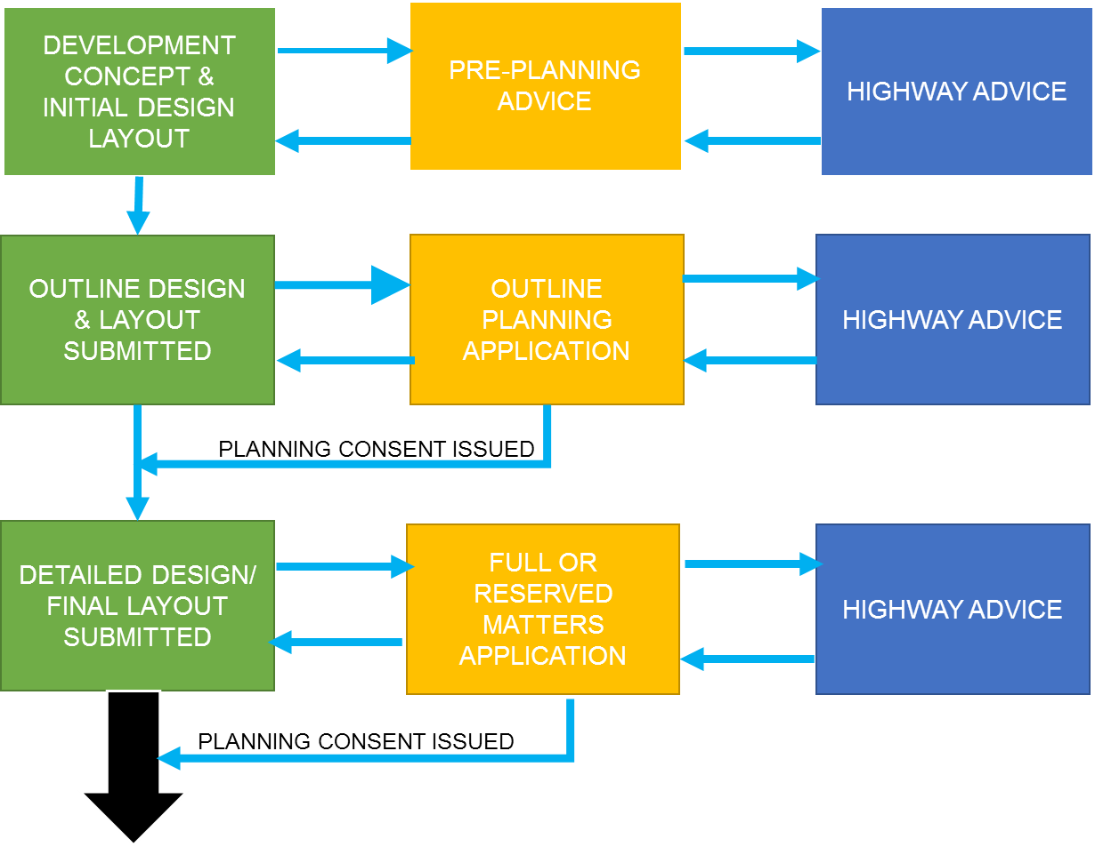

**STAGE 1**

**Start dialogue with Shropshire Council’s Street Works Team**

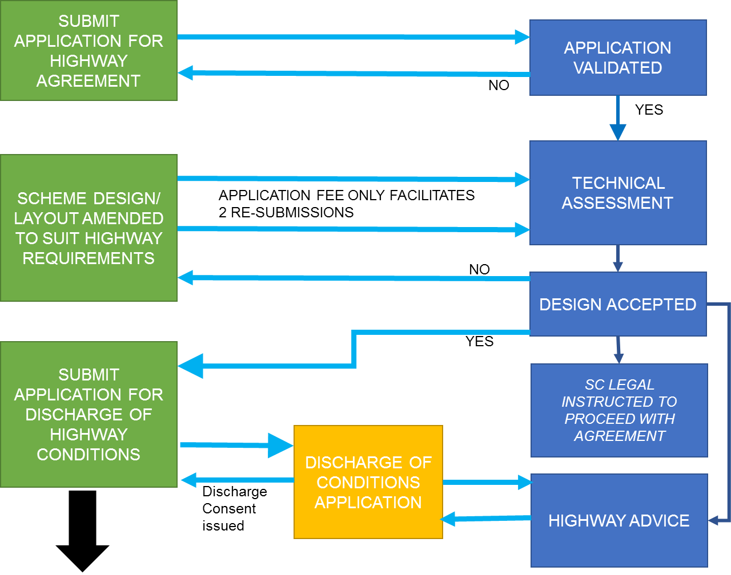

**Proceed to Legal Agreement**

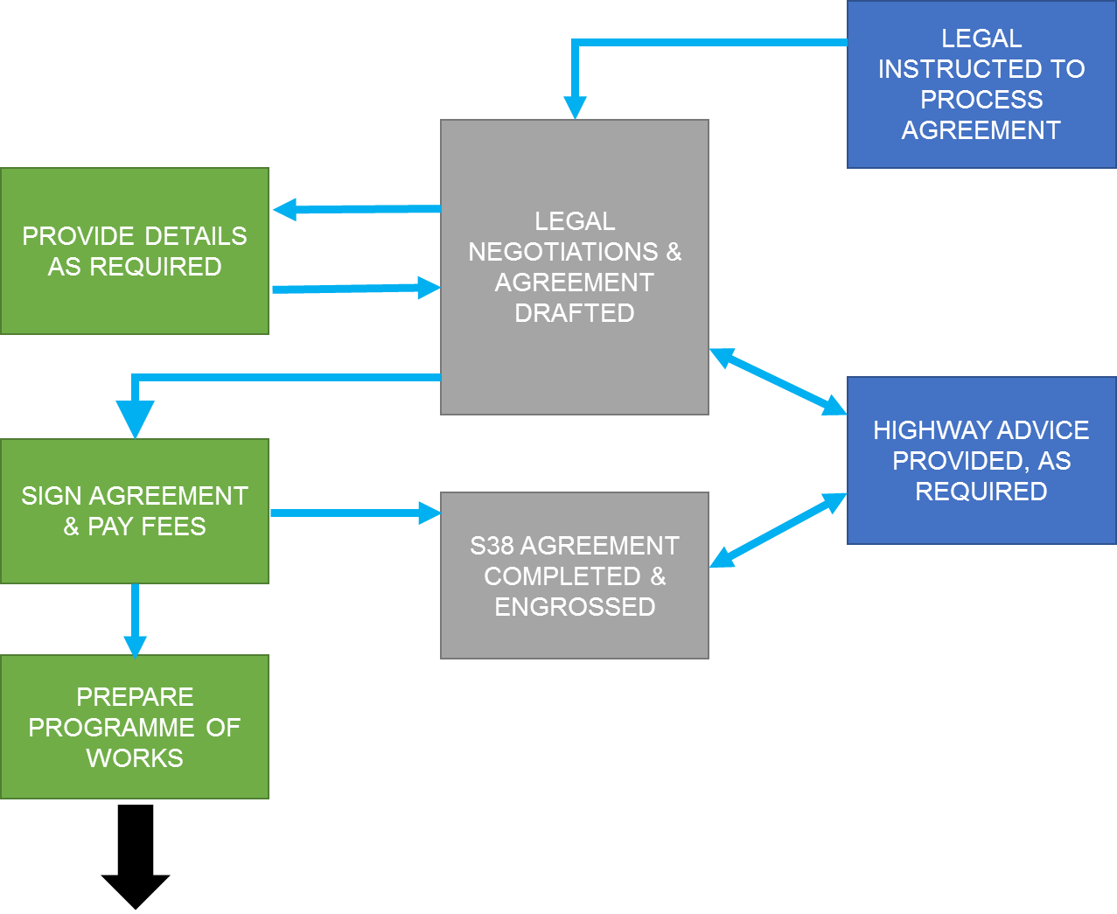

**STAGE 3**

**Legal Agreement**

**Proceed to Works Permitting**

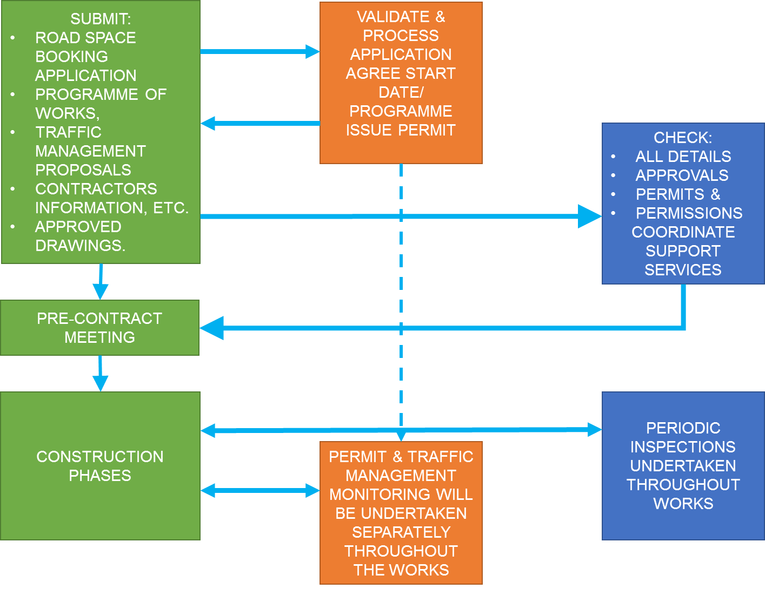

**STAGE 4**

**Works**

**STAGE 5**

**Works**

**Phases**

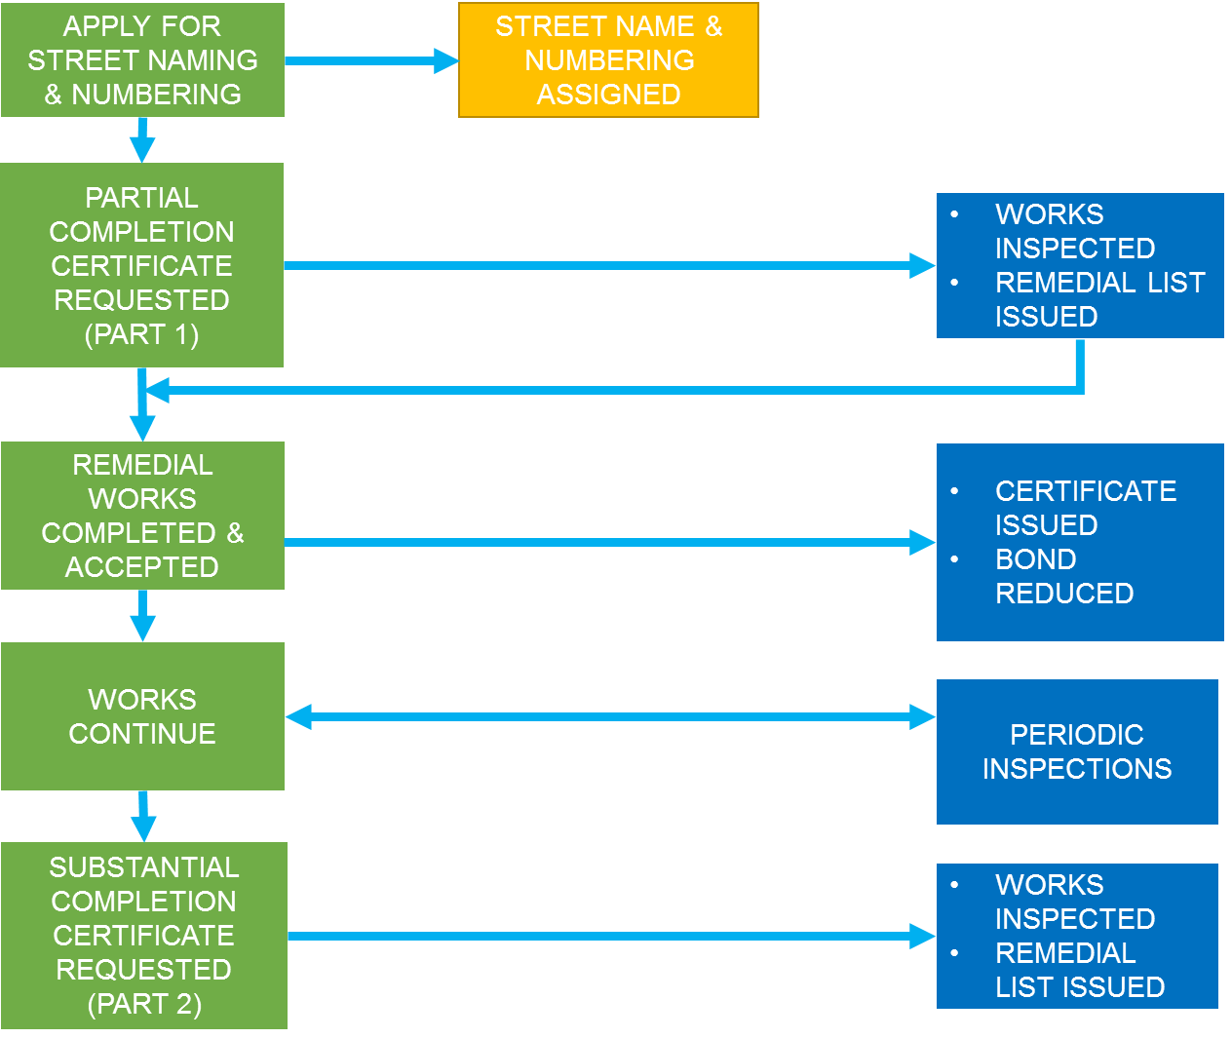

Elbow Connector 111, Shape

Straight Arrow Connector 102, Shape

**STAGE 6**

**Finishing Works and Highway Adoption**

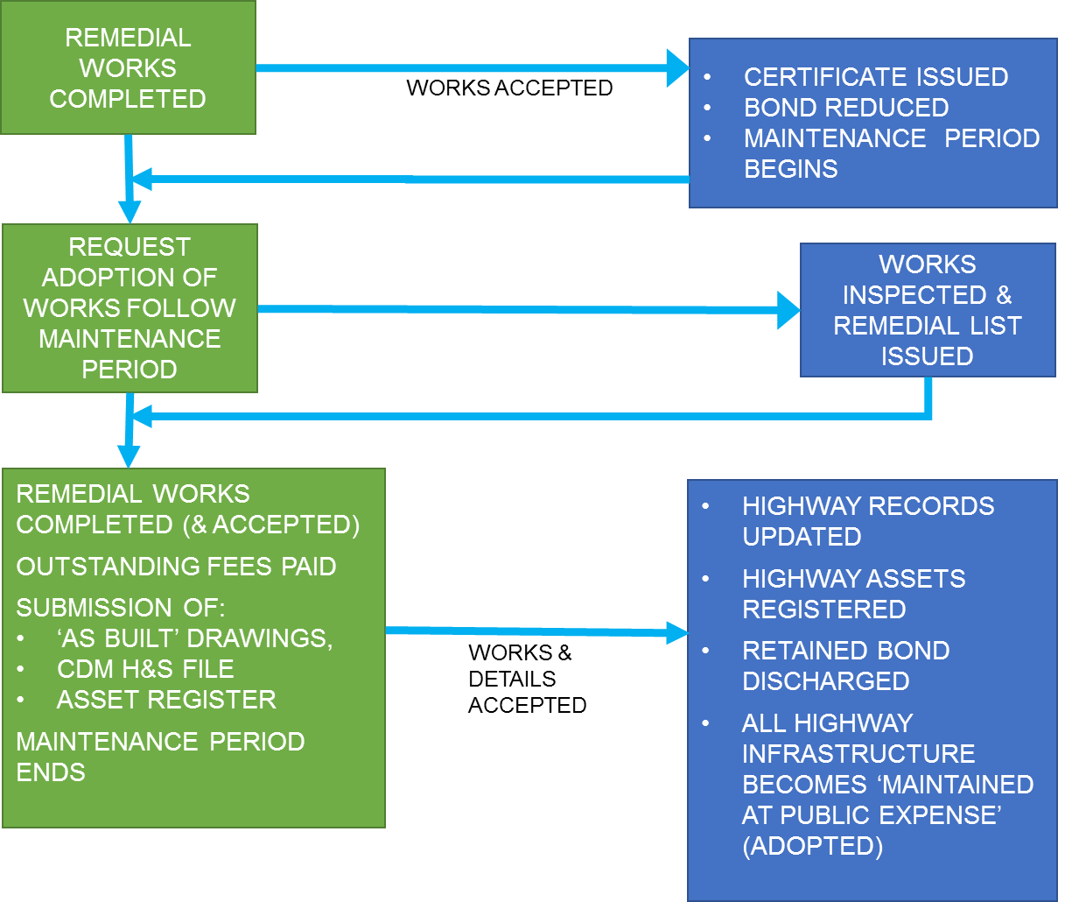

TN1.12. LIST OF DRAWINGS &   
DETAILS REQUIRED:

**Note: All drawings are to be submitted in PDF, AutoCAD & Printed formats)**

|  |  |
| --- | --- |
| **Location Plan** | A plan identifying the location of the site, site boundary, adjacent road names and nearest postcode. |
| **Planning Layout** | A copy of the approved planning layout plan and planning consent (inc. any conditions). |
| **Adoptable Area Plan** | Identify the limits of areas to be offered for adoption. S.38 elements to be tinted pink.  Buildings adjacent to the proposed adoption limits should allow 300mm for foundations and private drainage.  A copy of the existing adjoining adopted highway network should be submitted as basis of the technical drawings. |
| **Autotracks** | Using an ‘Econic 32’ refuse vehicle, all areas to be offered for adoption must be tracked.  All adoptable turning heads need to comply with the refuse vehicle and can manoeuvre within the adopted highway. |
| **Construction Programme** | Programme identifying the anticipated construction duration for all works to be adopted. |
| **Road Chainage & Numbers** | The carriageway chainage and road numbers (or identification) to be included on at least one drawing; plot numbers to also be stated. A drawing must also include dimensions where areas of the proposals are not as per any typical sections. |
| **Drainage/Contour Plan** | All proposed adoptable areas should be contoured at 25mm intervals including 10m past the tie in points to the existing highway, including all proposed gully locations. |
| **Private Drainage** | Spot levels and private drainage provision is required to demonstrate no surface water run-off onto adoptable areas. |
| **Discharge Consent (S104)** | Copy of confirmation from applicable drainage authority stating acceptance. |
| **Drainage Calculations** | Network & simulation results for all adoptable highway drainage systems with ‘Wallingford Procedure’ calculations. |
| **Visibility Splays** | Forward visibility and junction visibility to be included, stating ‘x’ and ‘y’ values. |
| **Longitudinal Section** | Section to indicate level information 10m beyond the design tie in. |
| **Pavement Layout Plan** | Plan identifying the type and extents of all pavement construction, key to match construction detail descriptions. |
| **Kerbing & Footways Plan** | Plan identifying the type, kerbface and limits of kerbing works proposed. Key to match construction detail descriptions. |
| **Tactile Paving** | All tactile paving to be in line with ‘DFT, Guidance on the use of Tactile Paving Surfaces’. |
| **Construction Details** | All features within the adopted highway should be depicted, including pavement construction, kerbing and drainage. |
| **Cross‐sections** | Appropriate cross‐section showing the existing landform is to be submitted together with topographical survey plan. |
| **Traffic Signing & Lining** | Where required sign details including foundation, post and sign face materials & white lining details and dimensions etc. |
| **Street Lighting** | A drawing identifying column locations and lantern type. and a ‘lux’ level plan and supporting calculations. |
| **Utilities** | Copies of all statutory undertakers’ apparatus plans identifying all new services, required diversions and ducting depths. |
| **Landscaping** | Location plan, tree species and planted size. Also, any tree pit, protection or watering system details. |
| **Structures** | Design drawings including rebar schedule, AIP or Design Certificates. |
| **Asset Inventory** | All assets and materials within adoption areas listed, specified and quantified (spreadsheet format). |
| **Bill of Quantities** | For bond calculation purposes. |

TN1.13. SECTION 38 – APPLICATION FORM

APPLICATION TO ENTER INTO AN AGREEMENT UNDER

SECTION 38 – HIGHWAYS ACT 1980

|  |  |  |  |  |  |  |  |  |  |  |
| --- | --- | --- | --- | --- | --- | --- | --- | --- | --- | --- |
| ***For office use only***   |  |  | | --- | --- | | **Date application received:** | **__________________** | | **IDOX system input date:** | **__________________** | | **Allocated Agreement Number** | **__________________** | | | | | |
| **Notes to be read by applicant:**  **Prior to completing this application form, the applicant should read Technical Note 1 – How to secure a Section 38 Agreement, part of the Shropshire Manual for Adoptable Roads & Transport - SMART, which precedes this application form. Please note there is a £5,000 application fee.**  **Link to this form xxxxxxx**  **The applicant is requested to complete this form in BLOCK CAPITALS and send to Developing Highways Team, Shropshire Council, Shirehall, Abbey Foregate, Shrewsbury, SY2 6ND or email to** [**highwayagreements@shropshire.gov.uk**](mailto:highwayagreements@shropshire.gov.uk) | | | | |
| 1. **Name and address of development** | | | | |
| **OS Grid ref** | | | | |
| **2. Name and registered address of developer** | | | | |
| Tel | Email | | | |
| **3. Name and address of agent where correspondence should be sent** | | | | |
| Tel | Email | | | |
| **4.Name and address of solicitor acting on behalf of the developer** | | | | |
| Tel | Email | | | |
| **5. A bond is normally required to the value of the adoptable highway works subject to approval by Shropshire Council. Name and address of bondsman /surety or state CASH if cash deposit to be made.** | | | | |
| Tel | Email | | | |
| **6. Name and Address of principal contractor** | | | | |
| Tel | Email | | | |
| **7. Planning permission reference numbers:** | | | | |
| **8. Estimated construction costs for adoptable roads** | | | | |
| **9. Approximate date the highway construction will start:** | | | | |
| **10. Approximate period of overall scheme construction (not just road construction):** | | | | |
| **11. Have you received building regulation approval for the scheme;** | | | | |
| Shape**YES** | | Shape**NO** | | |
| **12. Has a payment been made to Shropshire Council under the Advance Payment Code (APC) of the Highways Act 1980** | | | | |
| Shape**YES** | | Shape**NO** | | |
| **13. Give APC reference number & date - if an APC deposit has been made** | | | | |
| **14. Proof of ownership of the land and landowner’s name, company number  and address (if different from developer).** | | | | |
| **15. Nature of the development (e.g. supermarket with associated parking).** | | | | |
| **16. Is the development subject to a S106 planning agreement?** | | | | |
| **17. Construction, Design and Management (CDM) Regulations 2015**  The design, construction and management of highways subject to a road adoption (S38) or Highway Works (S278) Agreement are likely to fall within the scope of the CDM Regulations (2015). The Agreement requires formal identification of the individual nominated by the Developer as the CDM Coordinator/Site Supervisor, and places an obligation upon the Developer to inform the Council in the event that the named individual is replaced. | | | | |
| **18. Is it your intention to have Shropshire Council design the street lighting?** | | | | |
| Shape**YES** | | Shape **NO** | | |
| **19. Is the development to be constructed in phases?** | | | | |
| Shape**YES** | | Shape **NO** | | |
| If Yes please attach dates for each phase and attach phasing plan | | | | |
| **20. Will there be a Section 104 Agreement (or other agreement) with the Water Authority for adoption of the sewers on site**   1. **Foul Water Sewers** | | | | |
| Shape**YES** | | | Shape**NO** | |
| 1. **Surface Water Sewers** | | | | |
| Shape**YES** | | | Shape**NO** | |
| If the answer to a or b above is **no** please state the proposed alternative drainage arrangements; | | | | |
| **21. Are there likely to be any lengths of highway drain or soakaway?** | | | | |
| Shape**YES** | | | Shape**NO** | |
| If yes, are they to be proposed for adoption by this Council as Highway Authority? | | | | |
| Shape**YES** | | | Shape**NO** | |
| If yes - give brief details  (i.e. number and type of soakaways and approximate length of proposed  highway drain) | | | | |
| **22. Will a surface water easement be required (to be granted by the freehold owners of the land).** | | | | |
| **23. Structures**  Are there likely to be any other structures to be proposed for adoption as part of the highway (Inc. retaining or supporting walls, oversized pipes or culverts, either in or adjacent to the proposed Highway.)  If so please give brief details | | | | |
| **24. Are there any works proposed on an existing highway requiring a S278 Agreement?**   |  |  | | --- | --- | | Shape**YES** | Shape**NO** | | **If yes, please continue to Section 25 If no, please continue to Section 25** | | | | | | |
|  | |  | | |
| **25. Do the S278 works need to be in place before the new development commences?** | | | | |
| Shape**YES** | | Shape**NO** | | |
| **26. Do the Section 278 Works need to be in place before occupation?** | | | | |
| Shape**YES** | | Shape**NO** | | |
| **27. Is there an existing access that can be used to construct the new development prior to completion of the agreement?** | | | | |
| Shape**YES** | | Shape**NO** | | |
| **28.Brief description of additional highway works proposed:** | | | | |
|  | | | | |
| **29. Has a temporary access license (S184) been issued to facilitate the construction of the new development?** | | | | |
| Shape**YES** | | Shape**NO** | | |
| **30. Have the works been subject to a Stage 1/2 Safety Audit?** | | | | |
| **YES** | | Shape**NO** | | |
| **31. Application Checklist**  **Ensure the following are included with your application**: **X** | | | | |
| Application form fully completed and signed | | | |  |
| Detailed plan of proposal clearly showing the proposed location | | | |  |
| General layout drawing showing carriageway and footway design | | | |  |
| Layout drawings showing design of foul and surface water sewers: | | | |  |
| Drawings showing extents of highway to be adopted or modified. | | | |  |
| Specific detail including dimensions of proposed access crossing (see example) | | | |  |
| Longitudinal and cross-sections relating to layout drawings in 1 and 2 above, showing proposed and existing levels, gradients, and ‘K’ values vertical curves. | | | |  |
| Drawing(s) showing construction details, typical sections and specifications | | | |  |
| Drawing(s) showing proposed traffic signs and road markings | | | |  |
| Drawings and calculations showing your detailed proposals for the provision of street lighting | | | |  |
| Drawings showing detailed proposals of any provision of signalised crossings or junctions for the scheme, including full design calculations. | | | |  |
| Registered title from Land Registry Office indicating freehold ownership. | | | |  |
| **32. Declaration:**  I/We hereby apply to enter into a Section 38 Agreement with Shropshire Council for works in connection with the above planning permission.  I/We have read the notes attached to this form and agree to comply with these requirements contained therein.  If the Section 38 works commence in advance of completion of the agreement it is possible that Shropshire Council will be unable to adopt the works or will require extensive alterations prior to adoption.  Signature: Date:  Print Name: | | | | |

SMART

TECHNICAL NOTE TN2

[**How to SECURE a   
Section 184 Agreement**](https://www.shropshire.gov.uk/media/4270/s184-application-form-rev-b.doc)**\***

*Pre-written documents already   
available on SC website

**This document is part of the “Shropshire Manual   
for Adoptable Roads & Transport” (SMART) and  
 should be read in conjunction with all   
other appropriate documents.**

SMART

TECHNICAL NOTE TN3

**HOW TO secure a   
SECTION 278 AGREEMENT**

**This document is part of the “Shropshire Manual   
for Adoptable Roads & Transport” (SMART) and  
 should be read in conjunction with all   
other appropriate documents.**

Table of Contents

SMART TECHNICAL NOTE TN3 133

TN3.1. INTRODUCTION 133

TN3.2. BACKGROUND 133

TN3.3. PROCEDURE 134

TN3.4. STAGE 1: PLANNING 134

TN3.5. STAGE 2: TECHNICAL ASSESSMENT 135

TN3.6. STAGE 3: LEGAL AGREEMENT 137

TN3.7. STAGE 4: CONSTRUCTION & INSPECTION 137

TN3.8. STAGE 5: WORKS COMPLETION & HIGHWAY ADOPTION 138

TN3.9. S278 AGREEMENT PROCESS MAP 139

TN3.10. LIST OF DRAWINGS AND DETAILS REQUIRED 143

TN3.11. S278 AGREEMENT APPLICATION FORM 145

TECHNICAL NOTE TN3

HOW TO SECURE A SECTION 278 AGREEMENT

TN3.1. INTRODUCTION

1. This document is intended to guide a developer through the process of making a successful application and completing a Section 278 Agreement (Highways Act 1980) for works within the existing highway and where new public highway is created. This is to ensure that the responsibility for its future maintenance can be transferred to Shropshire Council, as Local Highway and Street Works Authority.
2. This document should be read in conjunction with the Shropshire Manual for Roads & Transport (SMART) suite of documents. This will give further detailed explanation of the local principles, best practice and legal requirements to be considered when seeking to undertake works within the existing public highway, as part of a prospective new residential or industrial development, where a new or modified vehicular or pedestrian access is required.

TN3.2. BACKGROUND

1. Shropshire Council is the Highway Authority for all *highways* in Shropshire, whether or not maintainable at the public expense, except for *trunk roads* for which the Highway Authority is Highways England.
2. This document specifically considers the **Section 278 (HA1980) Agreement** process used by Shropshire Council, which is the preferred mechanism required for a developer to undertake works within the publicly maintained highway.
3. Definition of principal roles used in this document (a further glossary of terms & acronyms is available in the Appendices)

* The **Council** refers to Shropshire Council as Unitary Authority and
* **Shropshire Highways** refers to the team carrying out ‘Local Highway Authority’ duties.
* **Development Management** refers to the team carrying out the Local Planning Authority duties.
* **Developer** refers to the landowner/organisation/person promoting the development
* **Contractor** refers to the organisation carrying out the S278 works on   
  behalf of the Developer

TN3.3. PROCEDURE

S

M

A

R

T

1. A process map illustrating this procedure can be found in Section TN3.9 of this Technical Note.
2. The developer must enter into a Section 278 Agreement if there is any intention to undertake works within an existing public highway. This will include: all road junctions and connections, carriageway and kerb realignment, verge, footway or cycleway works, street lighting changes and any traffic management works (i.e. traffic signal controls, speed limit changes, waiting restrictions, traffic calming measures, etc.)
3. If the proposed works are limited to just a simple vehicular connection to the existing public highway (i.e. footway/verge crossing or minor junction bellmouth), then the Council may allow this part of the works to be undertaken by means of a Section 184 Agreement (see Technical Note 2 of SMART) or included within any Section 38 Agreement process, if the development is to be adopted.
4. It is strongly recommended that should there be an intention to make material changes to an existing public highway to support and/or facilitate a proposed new development, then at an early stage in the development management process, direct contact should be made with the Shropshire Developing Highways Team.
5. Early liaison will ensure that any development works can be suitably co-ordinated, along with any future programmed highway schemes proposed within the immediate vicinity of the site, to minimise the impact on the general public.
6. The developer should review all relevant guidance and policies to establish the appropriate design criteria and specifications appropriate to the design of an acceptable junction layout and drainage strategy. The following suggested reading list is not exhaustive and the designer should review the most up to date guidance/best practice currently available;

* Design Manual for Roads & Bridges
* Manual for Streets 1 and 2
* Shropshire Manual for Adoptable Roads & Transport (SMART)

1. **Any proposed departure from ‘standard’ must be identified and demonstrated** **to fulfil the requirements of the scheme and location.**

TN3.4. STAGE 1: PLANNING

1. It is strongly recommended that the developer enters into pre-planning discussions with both Development Management and Shropshire Highways, prior to submitting any planning application. This is to ensure that the developer follows the appropriate best practice guidance and required specifications that will ensure that any alterations and additions to the existing highway infrastructure can be ultimately maintained at public expense (adopted), once the work has been completed.
2. Shropshire Highways, as a specialist statutory consultee within the planning application process, will make reference to the highway legal agreement process, as well as appropriate compliance with local/national policies, specifications and best practice.
3. Any highway design submitted as part of the planning application process will need to be supported by an appropriate Road Safety Audit in accordance with HD19/15 (DMRB) unless otherwise agreed.
4. Any proposed details or layouts submitted which do not accord with the relevant highway guidance, (without prior approval), will be recommended for refusal or result in specific conditions being added to any planning consent, or a requirement for the works to be included within a Planning Obligation Agreement (S106 – TCPA 1990). This will ensure compliance with the appropriate highway agreement requirements.
5. Where development proposals are submitted, which have not previously been considered by Shropshire Highways in respect to their compliance with the appropriate highway criteria, then significant alterations and amendments may be subsequently recommended. This may result in delays in any subsequent grant of planning consent.
6. Alternatively, where consent has been granted but compliance with the planning obligations, conditions or highway adoption criteria cannot be met without significant alteration to the proposed layout, then a variation and/or amendment planning applications will have to be submitted. This may result in delays in the progress of the development and/or the highway agreement process.
7. It is strongly recommended that an application for the Discharge of Highway Conditions should not be made until a formal Section 278 submission has been technically approved. The technically approved drawings can then be used for the discharge of highway conditions to avoid undue delays in the planning process.
8. In addition, the developer should make initial contact with Shropshire’s Street Works Team, who administrate the West & Shires Permit Scheme (WASPS), in order to facilitate discussion in respect of securing appropriate road-space allocation within the proposed scheme programme. The Street Works Team will ensure that any traffic management requirements within the existing public highway can be considered and agreed, so that the appropriate permits and/or licences can be issued to allow the developer’s contractor to work within or adjacent to the existing highway.

TN3.5. STAGE 2: TECHNICAL ASSESSMENT

1. The developer should submit their proposed S.278 detailed design, together with a completed application form and checking fee, to Shropshire Highways at the earliest opportunity following ‘outline’ or ‘full’ planning consent. The submission should be generally in accordance with that approved as part of the planning process. This will ensure that the proposed highway design & layout can be technically assessed and highway approval considered, concurrent with a ‘reserved matters’ application or to enable a ‘discharge of conditions’ consent to be issued.
2. The detailed submission to Shropshire Highways must be accompanied by the following items:

* Application form (completed);
* Two full sets of detailed design drawings;
* Transport Assessment and Junction Modelling (as appropriate);
* Road Safety Audit - Stages 1 and/or 2 (as appropriate);
* Extent of existing highway, local constraints and utility information;
* Land Registry Title for any land to be transferred to the Council (adopted);
* Planning Consent – identifying any appropriate highway related planning conditions;
* Section 106 Agreement (or Unilateral Undertaking) – identifying any appropriate highway planning obligations, including any specific timings for delivery of works.

1. If a S.278 submission is made without the completed application form, checking fee, or with missing details/plans, etc. the submission will be immediately rejected and the developer informed. **(Note: no further consideration will be given to the proposed works until such time as all the required information has been submitted.)**
2. When an appropriate S.278 agreement submission package has been received and accepted by Shropshire Highways, a technical review of the proposed scheme will be undertaken. Within 30 working days of receipt of the validated package the developer will be informed of the outcome of this technical review
3. If the details are considered to be acceptable:

* Shropshire Highways will issue formal technical acceptance of the details to the developer, together with instruction on how to proceed to the next stage of the process. This will include details of the bond sum, any commuted sums and any other fees & charges (including any discounts), as well as any other requirements necessary to facilitate the making and completion of a   
  S.278 agreement.

1. If the details are not considered to be acceptable:

* The developer shall be informed of the unacceptable items accordingly;
* The developer may, within six (6) weeks, undertake any appropriate amendments and resubmit the whole package of drawings so that a further technical assessment can be made.
* Shropshire Highways reserves the right to charge additional checking fees, as appropriate, to cover the additional costs of specialist assessments such as structures.
* If the developer fails to re-submit amended details or outstanding items required to facilitate the S.278 application within a reasonable period following the issue of any technical review report (i.e. 4 months), the corresponding S.278 file will be closed. Any re-submission of details thereafter will be considered to be a new S.278 Agreement application, and a whole new package together will have to be made to Shropshire Highways.

TN3.6. STAGE 3: LEGAL AGREEMENT

1. Following the issue of technical acceptance, it is recommended that the developer submits the required two (paper) sets of approved drawings, together with an appropriate electronic copy, as well as any other additional details required, as soon as practicable.
2. Upon receipt of these details/drawings the Council’s Legal Team will be instructed to prepare the S.278 Agreement.
3. The Legal Team will thereafter liaise directly with the developer and their legal representative, as required, until the S.278 Agreement is engrossed, signed and completed. It should be noted that this part of the process can become protracted and can take a significant time to complete. This is particularly so, if the information supplied changes and/or is legally challenged.
4. Should a developer and/or their legal representative seek changes to the wording and clauses of the S278 agreement, this would only serve to delay the process as Shropshire Council’s model S278 agreement is based upon, and fully complies with, the Law Society’s industry standard model S278 agreement, which is used by all local authorities nationwide. Changes to this agreement will only complicate, or damage the protections afforded to all parties built into the agreement. Furthermore, it is likely that additional fees & charges will have to be applied to cover the additional work undertaken.

**Construction will not be allowed to begin within the public highway before the S.278 Agreement is completed, especially if technical acceptance has not been issued.**

**A temporary ‘street works permit’ may be issued to facilitate some limited accommodation or utility works as long as it has been previously agreed with Shropshire Highways.**

**Any construction works within the public highway without formal consent or authority will be considered to be ‘obstruction’ of the highway under Section 137 of the Highways Act 1980, and enforcement action will be taken, followed by any appropriate criminal proceedings, as necessary.**

TN3.7. STAGE 4: CONSTRUCTION   
& INSPECTION

1. At least one month before the highway work commences, the developer will contact the Council to arrange a pre-start meeting, in order to introduce the appropriate nominated parties (inc. CDM Principal Designer, Principal Contractor, sub-contractor, site manager, Council representative/inspector, etc.)
2. The developer or principal contractor shall provide a detailed programme of works, keep the Shropshire Highways representative up to date with any construction slippage and/or arrange appropriate periodic inspections as well as review testing results, throughout the build process. (see below)
3. The Council’s representative shall, as part of the periodic inspections, be given access to all parts of the works, material certificates and testing results, when requested.
4. The full cost of normal supervision/inspection of the works is included within the standard S.278 Agreement fee calculation.
5. Where supervision is required over a protracted period or many visits are required to monitor activities, the Council reserves the right to recover any additional costs incurred from the developer.
6. The developer will be considered to be in contravention of the Section 278 Agreement if the time stated in the Agreement for the issue of Completion Certificates has elapsed, (inc. agreed extensions), or the works are not completed to the Council’s satisfaction.
7. Subsequently, the developer will be informed of the contravention and the Surety will be issued with a Default Notice.

**It should be clearly understood that the Council’s representative acts solely for the Local Highway Authority and must not be regarded as the ‘Clerk of Works’ acting for the contractor. The contractor must have a named representative on site whilst work is in progress who the Council’s representative can liaise with.**

**All bituminous material delivery tickets shall be made available for checking by the site inspector. Failure to comply with this requirement may result in the contractor being asked to undertake testing by a UKAS approved laboratory, at their own expense.**

TN3.8. STAGE 5: WORKS COMPLETION   
& HIGHWAY ADOPTION

1. On issue of the Provisional Certificate of Completion, the works will be considered to be on ’maintenance’ with the developer being responsible for the upkeep of the whole works (including street lighting electricity costs) for the period agreed by the Council, usually twelve months.
2. The developer may, on completion of the maintenance period and following the submission of ‘as built’ plans, satisfactory Road Safety Audit (Stages 3 & 4), Health & Safety File (CDM), updated Asset Register, together with the payment   
   of any outstanding fees and commuted sums, request the Council to adopt   
   the works
3. The Council shall inspect the works and within 28 days of the request will:

* Inform the developer that the works are unsatisfactory and supply a list of remedial works required, or:
* Issue the Final Certificate to the developer, subject to receipt of up-to-date title indicating the freehold ownership of the land to be dedicated evidencing the developer’s compliance with the terms and obligations of the Section 278 Agreement. Only then will the retained monies, surety and/or bond associated with the S.278 Agreement be discharged/returned.

1. The works have now been adopted as public highway and shall be maintained thereafter at public expense.

TN3.9. S278 AGREEMENT PROCESS MAP

1. The following process map is a simplified linear representation of the optimum Section 278 Agreement process, as discussed in detail above.
2. The actions/activities are colour coded to provide clarity between those parties involved:

**ACTION RESPONSIBILITY**

DEVELOPER (or their agent)

**HIGHWAY DEVELOPMENT CONTROL** (SC)

DEVELOPMENT MANAGEMENT (SC)

LEGAL SERVICES (SC)

STREET WORKS TEAM (SC)

**STAGE 1**

PLANNING

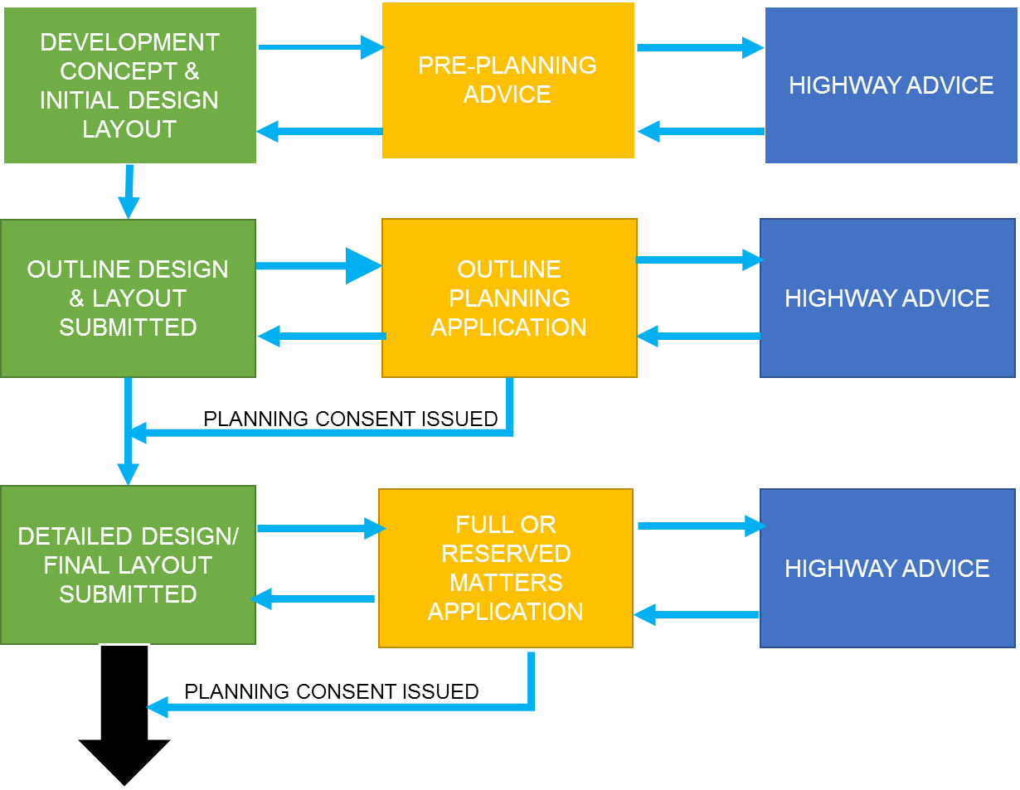

OUTLINE DESIGN & LAYOUT SUBMITTED to include any proposed works on highway

HIGHWAY ADVICE to include suitability of proposals to mitigate impact on the highway

**Start dialogue with Street Works Team**

**STAGE 2**

TECHNICAL ASSESSMENT

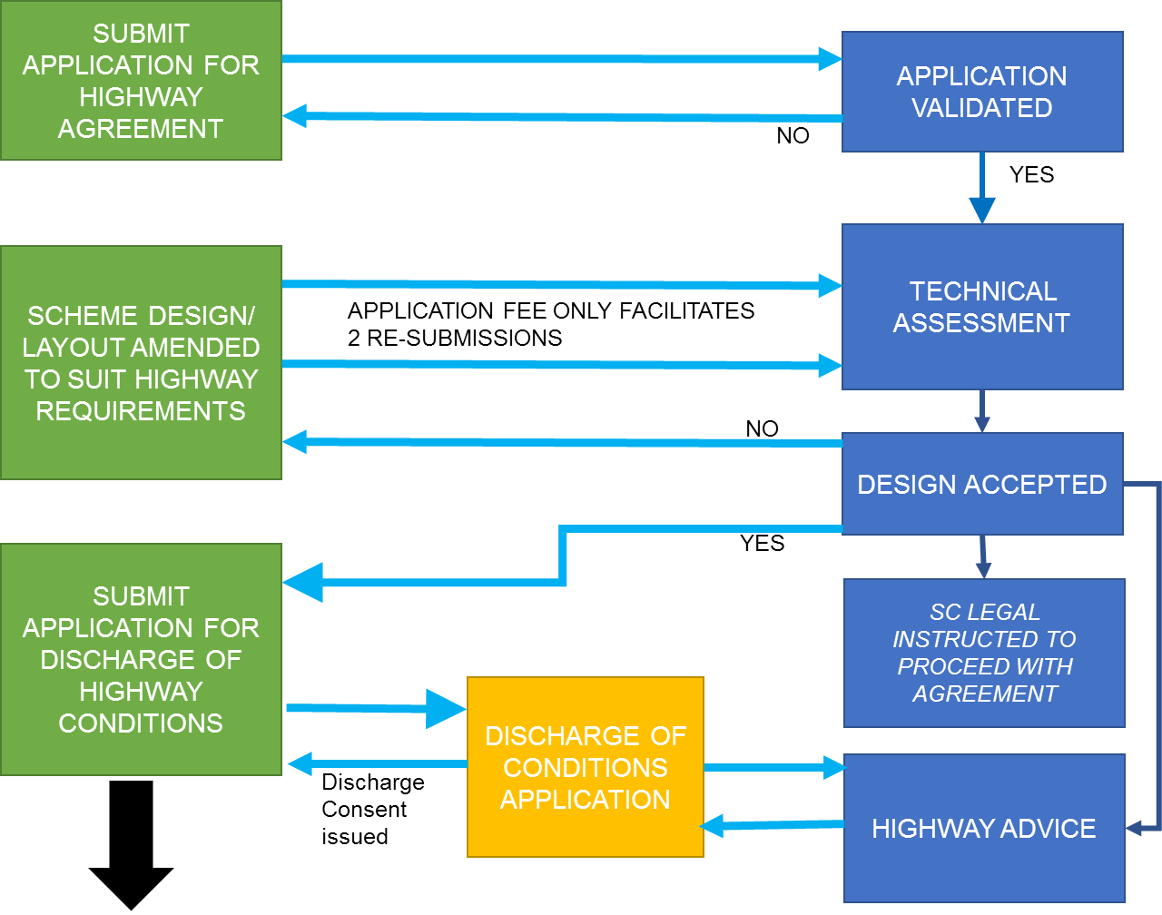

**Proceed to Technical Assessment**

**STAGE 3**

LEGAL AGREEMENT

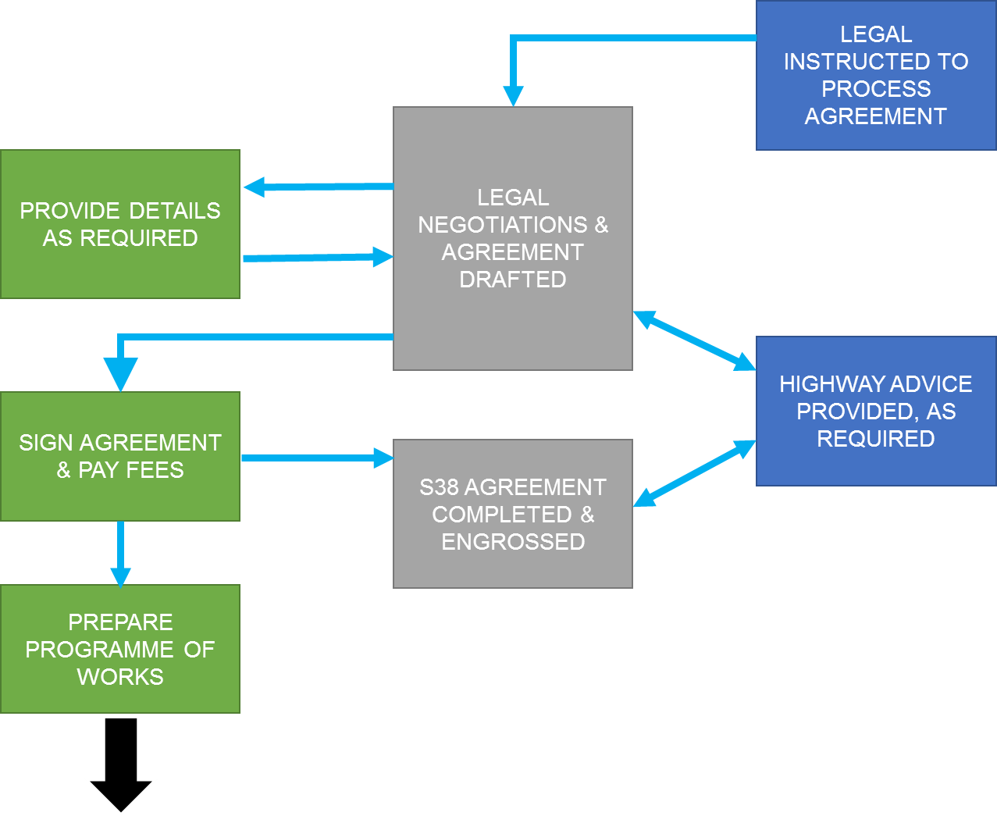

S278 AGREEMENT COMPLETED & ENGROSSED

**Proceed to Permitting & Construction**

**STAGE 5**

WORKS COMPLETION & ADOPTION

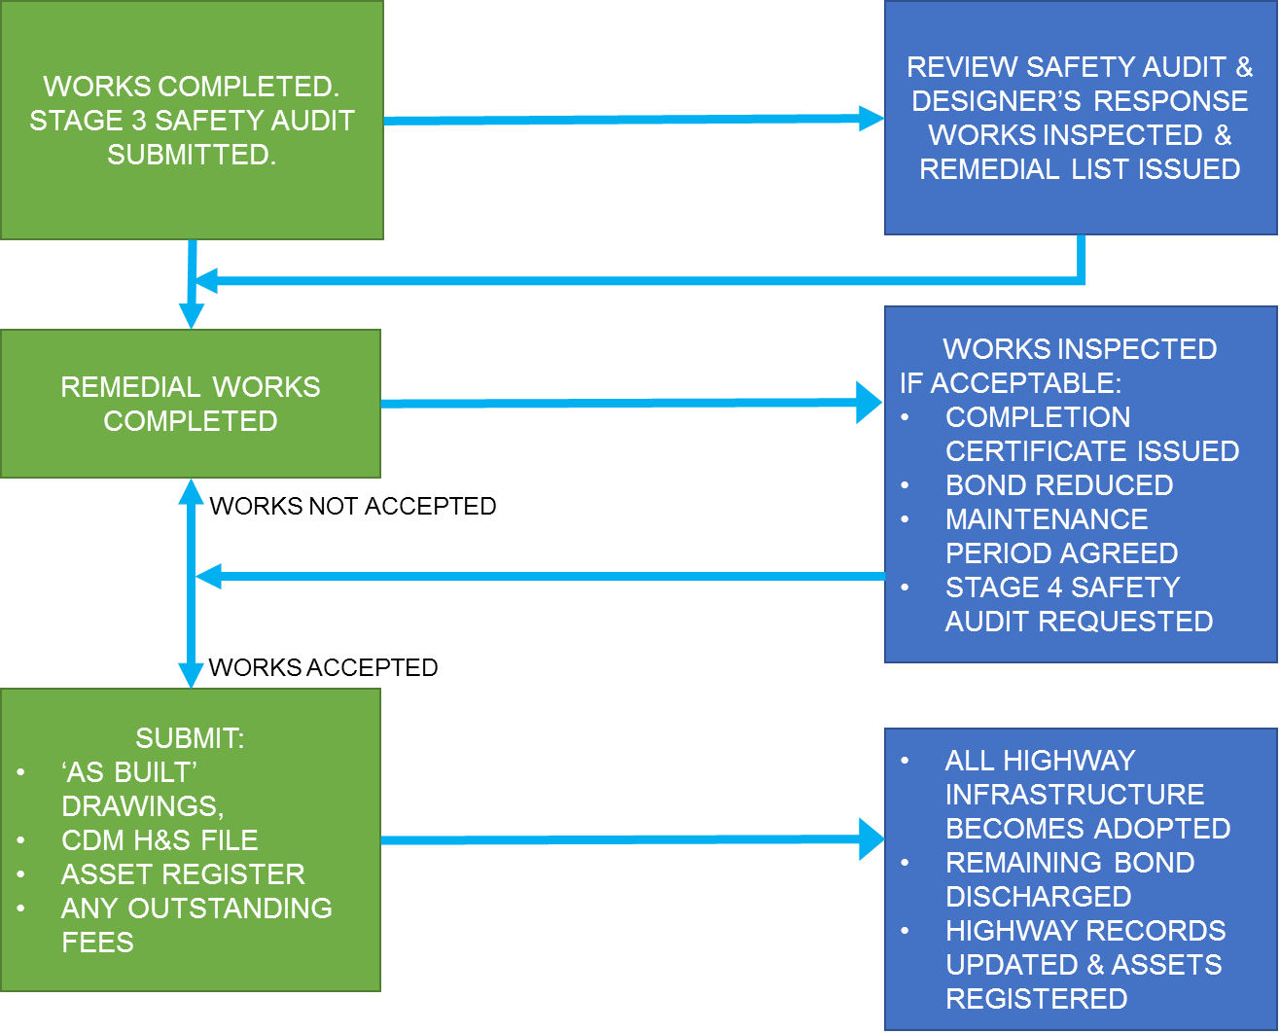

**STAGE 4**

COMMENCING WORKS

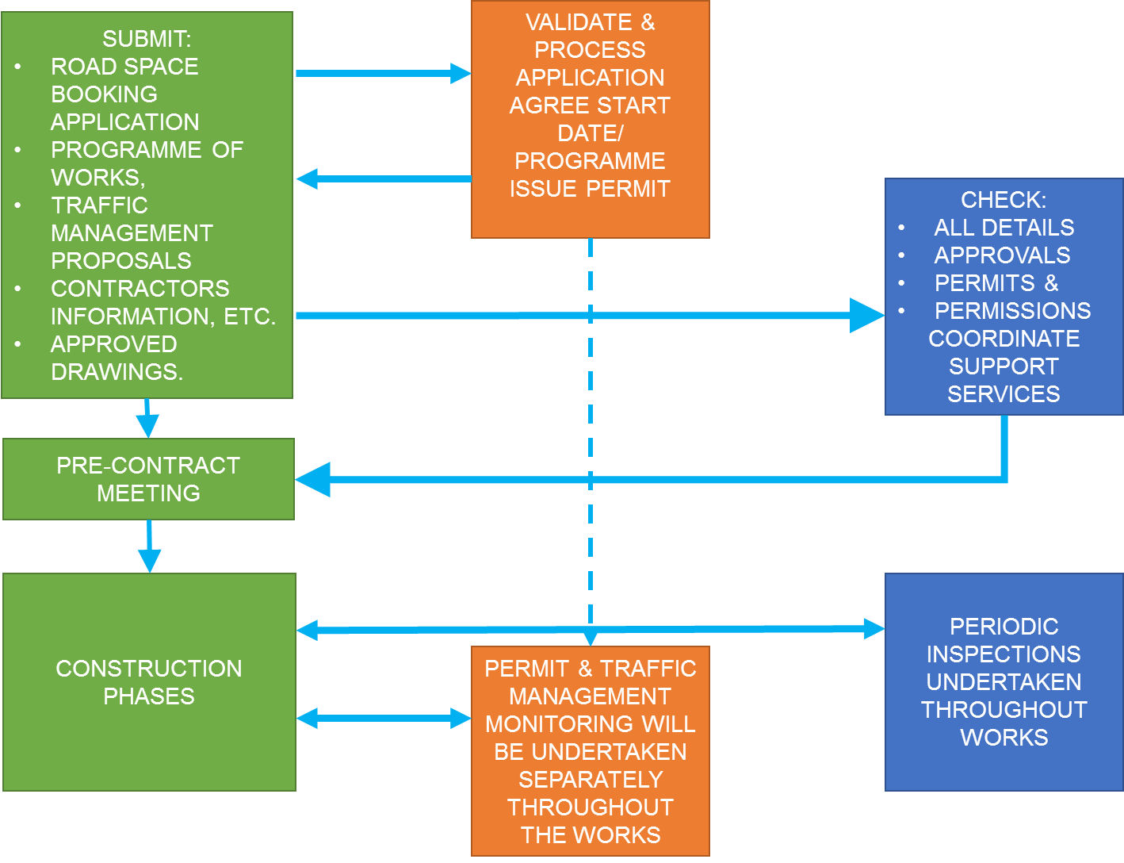

TN3.10. LIST OF DRAWINGS AND DETAILS REQUIRED

(Note: All drawings are to be submitted in PDF, AutoCAD & Printed formats)

|  |  |
| --- | --- |
| **Location Plan** | A plan identifying the location of the site, site boundary, adjacent road names and nearest postcode. |
| **Planning Layout** | A copy of the approved planning layout plan and planning consent (inc. any conditions) |
| **S278 Plan** | Identifying areas to be included in Section 278 Agreement. Area to be tinted pink, with existing Highway to be edged red. Land to be dedicated coloured pink or identified as appropriate.  Buildings adjacent to the proposed adoption limits should allow 300mm for foundations and private drainage.  A copy of the existing adjoining adopted highway network should be submitted as basis of the technical drawings |
| **Autotracks** | Using an ‘Econic 32’ refuse vehicle all areas subject to S278 must be tracked to ensure vehicles can manoeuvre within the adopted highway following the changes. |
| **Construction Programme** | Programme identifying the anticipated construction duration for all works to be completed. |
| **Road Chainage & Numbers** | The carriageway chainage and road numbers (or identification) to be included on at least one drawing; plot numbers to also be stated. A drawing must also include dimensions where areas of the proposals are not as per any typical sections |
| **Drainage/Contour Plan** | All proposed adoptable areas should be contoured at 25mm intervals including 10m past the tie in points to the existing highway, including all proposed gully locations. |
| **Private Drainage** | Spot levels and private drainage provision is required to demonstrate no surface water run-off onto adoptable areas |
| **Discharge Consent (S104)** | Copy of confirmation from applicable authority stating acceptance. |
| **Drainage Calculations** | Network & simulation results for all adoptable highway drainage systems with ‘Wallingford Procedure’ calculations |
| **Visibility Splays** | Forward visibility and junction visibility to be included, stating ‘x’ and ‘y’ values. |
| **Longitudinal Section** | Section to indicate level information 10m beyond the design tie in. |
| **Pavement Layout Plan** | Plan identifying the type and extents of all pavement construction, key to match construction detail descriptions. |
| **Kerbing & Footways Plan** | Plan identifying the type, kerbface and limits of kerbing works proposed. Key to match construction detail descriptions. |
| **Tactile Paving** | All tactile paving to be in line with ‘DFT, Guidance on the use of Tactile Paving Surfaces’. |
| **Construction Details** | All features within the adopted highway should be depicted, including pavement construction, kerbing and drainage. |
| **Cross‐sections** | Appropriate cross‐section showing the existing landform is to be submitted together with topographical survey plan |
| **Traffic Signing & Lining** | Where required sign details inc. foundation, post and sign face materials & white lining details and dimensions etc. |
| **Street Lighting** | A drawing identifying column locations and lantern type. & a ‘lux’ level plan and supporting calculations. |
| **Utilities** | Copies of all statutory undertakers’ apparatus plans identifying all new services, required diversions and ducting depths |
| **Landscaping** | Location plan, tree species and planted size. Also any tree pit, protection or watering system details |
| **Structures** | Design drawings including rebar schedule, AIP or Design Certificates. |
| **Asset Inventory** | All assets and materials within adoption areas listed, specified and quantified (spreadsheet format) |
| **Bill of Quantities** | For Bond calculation purposes |

TN3.11. S278 AGREEMENT APPLICATION FORM

APPLICATION TO ENTER INTO AN AGREEMENT UNDER

THE HIGHWAYS ACT (1980) - SECTION 278

|  |  |  |  |  |  |  |  |  |  |  |
| --- | --- | --- | --- | --- | --- | --- | --- | --- | --- | --- |
| ***For office use only***   |  |  | | --- | --- | | **Date application received:** | **__________________** | | **IDOX system input date:** | **__________________** | | **Allocated Agreement Number** | **__________________** | | | | | |
| **Notes to be read by applicant:**  Prior to completing this application form, the applicant should read the general conditions and guidance notes outlined in TN3 “How to secure a Section 278 Agreement” of SMART which precedes this form. Email to: [highwayagreements@shropshire.gov.uk](mailto:highwayagreements@shropshire.gov.uk)  **Please note there is a £5,000 application fee.**  **Link to this form xxxxxxx** | | | | |
| 1. **Name and address of development** | | | | |
| **OS Grid ref** | | | | |
| 1. **Name and registered address of developer** | | | | |
| Tel | Email | | | |
| **3. Name and address of agent where correspondence should be sent** | | | | |
| Tel | Email | | | |
| **4.Name and address of solicitor acting on behalf of the developer** | | | | |
| Tel | Email | | | |
| **5. Name and address of bondsman /surety** | | | | |
| Tel | Email | | | |
| **6. Name and Address of principal contractor** | | | | |
| Tel | Email | | | |
| **7. Planning permission reference numbers:** | | | | |
| **8. Proposed date for highway construction to start:** | | | | |
| **9. Approximate period of the overall construction of the full Development  (not just the S278 works):** | | | | |
| **10. Proof of ownership of the land** | | | | |
| **11. Construction, Design and Management (CDM) Regulations 2015**  The design, construction and management of highways subject to a road adoption (S38) or Highway Works (S278) Agreement are likely to fall within the scope of the CDM Regulations (2015). The Agreement requires formal identification of the individual nominated by the developer as the CDM Coordinator/ site supervisor, and places an obligation upon the developer to inform the Council in the event that the named individual is replaced. | | | | |
| **12. Is it your intention to have Shropshire Council design the street lighting?** | | | | |
| Shape**YES** | | Shape**NO** | | |
| **13. Have all utility companies and service connections/diversions been factored into scheme?** | | | | |
| Shape**YES** | | Shape**NO** | | |
| **If Yes please attach details** | | | | |
| **14. Are there likely to be any lengths of highway drain or soakaway?** | | | | |
| Shape**YES** | | | Shape**NO** | |
| If yes, are they to be proposed for adoption by this Council as Highway Authority? | | | | |
| Shape**YES** | | | Shape**NO** | |
| If yes - give brief details  (i.e. number and type of soakaways and approximate length of proposed  highway drain) | | | | |
| **15. Structures**  Are there likely to be any other structures to be proposed for adoption as part of the highway (Inc. retaining or supporting walls, oversized pipes or culverts, either in or adjacent to the proposed Highway.)  If so please give brief details | | | | |
| **16. Do the S278 works need to be in place before the new development commences?** | | | | |
| Shape**YES** | | Shape**NO** | | |
| **17. Do the Section 278 Works need to be in place before occupation?** | | | | |
| Shape**YES** | | Shape**NO** | | |
| **18. Is there an existing access that can be used to construct the new development prior to completion of the agreement?** | | | | |
| Shape**YES** | | Shape**NO** | | |
| **19. Has a temporary access license been issued to facilitate the construction of the new development?** | | | | |
| Shape**YES** | | Shape**NO** | | |
| **20. Have the works been subject to a Stage 1/2 Safety Audit?** | | | | |
| **YES** | | Shape**NO** | | |
| **21. Application Checklist**  **Ensure the following are included with your application**: **X** | | | | |
| Application form fully completed and signed | | | |  |
| Detailed plan of proposal clearly showing the proposed location | | | |  |
| General layout drawing showing carriageway and footway design | | | |  |
| Layout drawings showing design of foul and surface water sewers: | | | |  |
| Drawings showing extents of highway to be adopted or modified. | | | |  |
| Specific detail including dimensions of proposed access crossing | | | |  |
| Longitudinal and cross-sections relating to layout drawings in 1 and 2 above, showing proposed and existing levels, gradients, and ‘K’ values vertical curves. | | | |  |
| Drawing(s) showing construction details, typical sections and specifications | | | |  |
| Drawing(s) showing proposed traffic signs and road markings | | | |  |
| Drawings and calculations showing your detailed proposals for the provision of street lighting | | | |  |
| Drawings showing detailed proposals of any provision of signalised crossings or junctions for the scheme, including full design calculations. | | | |  |
| **22. Declaration:**  I/We hereby apply to enter into a Section 278 Agreement with Shropshire Council for works in connection with the above planning permission.  I/We have read the notes attached to this form and agree to comply with these requirements contained therein.  If the Section 278 works commence in advance of completion of the agreement it is possible that Shropshire Council will be unable to adopt the works or will require extensive alterations prior to adoption.  Signature: Date:  Print Name: | | | | |

SMART

TECHNICAL NOTE TN4

**BONDS, FEES &   
COMMUTED SUMS**

**This document is part of the “Shropshire Manual   
for Adoptable Roads & Transport” (SMART) and  
 should be read in conjunction with all   
other appropriate documents.**

Table of Contents

SMART TECHNICAL NOTE TN4 151

TN4.1. INTRODUCTION 151

TN4.2. BOND VALUE CALCULATION 151

TN4.3. COUNCIL FEES & CHARGES 152

TN4.4. BOND REDUCTION 152

TN4.5. COMMUTED SUMS 153

TECHNICAL NOTE TN4

BONDS, FEES & COMMUTED SUMS

TN4.1. INTRODUCTION

1. Shropshire Council will apply an appropriate value to an applicant’s work when they enter into a highway agreement where the proposed works are being undertaken:
2. within and/or adjacent to the public highway, or;
3. may become the future responsibility of Shropshire Council, as Local Highway Authority, or;
4. the Council may become liable for remedial works to ensure safety for the public.
5. Under these circumstances, Shropshire Council will, apply a suitable value to these works – **the Bond** – which will be the whole cost of the works, together with an appropriate contingency and/or abortive works rate applied.
6. The principle of the **Bond** is to ensure that there will be sufficient funds available to the Council, at any time, to cover any and all outstanding work required by the agreement, for the duration of that agreement.

TN4.2. BOND VALUE CALCULATION

1. For all highway agreements, the bond sum will be the total value of the works covered by that agreement, plus an appropriate additional contingency cost added to cover any abortive work and/or any additional expenses likely to be incurred by the Council, should the bond to be ‘called in’.
2. The value of the highway works (including traffic management and roadspace coordination fees) will be based on a Bill of Quantities, which is to be supplied by the developer with the detailed design submitted for technical assessment.
3. The submitted Bill of Quantities will be checked and compared against the Council’s term contractor rates. Should a significant variance be found in the costings, the higher value will be used to determine the Bond Sum applicable to the agreement.
4. The Bond Sum can be in the form of a further legal agreement, with a financial company such as a Bank or NHBC, or even as a cash deposit (although this is usually only used for minor works i.e. >£10,000.00).

TN4.3. COUNCIL FEES & CHARGES

1. The Local Highway Authority will apply appropriate fees and charges to a development to recover its expenses in carrying out certain functions, to ensure that the works undertaken to the highway are acceptable to be adopted by the Council as highway maintainable at public expense.
2. Principally, these Highway Authority fees will cover the following areas of expenditure:
3. On submission of application there will be a fee of £5,000.
4. Technical assessment of the proposed design
5. Site inspection of the works in progress
6. It should be noted that separate legal charges will be applied to the making of these highway agreements and will be charged independently by the Council’s Legal Department, based on an hourly rate.
7. For Section 38 Agreements the checking and inspection fees for each agreement will be based on 10% of the Bond value:
8. Furthermore, the Council reserves the right to make any appropriate and reasonable separate charges for any additional work, required due to the nature of the highway agreement. These works could include specialist structural or environmental assessment and/or inspection.

TN4.4. BOND REDUCTION

1. The amount of Bond Sum retained by the Council will be reviewed on request from the developer.
2. The principle of the Bond is to ensure that will be an adequate provision of funds, available to the Council, at any time, to cover any and all outstanding work required by the agreement, for the duration of that agreement.
3. Typically the Council will consider the following reduction stages and values:

|  |  |  |
| --- | --- | --- |
| **When** | **Stage** | **Reduction Value** |
| Substantial completion  **(S38 only)** | Part 1 Certificate | 50% of initial bond |
| Completion of works | Part 2 Certificate | 25% of initial Bond |
| Completion of Maintenance period | Adoption of highway works | Return of all remaining bond |

TN4.5. COMMUTED SUMS

1. The Council will make use of commuted sums in all highway agreements where it is considered necessary to cover all extraordinary maintenance costs likely to be incurred by the Council, in the dedicated future public realm (i.e. where non-standard materials and/or where high maintenance items are used).
2. Specifically, the Council will use the ADEPT Guidance on Commuted Sums to calculate all appropriate commuted sums to be paid.  
   [Commuted Sums for Highway Infrastructure Asset Management 2024.pdf](https://www.adeptnet.org.uk/sites/default/files/media/2024-05/Commuted%20Sums%20for%20Highway%20Infrastructure%20Asset%20Management%202024.pdf)
3. All commuted sums will be negotiated and agreed as part of the making of the appropriate highway agreement with all sums being paid in accordance with the signed agreement.

SMART

TECHNICAL NOTE TN5

[**Flood & Water Management + SuDS Guidance**](https://www.shropshire.gov.uk/drainage-and-flooding/development-responsibility-and-maintenance/new-development-and-watercourse-consenting/suds-requirements-for-new-developments/)**\***

*Pre-written documents already   
available on SC website

**This document is part of the “Shropshire Manual   
for Adoptable Roads & Transport” (SMART) and  
 should be read in conjunction with all   
other appropriate documents.**

SMART

TECHNICAL NOTE TN6

**BRIDGES & STRUCTURES**

**This document is part of the “Shropshire Manual   
for Adoptable Roads & Transport” (SMART) and  
 should be read in conjunction with all   
other appropriate documents.**

Table of Contents

SMART TECHNICAL NOTE TN6 156

TN6.1 Definition of a Structure: 156

TN6.2. Minimum Requirement 156

TN6.3. Retaining Walls 157

TN6.4. Extracts for Legislation & Guidance Documents: 160

TECHNICAL NOTE TN6

BRIDGES & STRUCTURES

TN6.1 Definition of a Structure:

*“A structure is one in which the members are arranged in such a way that the weights, loads & forces are transmitted to the foundations by the appropriate means consistent with the intended use and nature of the structure.”*

TN6.2. Minimum Requirement

1. Structures supporting, carrying, spanning or adjacent to the adopted highway require technical approval in accordance with the following documents:

* **Highways Act 1980 - Section 167** (extract below)*also see* [*www.legislation.gov.uk/ukpga/1980/66/section/167*](http://www.legislation.gov.uk/ukpga/1980/66/section/167)
* **Well-managed Highway Infrastructure – A Code of Practice - Oct 2016 – Part C -** [*www.ukroadsliaisongroup.org/en/codes/*](http://www.ukroadsliaisongroup.org/en/codes/)
* **DMRB – CG 300, Technical Approval of Highway Structures**[*https://www.standardsforhighways.co.uk/dmrb*](https://www.standardsforhighways.co.uk/dmrb)

1. Submissions will be based on the premise of Design Manual for Roads and Bridges (DMRB) CG 300, Technical Approval of Highway Structures, published by Highways England via their website.
2. All designs will also be in accordance with Eurocodes unless otherwise agreed with the Technical Approval Authority ie Shropshire Council Bridges (TAA).[*https://adeptnet.org.uk/search/node/Eurocodes*](https://adeptnet.org.uk/search/node/Eurocodes)
3. The minimum requirements for retaining walls are detailed below, and all other structures within or adjacent to the adopted highway will need to be designed in line with DMRB – CG 300 and reviewed during the technical review process.
4. The Council will require an appropriate ‘works examiner’ to independently check the structure during construction and compile the construction compliance certificate in line with DMRB – CG 300, Appendix N.

TN6.3. Retaining Walls

1. A retaining wall is any wall constructed that retains soil (or other materials) at locations where an abrupt change in level is generated. There are many types of structures used to retain soil and other materials including:

* Cantilever Walls (e.g. Reinforced Concrete)
* Gravity Walls (e.g. Mass Concrete, Masonry, Gabion Baskets)
* Sheet Piling
* Geotechnical Solutions (e.g. Reinforced Earth, Soil Nails)
* Reinforced Concrete Contiguous Pile Walls

1. A retaining wall (or similar structure) will be classed as a ‘Highway Related Structure’, requiring technical approval, if it should meet either of the following criteria:
2. **Retaining Wall examples:**

Fig. 1

Where the zone of influence width (**W**) is less than 1.5 times the retained height (**He**) of the structure.

This is considered to be a ‘Highway Related Structure’

**Key:**

**He** - effective retained height of material

**Ha** – actual height of structure

**W** – zone of influence width

**D** – Distance from Highway Boundary

**AIP** – Approval in Principle

**TAA** = Technical Approval Authority (Shropshire Council)

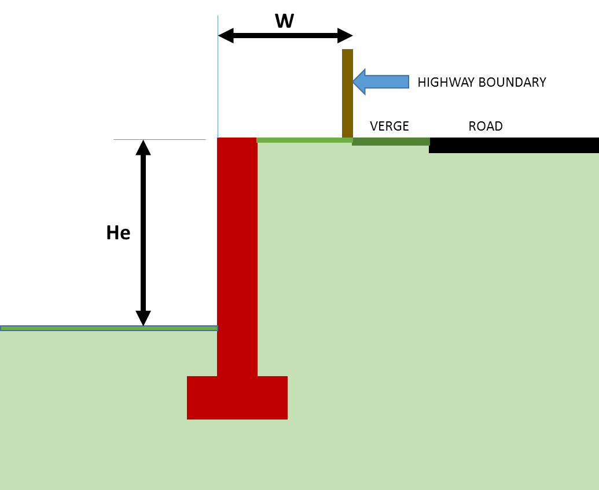

Fig. 2.

Where the distance from the highway boundary to the retained wall (**D**) is 3.66m (4 yards) or less and the effective retained height of wall (**He**) is 1.37m (4’6’’) or above.

This is considered to be a “Highway Related Structure”

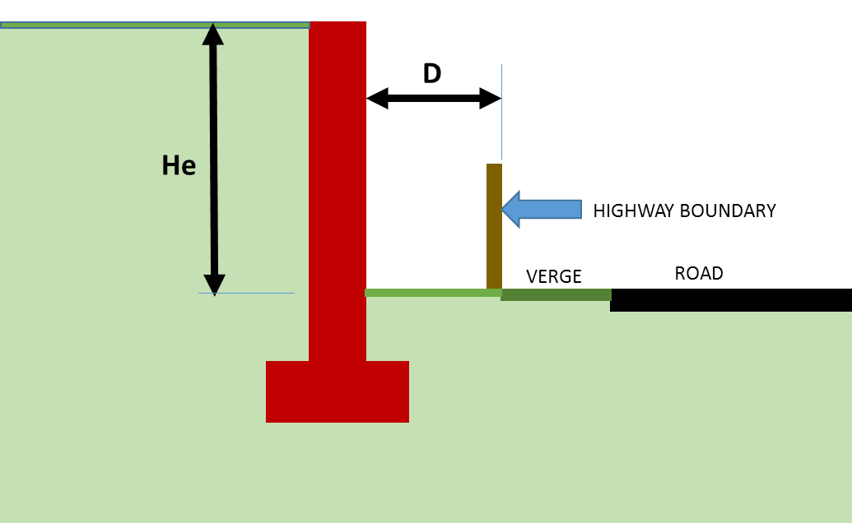

1. Once it has been determined that a retaining wall or similar structure requires technical approval, a category of check will be assigned to the structure in accordance with CG 300, with the addition of an enhanced check for minor structures.
2. The category check applied to a retaining wall will be defined by the effective retained height of material (He); typically, a structure will be appropriated to the following category check:

**Minor Structure** – He < 1.5m (where the distance from the highway boundary to the face of the structure is less than 1.5 x He)

**Category 0** – 1.5m < He < 2.0m

**Category 1** – 2.0m < He < 7.0m

**Category 2** – 7.0m < He < 14.0m

**Category 3** – He > 14.0m



1. It is the developer’s responsibility to propose a category of check to the Council. However, it is at the discretion of the Council to confirm the category of check required. The Council may determine that the actual height (Ha) of the retaining wall should define the check, rather than the effective height (He).

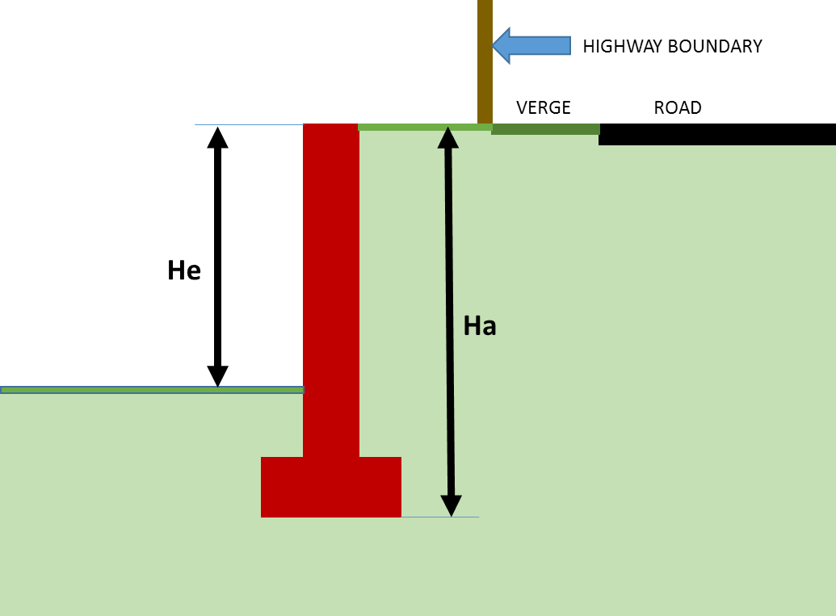

This scenario typically occurs where the presence of passive pressures cannot be guaranteed; (i.e. where a private landowner or utility company has the potential to excavate in front of the wall)

1. Where a retaining wall or similar form of structure is constructed alongside the highway and considered a ‘highway related structure’, the developer has a responsibility to assess road side hazards.
2. Road side hazards are generally assessed using the Road Restraints Risk Assessment Process (RRRAP), however the RRRAP is constrained by a speed limit of 50 mph or greater and/or an Annual Average Daily Traffic flow of 5,000 or greater. The alternative to this process is a risk assessment which must be undertaken in accordance with the Design Manual for Roads and Bridges, CD 377.
3. This process will be undertaken by the developer either internally or by a third party and will be submitted for review to the Council before the structure can receive certification. Where it is deemed that a road restraint system is required due to the hazards identified the detailed design and installation need to be completed by a registered supplier listed under National Highway Sector Scheme Certification.
4. The developer has the responsibility to employ a competent designer/ consultant to design their structures and a suitably qualified professional for the sign off, of the Technical Approval documentation submitted to the Council.
5. **The Council will not relax the requirement for AIP’s and/or Design & Check certificates to be signed by a Chartered Engineer (MICE, MIStructE or equivalent).**

TN6.4. Extracts for Legislation   
& Guidance Documents:

Highways Act 1980

S.167 Powers relating to retaining walls near streets

(1) This section applies to any length of a retaining wall, being a length—.

(a) any cross-section of which is wholly or partly within 4 yards (3.6m) of a street; and.

(b) which is at any point of a greater height than 4 feet 6 inches (1.35m) above the level of the ground at the boundary of the street nearest   
that point;

but does not apply to any length of a retaining wall erected on land belonging to any transport undertakers so long as that land is used by them primarily for the purpose of their undertaking or to any length of a retaining wall for the maintenance of which a highway authority are responsible.

(2) No length of retaining wall, being a length which when erected will be a length of retaining wall to which this section applies, shall be erected otherwise than in accordance with plans, sections and specifications approved by the local authority in whose area the street is situated; and before giving such approval that authority, if they are not the highway authority for the street, shall consult the highway authority.

(3) Any person aggrieved by the refusal of a local authority to approve any plans, sections and specifications submitted to them under this section may appeal to a magistrates’ court.

(4) If a person erects a length of retaining wall in contravention of this section, he is guilty of an offence and liable to a fine not exceeding level 3 on the standard scale.

(5) If a length of retaining wall to which this section applies is in such condition (whether for want of repair or some other reason) as to be liable to endanger persons using the street, the local authority in whose area the street is situated may, by notice served on the owner or occupier of the land on which that length of wall is, require him to execute such works as will obviate the danger.

(6) Where the power conferred by subsection (5) above is exercisable in relation to a length of wall and has not been exercised by the local authority empowered to exercise it, then, if that authority are not the highway authority for the street in question, the highway authority may request the local authority to exercise the power; and if the local authority refuse to comply with the request or fail within a reasonable time after the request is made to them to do so, the highway authority may exercise the power..

(7) Subsections (2) to (7) of section 290 of the Public Health Act 1936 (appeals against and the enforcement of, certain notices under that Act) apply to any notice served under subsection (5) above as they apply to such notices as are mentioned in subsection (1) of that section, but subject to the following modifications: —.

(a) references to the local authority are to be construed as including references to the highway authority;

(b) for paragraph (f) of subsection (3) there is substituted the following paragraph— “(f)that some other person ought to contribute towards the expense of executing any works required by the notice”.

(8) Sections 300 to 302 of the Public Health Act 1936 (supplementary provisions relating to appeals under the said section 290) apply, with the necessary modifications, to appeals brought by virtue of subsection (7) above.

(9) In this section “retaining wall” means a wall, not forming part of a permanent building, which serves, or is intended to serve, as a support for earth or other material on one side only.

GUIDANCE FOR THE Management of   
Highway Structures ACOP Sept 2005

**Appendix H – Process for Dealing with Developer Promoted Structures**

H.1.1. The following process for dealing with the technical approval of developer promoted structures supports the guidance in paragraphs 2.13.22 to 2.13.26.

(1) Appropriate parties within an authority and its agents should inform the bridge manager of all potential developer promoted highway schemes where structures may be involved. This may require the bridge manager to initiate contact with these parties to check that:

(a) They have the bridge manager’s contact details; and

(b) They have an appropriate process in place to alert the bridge manager when developer promoted schemes affect highway structures.

(2) The bridge manager should check that references to the required technical approval (TA) procedures are referred to in the schedules to the Section 278 or 38 Agreements for the proposed scheme. This will ensure that the developer is aware of the processes involved in TA prior to financial agreement.

(3) The bridge manager should check that adequate provision is made in the agreement for commuted maintenance sums and highway authority costs, if this is appropriate. It should also include the time scales for the stages of technical approval. A certification process, including certification of construction, should be specified to ensure compliance before formal adoption and release of bonds.

(4) Suitably qualified and experienced bridge engineers should be stipulated in the agreement for the design of all structures and the Approval in Principle (AIP) and certification preparation.

(5) An initial consultation meeting, attended by the bridge manager and the developer’s representatives, should be convened to discuss potential options.

(6) Whole life cost solutions should be requested and commuted sums for future maintenance.

(7) Processes for TA and treatment of departures from standard should be reiterated.

(8) Initial draft of AIP form should be submitted to the Technical Approval Authority (TAA) for comment.

(9) TAA, as appointed by the bridge manager, should review draft documents and respond with comments.

(10) Resubmit and review as necessary.

(11) Developer to submit final original signed copies for countersignature upon acceptance by the TAA.

(12) TAA to counter sign agreed AIP document. Retain one copy and return one copy to Developer.

(13) Developer’s designer/checker to progress with design and check.

(14) Developer’s designer/checker to submit design and check certificates.

(15) TAA to review construction drawings and audit as stated in Section 278 or 38 Agreements.

(16) TAA or bridge manager to audit construction as stated in agreement.

(17) Developer’s contractor and Works Examiner to certificate construction.

(18) Developer to pay commuted sum and other costs to the highway authority if required by the agreement.

(19) Handover inspection undertaken by bridge manager if the structure is to be maintained by the highway authority (see Section 6.4 on Acceptance Inspections).

(20) Health and Safety file, maintenance manual and “as-built” drawings to be submitted by developer in an agreed format before the road is adopted if the structure is to be maintained by the highway authority (see Section 6.4 on Acceptance Inspection).

(21) All remedial work undertaken prior to release of Section 278 or 38 bond.

SMART

TECHNICAL NOTE TN7

[**Street Lighting**](https://www.shropshire.gov.uk/media/21390/shropshire-lighting-design-guide-2020-v16.pdf)**\***

*Pre-written documents already   
available on SC website

**This document is part of the “Shropshire Manual   
for Adoptable Roads & Transport” (SMART) and  
 should be read in conjunction with all   
other appropriate documents.**

SMART

TECHNICAL NOTE TN8

[**Traffic Signals**](https://www.shropshire.gov.uk/traffic-management/traffic-signals/)**\***

*Pre-written documents already   
available on SC website

**This document is part of the “Shropshire Manual   
for Adoptable Roads & Transport” (SMART) and  
 should be read in conjunction with all   
other appropriate documents.**

SMART

TECHNICAL NOTE TN9

**CAR PARKING GUIDE**

**This document is part of the “Shropshire Manual   
for Adoptable Roads & Transport” (SMART) and  
 should be read in conjunction with all   
other appropriate documents.**

Table of Contents

SMART TECHNICAL NOTE TN9 166

TN9.1. INTRODUCTION 166

TN9.2. CAR PARKING LAYOUT AND DIMENSIONS 166

TN9.3. CAR PARKING LAYOUT EXAMPLES: 167

TN9.4. GARAGES AND CARPORTS 168

TN9.5. GARAGE PARKING 168

TN9.6. EXISTING GARAGES AND CAR PARKING SPACES 169

TN9.7. PRIVATE TURNING FACILITIES 169

TECHNICAL NOTE TN9

CAR PARKING GUIDE

TN9.1. INTRODUCTION

1. The provision for on and off-street car parking must be designed to current design standards and guidance to enable vehicles to circulate efficiently and provide adequate space for manoeuvring into and out of spaces.
2. Current design standards and guidance includes:

* Department for Transport: Manual for Streets 1&2
* English Partnerships: Car Parking - What Works Where
* BS 8300:2001: Design of buildings and their approaches to meet the needs of disabled people — Code of practice
* The Building Regulations 2000: Access and facilities for disabled people Part M, 2004 edition
* CIRIA (2004): Buildings for all to use 2 – improving the accessibility of public buildings and environments’
* Guidance Note: Residential Parking – IHE & CIHT

TN9.2. CAR PARKING LAYOUT   
AND DIMENSIONS

1. **Parking spaces** are recommended to be designed with a minimum internal dimension of **2500mm wide X 5000mm long**. However, the guidance set out within ‘Manual for Streets’ will be considered on the individual development’s merit.
2. Where car parking is proposed in the front garden, the following design features shall be incorporated:

* In line with the Permitted Development rights, permeable paving or border gardens should be part of the parking area.
* The parking area shall keep existing trees and hedges where possible.
* Retain existing built features such as walls, pavements and gates.
* Ensure that clear sight lines are maintained for cars reversing out of car parking spaces/driveways onto the highway.
* The parking space in front of the house must meet the minimum dimensions and no part of a vehicle should overhang the adjacent footway, verge, or carriageway, thereby obstructing pedestrians or other users of the highway.

TN9.3. CAR PARKING LAYOUT EXAMPLES:

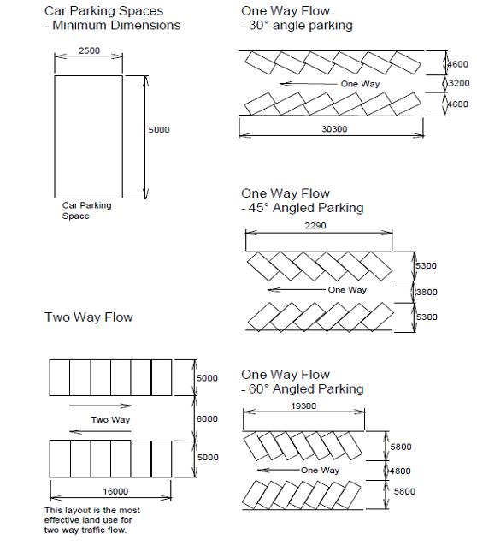

TN9.4. GARAGES AND CARPORTS

Car Port

1. It is recommended that the minimum internal dimensions are **5000mm long x 3000mm wide** to allow easy access to/from the vehicle.

Single Garage

1. It is recommended that the minimum internal dimensions are **7000mm long x 3000mm wide** to allow easy access to/from the vehicle and sufficient storage to the rear to accommodate a bicycle.

Double Garage

1. It is recommended that the minimum internal dimensions are **7000mm long x 5500mm** wide to allow easy access to/from each vehicle and sufficient storage to the rear to accommodate a bicycle.
2. Where a garage driveway is provided for the parking of cars and to prevent obstruction to the highway when accessing a garage the distance from the face of the garage to:
3. the highway boundary - shall be at least **6000mm**.
4. the carriageway edge on access ways - shall be at least **7000mm**.
5. This is to allow garage doors to be opened/ closed with a vehicle positioned in the driveway.

Note - in very quiet residential streets, the use of shorter driveways may be acceptable, in accordance with the requirements of Manual for Streets.

TN9.5. GARAGE PARKING

New Garages

1. All new garages with internal dimensions as set out above will be included in the parking provision for residential properties. Additional parking, where standards permit, can be provided on driveways. Conditions will be imposed to limit the amount of parking space on property frontages.
2. Where there is the potential to provide the number of spaces for the dwelling either in the garage; or in the garage and on the driveway, conditions may be imposed to restrict further paving of the garden for additional spaces.

TN9.6. EXISTING GARAGES AND   
CAR PARKING SPACES

1. Where the result of a proposed conversion or existing single or double garage originally designed for the purpose of parking a car would lead to the creation of additional parking within a property frontage in addition to any existing driveway, the Council is likely to restrict additional permanent parking.
2. This is also applicable where non-covered parking spaces (such as the driveway) will be built on to extend existing dwellings, resulting in a loss of car parking on the site. This is to ensure that the site is not overly developed or has an unacceptable amount of paving.
3. Conversion of an existing residential dwelling to multiple dwellings or redevelopment of a dwelling and creation of multiple units will not entitle the additional dwellings or units to additional parking permits.

TN9.7. PRIVATE TURNING FACILITIES

1. When drivers reverse vehicles out of an access and into a traffic stream, their visibility is restricted and the final part of the turning manoeuvre is carried out on the highway. Danger and inconvenience to other road users are inherent in such movements and can be tolerated in most residential developments fronting unclassified roads in 30 mph areas. Where a residential proposal involves increasing traffic at an existing access in the following circumstances, an internal turning area should be provided, see below.

* Generally on classified roads;
* In the vicinity of a school where pedestrian flows are high;
* On a minor road but near to a junction with a classified road;
* Shared private drives shall always incorporate turning facilities in the form of a common area available to all users of the drive.

**Typical Turning Arrangements**

SMART

TECHNICAL NOTE TN10

**STANDARD DETAILS**

**This document is part of the “Shropshire Manual   
for Adoptable Roads & Transport” (SMART) and  
 should be read in conjunction with all   
other appropriate documents.**

TECHNICAL NOTE TN10

STANDARD DETAILS

**Please click on links below to access Shropshire Council’s Adoptable Highway Standard Details**

|  |  |  |  |  |
| --- | --- | --- | --- | --- |
|  |  |  |  |  |
|  |  |  |  |  |
|  |  |  |  |  |
|  |  |  |  |  |
|  |  |  |  |  |
|  |  |  |  |  |
|  |  |  |  |  |
|  |  |  |  |  |
|  |  |  |  |  |
|  |  |  |  |  |
|  |  |  |  |  |

SMART

TECHNICAL NOTE TN11

[**Refuse & Recycling Guidance**](https://www.shropshire.gov.uk/media/22877/shropshire-refuse-and-recycling-planning-guidance-2022.pdf)**\***

*Pre-written documents already   
available on SC website

**This document is part of the “Shropshire Manual   
for Adoptable Roads & Transport” (SMART) and  
 should be read in conjunction with all   
other appropriate documents.**

SMART

TECHNICAL NOTE TN12

**Local Transport Plan   
(Core DOCUMENT) \***

*Pre-written documents already   
available on SC website

**This document is part of the “Shropshire Manual   
for Adoptable Roads & Transport” (SMART) and  
 should be read in conjunction with all   
other appropriate documents.**

SMART

TECHNICAL NOTE TN13

[**Shropshire Bus Strategy**](https://shropshire.gov.uk/committee-services/documents/s12624/13%20Appendix%20A%20Shropshire%20Council%20Bus%20Strategy.pdf)**\***

*Pre-written documents already   
available on SC website

**This document is part of the “Shropshire Manual   
for Adoptable Roads & Transport” (SMART) and  
 should be read in conjunction with all   
other appropriate documents.**

SMART

TECHNICAL NOTE TN14

**Cycling Guide\***

*Pre-written documents already   
available on SC website

**This document is part of the “Shropshire Manual   
for Adoptable Roads & Transport” (SMART) and  
 should be read in conjunction with all   
other appropriate documents.**

SMART

TECHNICAL NOTE TN15

**Travel Plan Guidance\***

*Pre-written documents already   
available on SC website

**This document is part of the “Shropshire Manual   
for Adoptable Roads & Transport” (SMART) and  
 should be read in conjunction with all   
other appropriate documents.**

SMART

TECHNICAL NOTE TN16

[**Mobility Guidance**](https://www.shropshire.gov.uk/media/3830/mobility-guidance-for-shropshire.pdf)**\***

*Pre-written documents already   
available on SC website

**This document is part of the “Shropshire Manual   
for Adoptable Roads & Transport” (SMART) and  
 should be read in conjunction with all   
other appropriate documents.**

SMART

TECHNICAL NOTE TN17

[**Private Street Works Code**](https://www.shropshire.gov.uk/roads-and-highways/road-network-management/find-out-more-about-our-service/section-58-restrictions/)**\***

*Pre-written documents already   
available on SC website

**This document is part of the “Shropshire Manual   
for Adoptable Roads & Transport” (SMART) and  
 should be read in conjunction with all   
other appropriate documents.**

SMART

TECHNICAL NOTE TN18

**HIGHWAY ADVICE -**

**MINOR PLANNING APPLICATIONS**

**This document is part of the “Shropshire Manual   
for Adoptable Roads & Transport” (SMART) and  
 should be read in conjunction with all   
other appropriate documents.**

Table of Contents

SMART TECHNICAL NOTE TN18 181

INTRODUCTION 181

APPLICATIONS COVERED BY THIS STANDING ADVICE: 181

ADVERTISEMENT SIGNS 182

APPLICATIONS TO BE FORWARDED TO HDC 183

CHANGE OF USE PROPOSALS 184

MINOR RESIDENTIAL APPLICATIONS 185

GENERAL GUIDANCE 185

VISIBILITY 186

RESIDENTIAL PARKING 190

GARAGES 191

TURNING FACILITIES 191

GATES 192

WINDOWS, DOORS & PROJECTIONS: 192

CONSTRUCTION VEHICLE CONSIDERATION 193

TECHNICAL NOTE TN18

HIGHWAY ADVICE -

MINOR PLANNING APPLICATIONS

INTRODUCTION

This document is intended to assist with consultation arrangements relating to planning applications referred for highways and transportation comments. Particularly, where a planning application may have only a minor implication on the adjacent highway and where a standard type of response from the Highways Development Control Team would be generally applied.

These guidelines cannot offer a recommendation to suit all circumstances on all minor development proposals. Therefore, this document provides basic guidance to Development Management Case Officers, to enable a degree of evaluation and assessment to facilitate a reasoned and justified decision to be made, by that case officer.

If development proposals should fall short of the requirements set out in these guidelines, it is incumbent upon the Development Management Case Officer to decide whether amended details need be submitted or whether to impose suitable planning conditions to ensure that the development, when constructed, can be made acceptable.

Any applications, subject to this advice, being considered for refusal on highway grounds **must** be referred to the Highways Development Control Team, prior to the issue of any decision, particularly if an HDC Officer would be required to support the DM case officers decision and defend the refusal reason at Planning Appeal.   
In such cases, a formal consultation with Highways Development Control **must**   
be undertaken.

APPLICATIONS COVERED BY THIS STANDING ADVICE:

This Standing Advice only covers the following minor application types:

* + - Advertisement Signs
* Minor Change of Use Proposals
  + - Minor Residential Developments,(served off unclassified roads, subject   
      to a 30 mph speed limit or less) defined as:

1. Up to 5 dwellings
2. Extensions
3. Garages
4. Substitute house types

**Note: With any application it is difficult to be too prescriptive and if Development Management is in any doubt about the likely traffic/highway/transportation implications of such a development defined above a formal consultation should be carried out with the Highways Development Control team.**

ADVERTISEMENT SIGNS

Standing Advice

Advertisements to be dealt with by Development Management and not requiring a consultation with HDC will include any non-illuminated and illuminated signs that do not fall within paragraph 3.7 below. Examples are likely to include fascia signs on shop/business frontages, free standing signs on petrol filling station/public house forecourts. These could also include fascia and other forms of overhanging signs within pedestrian or public footway/footpath areas although the following standard requirements shall be applied:

The projection from the face of the building over the public highway shall not be within 600mm of any area used by vehicles;

There shall be a minimum 2.4m height clearance between the footway level and the underside of any projecting sign.

The Institution of Lighting Engineers Technical Report No.5 - 3rd Edition (2001) is used to assess acceptable lighting levels and to calculate appropriate luminance limits for signs.

This Technical report provides guidance on the methods of measurements and the control of illuminated advertisements. There is a limit of luminance to be imposed as a condition of consent and there is a table within the report setting down recommendations of maximum luminance in candelas per square metre (cd/m2). This report provides guidelines in three main areas;

* Establishes suitable lighting levels for illuminated advertisements.
* Provides guidance to advertisement designers and manufacturers in order to produce acceptable results.
* Provides advice to Local Authority Lighting Engineers/Local Planning Authorities on how to assess and measure their completed installation in order to ensure that it complies with specified limits of lighting levels and continues to do so throughout its life.

The following is a quick-reference for calculating luminance levels and detailed guidance should be obtained from The Institution of Lighting Engineers Technical Report.

**Definition of Zones**

|  |  |
| --- | --- |
| **E1** | **Intrinsically dark areas (e.g. National Parks, Areas of Outstanding Natural Beauty** |
| **E2** | **Low district brightness areas (e.g. rural or small village locations)** |
| **E3** | **Medium district brightness areas (e.g. small town centres, urban locations)** |
| **E4** | **High district brightness areas (e.g. city and town centres with high levels of night time activity.** |

There are only 2 sign area ranges and the appropriate luminance levels (cd/m2) for each are as follows: -

|  |  |  |  |  |
| --- | --- | --- | --- | --- |
| **Illuminated** | **Zone E1** | **Zone E2** | **Zone E3** | **Zone E4** |
| **Area (m2)** |  |  |  |  |
| Up to 10.00 | 100 | 600 | 800 | 1000 |
| Over 10.00 | n/a | 300 | 600 | 600 |

When granting consent for illuminated signs it is necessary to impose constraints on luminance levels and the above table is to be used for setting limits. With externally illuminated signs it is necessary to ensure that luminaires are positioned such that the light source itself is not directly visible to users of the public highway.

APPLICATIONS TO BE FORWARDED TO HDC

It is considered that the following cases should **continue to be forwarded** to the HDC team for comments:-

* Any advertisement proposed within highway limits or projecting over the public highway with the exception of those proposals referred to in paragraph 4.2 below.
* Advertisements which obstruct or could confuse road users view of a traffic sign or signal.
* Floodlit advertisements where the means of illumination are directly visible from any part of the road for flashing illuminated advertisements on or near the line of sight which would be likely to dazzle or confuse road users, or to be mistaken for traffic lights or other authorised signs.
* Prominent (a sign that is designed to stand out and is clearly visible to the road user) or large animated advertisements sited where they will be likely to distract the attention of road users at potentially hazardous locations such as at junctions, close to the brow of a hill, on a bend etc.
* Advertisements which embody directional or other traffic elements and which need special scrutiny because of possible resemblance to, or confusion, with traffic signs.
* Advertisements requiring close study such as public information panels (i.e. location plans of employment sites) so situated that people looking at them would be insufficiently protected from passing traffic or cause pedestrians to obstruct the footway.
* Advertisements which are likely to obstruct the line of sight for drivers emerging from private accesses.

CHANGE OF USE PROPOSALS

Consultation Requirements

Developments involving only small changes in use would result in insignificant traffic implications. Only developments involving a change of use above the following thresholds should be referred to HDC:

* Within existing built up areas or within the Residential Development Boundaries as defined in the adopted Local Plans and on unclassified roads within 30 mph speed limit zones, change of use to residential up to five dwellings.
* Within existing established industrial estates changes of use involving industrial/warehousing (B2 and B8) up to 250 sq. metres GFA.
* Within existing town centres and established village shopping areas   
  (not isolated shops) change of use to retail (A1 and A2) up to 50 sq.   
  metres GFA;
* Within established town centres and village shopping areas including established industrial estates change of use to Business (B1) up to 200 sq. metres GFA.

Loading

Where loading/unloading facilities are needed, sufficient area must be provided within the development site to allow vehicles to load/unload, together with the appropriate areas for manoeuvring, to ensure that there are no adverse effects on the adjoining highway due to vehicles reversing / manoeuvring in the highway. Such loading/unloading & turning facilities should thereafter be kept free of any impediment to the intended use.

**Note: with any change of use application it is difficult to be too prescriptive and therefore should Development Management be in any doubt about the likely traffic/highway safety implications consultation with Highways Development Control is recommended.**

MINOR RESIDENTIAL APPLICATIONS

Standing Advice

The highway implications relating to a considerable proportion of these types of development proposals generally require a standard approach and could be dealt with by Development Management without reference to Highways Development Control. It is therefore proposed that this **Standing Advice** will include the following residential proposals, which are served off **unclassified** roads, subject to a **30 mph speed limit** (or less) :-

* Residential development proposals – (including barn conversions) which when added to existing development would result in no more than five dwellings off a private drive;
* Side and rear domestic extensions;
* New and replacement garages;
* Substitution of house types (where type and/or the number of   
  bedrooms is similar).

**Note: - These will exclude any development that includes the formation, laying out, or alteration of any means of vehicle access to a public highway. The Development Management Case Officer will need to assess proposals against the 'General Guidelines' below to ensure that appropriate standards are met.**

**If there is any doubt a consultation should be undertaken with HDC.**

GENERAL GUIDANCE

Private Shared Drives/ Single Access

A private drive may serve up to five (5) dwellings (or thereabouts) and are useful in many infill situations. However, such roads **will not** **be adopted**, by Shropshire Council, as highway maintainable at public expense.

The extensive use of private drives, particularly where the number of dwellings served is significantly greater than 5, should be resisted, unless appropriate provisions are made for future their maintenance. This is due to problems that can arise in the provision of utility service equipment (gas, water, electricity, etc.), via private pipes, cables etc. as well as the private road, footway, visibility splays, where the maintenance liabilities are the responsibility of the occupiers. This can result in neighbour disputes and the infrastructure falling into disrepair

Providing careful thought is given to the design layout, (see The Shropshire Street Guide and Manual for Streets for further guidance), all forms of housing development can be adequately served by either a private drive or an adopted road. Nevertheless, where private drives are used it is recommended that they be constructed to a similar standard to that of an adopted road to ensure their longevity and where possible some form of management agreement should be in place avoid future maintenance problems.

Access Drive Widths

Individual accesses serving single dwellings should have a minimum width of   
3.6 metres. Shared accesses should be 4.2 metres in width, which should be maintained for the first 6 metres into the site from the highway boundary.

If an access is bounded immediately on one side by a wall, fence or other structure, an additional 0.6 metres strip will be required on that side. If it is bounded on both sides additional 0.6 metres of driveway width will be required on both sides.

Service Access

Residential developments which cannot be easily serviced by emergency vehicles and refuse collection vehicles from the public highway will require 6.0 metres (min.) radius kerbs at the access. The recommended maximum servicing distances are as follows:

|  |  |  |
| --- | --- | --- |
| **From** | **To** | **Max. Distance (metres)** |
| Resident & visitors cars | Dwelling | As near as possible |
| Resident & visitor cars | Furthest dwelling in a pedestrian court | 40 m |
| Refuse collection vehicle | Dustbin | 25 m |
| Refuse collection vehicle | Communal container bin | 9m |
| Oil tankers | Fuel inlet point | 30m |
| Service vehicles | Dwelling | 35 m (approx.) |
| Fire Appliances | Main entrance to 1 and 2 storey dwellings | 45m |

**Note: - The DM Case Officer will need to assess proposals against these 'General Guidelines' to ensure that appropriate standards are met. If there   
is any doubt a consultation should be undertaken with Highways Development Control.**

VISIBILITY

Vehicle to vehicle visibility splays consists of two components. These are the 'x' or minor road distance and the 'y' or major road distance.



For all residential private accesses to unclassified roads within 30mph zones the recommended **'x'** distance is **2.4** metres back from the nearside edge of carriageway. The case officer should check with HDC before accepting this reduced visibility set back.

The 'y' distance, is measured along the nearside edge of carriageway, should reflect either the design speed or the speed limit.

Visibility standards are set out below. Where the standards relate to the **speed limit** reference shall be made to **Table 1**. However, where it can be demonstrated through 85th percentile speed surveys or through design initiatives that lower vehicle speeds will be achieved then reference can be made to Table 2.

**Table 1:** Visibility requirements for private accesses to roads where there is a speed limit (this includes an allowance for motorists travelling at 10Kph above the speed limit)

|  |  |
| --- | --- |
| **Speed of Priority Road** | **50 Kph (30 mph Speed Limit)** |
| **'X' Distance (metres)** | **2.4** |
| **'Y' Distance (metres)** | **90** |

**Notes:-**

* **Where it is suspected that 85th percentile wet weather speeds are above any mandatory speed limit or where it is unlikely that the desirable target speed cannot be met through design or other speed restraint initiatives to be agreed with the LHA then the 'Y' distance   
  will be determined by HDC on the basis of actual or likely 85th percentile speeds.**
* **Where it can be demonstrated through 85th percentile wet weather   
  speed surveys or through design initiatives that the vehicle speeds are contained to 50Kph (30mph) the 'Y' distance can be amended to   
  60 metres.**

Notwithstanding the above, the DM case officer should be mindful that in urban locations, it may be appropriate to reduce the required 'visibility splays' as shown in **Table 2** below. The reduced splay lengths will be considered in locations where it is felt that the adjacent road is characterised by significant frontage activity (known as ‘side friction’), such as busy urban streets enclosed by buildings, with existing accesses to adjacent properties as well as significant pedestrian activity at the road side.

**Table 2:**

Visibilityrequirements for private accesses to lower order roads (in accordance with Manual for Streets)

|  |  |  |  |  |
| --- | --- | --- | --- | --- |
|  | **Speed of Priority Road (85th %ile)** | | | |
|  | **50 kph**  **(30 mph)** | **30 kph**  **(20 mph)** | **24 kph**  **(15 mph)** | **16 kph**  **(10 mph)** |
| **'X' Distance (metres)** | **2.4** | **2.4** | **2.4** | **2.4** |
| **'Y' Distance (metres)** | **45** | **30** | **20** | **15** |

**The safe stopping distances shown in table 2 above, are subject to continuing research and may not be appropriate where there is a significant amount of bus or HGV activity**. **Therefore, where the visibility splay is likely to be an issue the Highway Advice should be sought.**

Visibility splays are measured at a height of 1.05 metres above ground level.   
This is the height of a driver's eye above the ground when driving the majority of modern cars.

If at that level you cannot see the nearside edge of the road at the appropriate distance along the road, visibility is not available.

The area contained within a visibility splay, whether vehicular or pedestrian, should be provided and maintained free of any obstruction over a height of 600mm above the footway or verge level.

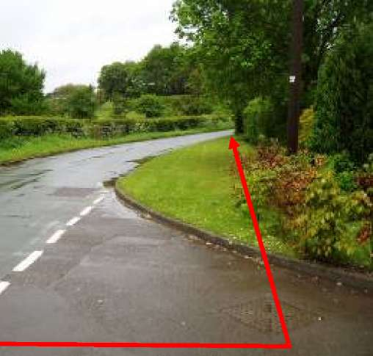

Pedestrian to vehicle visibility splays is appropriate wherever a vehicle access joins the public highway. The recommended dimensions for pedestrian visibility splays are shown below.

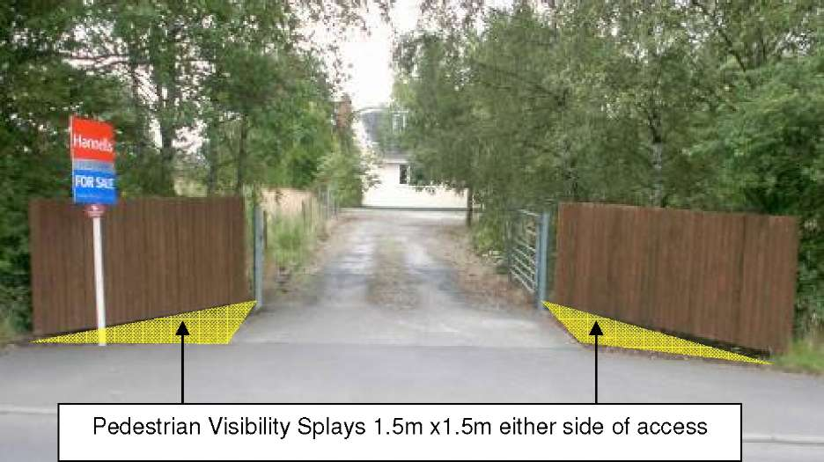

You will be required to make an assessment as to whether, by removal of a hedge, fence, wall, etc., under the control of the applicant, visibility can be provided. If it can, it is recommended that an appropriate condition be imposed.

**Note: If in doubt or it appears that visibility cannot be made available, refer the application to Highways Development Control for formal comment.**

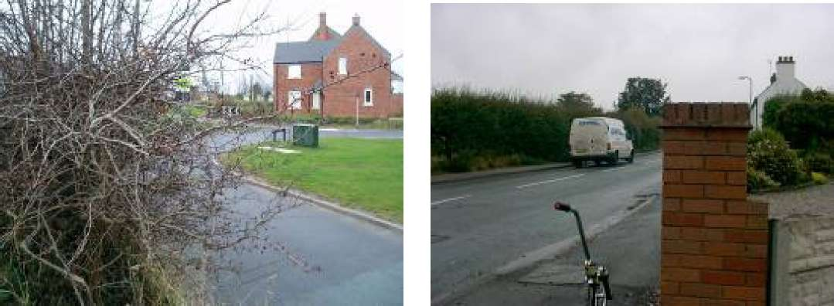

In instances where residential proposals would be likely to result in an increase in traffic at an existing access where visibility is **substandard**, consultation should be undertaken with the Highways Development Control.

RESIDENTIAL PARKING

Parking standards are already determined by Development Management and should therefore be a straightforward task.

If the DM Case Officer is concerned about inadequate off-street parking provision, which may increase existing on-street parking problems, particularly in the vicinity of bends or at junctions, where pedestrian flows are high or where a high proportion of pedestrians are children, the views of Highways Development Control should be sought.

It is important to assess whether the parking provision proposed is effective and also whether a vehicle turning area should be provided.

Residential parking standards should always be fully applied in the case of dwellings served directly or indirectly by a 'Shared Surface' housing estate road. Such roads are intended to provide an environment where pedestrian traffic has priority and therefore conflicts arising from on-street parking should be avoided.

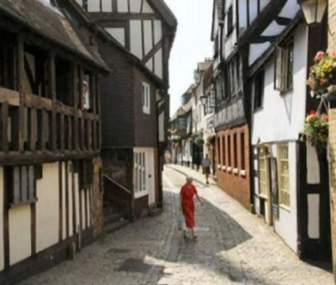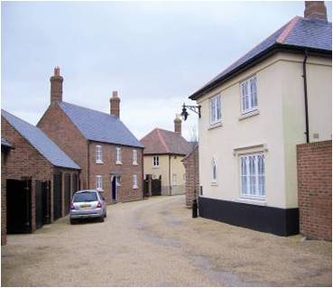

GARAGES

Any garage which has its door(s) facing the highway should be sited at least 6.0 m away from the highway boundary. This is to ensure that the door(s) can be opened when the vehicle is fully parked off the highway.

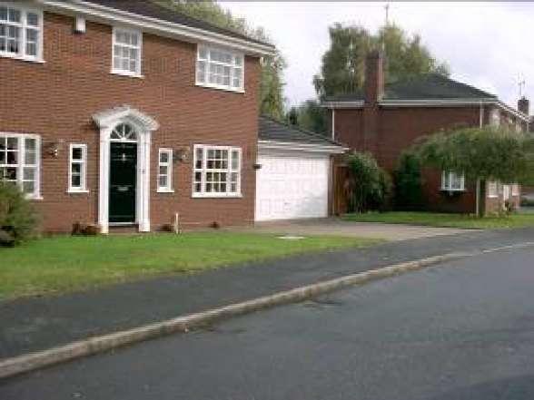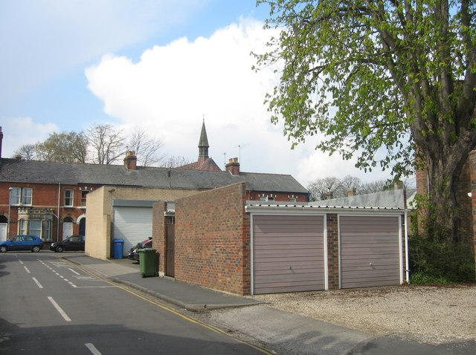

Alternatively, the garage may be sited with its doors at right angles to the highway boundary. In these circumstances sufficient on-site turning room space should be provided within the curtilage of the site.

TURNING FACILITIES

When drivers reverse vehicles out of an access and into a traffic stream, their visibility is restricted and the final part of the turning manoeuvre is carried out on the highway. Danger and inconvenience to other road users are inherent in such movements and can be tolerated in the majority of residential developments fronting unclassified roads in 30 mph areas. Where a residential proposal involves increasing traffic at an existing access in the following circumstances, an internal turning area should be provided, see below.

* Generally on classified roads;
* In the vicinity of a school where pedestrian flows are high;
* On a minor road but near to a junction with a classified road;
* Shared private drives shall always incorporate turning facilities in the form of a common area available to all users of the drive.

**Typical Turning Arrangements**

GATES

No gates shall be positioned so as to open outwards over the highway in order to protect the passing public, particularly pedestrians.

A need to ensure gates are set back is not usually justified on residential estate roads due to relatively low traffic flows. Any consequential short term ‘obstruction’ of the road is therefore of much less concern than on a busier ‘main’ road.

On busier (main) roads, (normally where 2-way traffic flow is predicted to be greater than 100 vehicles per hour in the peak hour) it is important to ensure that a vehicle is not left blocking a footway or verge while a gate (or other form of enclosure) is being opened (or closed) as it can mean that pedestrians have to step into the carriageway.

Any new or replacement gate(s), security barrier(s) or any other obstacle to free access into the site must be set back a sufficient distance to allow the longest vehicle or vehicle combination that can be expected to visit the site, to stand clear of the highway whilst the gate etc. is operated.

**Typical gate set-back distances**

|  |  |
| --- | --- |
| Residential (up to 5 units) | 5m |
| Residential (over 5) | 10m |
| Agricultural No HGV access  With HGV access | 7.5m  15m |
| Offices | 10m |
| Industrial | 15m |
| Caravan Park or Storage | 15m |

WINDOWS, DOORS & PROJECTIONS:

Any consent for the construction of any building immediately adjacent to a highway or pedestrian area should ensure that no windows or doors are allowed to open outwards over the public space.

Similarly, any consent shall also ensure that there are no projections from the   
face of the building, below a height of 2.4 m above the adjacent highway or pedestrian area.

Where it is likely that a development will result in a projection over the highway, i.e. balcony, cantilevered porch or canopy, then the Case Officer shall ensure that the appropriate condition and informative note is attached to any consent granted. (see sections 7 & Appendix 11, below)

CONSTRUCTION VEHICLE CONSIDERATION

In both urban and rural situations consideration should be given to how the site will be serviced by construction vehicles (i.e. building material deliveries by HGV). Where it is likely that such vehicles could be compromised by local highway network constraints, (e.g. low or weak bridge, narrow access between buildings, one way traffic orders, etc.) the DM Case Officer will be required to ensure that any construction of the development does not lead to a situation on the adjacent highway network which my compromise the safe and free flow of traffic and/or pedestrians.

In such circumstances, the Case Officer should consider an appropriate condition requiring the developer to submit an appropriate “Construction Traffic Management Plan”, for approval prior to the commencement of any works, which the developer will be required to follow throughout the construction of the site.

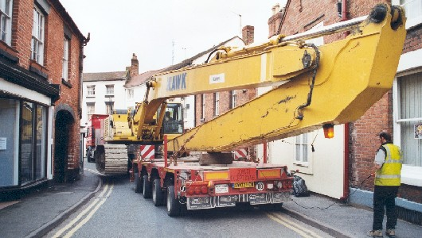

**Note: If Development Management is in any doubt about the likely traffic/highway safety implications - consultation should be carried out with Highways Development Control.**

SMART

TECHNICAL NOTE TN19

**Glossary of Terms   
& Abbreviations**

**This document is part of the “Shropshire Manual   
for Adoptable Roads & Transport” (SMART) and  
 should be read in conjunction with all   
other appropriate documents.**

TECHNICAL NOTE TN19

**Glossary of Terms & Abbreviations**

|  |  |
| --- | --- |
| **Terminology** | **Definition** |
| ADEPT | Association of the Directors of Environment, Economics, Planning and Transportation (formerly CSS) |
| AIS | Asset Information Strategy |
| AONB | Area of Outstanding Natural Beauty |
| Asset Management | A strategic approach that identifies the optimal allocation of resources for the management, operation, preservation and enhancement of the highway infrastructure to meet the needs of current and future customers. |
| Asset Management Regime | Comprises the organisational structure and business processes, asset management planning and work planning and information management and systems that enable asset management to be effectively planned and delivered. |
| Asset Management System | The hardware and software that supports Asset Management practices and processes. Used to store the asset data and information. |
| Asset Valuation | The procedure used to calculate the asset value. |
| Backlog | The monetary value of work required to close the gap between the current performance provided by an asset and the required performance. |
| BCI | Bridge Condition Indices |
| BSCI | Bridge Stock Condition Indicator |
| BVPI | Best Value Performance Indicator |
| Chart | Computerised Highway Assessment of Ratings and Treatment |
| CONFIRM | Computer Based Maintenance Management System |
| CROW | Countryside and Rights of Way Act 2000 |
| CSCS cards | Construction Skills Certification Scheme |
| CSS | County Surveyors’ Society |
| CVI | Coarse Visual Inspection |
| Data | Numbers, words, symbols, pictures, etc. without context or meaning,  i.e. data in a raw format. |
| DfT | Department for Transport |
| DM | Development Management |
| DMRB | Design Manual For Roads And Bridges |
| DNO’s | Distribution Network Operator |
| DRC | Depreciated Replacement Cost |
| DVI | Detailed Visual Inspection |
| Excel | Software Spreadsheet |
| FMS | Fault Management System |
| FNS | Footway Network Survey |
| GAAP | Generally Accepted Accounting Practice |
| GIS | Geographical Information System |
| GRC | Gross Replacement Cost |
| Hazard | A source of potential harm |
| Highway Network | Collective term for publicly maintained facilities laid out for all types of user, and for the purpose of this guidance includes, but is not restricted to, roads, streets, footways, footpaths and cycle routes. |
| Highways England | Organisation that operates, maintains and improves the Motorway and Trunk Road Network |
| HMEP | Highways Maintenance Efficiency Programme |
| HNA Code | Code of Practice for the valuation of the Highway Network Asset |
| HRA | Hot Rolled Asphalt |
| ICP’s | Independent Connection Providers |
| ILP | Institution Of Lighting Professionals |
| Inventory | Information used to describe each individual asset, including but not restricted to location, type, dimensions, construction information and records of use. |
| ISO standards | Internal Organisation for Standardisation |
| KPI | Key Performance Indicator |
| LA | Local Authority |
| Level of Service | A statement of the performance of the asset in terms that the stakeholder can understand. They cover the condition of the asset and non-condition related demand aspirations, i.e. a representation of how the asset is performing in terms of both delivering the service and maintaining its physical integrity at an appropriate level. |
| LHA | Local Highway Authority |
| Lifecycle Plan | A considered strategy for managing an asset, or group of similar assets, from conception construction (planning and design) to disposal. A lifecycle plan should give due consideration to minimising costs and providing the required performance. |
| LPA | Local Planning Authority |
| LTP | Local Transport Plan |
| Maintenance | A term used to describe the activities and operations undertaken to manage /maintain highway assets, e.g. inspection, assessment, renewal, upgrade etc. |
| MOVA | Microprocessor Optimised Vehicle Actuation |
| NI | National Indicators |
| OS | Ordnance Survey |
| OSGR | Ordnance Survey Grid Reference |
| PCC | Pre Cast Concrete |
| Performance | A term used to describe the service delivered as measured by a series of levels of service. It comprises of both condition |
| Performance Measure | A generic term used to describe a measure or indicator that reflects the performance and/or condition of an asset. |
| PPE | Personal Protective Equipment |
| PROW | Public Right of Way |
| Residual Risk | Remaining risk after implementation of risk treatment or control |
| Risk Assessment | The process of risk identification, risk analysis and risk evaluation |
| Risk Evaluation | Comparison of the risk score against the risk tolerance |
| Risk Identification | The process of determining what, where, when, how and why something could happen |
| Risk Management | The chance of something happening which will have an impact on corporate, departmental, tactical, operational or project objectives |
| Risk Reduction | Action taken to lessen the likelihood, negative consequence or both |
| ROW | Rights of Way |
| RTAs | Road Traffic Accidents |
| RUPP | Roads Used as Public Path |
| SCRIM | Sideway-force Coefficient Routine Investigation Machine |
| SHE | Safety, Health & Environmental services |
| SPONS | Spon's Civil Engineering and Highway Works Price Book 2009 |
| SSSI | Sites Of Special Scientific Interest |
| Stakeholder | An individual, group, body or organisation with a vested interest in the management of the transport network, e.g. authority/owner, public, users, community, customers, maintenance contractors and businesses. |
| TRO | Traffic Regulation Order |
| TSRGD | Traffic Signs Regulations & General Directions |
| UKPMS | United Kingdom Pavement Management System |
| UKRLG | United Kingdom Roads Liaison Group |
| UTC | Urban Traffic Control |
| Value Engineering | Development of optimal solutions for prioritised maintenance needs using option appraisal, whole life costing, scheme development, and synergies with other highway schemes. |
| Value Management | Assessment and prioritisation of identified maintenance needs. |
| VAS | Vehicle Activated Signs |
| Whole Life Cost | Total cost of the asset over the term of its life including planning, design, construction, acquisition, operation, maintenance, rehabilitation and disposal. |