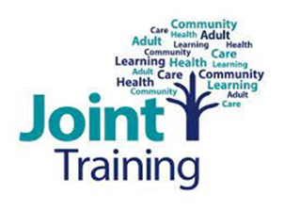

Additional information on courses delivered by Peter Bullimore and colleagues, National Paranoia Network
Maastricht training for Voices/Problematic Thoughts.
Our trainers
These sessions are delivered by experts with lived experience. The stories shared are their own individual experiences which include meaningful expressions and reactions to difficult events, some of which may seem bizarre, though reality for the trainer at that time. The trainers discuss the support they have received from staff within services, both helpful and unhelpful. In sharing their stories, the hope is that learners gain an awareness of some of the less helpful interactions that service users may encounter, and to use this knowledge to better their own practice and understanding. This can help support positive professional relationships with the people accessing their services.
Some of our trainer’s personal stories include events which learners may find distressing. Some of the language used is of a graphic, explicit and sensitive nature. These are experts sharing their stories how they experienced them. Please be aware of this content with respect to your own well-being and seek support should you need to.
Expectations on the day
Both of our Maastricht courses are 3-day courses that focus on developing your understanding and confidence in using the Maastricht Interview technique. This is an assessment tool developed by Dr Sandra Escher and Professor Marius Romme which can be used to support people who hear voices and/or experience problematic thoughts. Throughout the 3 days, a variety of different learning methods will be used, including group work. There will be several opportunities to practice the interviewing skills with peers, as well as with the trainers in relation to their own experiences. Our trainers receive external support for their own wellbeing around this training. It can be an intensive 3 days - we recommend that you attend to your own self-care between and following the sessions, whatever that may look like for you. The trainers will also be mindful to provide frequent breaks and support to learners throughout.
The skills learned through the 3 days are not therapy skills and are appropriate for all roles who may be supporting people who experience voices/problematic thoughts. If learners feel they require further support in implementing the skills learned within their role, we advise seeking this within your teams or contacting the trainer following the course.

