
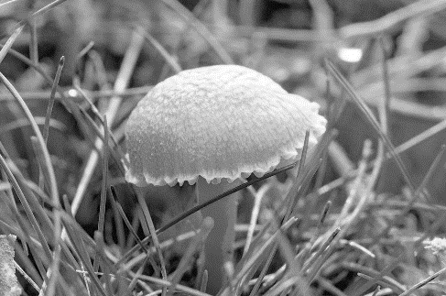
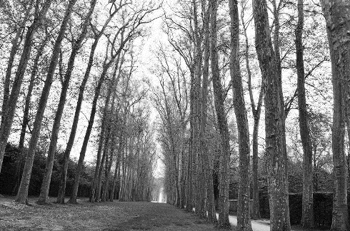
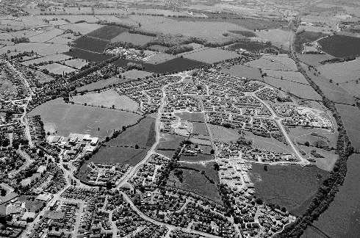
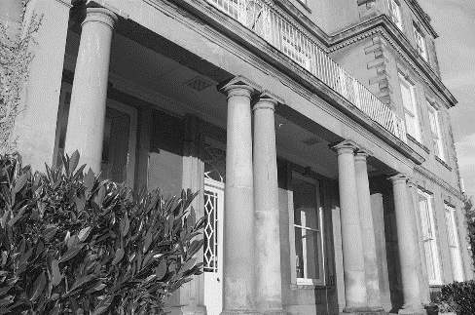
Town and Country Act 1990 Appeal - Statement of Common Ground for Arboriculture

Appellant
Boningale Developments Limited
Respondent
South Staffordshire Council
Site
Patshull Road, Albrighton, Shropshire
Date
June 2026

Appeal Reference: APP/6007402
Local Authority Planning Application Reference: 24/02108/OUT
Contents
1.0 BackGROUND AND PURPOSE 1
2.0 THE APPEAL SITE 1
3.0 SUBMITTED DOCUMENTS 2
4.0 SUpplementary information 2
5.0 tree preservation order 3
6.0 SUMMARY - Matters of agreement 3
7.0 conditions 3
8.0 Parties 3

Plans
Tree Retention Plan (12322-T-02B)
Tree Retention Plan – Access (12322-T-03B)

Rev | Issue Status | Prepared/Date | Approved/Date
- | Draft | HCK / 20.04.26 | SMM / 24.04.26
 | Final | HCK / 14.05.26 | SMM / 14.05.26
A | Final | HCK / 20.07.26 | SMM / 20.07.26

- BackGROUND AND PURPOSE
  - This Statement of Common Ground for Arboriculture (SoCG) has been jointly prepared for The Inspector by FPCR Environment and Design Limited (FPCR) and Shropshire Council (‘the Council’) relating to an appeal for refusal of outline planning permission (application reference 24/02108/OUT).
  - It is agreed that the planning application is an Outline application for a mixed-use development comprising up to 800 no dwellings, a care home of up to 80 units, a secondary school and local centre with associated access, infrastructure, landscaping and drainage. The means of access are being sought in detail, and all other matters are to be reserved for subsequent approval.
  - The application has been refused planning permission with the Council citing two reasons for refusal (Decision Notice dated 16th December 2025).
  - It is agreed there are no Reasons for Refusal that relate specifically to trees. By virtue of Article 35 of the Town and Country Planning (Development Management Procedure) (England) Order 2015 this implies the Council are satisfied that the proposed development is acceptable from an Arboricultural perspective. The aim of this SoCG is therefore to seek agreement to aspects of the proposed application as it relates to trees between the Appellant and the Council for the benefit of the Inspector.
- THE APPEAL SITE
  - This section of the SoCG sets out the agreed factual description of the tree cover associated with the appeal site.

Arboricultural Baseline
  - The Appellant submitted an Arboricultural Assessment carried out in accordance with British Standard 5837 (2012) ‘Trees in Relation to Design, Demolition and Construction – Recommendations’ (hereafter referred to as BS5837). The tree cover is fully described in the submitted Arboricultural Assessment prepared by FPCR Environment and Design Limited dated June 2024 (CD10.3).
  - A total of seventy-eight individual trees, twenty-one groups of trees and eighteen hedgerows were surveyed as part of the Arboricultural Assessment. Trees were surveyed as individual trees, groups and hedgerows in accordance with the survey methodology outlined in BS5837, an industry accepted method by which to evaluate trees associated with proposed development and is set out within the submitted Arboricultural Assessment.
  - In summary, the appeal site supported mainly native species including English oak Quercus robur, common ash Fraxinus excelsior, common lime Tilia x europaea and hawthorn Crataegus forming hedgerows. With a few notable exceptions, most trees and tree groups occupied locations around the boundaries of the various field parcels, meaning central areas were largely devoid of trees. Trees were also forming boundaries with roads and lanes which surrounded and bisected the appeal site area.
  - Assessed in accordance with BS5837, trees ranged in quality from Category A (high arboricultural quality and value) to category C (low arboricultural quality and value) with two trees being regarded as ‘unsuitable for retention’, Category U. The majority of trees across the appeal site were of a mature age class with the most abundant species being English oak.
  - None of the assessed trees were considered as ancient or veteran trees in accordance with the definition of a veteran tree within BS:5837 and the definition of an ancient tree within government guidance ‘Ancient woodland, ancient trees and veteran trees: advice for making planning decisions’, nor were there any Ancient Woodlands associated with appeal site.
  - The submitted Arboricultural Assessment does not consider hedgerows in accordance with the criteria for determining ‘importance’ within the Hedgerows Regulations 1997.
- SUBMITTED DOCUMENTS
  - This statement seeks agreement between the parties over the submitted documents relating to the above applications in respect of arboriculture.
  - It is agreed that an Arboricultural Assessment dated June 2024 including a Tree Survey Plan, Tree Retention Plan and Arboricultural Impact Assessment (AIA) was submitted as part of the planning application (CD10.3) and it was deemed fit for the purpose of setting out the Arboricultural baseline and identification of any projected impacts to existing trees arising from the appeal proposals.
  - It is agreed that the plans contained within the above assessment are as follows:
- Tree Survey Plan (12322-T-01)
- Tree Retention Plan (12322-T-02 Rev A)
- SUpplementary information
  - The County Arboriculturist provided his initial consultation response to the application on 22nd July 2024 (CDXX).
  - In these comments, he set out general advice in respect of the application including guidance to the planning team on dealing with any potential ancient woodland, veteran or ancient trees and ‘important’ hedgerows. He concluded his comments by stating that, ‘although a tree survey plan and schedule have been submitted, no assessment appears to have been made of the arboricultural impacts of the indicative layout as submitted. Since access is included in this application, the Tree Team recommends that an Arboricultural Impact Assessment (AIA) is provided prior to determination for those elements of access infrastructure (including visibility splays) that fall within the scope of the current application. The AIA must be undertaken by a competent arborist in accordance with BS5837: 2012. A tree protection plan and arboricultural method statement should be provided as necessary to show how retained trees and hedges that may be affected by nearby access related works are to be protected during any approved development.’
  - The Appellant had, in fact, submitted the Arboricultural Assessment, but it appears that it may not have been available to the Officer.
  - Further comments were made on 10th October 2025, which can be found within the Committee Report (16th December 2025) (CD1.6), where clearly the Officer had between July 2024 and October 2025 sight of the submitted Arboricultural Assessment and where in summary, he stated ‘The findings and recommendations of the Arboricultural Assessment (AA) are accepted. The development layout on the Tree Retention Plan in the AA would require removal of short section from seven hedgerows to create site accesses and internal access roads. One category 'B' mature English Oak tree would also require removal to create a new access onto Newhouse Lane. SC Trees consider that the road alignment could be adjusted slightly to avoid this loss. Pre-commencement tree protection and landscaping conditions recommended.’

  - The proposals have since been amended and the revised layout (CDXX) has realigned the access onto Newhouse Lane to retain the Category B tree, namely T75. This can be found on Tree Retention Plan (12322-T-02 Rev B).
  - It is agreed that the concern for the loss of the Category B tree, T75 has now been addressed by the slight modified alignment of access position on Newhouse Lane. The retention of T75 can be confirmed by Rev B versions of the Access Drawings prepared by the Highways Consultants formally submitted to the Council as part of Technical Note 4.
- tree preservation order
  - It is agreed that none of the trees associated with the appeal site are afforded statutory protection through a Tree Preservation Order (TPO), nor is the site within a Conservation Area.
- SUMMARY - Matters of agreement
  - The parties agree on the following:
  - It is agreed that an assessment of the appeal site for its arboricultural merit and any impacts arising was undertaken in accordance with British Standard 5837 (2012) ‘Trees in Relation to Design, Demolition and Construction – Recommendations’.
  - It is agreed that to facilitate the vehicular access into the site and to achieve the internal road layout will require the loss of limited sections from six hedgerows, namely H1, H2, H5, H11, H12 and H15 of the Arboricultural Assessment (CD10.3) and there would be very limited overall arboricultural impact arising from these losses. There is extensive landscaping, including planting of new and replacement hedgerows as part of the Green Infrastructure proposals to be designed as part of a future RMA, all of which can be secured through a condition.
  - It is agreed that there are no veteran or ancient trees are present on site, in accordance with the definitions in Section 2.6 above.
  - It is agreed that except for the above losses, no further tree removal would be necessary to facilitate the appeal proposals.
  - It is agreed that the proposals are in Outline with all matters to be reserved for a future application, except for the means of access. At a Reserved Matters stage and also in relation to construction of the access included within the appeal proposals, the use of suitably worded planning condition(s) can ensure that tree protection for all retained trees and hedgerows will be approved by the Council prior to any commencement of construction work on site as requested by the County Arboriculturist.
- conditions
  - The Appellant would agree to the imposition of suitably worded planning conditions to ensure that all retained trees and hedgerows are suitably protected during the construction of the appeal proposals, should the appeal be allowed.

- Parties
  - This Statement of Common Ground for Arboriculture is jointly agreed upon by both parties:
Signed: Mrs Helen Kirk
Date: 14th May 2025
Name: Helen Kirk
ND Arb Arboriculture, MICFor, MArborA
Director for Arboriculture
On behalf of FPCR Environment and Design

Martin Sutton (Signature needed)
Date:
Name: Martin Sutton
County Arboriculturist
On behalf of Shropshire Council

FPCR Environment and Design Ltd
Registered Office: Lockington Hall, Lockington, Derby DE74 2RH
Company No. 07128076. [T] 01509 672772 [E] mail@fpcr.co.uk [W] www.fpcr.co.uk

This report is the property of FPCR Environment and Design Ltd and is issued on the condition it is not reproduced, retained or disclosed to any unauthorised person, either wholly or in part without the written consent of FPCR Environment and Design Ltd. Ordnance Survey material is used with permission of The Controller of HMSO, Crown copyright 100019980.

