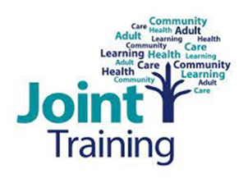

Additional information on courses delivered by Peter Bullimore and colleagues, National Paranoia Network
Working Through Paranoia and Unusual Beliefs/Working with Childhood Trauma and Abuse
Our trainers
These sessions are delivered by experts with lived experience. The stories shared are their own individual experiences which include meaningful expressions and reactions to difficult events, some of which may seem bizarre, though reality for the trainer at that time. The trainers discuss the help and support they have received from staff within services, both helpful and unhelpful. In sharing their stories, the hope is that learners gain an awareness of some of the less helpful interactions that service users may encounter, and to use this knowledge to better their own practice and understanding. This can help support more positive professional relationships with the people accessing their services.
Some of our trainer’s personal stories include events which learners may find distressing. Some of the language used is of a graphic, explicit and sensitive nature. These are experts sharing their stories how they experienced them. Please be aware of this content with respect to your own well-being and seek support should you need to.
Expectations on the day
These courses are delivered by experts with lived experience. You will be able to interact and ask questions throughout the day. As well as the trainers’ personal experiences, other case studies may be used within the training that may be of a sensitive nature. We recommend that you attend to your own self-care during and following the session, whatever that may look like for you. The trainers will also be mindful to provide frequent breaks and support to learners throughout.
Our trainers receive external support for their own wellbeing around this training.

