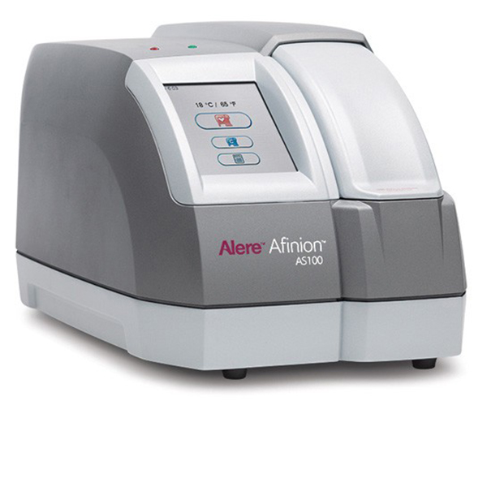

Quality Controls
Frequency of control testing
Controls should be analyzed:
- As part of the Monthly Internal Quality Control Regime
- Any time an unexpected test result or error is obtained.
- When training new operators in the correct use of the Afinion™ Analyzer.
- In compliance with national or local regulations.
Please document:
- The Month and Date of the Quality Control
- Record the LOT number of the 2 cassettes used to complete each round of samples – please use 2 cassettes from the same box with the same LOT numbers.
- Record LOT numbers of the C I and C II samples.
- Record results from both C I and C II samples.
- Record HBA1C - Target - Range – and result in mmol/mol
- Record LIPID - Target – Range and Total Cholesterol and HDL level in mmol/L
- Record a PASS If result on target or within range – Record a FAIL – if result is outside of range

Quality Control Log - Sample of completion

Months | July / August 25 | Sample Lot no. | HBA1C CI | HBA1C CII
Practitioner | Alan Smithee | Sample Lot no. | 10225042 | 10225272
Month | Date of Test | Target (Range)  in mmol/mol | 43 (37 – 50) | 68 (60 – 77)
July | 05/7/24 | Sample Lot no. | LIPID CI | LIPD CII
July | 05/7/24 | Sample Lot no. | 10223384 | 10223385
August | 05/8/24 | Target (Range) in mmol/L  TOT CHL | 4.80 (3.84 – 5.76) | 6.51 (5.21 – 7.81)
August | 05/8/24 | HDL | 0.95 (0.73 – 1.17) | 1.50 (1.16 – 1.85)
Month 1 | HBA1C | Cassette Lot | Result | Pass/fail
July | HBA1C CI | 102234576 | 42 | PASS
July | HBA1C CII | 102234576 | 68 | PASS
July | LIPID | Cassette Lot | Result | Pass/fail
July | LIPID CI | 105432265 | TOT 4.79 HDL 0.96 | PASS
July | LIPID CII | 105432265 | TOT 6.49 HDL 1.46 | PASS
Month 2 | HBA1C | Cassette Lot | Result | Pass/fail
August | HBA1C CI | 10345689 | 44 | PASS
August | HBA1C CII | 10345689 | 67 | PASS
August | LIPID | Cassette Lot | Result | Pass /Fail
August | LIPID CI | 102346753 | TOT 4.78 HDL 0.97 | PASS
August | LIPID CII | 102346753 | TOT 6.51 HDL 1.51 | PASS

Quality Control Log No.1.

Months | July / August 25 | Sample Lot no. | HBA1C CI | HBA1C CII
Practitioner |  | Sample Lot no.
Month | Date of Test | Target (Range)  in mmol/mol
July |  | Sample Lot no. | LIPID CI | LIPD CII
August |  | Target (Range) in mmol/L  TOT CHL
August |  | HDL
Month 1 | HBA1C | Cassette Lot | Result | Pass/fail
July | HBA1C CI
July | HBA1C CII
July | LIPID | Cassette Lot | Result | Pass/fail
July | LIPID CI |  | TOT HDL
July | LIPID CII |  | TOT HDL
Month 2 | HBA1C | Cassette Lot | Result | Pass/fail
August | HBA1C CI
August | HBA1C CII
August | LIPID | Cassette Lot | Result | Pass /Fail
August | LIPID CI |  | TOT HDL
August | LIPID CII |  | TOT HDL

Quality Control Log No. 2
Months | September / October 2025 | Sample Lot no. | HBA1C CI | HBA1C CII
Practitioner |  | Sample Lot no.
Month | Date of Test | Target (Range)  in mmol/mol
September |  | Sample Lot no. | LIPID CI | LIPD CII
October |  | Target (Range) in mmol/L  TOT CHL
October |  | HDL
Month 1 | HBA1C | Cassette Lot | Result | Pass/fail
September | HBA1C CI
September | HBA1C CII
September | LIPID | Cassette Lot | Result | Pass/fail
September | LIPID CI |  | TOT HDL
September | LIPID CII |  | TOT HDL
Month 2 | HBA1C | Cassette Lot | Result | Pass/fail
October | HBA1C CI
October | HBA1C CII
October | LIPID | Cassette Lot | Result | Pass /Fail
October | LIPID CI |  | TOT HDL
October | LIPID CII |  | TOT HDL

Quality Control Log No. 3

Months | November / December 2025 | Sample Lot no. | HBA1C CI | HBA1C CII
Practitioner |  | Sample Lot no.
Month | Date of Test | Target (Range)  in mmol/mol
November |  | Sample Lot no. | LIPID CI | LIPD CII
December |  | Target (Range) in mmol/L  TOT CHL
December |  | HDL
Month 1 | HBA1C | Cassette Lot | Result | Pass/fail
November | HBA1C CI
November | HBA1C CII
November | LIPID | Cassette Lot | Result | Pass/fail
November | LIPID CI |  | TOT HDL
November | LIPID CII |  | TOT HDL
Month 2 | HBA1C | Cassette Lot | Result | Pass/fail
December | HBA1C CI
December | HBA1C CII
December | LIPID | Cassette Lot | Result | Pass /Fail
December | LIPID CI |  | TOT HDL
December | LIPID CII |  | TOT HDL

Quality Control Log No. 4

Months | January / February 2026 | Sample Lot no. | HBA1C CI | HBA1C CII
Practitioner |  | Sample Lot no.
Month | Date of Test | Target (Range)  in mmol/mol
January |  | Sample Lot no. | LIPID CI | LIPD CII
February |  | Target (Range) in mmol/L  TOT CHL
February |  | HDL
Month 1 | HBA1C | Cassette Lot | Result | Pass/fail
January | HBA1C CI
January | HBA1C CII
January | LIPID | Cassette Lot | Result | Pass/fail
January | LIPID CI |  | TOT HDL
January | LIPID CII |  | TOT HDL
Month 2 | HBA1C | Cassette Lot | Result | Pass/fail
February | HBA1C CI
February | HBA1C CII
February | LIPID | Cassette Lot | Result | Pass /Fail
February | LIPID CI |  | TOT HDL
February | LIPID CII |  | TOT HDL

Quality Control Log No. 5

Months | March / April 2026 | Sample Lot no. | HBA1C CI | HBA1C CII
Practitioner |  | Sample Lot no.
Month | Date of Test | Target (Range)  in mmol/mol
March |  | Sample Lot no. | LIPID CI | LIPD CII
April |  | Target (Range) in mmol/L  TOT CHL
April |  | HDL
Month 1 | HBA1C | Cassette Lot | Result | Pass/fail
March | HBA1C CI
March | HBA1C CII
March | LIPID | Cassette Lot | Result | Pass/fail
March | LIPID CI |  | TOT HDL
March | LIPID CII |  | TOT HDL
Month 2 | HBA1C | Cassette Lot | Result | Pass/fail
April | HBA1C CI
April | HBA1C CII
April | LIPID | Cassette Lot | Result | Pass /Fail
April | LIPID CI |  | TOT HDL
April | LIPID CII |  | TOT HDL

Quality Control Log No. 6

Months | May / June 2026 | Sample Lot no. | HBA1C CI | HBA1C CII
Practitioner |  | Sample Lot no.
Month | Date of Test | Target (Range)  in mmol/mol
May |  | Sample Lot no. | LIPID CI | LIPD CII
June |  | Target (Range) in mmol/L  TOT CHL
June |  | HDL
Month 1 | HBA1C | Cassette Lot | Result | Pass/fail
May | HBA1C CI
May | HBA1C CII
May | LIPID | Cassette Lot | Result | Pass/fail
May | LIPID CI |  | TOT HDL
May | LIPID CII |  | TOT HDL
Month 2 | HBA1C | Cassette Lot | Result | Pass/fail
June | HBA1C CI
June | HBA1C CII
June | LIPID | Cassette Lot | Result | Pass /Fail
June | LIPID CI |  | TOT HDL
June | LIPID CII |  | TOT HDL



© 2023 Abbott. All rights reserved. All trademarks referenced are trademarks of either the Abbott group of companies or their respective owners. COL- 00983 v2 03/ 2023

